PHYSICAL REVIEW D 86, 072006 (2012)

ATLAS measurements of the properties of jets for boosted particle searches
G. Aad et al. *
(ATLAS Collaboration)
(Received 23 June 2012; published 15 October 2012)
Measurements are presented of the properties of high transverse momentum jets, produced in proton-
proton collisions at a center-of-mass energy of -fs = 7 TeV. The data correspond to an integrated
luminosity of 35 pb_1 and were collected with the ATLAS detector in 2010. Jet mass, width, eccentricity,
planar flow and angularity are measured for jets reconstructed using the anti-kt algorithm with distance
parameters R = 0.6 and 1.0, with transverse momentum pT > 300 GeV and pseudorapidity |p| < 2. The
measurements are compared to the expectations of Monte Carlo generators that match leading-logarithmic
parton showers to leading-order, or next-to-leading-order, matrix elements. The generators describe the
general features of the jets, although discrepancies are observed in some distributions.
DOI: 10.1103/PhysRevD.86.072006
- INTRODUCTION
The high center-of-mass energy at the Large Hadron
Collider (LHC) combined with the coverage and gran-
ularity of the ATLAS calorimeter provide an excellent
environment to study hadronic jets. Measurements of
dijet cross sections [1,2], jet shapes [3,4], jet substruc-
ture [5] and angular correlations [6,7] have already been
published using the data taken by the ATLAS and CMS
Collaborations in 2010.
Massive, hadronically decaying particles produced with
a significant boost (such as top quarks, Higgs bosons, or
new particles) will tend to have collimated decays, such
that their decay products are contained within a single jet.
The substructure of jets resulting from such decays is
expected to result in deviations in the observables mea-
sured here for light quarks and gluons, thus providing
discriminating power in heavy particle searches.
The observable jet properties presented here are mass,
width, eccentricity, planar flow and angularity. All of these
have been shown to be useful in Monte Carlo studies in the
search for high transverse momentum (pT), massive parti-
cles [8-14], and together they provide an important set of
probes of the substructure of jets.
Three of these (mass, planar flow and angularity) have
recently been measured by CDF [13] at the Tevatron.
Angularities are a family of infrared-safe quantities that
have characteristic distributions for two-body decays,
while planar flow discriminates between two-body and
many-body decays and, for large jet masses (above about
100 GeV), is largely independent of the jet mass.
Eccentricity is a complementary observable to planar
flow, with which it is highly anticorrelated. Jet width is a
*Full author list given at the end of the article.
Published by the American Physical Society under the terms of
the Creative Commons Attribution 3.0 License. Further distri-
bution of this work must maintain attribution to the author(s) and
the published article’s title, journal citation, and DOI.
PACS numbers: 12.38.—t, 13.30.Eg
dimensionless quantity related to the jet mass and is thus
expected to retain much of the discriminatory power with-
out being as sensitive to the detector effects on energy scale
and resolution that can hinder a mass measurement.
Jet substructure measurements can be particularly vul-
nerable to “pileup,” i.e. particles produced in multiple pp
interactions that occur in addition to the primary interac-
tion, within the sensitive time of the detector. These addi-
tional interactions result in diffuse, usually soft, energy
deposits throughout the central region of the detector—the
region of interest for the study of high-pT jets. This addi-
tional energy deposition can be characterized by the num-
ber of reconstructed primary vertices (NPV) [15,16], with
events having a single good vertex (NPV = 1) being con-
sidered free from the effects of pileup. The 2010 ATLAS
data set provides a unique opportunity to study these
effects; a significant fraction of the 2010 data set comprises
NPV = 1 events, making this data set ideal for evaluating
the effects of pileup on jet substructure measurements.
This data set has an average NPV ' 2.2.
- THE ATLAS DETECTOR
The ATLAS detector [17] at the LHC was designed to
study a wide range of physics. It covers almost the entire
solid angle around the collision point with layers of track-
ing detectors, calorimeters and muon chambers. Tracks
and vertices are reconstructed with the inner detector,
which consists of a silicon pixel detector, a silicon strip
detector and a transition radiation tracker, all immersed in
a 2 T axial magnetic field provided by a superconducting
solenoid.
The ATLAS reference system is a Cartesian right-
handed coordinate system, with the nominal collision point
at the origin. The anticlockwise beam direction defines
the positive z axis, while the positive x axis is defined
as pointing from the collision point to the center of the
LHC ring and the positive y axis points upwards. The
azimuthal angle is measured around the beam axis,
1550-7998/ 2012/86(7)/072006(30)
072006-1
© 2012 CERN, for the ATLAS Collaboration
G. AAD et al.
and the polar angle 6 is the angle measured with respect
to the z axis. The pseudorapidity is given by 77 =
— ln tan(6/2). Transverse momentum is defined relative
to the beam axis.
For the measurements presented here, the high-
granularity calorimeter systems are of particular impor-
tance. The ATLAS calorimeter system provides fine-grained
measurements of shower energy depositions over a large
range in 77.
Electromagnetic calorimetry in the range |^| < 4.9 is
provided by liquid-argon (LAr) sampling calorimeters.
This calorimeter system enables measurements of the
shower energy in up to four depth segments. For the jets
measured here, the transverse granularity ranges from
- 003 X 0.10 to 0.10 X 0.10 in A^ X A^, depending on
depth segment and pseudorapidity.
Hadronic calorimetry in the range |^| < 1.7 is provided
by a steel/scintillator-tile sampling calorimeter. This sys-
tem enables measurements of the shower energy deposition
in three depth segments at a transverse granularity of
typically 0.1 X 0.1. In the end caps (|^| > 1.5), LAr
technology is used for the hadronic calorimeters that
match the outer 77 limits of the electromagnetic end-cap
calorimeters. This system enables four measurements in
depth of the shower energy deposition at a transverse
granularity of either 0.1 X 0.1 (1.5 < |^| < 2.5) or 0.2 X
- 2 (2.5 < |q| < 3.2).
- MONTE CARLO SIMULATION
The QCD predictions for the hadronic final state in
inelastic pp collisions are based on several Monte Carlo
generators with different tunes.
The PYTHIA 6.423 generator [18] with the ATLAS
Minimum Bias Tune 1 (AMBT1) [19] parameter set is used
as the primary generator for comparisons with the data and
for extracting corrections to the data for detector effects.
The AMBT1 tune uses the MRST LO* [20] parton distribu-
tion function (PDF) set with leading-order (LO) perturba-
tive QCD matrix elements for 2 ! 2 processes and a
leading-logarithmic, pT-ordered parton shower followed
by fragmentation into final-state particles using a string
model [21] with Lund functions [22] for light quarks and
Bowler functions [23] for heavy quarks. In addition to
charged particle measurements from ATLAS minimum
bias data [24,25], the AMBT1 tune uses data from LEP,
SPS and the Tevatron.
An additional PYTHIA tune, PERUGIA2010 [26,27], is used
for comparison with AMBT1. The PERUGIA2010 tune also
uses data from LEP, SPS and the Tevatron and additionally
improves the description of jet shape measurements in LEP
data. The CTEQ5L [28] PDF set is used. This tune of
PYTHIA is used in the calculation of the systematic uncer-
tainties on the measurements and for comparison with the
data, along with the HERWIG++ 2.4.2 generator with its
default settings [29].
PHYSICAL REVIEW D 86, 072006 (2012)
The more recent HERWIG++ 2.5.1 generator is included for
comparison with the final measurements at particle level, as
are the AUET2B tune [30,31] of PYTHIA 6.423, the POWHEG
generator interfaced to this same PYTHIA tune, and the
PYTHIA 8.153 generator [32] with tune 4C [27,30]. The
major difference between HERWIG++ versions 2.4.2 and
- is the inclusion of color reconnections in the latter.
The POWHEG generator, which implements next-to-leading-
order (NLO) calculations within a shower Monte Carlo
context [33-36], uses the CTEQ6M [28] PDF set.
Generated events are passed through the ATLAS detec-
tor simulation program [37], which is based on GEANT4
[38]. The quark-gluon string model with an additional
precompound [39] is used for the fragmentation of nuclei,
and the Bertini cascade model [40] is used to describe the
interactions of hadrons with the nuclear medium.
Monte Carlo events are reconstructed and analyzed
using the same event selection and simulated trigger as for
the data. The size and position of the collision beam spot
and the detailed description of detector conditions during
the data-taking runs are included in the simulation.
- EVENT SELECTION
Events containing pileup can be identified by the pres-
ence of more than one primary vertex in the event, herein
referred to as NPV > 1. Events recorded in the 2010
ATLAS data set contain an average NPV ' 2.2 and include
a significant fraction of NPV = 1 events (' 28%); these
may be used for testing the pileup correction methods.
After applying data-quality requirements, the data sam-
ple corresponds to a total integrated luminosity of 35.0 ±
- pb—1 [41,42].
- Trigger selection
Events must pass the ATLAS first-level trigger requiring
a jet (built from calorimeter towers with a granularity of
- 1 X 0.1 in A^ X A^) with transverse energy £T >
95 GeV. The selection efficiency of this trigger has been
found to be close to 100% for events satisfying the offline
selection criteria implemented here, with a negligible de-
pendence on jet mass [5].
- Primary vertex selection
All events are required to have at least one good primary
vertex. This is defined as a vertex with at least five tracks
with pT > 150 MeV and both transverse and longitudinal
impact parameters consistent with the LHC beamspot
[15,16]. The analysis presented here makes use of the
full 2010 data set. The requirement of NPV = 1 is applied
only where derivation of pileup corrections is not possible.
- High-pT jet selection
Jets are reconstructed from locally calibrated topologi-
cal clusters [43] using the anti-kt algorithm [44] with
072006-2
ATLAS MEASUREMENTS OF THE PROPERTIES OF JETS
PHYSICAL REVIEW D 86, 072006 (2012)
distance parameters of R = 0.6 and 1.0. Jets satisfying
pT > 300 GeV and |p| < 2 are selected for analysis.
Any event containing an R = 0.6 jet with pT > 30 GeV
that fails to satisfy the criteria [45] designed to safeguard
against jets caused by transient detector effects and beam
backgrounds is excluded from this analysis.
In simulated data, jets are reconstructed from locally
calibrated topological clusters to derive corrections for
pileup and determine the systematic uncertainties and de-
tector correction factors. The corrected data distributions are
then compared to Monte Carlo predictions at particle level;
in this case jets are reconstructed from stable particles as
opposed to clusters. Particles are deemed to be stable for the
purpose of jet reconstruction if their mean lifetimes are
longer than 10 ps. Neutrinos and muons are excluded, just
as they are for the Monte Carlo-based jet energy scale
calibration that is applied to the data. This exclusion has a
negligible effect on the final measurements.
The total numbers of jets in data satisfying the selection
criteria detailed here are —122000 R = 1.0 jets and
—87 000 R = 0.6 jets; however, only the highest pT jet
in each event is selected for this analysis. The total num-
bers selected for analysis are —83 000 R = 1.0 jets and
—62000 R = 0.6 jets.
V. SUBSTRUCTURE OBSERVABLES AND
THEIR CORRELATIONS
A. Jet mass
The jet mass M is calculated from the energies and
momenta of its constituents (particles or clusters) as follows:
M2 =
CN2 - C?>)2
(i)
where £)■ and p, are the energy and three-momentum of the
ith constituent. The sum is over all jet constituents in this
and all subsequent summations. The standard ATLAS re-
construction procedure is followed: clusters have their
masses set to zero, while Monte Carlo particles are assigned
their correct masses.
provides the vector which best describes the energy-
weighted geometrical distribution of the jet constituents
in the (7, <^) plane. The eccentricity is used to characterize
the deviation of the jet profile from a perfect circle in this
plane, and is defined as
E = 1 -
(3)
where vmax(vmin) is the maximum (minimum) value of
variance of the jet constituents’ positions with respect to
the principal vector. The calculation consists of the follow-
ing steps:
(1) For each jet the energy-weighted centers in 7 and
are calculated as
'jet
i
“ZET
TJjet
ZA^iEi
i
“ZET
(4)
where the energy and position in the (7, <^) plane of
the ■th constituent with respect to the jet axis are
denoted by £), A 7, and A^,.
(2) The PCA is performed to determine the vector i in
(7, <^) space that passes through the energy-
weighted center of the face of the jet and results in
a minimum in the variance of the constituents’
positions. The angle 6 of this vector with respect
to the jet center (j <jt) is given by
tan20 =
2 X ZEiA^iA^i
Z£i(A^2 - a 72)
(5)
and the angle of the orthogonal vector x2 is 0 — .
(3) The energy-weighted variances vj and v2 with re-
spect to xj and x2 are calculated as
1 = ^XEi(cos0A^i - sin^A^i)2,
V2 = Ei(sin0A^i + cos^A^i)2,
(6)
- Jet width
The jet width W is defined as:
PARpT
W = '

ZpT ’
(2)
where AR = V(A^i)2 + (Ap,)2 is the radial distance
between the jet axis and the ith jet constituent and pT is
the constituent pT with respect to the beam axis.
where N is the number of constituents.
(4) Finally, the largest value of the variance is assigned
to vmax and the smallest to vmin. The jet eccentricity
ranges from zero for perfectly circular jets to one for
jets that appear pencil-like in the (7, <^) plane.
Eccentricity is measured for jets in the mass range M >
100 GeV; this is the mass region of interest for the search
for a Higgs boson or other massive, hadronically decaying
particles predicted in various extensions to the Standard
Model.
- Eccentricity
The jet eccentricity E is calculated using a principal
component analysis (PCA) [12]. The PCA method
- Planar flow
A variable complementary to the eccentricity is planar
flow P [10,46,47]. The planar flow measures the degree to
v
v
max
v
072006-3
G. AAD et al.
PHYSICAL REVIEW D 86, 072006 (2012)
which the jet’s energy is evenly spread over the plane
across the face of the jet (high planar flow) versus spread
linearly across the face of the jet (small planar flow).
To calculate planar flow, one first constructs a two-
dimensional matrix /g1:
1

/E1 =
(7)
Here, M is the jet mass, £)■ is the energy of the ith
constituent of the jet and pik and pi;1 are the k and l
components of its transverse momentum calculated with
respect to the jet axis. The planar flow is
det(/£)
P = 4
Tr(/£)2'
(8)
Vanishing or low planar flow corresponds to a linear
energy deposition, as in the case of a two-pronged decay,
while completely isotropic energy distributions are charac-
terized by unit planar flow [10]. Jets with many-body kine-
matics are expected to have a planar flow distribution that
peaks towards unity. In general, QCD jets have a rising P
distribution that peaks at P = 1; the hadronization
process has contributions from many soft gluons and is
largely isotropic. However, jets with high pT and high
mass are well described by a single hard gluon emission.
Consequently, these jets have a planar flow distribution that
peaks at a low value [13]. The planar flow distributions are
measured in the context of boosted, massive particle
searches by applying a mass cut, 130 <M< 210 GeV,
consistent with the window in which one would expect to
observe a boosted top quark decay collimated within a single
jet. The contribution from top quark decays in this subset of
the data is negligible—here we measure the properties of
light-quark and gluon jets that constitute a substantial frac-
tion of the background in boosted top quark measurements.
- Angularity
Angularities (ra) are a family of observables that are
sensitive to the degree of symmetry in the energy flow
inside a jet. The general formula for angularity [10] is
given by
1

Ta = _ cos0¿]
1 —a
(9)
Here a is a parameter that can be chosen to emphasize
radiation near the edges (a < 0) or core (a > 0) of the jet,
M is the jet mass, £j- is the energy of the ith jet constituent
and 0, is its angle with respect to the jet axis. In the limit of
small-angle radiation (0, ^ 1), ra is approximated by
2.(a — 1) ,
M
Q(2 a)
(10)
Angularities are infrared-safe for a < 2 [13]. In the
analysis presented here, Eq. (9) with a value of a = —2
is used. The t—2 observable can be used as a discriminator
for distinguishing QCD jets from boosted particle decays
by virtue of the broader tail expected in the QCD distribu-
tion [10]. At a given high mass, the angularity of jets with
two-body kinematics should peak around a minimum value
^aeak ' (2p:)1—a, which corresponds to the two hard con-
stituents being in a symmetric pT configuration around
the jet axis. An estimate for the maximum of the distribu-
tion can also be calculated in the limit of small-angle
radiation, rmax ' (^(2^ [13], which corresponds to a
hard constituent close to the jet axis and a soft constituent
on the jet edge.
The measurement of t—2 is aimed primarily at testing
QCD, which makes predictions for the shape of the t—2
distribution in jets where the small-angle approximation is
valid. For this reason, this measurement is made only for
anti-kt jets with R = 0.6.
Here, t—2 is measured for jets in the mass range 100 <
M < 130 GeV. This mass region is chosen to have mini-
mal contributions from hadronically decaying W or Z
bosons or boosted top quarks (PYTHIA predictions estimate
a relative fraction below 0.2%).
- Correlations between the observables
The levels of correlation between the variables presented
here provide information that is valuable in deciding which
variables may potentially be used together in a search for
boosted particles. Here the correlation factors between
pairs of variables are calculated as their covariance divided
by the product of their standard deviations:
cov(x, y)

(11)
Summaries of the correlations between all of the observ-
ables studied here are shown in Fig. 1 for R = 1.0 jets in
PYTHIA at particle level. The coefficients are shown both
with and without a jet mass cut of M > 100 GeV—the
individual mass constraints for each observable are
dropped here to allow the correlations between them to
be calculated. Jets subjected to a mass cut are also re-
stricted to |p| < 0.7. This additional restriction on 77 is
applied wherever a mass cut is made on the observables
presented here; this has a negligible effect on the shapes of
the distributions while allowing direct comparisons with
other measurements of the same quantities [13].
The strongest correlations observed are those between
jet mass and width (85%) and between planar flow and
eccentricity (— 80%). The correlation between mass and
width reduces considerably when jets are required to be in
the kinematic region M > 100 GeV. This trend is followed
by almost all observables. The planar flow and eccentricity,
however, are even more strongly anticorrelated in
high-mass jets (— 90%). The correlation between mass
and pT is weak (12%-16%). Angularity is largely uncorre-
lated with all of the other observables.
a
072006-4
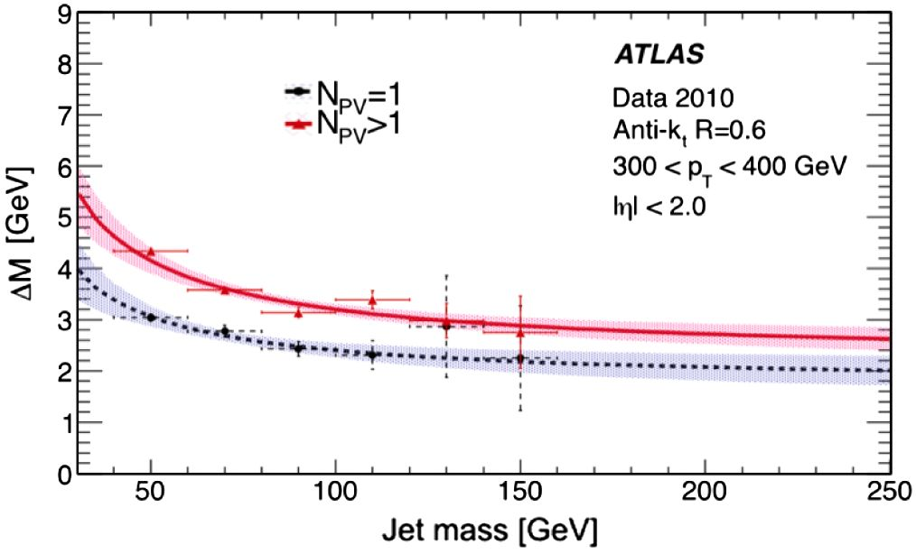
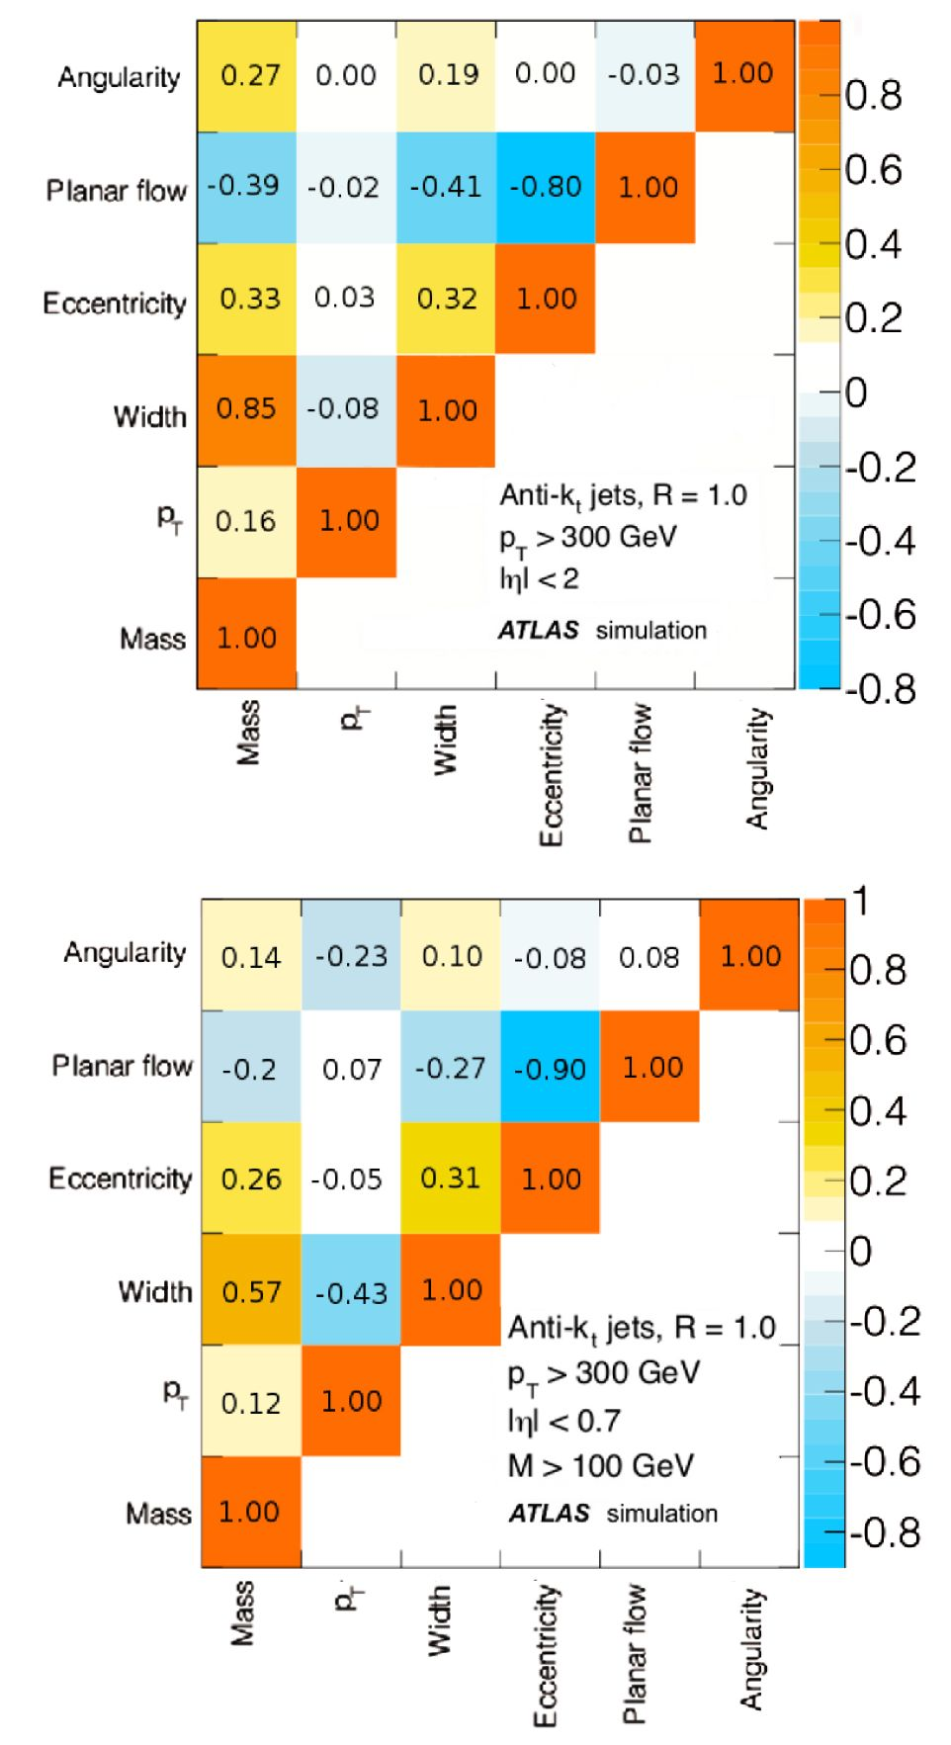
ATLAS MEASUREMENTS OF THE PROPERTIES OF JETS
1
PHYSICAL REVIEW D 86, 072006 (2012)
and pileup): the difference between the average shift for
single-vertex and multiple-vertex events is attributed to the
contribution from pileup only.
The presence of additional energy in events with NPV > 1
affects the substructure observables in different ways; the
effect of pileup on the shape of the t_2 distribution is
negligible (below 1%) in this data set, and so no correc-
tions are applied. The other observables under study have
their distributions noticeably distorted by the presence of
pileup. The pT-dependent corrections for this effect are
applied to the mass, width and eccentricity distributions,
while the planar flow distribution of high-mass jets is
measured only in events with NPV = 1. There are a small
number of jets (~ 100 anti-kt R = 0.6 jets) in the high-
mass range (M > 130 GeV), making it too difficult to
derive robust pileup corrections for planar flow (which is
limited to this mass range in this analysis) in this data set.

A. Pileup corrections for R = 0.6 jets
The mass shift due to the UE and pileup in NPV = 1 and
NPV > 1 events is shown in Fig. 2 for R = 0.6 jets in the
range 300 < pT < 400 GeV. The shift follows the ex-
pected behavior, given by
AM = Po„ +
(12)
where p and their associated uncertainties are deter-
mined from the data. AM is the increase in the jet mass
due to the addition of the energy deposits in the comple-
mentary cone to the jet. Corrections to the jet mass are
limited to the region M > 30 GeV, as the ^ parametri-
zation uses a leading-order approximation [48] and is only
valid for AM ^ M. This has a negligible effect on the final
measurements in the range M > 20 GeV, as illustrated for
FIG. 1 (color online). The correlation coefficients between
pairs of variables calculated in PYTHIA at particle level for
R = 1.0 jets with no mass constraint (top panel) and with a
mass constraint of M > 100 GeV (bottom panel).

VI. CORRECTIONS FOR PILEUP AND
DETECTOR EFFECTS
The contribution from pileup is measured using the
complementary cone method first introduced by the CDF
experiment [13,48]. A complementary cone is drawn at a
right angle in azimuth to the jet (^comp = ± f,
^7comp = ^jet) and the energy deposits in this cone are
added into the jet such that the effect on each of the jet
properties can be quantified. The shift in each observable
after this addition is attributed to pileup and the underlying
event (UE), the latter being the diffuse radiation present in
all events and partially coherent with the hard scatter. The
effects of these two sources are separated by comparing
events with NPV = 1 (UE only) to those with NPV > 1 (UE
FIG. 2 (color online). The size of the mass shift in anti-kt
R = 0.6 jets with 300 < < 400 GeV in jets with pileup and
UE (NPV > 1, average NPV ' 2.2) and with UE alone (NPV = 1).
The curves are fits of the form AM = p0 + . The difference
r °M M
between the curves gives the contribution to the jet mass from
pileup only. The 1ct- uncertainties on the fits are shown in the
error bands.
072006-5
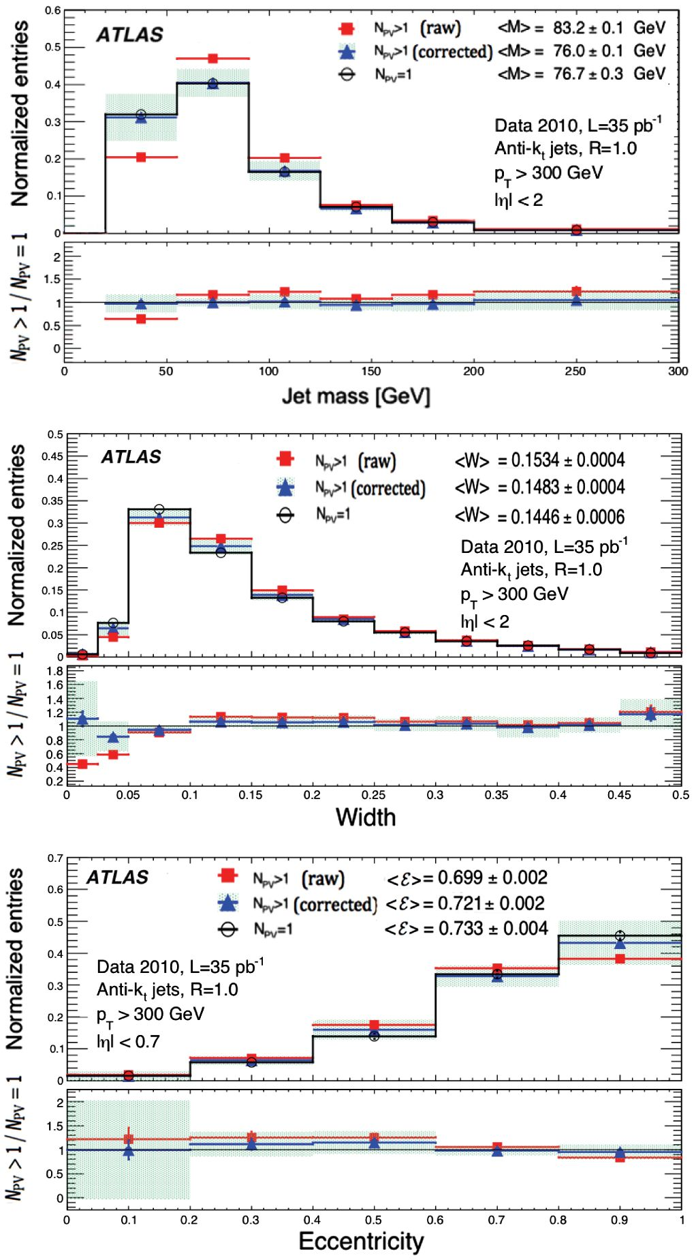
G. AAD et al.
PHYSICAL REVIEW D 86, 072006 (2012)
R = 1.0 jets in Fig. 3; low mass, high-pT jets tend to have a
small contribution from pileup.
The corresponding parametrizations for the shifts in
width AW and eccentricity AE are
AW = pow + PiwW, AE = poe + PieE + PisE2. (13)
The pileup corrections for width and eccentricity are
applied to jets across the full mass range.
FIG. 3 (color online). The mass, width and eccentricity distri-
butions before and after the pileup corrections. The (red) squares
indicate the uncorrected data in the full data set, the (black)
circles indicate the subset of this data with NPV = 1 and the
(blue) triangles indicate the full data set after pileup corrections.
The mean value of each distribution is indicated in the legend
with the corresponding statistical uncertainty. The lower region
of each figure shows the measured ratio of NPV > 1 to NPV = 1
events.
- Pileup corrections for R = 1.0 jets
The complementary cone technique cannot be applied
directly to R = 1 :0 jets due to the high probability of
overlap between the complementary cone and the jet;
scaling factors are therefore applied to the corrections
measured for R = 0.6 jets.
The scaling behavior is determined experimentally by
comparing the pileup dependence in R = 0.6 and R = 0.4
jets. For each observable, the shifts for R = 0.4 jets are fit
to a functional form. The shifts for R = 0.6 jets are then fit
to a scaled version of this function, where all parameters
are fixed at their R = 0:4 values and the scaling is the only
free parameter of the fit. The measured R dependence is
then validated with a comparison between R = 1:0 jets in
NPV > 1 and NPV = 1 events.
The predicted (observed) behaviors for the scaling of the
shifts in mass and width are
AM: p, ~ R4(R35), (14)
AW: p0w ~ R3(R25); piw ~ R2(R1). (15)
The phenomenological predictions [49] for scaling are
used, and the discrepancies between predictions and ob-
servations are considered systematic uncertainties in this
procedure.
There is no phenomenological prediction for the scaling
of AE with pileup; therefore the nominal value of the
scaling of the shift in this variable is measured in data.
The measurements find the scaling of the parametrization
to be a function of mass:
AE(M < 40 GeV): piE ~ R2,
AE(M > 40 GeV): piE ~ R3.
(16)
The measured scaling is varied between R2 and R3
across the mass range in order to determine a conservative
estimate of the systematic uncertainty introduced by this
procedure.
The performance of the pileup correction procedure in
the case of mass, width and eccentricity is shown in Fig. 3.
The observable most sensitive to pileup is the jet mass; the
mean R = 1.0 jet mass is shifted upwards by ~7 GeV in
events with NPV > 1, and there is a significant change in
the shape of the mass distribution. In the case of jet width
and eccentricity, the effect of pileup is a small (~ 5%)
shift towards wider, less eccentric jets. This supports the
expected behavior: width is less sensitive to pileup than
mass, making it a promising alternative to mass as a
criterion for selecting jets of interest in boosted particle
searches in the high pileup conditions of later LHC opera-
tions. For all observables the discrepancies between the
pileup-corrected distributions and those for events with
NPV = 1 are small, and agreement is obtained within the
systematic uncertainties on the corrections.
072006-6
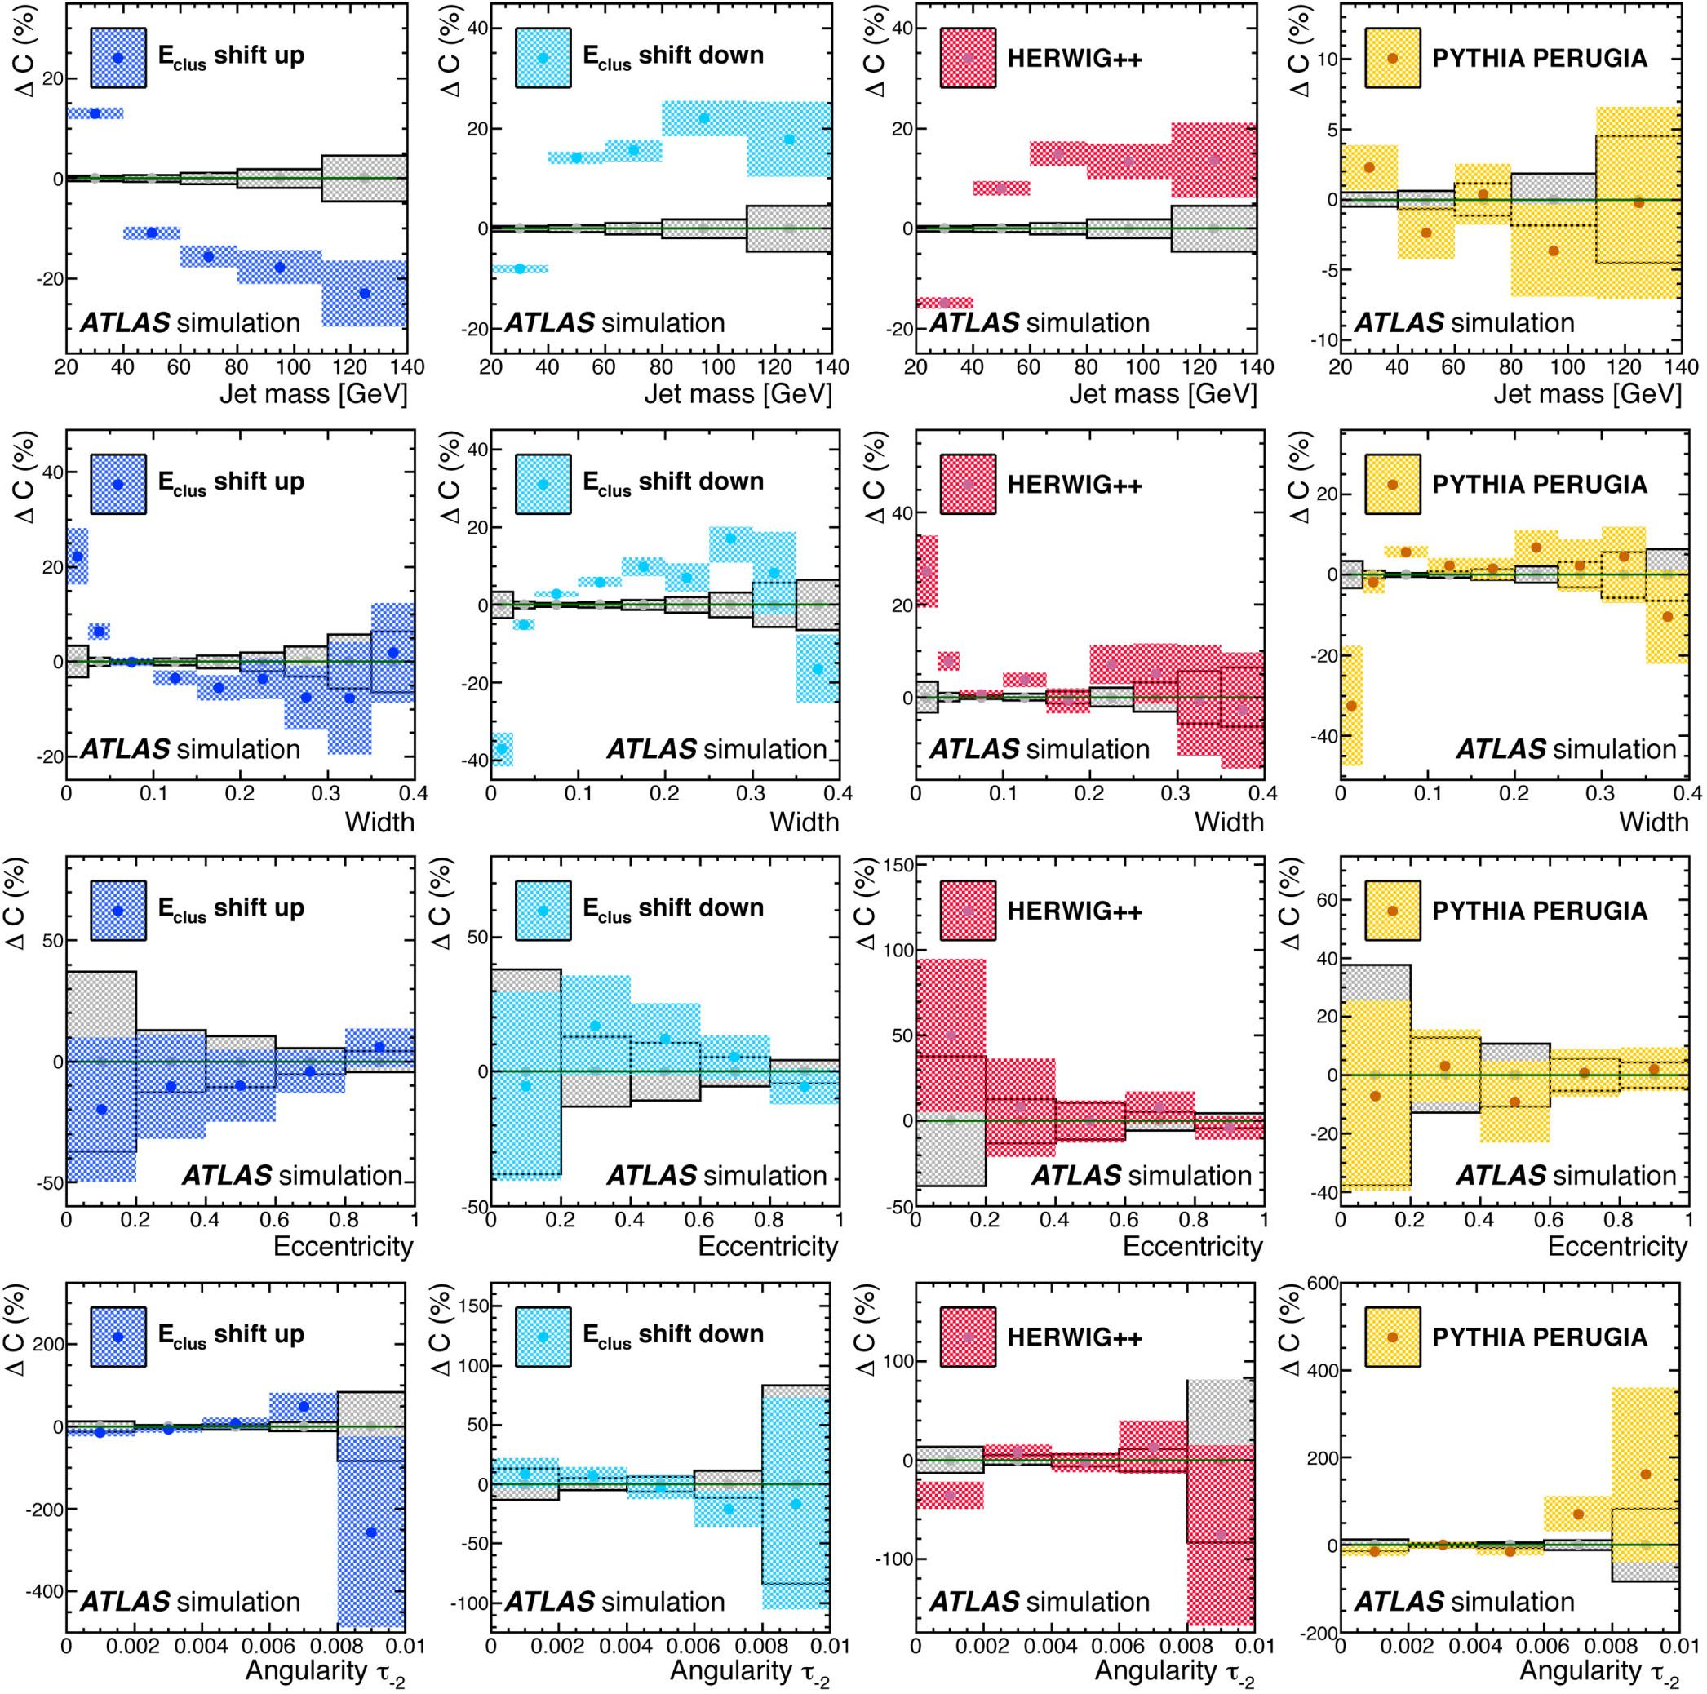
ATLAS MEASUREMENTS OF THE PROPERTIES OF JETS ...
PHYSICAL REVIEW D 86, 072006 (2012)
FIG. 4 (color online). The dominant sources of systematic uncertainty on the measurements are those resulting in large variations in
the detector correction factors C. These correction factors are found bin by bin using R = 0.6 jets in a PYTHIA AMBT1 sample with
upward and downward variations of the cluster energy scale (first and second columns), and by using HERWIG++ (third column) and
PYTHIA PERUGIA2010 (fourth column) in place of PYTHIA AMBT1. The differences AC found when comparing the correction factors
obtained with the baseline PYTHIA AMBT1 sample are shown here for each of the properties measured in R = 0.6 jets. The shaded bands
indicate the statistical uncertainties.
C. Corrections for detector effects
After correcting the distributions for pileup, each
distribution is corrected to particle level, using bin-by-bin
corrections for detector effects. The bin migrations
due to detector effects are determined and controlled
by increasing the bin sizes until all bins have a
purity and efficiency above 50% according to
Monte Carlo predictions, where purity and efficiency
are defined as
A
part+det
A
part+det
Pi
A
det
A part
(17)
072006-7
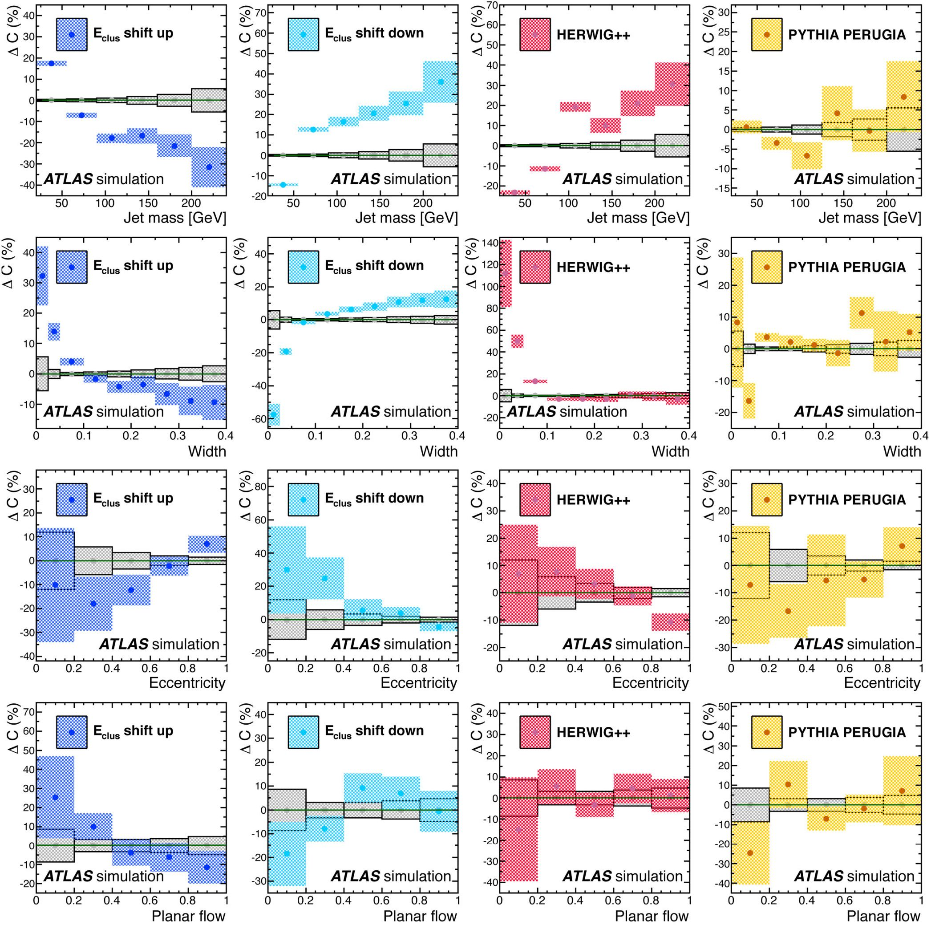
G. AAD et al.
PHYSICAL REVIEW D 86, 072006 (2012)
FIG. 5 (color online). The dominant sources of systematic uncertainty on the measurements are those resulting in large variations in
the detector correction factors C. These correction factors are found bin by bin using R = 1.0 jets in a PYTHIA AMBT1 sample with
upward and downward variations of the cluster energy scale (first and second columns), and by using HERWIG++ (third column) and
PYTHIA PERUGIA2010 (fourth column) in place of PYTHIA AMBT1. The differences AC found when comparing the correction factors
obtained with the baseline PYTHIA AMBT1 sample are shown here for each of the properties measured in R = 1.0 jets. The shaded bands
indicate the statistical uncertainties.
Here Apart+det is the number of detector-level jets (re-
constructed from locally calibrated clusters) in bin i that
have a particle-level jet (reconstructed from stable
Monte Carlo particles), matched within AR < 0.2 and
falling in the same bin. Apart is the total number of
particle-level jets in bin i and Adet is the total number of
detector-level jets in bin i.
The particle-level value for an observable in bin i is
found by multiplying its measured value by the relevant
correction factor Ci:
072006-8
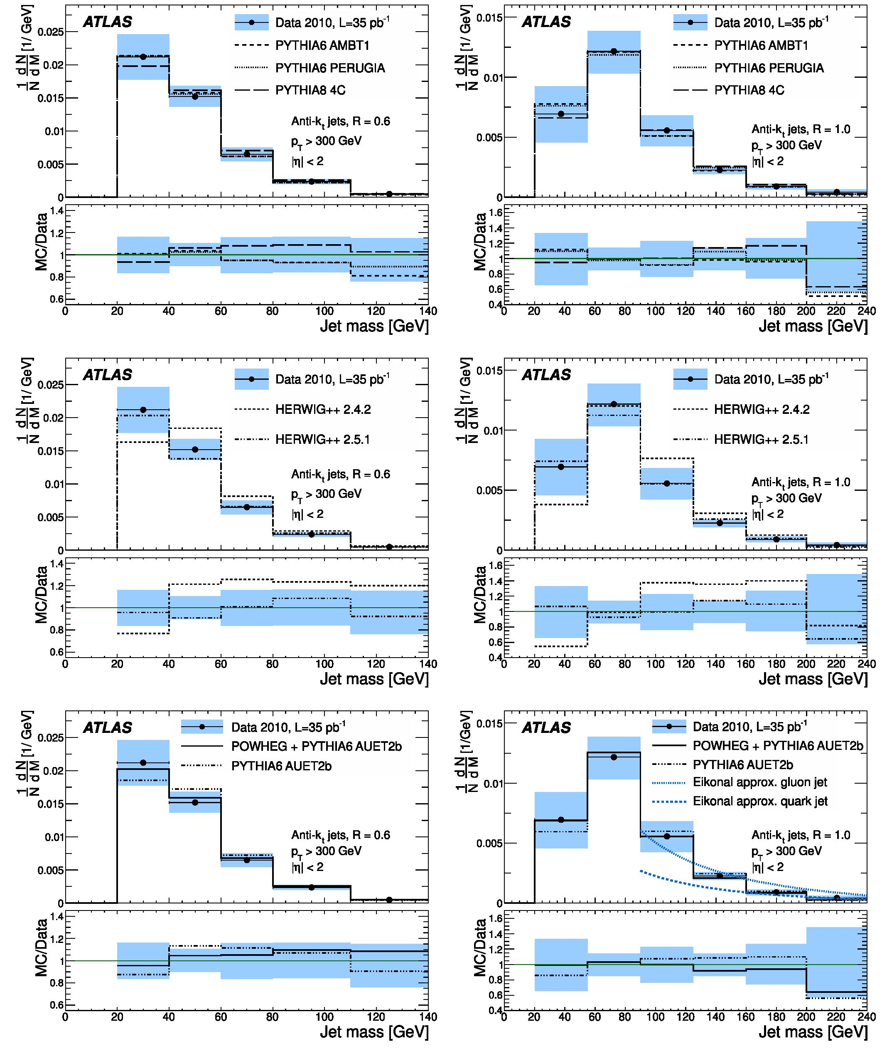
ATLAS MEASUREMENTS OF THE PROPERTIES OF JETS ...
PHYSICAL REVIEW D 86, 072006 (2012)
FIG. 6 (color online). The jet mass distributions for leading pT, anti-kt R = 0.6 (left) and R = 1.0 (right) jets in the full 2010 data
set, corrected for pileup and corrected to particle level. The data are compared to various tunes of PYTHIA 6 and PYTHIA 8 (top), HERWIG
++ 2.4.2 and 2.5.1 (center) and PYTHIA AUET2B with and without POWHEG (bottom). The eikonal approximation of NLO QCD for quark
and gluon jets is also included for the R = 1.0 case (right, bottom). The shaded bands indicate the sum of statistical and systematic
uncertainties.
072006-9

G. AAD et al.
PHYSICAL REVIEW D 86, 072006 (2012)
C, =
Apart
A
det
(18)
The size of the corrections varies quite significantly
between observables and between bins, being around
20% for mass (5%-10% around the peak, 20% elsewhere)
and width (30% in the peak for R = 0. 6 jets, 1%-5%
elsewhere). The corrections for eccentricity are below
10% in the peak, increasing to 40% in the most sparsely
populated bin. The detector corrections for angularity and
planar flow are smaller, generally around 0%-5%.
- SYSTEMATIC UNCERTAINTIES
The experimental systematic uncertainties can be di-
vided into three categories: how well modeled the observ-
ables are in Monte Carlo simulations (Sec. VII A), the
modeling of the detector material and cluster reconstruc-
tion (Sec. VIIB) and the pileup corrections (Sec. VIIC).
These are evaluated by determining the difference in the
factors obtained after the application of systematic varia-
tions to the samples used in the correction for detector
effects. The dominant sources of uncertainty, described in
detail below, arise from varying the cluster energy scale
(CES) and from the differences found when the calculation
of detector corrections is done using the HERWIG++
Monte Carlo sample in place of PYTHIA AMBT1. These
dominant effects are shown in Fig. 4 for R = 0. 6 jets and
Fig. 5 for R = 1. 0 jets.
- Uncertainties on the Monte Carlo model
The distributions are corrected to particle level
using the correction factors C, determined with a specific
Monte Carlo generator, inclusive of parton shower, hadro-
nization and UE model, which in this case is PYTHIA with
the AMBT1 tune. To determine the uncertainty introduced
on the final measurement by choosing this particular model
to calculate the detector correction factors, the differences
in these C, are found when the PYTHIA AMBT1 tune is
replaced with the PERUGIA2010 tune, and with HERWIG++
(2.4.2).
A primary source of the uncertainty on the mass mea-
surements is due to the observed differences in the detector
correction factors between HERWIG++ and PYTHIA, with
uncertainties ranging between 10% and 20% as shown in
Figs. 4 and 5.
- Uncertainties on the detector material description
and cluster reconstruction
Performance studies [50] have shown that there is
excellent agreement between the measured positions of
clusters and tracks in data, indicating no systematic mis-
alignment between the calorimeter and inner detector.
The Monte Carlo modeling of the position of clusters
with respect to tracks is also good, indicating that the
TABLE I. Measured values of the anti-kt R = 0. 6 jet
mass distribution given with their statistical and systematic
uncertainties.
Bin (GeV)

N 3M ± stat ± sys(x10 4)[Gv]
20-40
40-60
60-80
80-110
110-140
212 ± 2 ± 34
152 ± 1 ± 16
65 ± 1+1?
24 ± 1 ±4
5. 0 ± 0. 2±0'2
detector simulation models the calorimeter position reso-
lution adequately; however, there remains a small dis-
crepancy between data and Monte Carlo in the mean and
RMS of the track-cluster separation. This source of
uncertainty is taken into account by (Gaussian) smearing
the positions of simulated clusters in 77 and by 5 mrad.
This smearing is done independently in 77 and <^, and the
impact on the measurement of the correction factors for
each observable, bin by bin, is quantified by taking the
difference, AC,, between the correction factors obtained
before and after the position smearing. Smearing the
positions in 77 and results in small AC, for mass and
shapes alike, introducing uncertainties that do not exceed
5% in any bin.
The variation on the CES follows the procedure used by
previous studies [3] according to
pclus,new pclus X ( 1 ± 0 05 X ( 1 +

(' ±005 X 0+PTTGev)}
(19)
where pclus is each component of the cluster’s four-
momentum and pT is the cluster pT in GeV. The CES
is varied up and down independently for each momen-
tum component of each cluster, and the correction fac-
tors are recalculated in each case as before. The CES is a
large source of systematic uncertainty in the measure-
ment of mass (of order 20% across the mass range) and
width (of order 10% beyond the first two bins). The
effects of varying the CES are, in general, smaller for the
eccentricity, planar flow and angularity measurements, all
TABLE II. Measured values of the anti-kt R = 1. 0 jet
mass distribution given with their statistical and systematic
uncertainties.
Bin (GeV) N 3M ± stat ± sys(X 10_4)[g1v]
20-55 | 69 ± 1+24
55-90 | 122 ± 1±18
90-125 | 56 ± 1 ± 13
125-160 | 22. 6 ± 0. 4i3;4
160-200 | 9. 0 ± 0. 2i| 3
200-240 | 4. 3 ± 0. 2±f; 8
072006-10
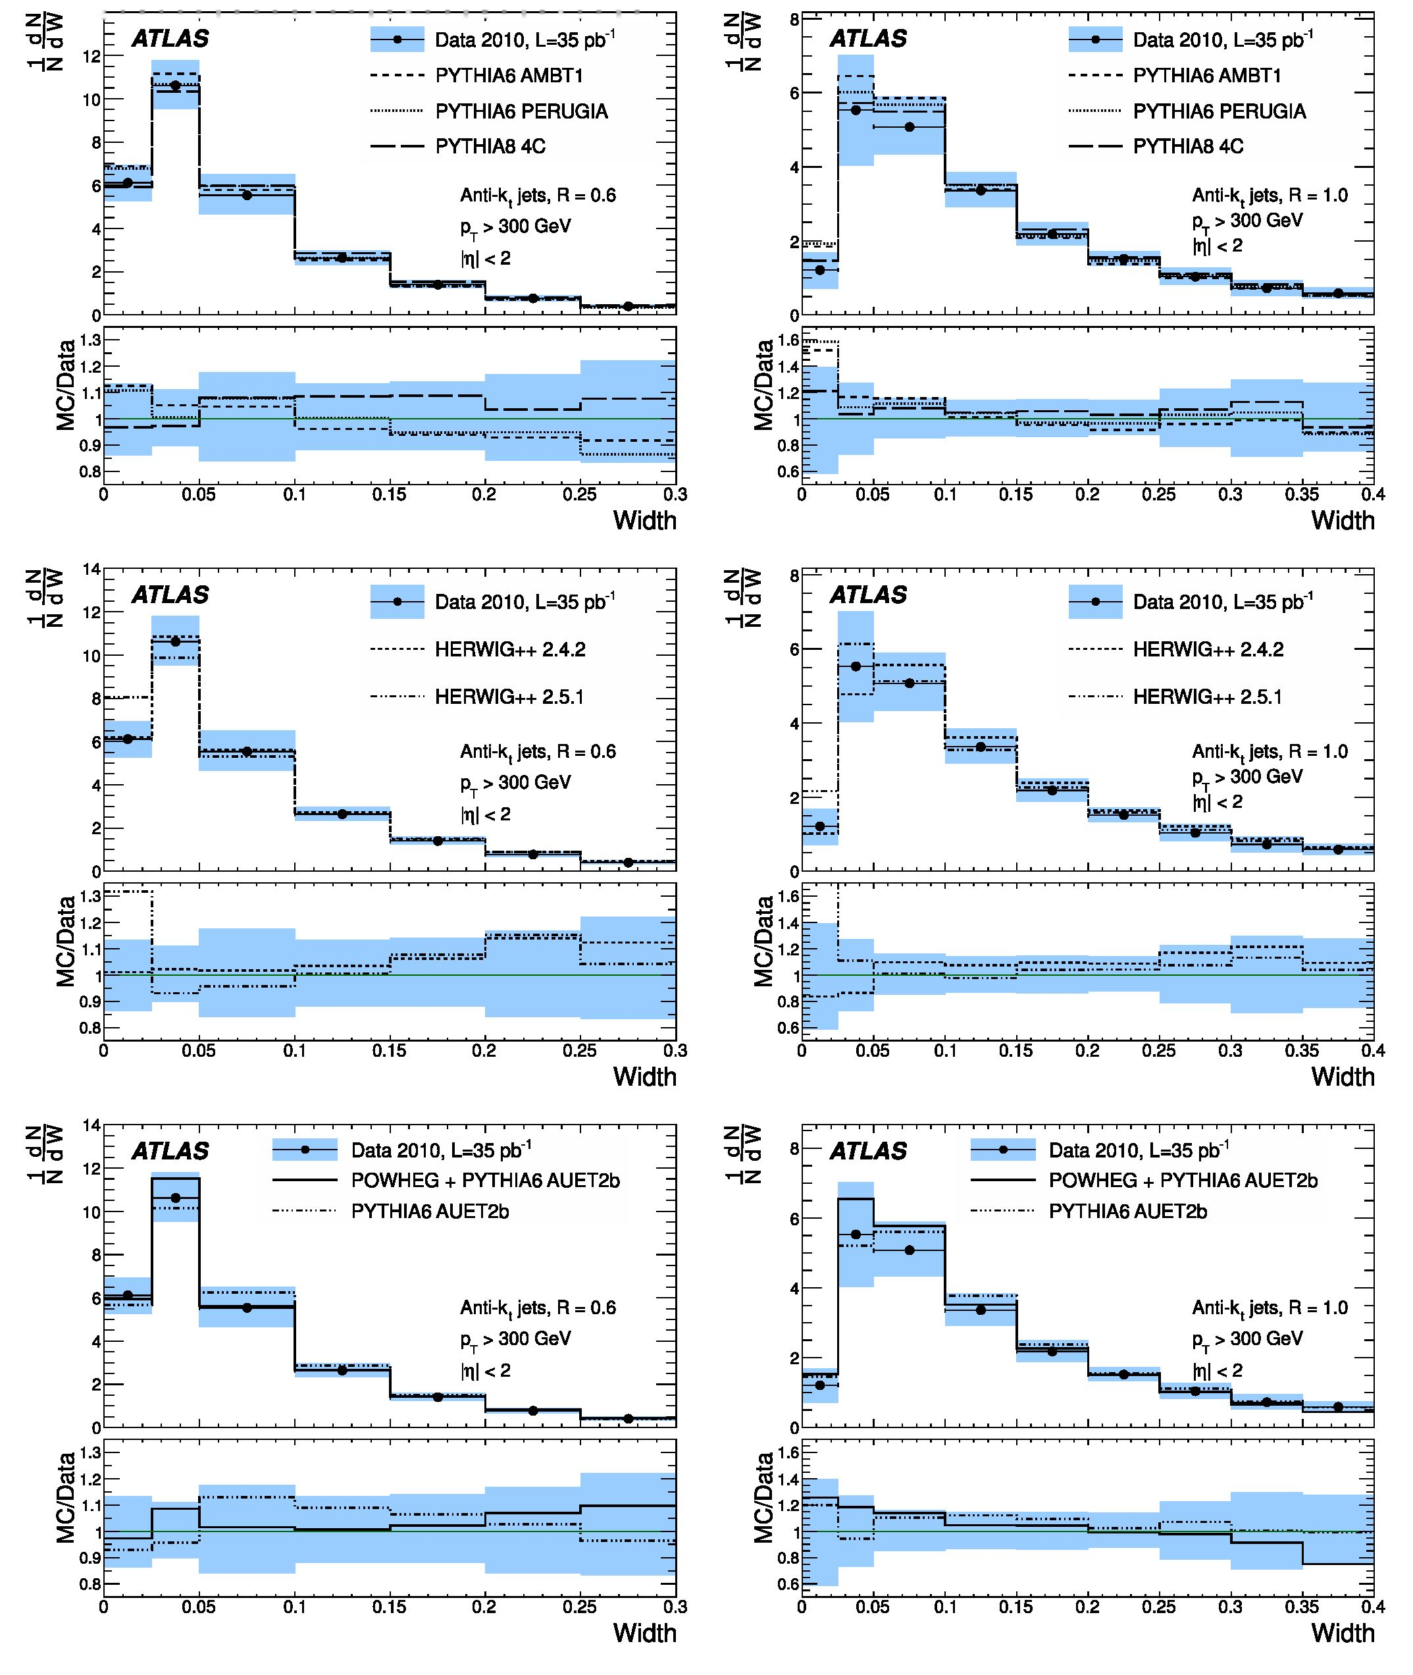
ATLAS MEASUREMENTS OF THE PROPERTIES OF JETS ...
14i .... . .... i .... . .... I .... i ■■ ■
PHYSICAL REVIEW D 86, 072006 (2012)
FIG. 7 (color online). The jet width distributions for leading pT, anti-kt R = 0.6 (left) and R = 1.0 (right) jets in the full 2010 data
set, corrected for pileup and corrected to particle level.
072006-11
G. AAD et al.
PHYSICAL REVIEW D 86, 072006 (2012)
of which are made on high-mass jets only. The effects
of varying the CES on all observables are shown with
the label Eclus in Fig. 4 for R = 0. 6 jets and Fig. 5 for
R = 1. 0 jets.
The uncertainty introduced as a result of losing energy
due to dead material in the detector is taken into account by
discarding a fraction of low energy (E < 2. 5 GeV) clus-
ters, following the technique and utilizing the observations
of a previous study of the single hadron response at *Js =
900 GeV [51]. Clusters are not included in jet reconstruc-
tion if they satisfy
r < P(E0) X e—2E, (20)
where r is a random number r 2 (0, 1], P(E0) is the
measured uncertainty (28%) on the probability that a par-
ticle does not leave a cluster in the calorimeter, and E is the
cluster energy in GeV. The impact on the measurement of
each observable is quantified by comparing the correction
factors before and after this dropping of low energy clus-
ters. The impact of this variation is small, resulting in a
contribution to the systematic uncertainty of less than a few
percent in all measurements.
- Uncertainties on the pileup corrections
There is a statistical uncertainty on the fit f(x, pT, M)
describing the pileup correction Ax for observable x in
R = 0. 6 jets. Dedicated studies have shown that the pa-
rametrizations of the pileup corrections in data and in
PYTHIA AMBT1 Monte Carlo with simulated pileup agree,
within the statistical uncertainties, for jets across the pT
range considered. The statistical uncertainties on these fits
are accounted for by implementing +1 a and — 1 a varia-
tions independently, as shown for mass in Fig. 2. The
correction factors are recalculated, and in each case the
difference is taken as a contribution to the systematic
uncertainty on the measurement. This is a small contribu-
tion to the overall systematic uncertainty on the measure-
ments, contributing at most a few percent in bins that are
statistically limited, and is a negligible (< 1%) effect
elsewhere.
TABLE III. Measured values of the anti-kt R = 0. 6 jet
width distribution given with their statistical and systematic
uncertainties.
Bin N ddW — stat — sys(X10—1)
0-0.025 | 61. 1 — 1. 2—8 5
0.025-0.05 | 106 — 1—11
0.05-0.1 | 55. 3 — 0. 4—90
0.1-0.15  0.15-0.2  0.2-0.25 | 26. 4 — 0. 3ij  14. 0 — 0. 3 —2  7. 7 — 0. 2—1. 2
0.25-0.3 | 4. 0 — 0. 2—0. 7
For R = 1 0 jets, the correction factors are scaled using
the phenomenological predictions described in Sec. VI B.
These scaling factors are also calculated in data and in
PYTHIA AMBT1 Monte Carlo with simulated pileup; good
agreement is observed, indicating that the effect of pileup
on jets is well modeled. In the case of mass and width,
where there is a phenomenological prediction for the scal-
ing, this prediction is used for the determination of the
nominal scaling factors and the variation is taken from the
scaling factors found in data. In the case of eccentricity
there is no phenomenological prediction for the scaling of
the pileup corrections with R, so the behavior observed in
data is used. The R scaling of the pileup corrections for
eccentricity is dependent on jet mass, so the variations
found in data across the mass range are taken as the
systematic variations.
The uncertainties introduced by the pileup corrections
contribute a small amount (in general 1%-2%) to the
total systematic uncertainties on the mass, width and
eccentricity.
The sources of systematic uncertainty described above
are added in quadrature with the statistical uncertainty in
each bin and symmetrized where appropriate (the contri-
butions from the cluster energy scale and parametrization
of the pileup corrections are determined separately for
upward and downward fluctuations, and so are not
symmetrized).
- RESULTS
The distributions of jet characteristics presented in this
section are corrected for detector effects and are com-
pared to Monte Carlo predictions at the particle level. In
the case of mass and t_2, comparison is also made
between data and the eikonal approximation [46] of
NLO QCD. The results shown here are available in
HEPDATA [52,53] and the analysis and data are available
as a RIVET [54,55] routine.
TABLE IV. Measured values of the anti-kt R = 1. 0 jet
width distribution given with their statistical and systematic
uncertainties.
Bin N ddN — stat — sys(X10—1)
0-0.025 | 12. 1 — 0. 5—4. 0
0.025-0.05  0.05-0.1 | 55. 3 — 0. 8 — 15. 0  50. 8 — 0. 4—8. 5
0.1-0.15  0.15-0.2 | 33. 6 — 0. 3—4. 5  21. 8 — 0. 3—3. 0
0.2-0.25 | 15. 1 — 0. 2—2. 9
0.25-0.3 | 10. 4 — 0. 2—22
0.3-0.35 | 7. 3 — 0. 2—2. 1
0.35-0.4 | 5. 9 — 0. 2—1. 4
072006-12
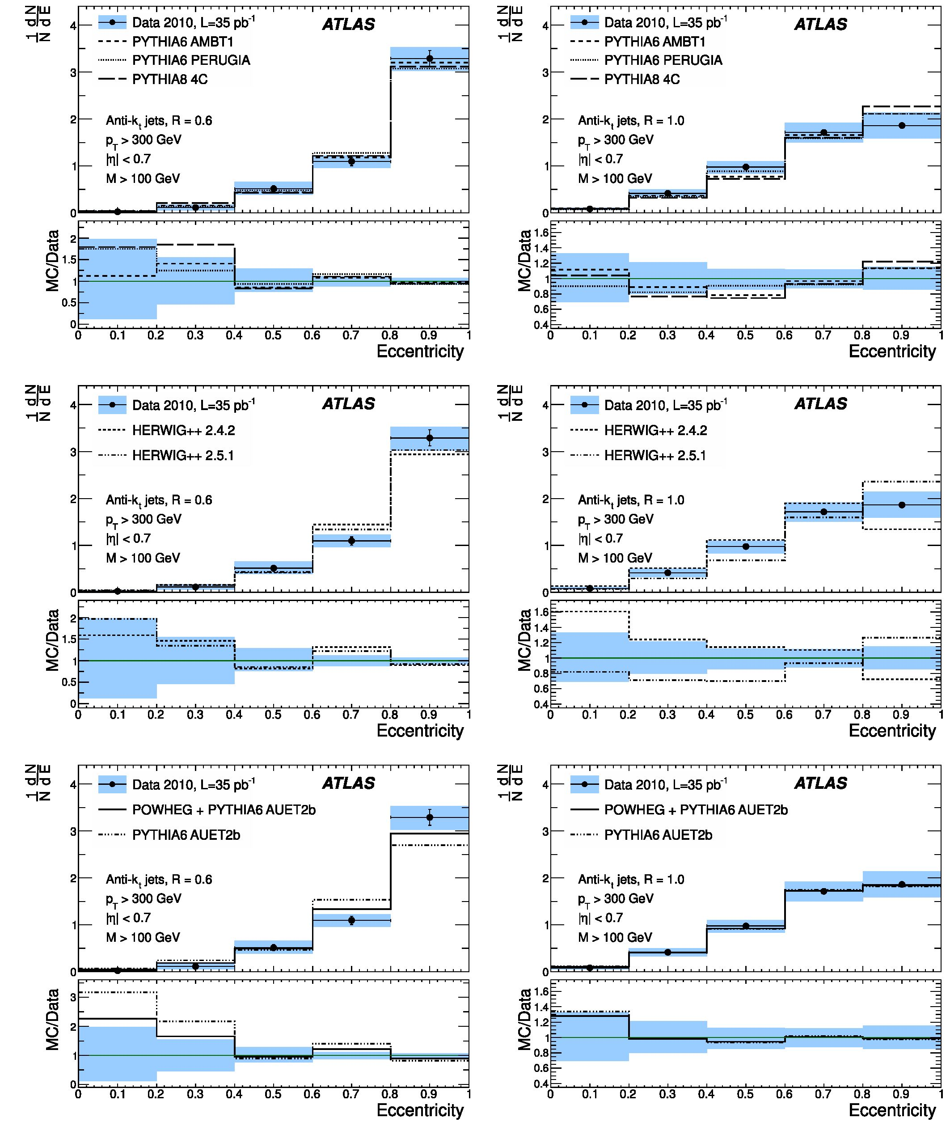
ATLAS MEASUREMENTS OF THE PROPERTIES OF JETS
PHYSICAL REVIEW D 86, 072006 (2012)
FIG. 8 (color online). The jet eccentricity distributions for high-mass (M > 100 GeV), leading pT, anti-kt R = 0.6 (left) and R
1 . 0 (right) jets in the full 2010 data set, corrected for pileup and corrected to particle level.
072006-13

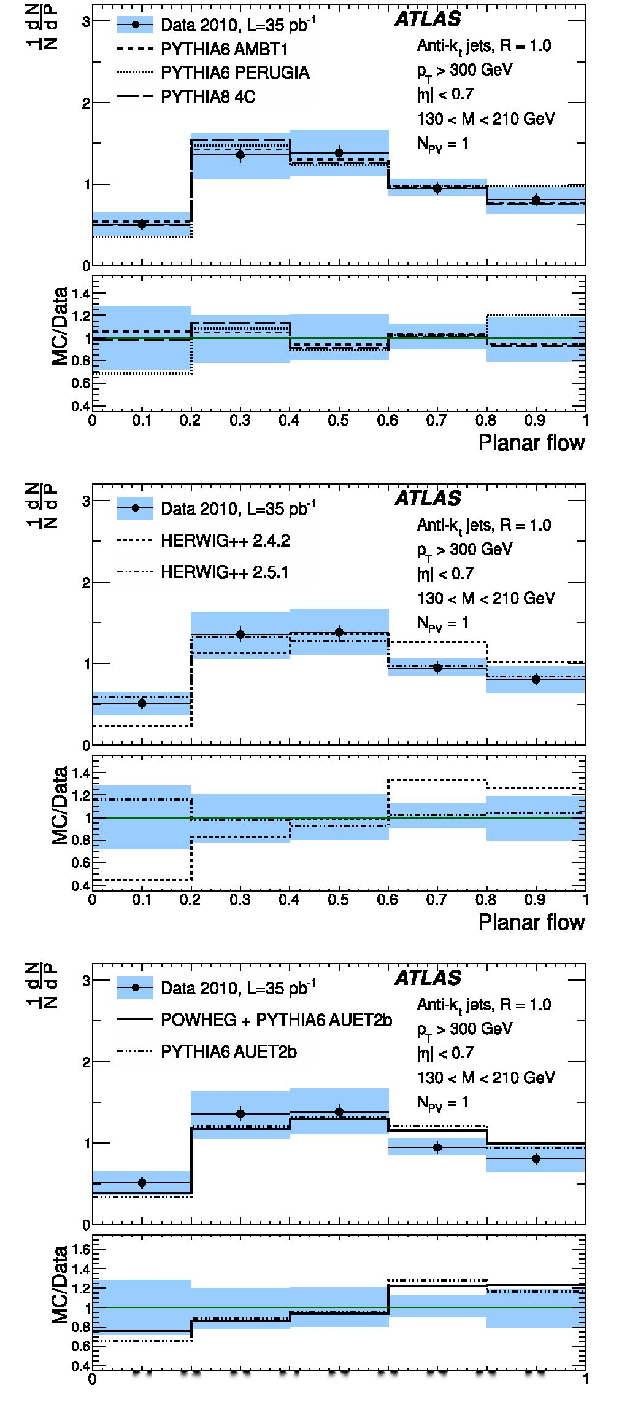
G. AAD et al.
TABLE V. Measured values of the eccentricity distribution for
anti-kt R = 0. 6 jets with M > 100 GeV, given with their statis-
tical and systematic uncertainties.
Bin N dE ± stat ± sys(X10_1)
PHYSICAL REVIEW D 86, 072006 (2012)
0-0.2
0.2-0.4
0.4-0.6
0.6-0.8
0.8-1.0
0. 2 ± 0. 1 ± 0. 2
1. 1 ± 0. 3 ± 0. 6
5. 1 ± 0. 7±1;3
11. 0 ± 0. 9±1;4
32. 9 ± 1. 7±2.7

A. Jet mass
The jet mass distributions are shown in Fig. 6 for jets
satisfying pT > 300 GeV and | ^ | < 2, corrected to the
particle level, and the corresponding numerical values are
given in Tables I and II.
In the case of R = 1 0 jets, the data are compared to the
calculations for jet masses derived at NLO QCD in the
eikonal approximation:
‘ “s EiME “(fV4-?), <21)
j
where J is the value of the jet mass distribution at M, aS is
the strong coupling constant, z = M/pT, c represents the
flavor of the parton which initiated the jet and Cc = | (3)
for quarks (gluons). The strong coupling constant is calcu-
lated using the PYTHIA prediction of the average jet pT ‘
365 GeV and has the value of aS = 0. 0994. Theoretical
uncertainties for such predictions are sizable (more than
30%) [46] in the region above the mass peak. The lower
mass region M ^ 90 GeV is strongly affected by nonper-
turbative physics and as such cannot be predicted by such
calculations. The size and shape of the high-mass tail is in
rough agreement with the analytical eikonal approximation
for NLO QCD for jet masses above 90 GeV, with most of
the data points lying between the predictions for quark-
initiated and gluon-initiated jets. QCD LO calculations
predict that the jets in this sample should be roughly
50% quark initiated, with this fraction increasing as a
function of the jet pT cut [56].
Also included in Fig. 6 are a number of PYTHIA,
HERWIG++, and POWHEG predictions for the jet mass
distributions. Unlike the analytical calculation discussed
TABLE VI. Measured values of the eccentricity distribution
for anti-kt R = 1. 0 jets with M > 100 GeV, given with their
statistical and systematic uncertainties.
Bin N dE ± stat ± sys(X10_1)
0-0.2
0.2-0.4
0.4-0.6
0.6-0.8
0.8-1.0
0. 8 ± 0. 1 ± 0. 3
4 2 ± 0 2 ± 0 9
9. 8 ± 0. 3±1; 4
- 2 ± 0. 4i| 2
- 6 ± 0. 4±2:7
0.1 0.2 0.3 0.4 0.5 0.6 0.7 0.8 0.9
Planar flow
FIG. 9 (color online). The jet planar flow distributions for
high-mass (130 < M < 210 GeV), leading pT, anti-kt R = 1. 0
jets in NPV = 1 events, corrected to particle level.
above, the Monte Carlo predictions are meaningful down
to the low mass region due to the inclusion of soft radiation
and hadronization. The PYTHIA calculation describes the
data well. The HERWIG++ 2.4.2 prediction indicates a sig-
nificant shift to a higher jet mass that is inconsistent with
072006-14
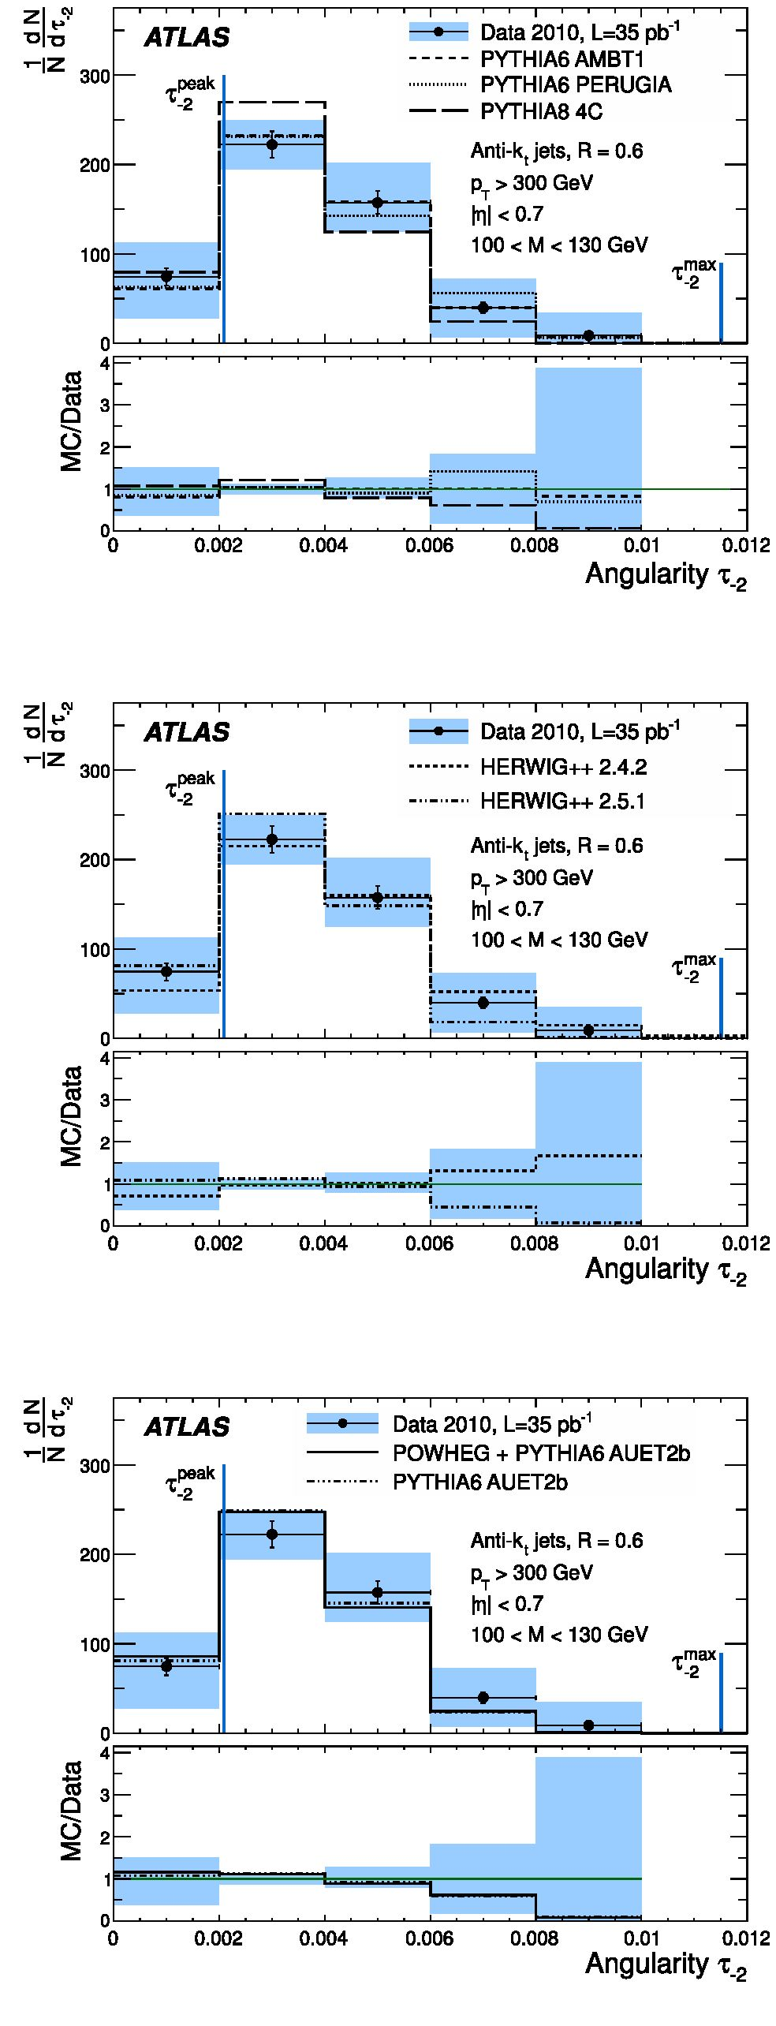
ATLAS MEASUREMENTS OF THE PROPERTIES OF JETS .
the data and the other Monte Carlo predictions, while the
more recent HERWIG++ 2.5.1 generator is in much better
agreement with the data. POWHEG+PYTHIA is in good
agreement with data within systematic uncertainties across
the whole mass range.

B. Width
The jet width distributions are shown in Fig. 7 for anti-kt
jets reconstructed with distance parameters of R = 0.6 and
1.0, and the corresponding numerical values are given in
Tables III and IV. There is significant variation between the
different Monte Carlo predictions in the first bin, beyond
which there is good agreement between the distribution
measured in data and all the predictions.
PHYSICAL REVIEW D 86, 072006 (2012)

C. Eccentricity
The eccentricity distributions for high-mass (M >
100 GeV) anti-kt jets reconstructed with distance parame-
ters of R = 0.6 and R = 1.0 are shown in Fig. 8, and
the corresponding numerical values are given in Tables V
and VI. The Monte Carlo predictions generally describe
the data, while some small discrepancies can be observed
between the various predictions and between predictions
and data.

D. Planar flow
The planar flow distributions are shown only for events
known to be uncontaminated by pileup, corresponding to
events with NPV = 1. These distributions are shown in
Fig. 9 for jets reconstructed with the anti-kt algorithm
with R = 1.0 for the mass range 130 < M < 210 GeV,
and the corresponding numerical values are given in
Table VII. The HERWIG++ 2.4.2 generator predicts jets
with a more planar, isotropic energy distribution than is
observed in data, while version 2.5.1 provides a very accu-
rate description of the planar flow. The various PYTHIA and
POWHEG Monte Carlo predictions also describe the data
well, within uncertainties.

E. Angularity
The t_2 distribution for anti-kt R = 0.6 jets in the mass
region 100 < M < 130 GeV is presented in Fig. 10, and
TABLE VII. Measured values of the planar flow distribution for
anti-kt R = 1.0 jets in NPV = 1 events with 130 < M < 210 GeV,
given with their statistical and systematic uncertainties.
Bin | N dp ± stat ± sys(Xl0 1)
0-0.2  0.2-0.4 | 5.1 ± 0.? ± 1.4  13.6 ± G.9_2.0
0.4-0.6 | 13.8 ± G.9_2.?
0.6-0.8 | 9. 5 ± 0. 8_1.9
0.8-1.0 | 8. 1 ± 0. ?_1. ?
FIG. 10 (color online). The angularity t_2 distributions for
leading pT, anti-kt R = 0.6 jets in the mass range 100 < M <
130 GeV, in the full 2010 data set, corrected to particle level.
The peak and maximum positions predicted by the small-angle
approximation of Eq. (10) are indicated.
072006-15
G. AAD et al.
TABLE VIII. Measured values of the angularity t_2 distribu-
tion for anti-kt R = 0.6 jets with 100 < M < 130 GeV, given
with their statistical and systematic uncertainties.
Bin | N diN ± stat ± sys
0-0.002  0.002-0.004 | 75 ± 10246  223 ± 15228
0.004-0.006 | 158 ± 13233
0.006-0.008  0.008-0.010 | 40 ± 6 ± 33  9 ± 5296
the corresponding numerical values are given in
Table VIII. The QCD predictions for the peak position
and the maximum value of t_2 [13], calculated using the
averages (M) = 111 GeV and (pT) = 434 GeV of the jets
in this kinematic region, are also shown on the distribu-
tions. Good agreement is observed between the data and
the Monte Carlo simulation for the shape of the t_2
distribution.
The comparison between data and the analytic QCD
prediction is limited by the intrinsic resolution of the
data distribution; however, there is good agreement be-
tween theory and data within these limitations. The posi-
tion of the peak of the distribution, rpe^, indicates that the
majority of jets in this data set can be described by a two-
body substructure in a symmetric pT configuration with
respect to the jet axis. No jets are observed above the small-
angle kinematic limit, t™*.
- CONCLUSIONS
The properties of high-pT ( > 300 GeV) jets recon-
structed with the anti-kt jet algorithm have been studied
in pp collisions at a center-of-mass energy of 7 TeV. There
is good agreement between data and PYTHIA for all ob-
servables, and the POWHEG+PYTHIA prediction describes
the mass distribution well for jets with M > 20 GeV.
HERWIG++ 2.4.2 predicts jets with a slightly more isotropic
PHYSICAL REVIEW D 86, 072006 (2012)
energy flow and higher mass than observed in data, while
HERWIG++ 2.5.1 predictions are in good agreement with the
data. The angularity measurement of high-mass jets agrees
with the small-angle QCD approximations.
ACKNOWLEDGMENTS
We thank CERN for the very successful operation of the
LHC, as well as the support staff from our institutions
without whom ATLAS could not be operated efficiently.
We acknowledge the support of ANPCyT, Argentina;
YerPhI, Armenia; ARC, Australia; BMWF, Austria;
ANAS, Azerbaijan; SSTC, Belarus; CNPq and FAPESP,
Brazil; NSERC, NRC and CFI, Canada; CERN;
CONICYT, Chile; CAS, MOST and NSFC, China;
COLCIENCIAS, Colombia; MSMT CR, MPO CR and
VSC CR, Czech Republic; DNRF, DNSRC and
Lundbeck Foundation, Denmark; EPLANET and ERC,
European Union; IN2P3-CNRS, CEA-DSM/IRFU,
France; GNAS, Georgia; BMBF, DFG, HGF, MPG and
AvH Foundation, Germany; GSRT, Greece; ISF,
MINERVA, GIF, DIP and Benoziyo Center, Israel; INFN,
Italy; MEXT and JSPS, Japan; CNRST, Morocco; FOM
and NWO, Netherlands; RCN, Norway; MNiSW, Poland;
GRICES and FCT, Portugal; MERYS (MECTS), Romania;
MES of Russia and ROSATOM, Russian Federation;
JINR; MSTD, Serbia; MSSR, Slovakia; ARRS and
MVZT, Slovenia; DST/NRF, South Africa; MICINN,
Spain; SRC and Wallenberg Foundation, Sweden; SER,
SNSF and Cantons of Bern and Geneva, Switzerland; NSC,
Taiwan; TAEK, Turkey; STFC, the Royal Society and
Leverhulme Trust, United Kingdom; DOE and NSF,
United States of America. The crucial computing support
from all WLCG partners is acknowledged gratefully, in
particular from CERN and the ATLAS Tier-1 facilities at
TRIUMF (Canada), NDGF (Denmark, Norway, Sweden),
CC-IN2P3 (France), KIT/GridKA (Germany), INFN-
CNAF (Italy), NL-T1 (Netherlands), PIC (Spain), ASGC
(Taiwan), RAL (UK) and BNL (USA) and in the Tier-2
facilities worldwide.
- ATLAS Collaboration, Phys. Rev. D 86, 014022 (2012).
- CMS Collaboration, Phys. Lett. B 700, 187 (2011).
- ATLAS Collaboration, Phys. Rev. D 83, 052003 (2011).
- CMS Collaboration, J. High Energy Phys. 06 (2012) 160.
- ATLAS Collaboration, J. High Energy Phys. 05 (2012)
128.
- ATLAS Collaboration, New J. Phys. 13, 053044 (2011).
- CMS Collaboration, Phys. Rev. Lett. 106, 201804
(2011).
- A. Altheimer et al., J. Phys. G 39, 063001 (2012).
- J. Butterworth, A. R. Davison, M. Rubin, and G. P. Salam,
Phys. Rev. Lett. 100, 242001 (2008).
- L. Almeida, S. Lee, G. Perez, G. Sterman, I. Sung, and J.
Virzi, Phys. Rev. D 79, 074017 (2009).
- Y. Cui, Z. Han, and M. Schwartz, Phys. Rev. D 83, 074023
(2011).
- S. Chekanov and J. Proudfoot, Phys. Rev. D 81, 114038
2010.
- T. Aaltonen et al. (CDF Collaboration), Phys. Rev. D 85,
091101 (2012).
072006-16

ATLAS MEASUREMENTS OF THE PROPERTIES OF JETS
- T. Plehn, G. Salam, and M. Spannowsky, Phys. Rev. Lett.
104, 111801 (2010).
- ATLAS Collaboration, New J. Phys. 13, 053033 (2011).
- ATLAS Collaboration, Report No. ATLAS-CONF-2010-
069, 2010 (https://cdsweb.cern.ch/record/1281344).
- ATLAS Collaboration, JINST 3, S08003 (2008).
- T. Sjostrand, S. Mrenna, and P. Skands, J. High Energy
Phys. 05 (2006) 026.
- ATLAS Collaboration, Report No. ATLAS-CONF-2010-
031, 2010 (https://cdsweb.cern.ch/record/1277665).
- A. Sherstnev and R. Thorne, Eur. Phys. J. C 55, 553
(2008).
- B. Andersson, G. Gustafson, G. Ingelman, and T.
Sjostrand, Phys. Rep. 97, 31 (1983).
- B. Andersson, G. Gustafson, and G. Soderberg, Z. Phys. C
20, 317 (1983).
- M. Bowler, Z. Phys. C 11, 169 (1981).
- ATLAS Collaboration, Phys. Lett. B 688, 21 (2010).
- ATLAS Collaboration, Report No. ATLAS-CONF-2010-
024, 2010 (https://cdsweb.cern.ch/record/1277656).
- P. Skands, Phys. Rev. D 82, 074018 (2010).
- ATLAS Collaboration, Phys. Rev. D 84, 054001 (2011).
- H. L. Lai, J. Huston, S. Kuhlmann, J. Morfin, F. Olness,
J. F. Owens, J. Pumplin, and W. K. Tung, Eur. Phys. J. C
12, 375 (2000).
- M. Bahr et al., Eur. Phys. J. C 58, 639 (2008).
- ATLAS Collaboration, Report No. ATL-PHYS-PUB-
2011-009, 2011 (https://cdsweb.cern.ch/record/1363300).
- ATLAS Collaboration, Report No. ATL-PHYS-PUB-
2011-014, 2011 (https://cdsweb.cern.ch/record/1400677).
- T. Sjostrand, S. Mrenna, and P. Skands, Comput. Phys.
Commun. 178, 852 (2008).
- S. Alioli, K. Hamilton, P. Nason, C. Oleari, and E. Re, J.
High Energy Phys. 04 (2011) 081.
- P. Nason, J. High Energy Phys. 11 (2004) 040.
- S. Frixione, P. Nason, and C. Oleari, J. High Energy Phys.
11 (2007) 070.
PHYSICAL REVIEW D 86, 072006 (2012)
- S. Alioli, P. Nason, C. Oleari, and E. Re, J. High Energy
Phys. 06 (2010) 043.
- ATLAS Collaboration, Eur. Phys. J. C 70, 823 (2010).
- S. Agostinelli et al., Nucl. Instrum. Methods Phys. Res.,
Sect. A 506, 250 (2003).
- G. Folger and J. Wellisch, arXiv:nucl-th/0306007.
- H.W. Bertini, Phys. Rev. 188, 1711 (1969).
- ATLAS Collaboration, Eur. Phys. J. C 71, 1630 (2011).
- ATLAS Collaboration, Report No. ATLAS-CONF-2011-
011, 2011 (https://cdsweb.cern.ch/record/1334563).
- ATLAS Collaboration, Report No. ATL-LARG- PUB-
2008-002, 2008 (https://cdsweb.cern.ch/record/1099735).
- M. Cacciari, G. Salam, and G. Soyez, J. High Energy
Phys. 04 (2008) 063.
- ATLAS Collaboration, arXiv:1112.6426 [Eur. Phys. J. C
(to be published)].
- L. Almeida, S. Lee, G. Perez, I. Sung, and J. Virzi, Phys.
Rev. D 79, 074012 (2009).
- J. Thaler and L.-T. Wang, J. High Energy Phys. 7 (2008) 092.
- R. Alon, E. Duchovni, G. Perez, A. Pranko, and P. Sinervo,
Phys. Rev. D 84, 114025 (2011).
- M. Dasgupta, L. Magnea, and G. Salam, J. High Energy
Phys. 02 (2008) 055.
- ATLAS Collaboration, Phys. Rev. Lett. 106, 172002, 2011.
- ATLAS Collaboration, arXiv:1203.1302 [Eur. Phys. J. C
(to be published)].
- A. Buckley and M. Whalley, Proc. Sci., ACAT2010 (2010)
067 [http://arxiv.org/abs/1006.0517v2].
- HEPDATA: ATLAS measurements of the properties of jets
for boosted particle searches, http://hepdata.cedar.ac.uk/
view/red4992.
- A. Buckley et al., arXiv:1003.0694v6.
- RIVET routine: ATLAS measurements of the properties of
jets for boosted particle searches, http://rivet.hepforge.org/
analyses.
- J. Gallichio and M. Schwartz, J. High Energy Phys. 10
(2011) 103.
G. Aad,47 B. Abbott,110 J. Abdallah,11 S. Abdel Khalek,114 A. A. Abdelalim,48 O. Abdinov,10 B. Abi,111
M. Abolins,87 O. S. AbouZeid,157 H. Abramowicz,152 H. Abreu,135 E. Acerbi,88a,88b B. S. Acharya,163a,163b
L. Adamczyk,37 D. L. Adams,24 T. N. Addy,55 J. Adelman,175 S. Adomeit,97 P. Adragna,74 T. Adye,128 S. Aefsky,22
J. A. Aguilar-Saavedra,123b’b M. Aharrouche,80 S. P. Ahlen,21 F. Ahles,47 A. Ahmad,147 M. Ahsan,40
G. Aielli,132a’132b T. Akdogan,18a T. P. A. Akesson,78 G. Akimoto,154 A. V. Akimov,93 A. Akiyama,65 M. S. Alam,1
M. A. Alam,75 J. Albert,168 S. Albrand,54 M. Aleksa,29 I. N. Aleksandrov,63 F. Alessandria,88a C. Alexa,25a
G. Alexander,152 G. Alexandre,48 T. Alexopoulos,9 M. Alhroob,163a’163c M. Aliev,15 G. Alimonti,88a J. Alison,119
- M.M. Allbrooke,17 P.P. Allport,72 S.E. Allwood-Spiers,52 J. Almond,81 A. Aloisio,101a101b R. Alon,171
A. Alonso,78 B. Alvarez Gonzalez,87 M. G. Alviggi,101a’101b K. Amako,64 C. Amelung,22 V. V. Ammosov,127’a
A. Amorim,123a’c N. Amram,152 C. Anastopoulos,29 L. S. Ancu,16 N. Andari,114 T. Andeen,34 C. F. Anders,57b
G. Anders,57a K. J. Anderson,30 A. Andreazza,88a’88b V. Andrei,57a X. S. Anduaga,69 P. Anger,43 A. Angerami,34
- Anghinolfi,29 A. Anisenkov,106 N. Anjos,123a A. Annovi,46 A. Antonaki,8 M. Antonelli,46 A. Antonov,95
J. Antos,143b F. Anulli,131a S. Aoun,82 L. Aperio Bella,4 R. Apolle,117,d G. Arabidze,87 I. Aracena,142 Y. Arai,64
- T. H. Arce,44 S. Arfaoui,147 J-F. Arguin,14 E. Arik,18a,a M. Arik,18a A. J. Armbruster,86 O. Arnaez,80 V. Arnal,79
- Arnault,114 A. Artamonov,94 G. Artoni,131a,131b D. Arutinov,20 S. Asai,154 R. Asfandiyarov,172 S. Ask,27
- Asman,145^1451’ L. Asquith,5 K. Assamagan,24 A. Astbury,168 B. Aubert,4 E. Auge,114 K. Augsten,126
M. Aurousseau,144a G. Avolio,162 R. Avramidou,9 D. Axen,167 G. Azuelos,92,e Y. Azuma,154 M. A. Baak,29
G. Baccaglioni,88a C. Bacci,133a,133b A.M. Bach,14 H. Bachacou,135 K. Bachas,29 M. Backes,48 M. Backhaus,20
072006-17
G. AAD et al.
PHYSICAL REVIEW D 86, 072006 (2012)
- Badescu,25a P. Bagnaia,131a,131b S. Bahinipati,2 Y. Bai,32a D. C. Bailey,157 T. Bain,157 J. T. Baines,128
O.K. Baker,175 M.D. Baker,24 S. Baker,76 E. Banas,38 P. Banerjee,92 Sw. Banerjee,172 D. Banfi,29 A. Bangert,149
V. Bansal,168 H. S. Bansil,17 L. Barak,171 S. P. Baranov,93 A. Barbaro Galtieri,14 T. Barber,47 E. L. Barberio,85
D. Barberis,49a,49b M. Barbero,20 D.Y. Bardin,63 T. Barillari,98 M. Barisonzi,174 T. Barklow,142 N. Barlow,27
- M. Barnett,128 R. M. Barnett,14 A. Baroncelli,133a G. Barone,48 A. J. Barr,117 F. Barreiro,79
J. Barreiro Guimaraes da Costa,56 P. Barrillon,114 R. Bartoldus,142 A. E. Barton,70 V. Bartsch,148 R. L. Bates,52
L. Batkova,143a J. R. Batley,27 A. Battaglia,16 M. Battistin,29 F. Bauer,135 H. S. Bawa,142,f S. Beale,97 T. Beau,77
P. H. Beauchemin,160 R. Beccherle,49a P. Bechtle,20 H. P. Beck,16 A. K. Becker,174 S. Becker,97 M. Beckingham,137
K. H. Becks,174 A. J. Beddall,18c A. Beddall,18c S. Bedikian,175 V. A. Bednyakov,63 C.P. Bee,82 M. Begel,24
S. Behar Harpaz,151 M. Beimforde,98 C. Belanger-Champagne,84 P. J. Bell,48 W. H. Bell,48 G. Bella,152
L. Bellagamba,19a F. Bellina,29 M. Bellomo,29 A. Belloni,56 O. Beloborodova,106,g K. Belotskiy,95 O. Beltramello,29
O. Benary,152 D. Benchekroun,134a K. Bendtz,145a145b N. Benekos,164 Y. Benhammou,152 E. Benhar Noccioli,48
J. A. Benitez Garcia,158b D. P. Benjamin,44 M. Benoit,114 J. R. Bensinger,22 K. Benslama,129 S. Bentvelsen,104
- Berge,29 E. Bergeaas Kuutmann,41 N. Berger,4 F. Berghaus,168 E. Berglund,104 J. Beringer,14 P. Bernat,76
R. Bernhard,47 C. Bernius,24 T. Berry,75 C. Bertella,82 A. Bertin,19a19b F. Bertolucci,121a121b M. I. Besana,88a,88b
G. J. Besjes,103 N. Besson,135 S. Bethke,98 W. Bhimji,45 R. M. Bianchi,29 M. Bianco,71a,71b O. Biebel,97
S. P. Bieniek,76 K. Bierwagen,53 J. Biesiada,14 M. Biglietti,133a H. Bilokon,46 M. Bindi,19a19b S. Binet,114
A. Bingul,18c C. Bini,131a,131b C. Biscarat,177 U. Bitenc,47 K.M. Black,21 R.E. Blair,5 J.-B. Blanchard,135
G. Blanchot,29 T. Blazek,143a C. Blocker,22 J. Blocki,38 A. Blondel,48 W. Blum,80 U. Blumenschein,53
G.J. Bobbink,104 V.B. Bobrovnikov,106 S.S. Bocchetta,78 A. Bocci,44 C.R. Boddy,117 M. Boehler,41 J. Boek,174
N. Boelaert,35 J. A. Bogaerts,29 A. Bogdanchikov,106 A. Bogouch,89,a C. Bohm,145a J. Bohm,124 V. Boisvert,75
T. Bold,37 V. Boldea,25a N.M. Bolnet,135 M. Bomben,77 M. Bona,74 M. Bondioli,162 M. Boonekamp,135
- N. Booth,138 S. Bordoni,77 C. Borer,16 A. Borisov,127 G. Borissov,70 I. Borjanovic,12a M. Borri,81 S. Borroni,86
V. Bortolotto,133a,133b K. Bos,104 D. Boscherini,19a M. Bosman,11 H. Boterenbrood,104 D. Botterill,128 J. Bouchami,92
J. Boudreau,122 E. V. Bouhova-Thacker,70 D. Boumediene,33 C. Bourdarios,114 N. Bousson,82 A. Boveia,30 J. Boyd,29
I. R. Boyko,63 I. Bozovic-Jelisavcic,12b J. Bracinik,17 P. Branchini,133a A. Brandt,7 G. Brandt,117 O. Brandt,53
U. Bratzler,155 B. Brau,83 J. E. Brau,113 H. M. Braun,174,a S.F. Brazzale,163a,163c B. Brelier,157 J. Bremer,29
K. Brendlinger,119 R. Brenner,165 S. Bressler,171 D. Britton,52 F. M. Brochu,27 I. Brock,20 R. Brock,87 E. Brodet,152
- Broggi,88a C. Bromberg,87 J. Bronner,98 G. Brooijmans,34 T. Brooks,75 W. K. Brooks,31b G. Brown,81 H. Brown,7
P.A. Bruckman de Renstrom,38 D. Bruncko,143b R. Bruneliere,47 S. Brunet,59 A. Bruni,19a G. Bruni,19a
M. Bruschi,19a T. Buanes,13 Q. Buat,54 F. Bucci,48 J. Buchanan,117 P. Buchholz,140 R. M. Buckingham,117
- G. Buckley,45 S. I. Buda,25a I. A. Budagov,63 B. Budick,107 V. Büscher,80 L. Bugge,116 O. Bulekov,95
- C. Bundock,72 M. Bunse,42 T. Buran,116 H. Burckhart,29 S. Burdin,72 T. Burgess,13 S. Burke,128 E. Busato,33
P. Bussey,52 C.P. Buszello,165 B. Butler,142 J.M. Butler,21 C.M. Buttar,52 J.M. Butterworth,76 W. Buttinger,27
S. Cabrera Urban,166 D. Caforio,19a,19b O. Cakir,3a P. Calafiura,14 G. Calderini,77 P. Calfayan,97 R. Calkins,105
L. P. Caloba,23a R. Caloi,131a,131b D. Calvet,33 S. Calvet,33 R. Camacho Toro,33 P. Camarri,132a,132b D. Cameron,116
L. M. Caminada,14 S. Campana,29 M. Campanelli,76 V. Canale,101a,101b F. Canelli,30,h A. Canepa,158a J. Cantero,79
R. Cantrill,75 L. Capasso,101a,101b M.D.M. Capeans Garrido,29 I. Caprini,25a M. Caprini,25a D. Capriotti,98
M. Capua,36a,36b R. Caputo,80 R. Cardarelli,132a T. Carli,29 G. Carlino,101a L. Carminati,88a,88b B. Caron,84
S. Caron,103 E. Carquin,31b G. D. Carrillo Montoya,172 A. A. Carter,74 J. R. Carter,27 J. Carvalho,123a i D. Casadei,107
M.P. Casado,11 M. Cascella,121a,121b C. Caso,49a,49b,a A.M. Castaneda Hernandez,172,j E. Castaneda-Miranda,172
V. Castillo Gimenez,166 N. F. Castro,123a G. Cataldi,71a P. Catastini,56 A. Catinaccio,29 J. R. Catmore,29 A. Cattai,29
- Cattani,132a,132b S. Caughron,87 P. Cavalleri,77 D. Cavalli,88a M. Cavalli-Sforza,11 V. Cavasinni,121a,121b
- Ceradini,133a,133b A. S. Cerqueira,23b A. Cerri,29 L. Cerrito,74 F. Cerutti,46 S. A. Cetin,18b A. Chafaq,134a
- Chakraborty,105 I. Chalupkova,125 K. Chan,2 B. Chapleau,84 J. D. Chapman,27 J.W. Chapman,86 E. Chareyre,77
- G. Charlton,17 V. Chavda,81 C.A. Chavez Barajas,29 S. Cheatham,84 S. Chekanov,5 S.V. Chekulaev,158a
- A. Chelkov,63 M. A. Chelstowska,103 C. Chen,62 H. Chen,24 S. Chen,32c X. Chen,172 A. Cheplakov,63
R. Cherkaoui El Moursli,134e V. Chernyatin,24 E. Cheu,6 S.L. Cheung,157 L. Chevalier,135 G. Chiefari,101a,101b
L. Chikovani,50a,a J. T. Childers,29 A. Chilingarov,70 G. Chiodini,71a A. S. Chisholm,17 R. T. Chislett,76
M.V. Chizhov,63 G. Choudalakis,30 S. Chouridou,136 I.A. Christidi,76 A. Christov,47 D. Chromek-Burckhart,29
M. L. Chu,150 J. Chudoba,124 G. Ciapetti,131a,131b A. K. Ciftci,3a R. Ciftci,3a D. Cinca,33 V. Cindro,73 C. Ciocca,19a,19b
072006-18
ATLAS MEASUREMENTS OF THE PROPERTIES OF JETS ... PHYSICAL REVIEW D 86, 072006 (2012)
A. Ciocio,14 M. Cirilli,86 P. Cirkovic,12h M. Citterio,88a M. Ciuhancan,25a A. Clark,48 P.J. Clark,45 W. Cleland,122
J. C. Clemens,82 B. Clement,54 C. Clement,145a’145h Y. Coadou,82 M. Cohal,163a’163c A. Coccaro,137 J. Cochran,62
J. G. Cogan,142 J. Coggeshall,164 E. Cogneras,177 J. Colas,4 A. P. Colijn,104 N.J. Collins,17 C. Collins-Tooth,52
J. Collot,54 T. Colombo,118a118h G. Colon,83 P. Conde Muino,123a E. Coniavitis,117 M.C. Conidi,11
S.M. Consonni,88a’88h V. Consorti,47 S. Constantinescu,25a C. Conta,118a’118h G. Conti,56 F. Conventi,101a’k
M. Cooke,14 B. D. Cooper,76 A. M. Cooper-Sarkar,117 K. Copic,14 T. Cornelissen,174 M. Corradi,19a F. Corriveau,843
A. Cortes-Gonzalez,164 G. Cortiana,98 G. Costa,88a M. J. Costa,166 D. Costanzo,138 T. Costin,30 D. Côte,29
L. Courneyea,168 G. Cowan,75 C. Cowden,27 B.E. Cox,81 K. Cranmer,107 F. Crescioli,121a121h M. Cristinziani,20
- Crosetti,36a36h R. Crupi,71a71h S. Crepe-Renaudin,54 C.-M. Cuciuc,25a C. Cuenca Almenar,175
T. Cuhadar Donszelmann,138 M. Curatolo,46 C. J. Curtis,17 C. Cuthhert,149 P. Cwetanski,59 H. Czirr,140
P. Czodrowski,43 Z. Czyczula,175 S. D’Auria,52 M. D’Onofrio,72 A. D’Orazio,131a131h
M. J. Da Cunha Sargedas De Sousa,123a C. Da Via,81 W. Dahrowski,37 A. Dafinca,117 T. Dai,86 C. Dallapiccola,83
M. Dam,35 M. Dameri,49a’49h D.S. Damiani,136 H.O. Danielsson,29 V. Dao,48 G. Darho,49a G.L. Darlea,25h
W. Davey,20 T. Davidek,125 N. Davidson,85 R. Davidson,70 E. Davies,117’3 M. Davies,92 A. R. Davison,76
Y. Davygora,57a E. Dawe,141 I. Dawson,138 R. K. Daya-Ishmukhametova,22 K. De,7 R. de Asmundis,101a
S. De Castro,19a19h S. De Cecco,77 J. de Graat,97 N. De Groot,103 P. de Jong,104 C. De La Taille,114 H. De la Torre,79
- De Lorenzi,62 L. de Mora,70 L. De Nooij,104 D. De Pedis,131a A. De Salvo,131a U. De Sanctis,163a163c
- De Santo,148 J.B. De Vivie De Regie,114 G. De Zorzi,131a131h W. J. Dearnaley,70 R. Dehhe,24 C. Dehenedetti,45
- Dechenaux,54 D.V. Dedovich,63 J. Degenhardt,119 C. Del Papa,163a163c J. Del Peso,79 T. Del Prete,121a121h
T. Delemontex,54 M. Deliyergiyev,73 A. Dell’Acqua,29 L. Dell’Asta,21 M. Della Pietra,101a k D. della Volpe,101a101h
M. Delmastro,4 P.A. Delsart,54 C. Deluca,104 S. Demers,175 M. Demichev,63 B. Demirkoz,11m J. Deng,162
S. P. Denisov,127 D. Derendarz,38 J. E. Derkaoui,134d F. Derue,77 P. Dervan,72 K. Desch,20 E. Devetak,147
P.O. Deviveiros,104 A. Dewhurst,128 B. DeWilde,147 S. Dhaliwal,157 R. Dhullipudi,24n A. Di Ciaccio,132a132h
L. Di Ciaccio,4 A. Di Girolamo,29 B. Di Girolamo,29 S. Di Luise,133a133h A. Di Mattia,172 B. Di Micco,29
R. Di Nardo,46 A. Di Simone,132a132h R. Di Sipio,19a19h M. A. Diaz,31a E. B. Diehl,86 J. Dietrich,41 T. A. Dietzsch,57a
S. Diglio,85 K. Dindar Yagci,39 J. Dingfelder,20 C. Dionisi,131a131h P. Dita,25a S. Dita,25a F. Dittus,29 F. Djama,82
T. Djohava,50h M. A. B. do Vale,23c A. Do Valle Wemans,123a o T. K. O. Doan,4 M. Dohhs,84 R. Dohinson,29 a
- Dohos,29 E. Dohson,29 p J. Dodd,34 C. Doglioni,48 T. Doherty,52 Y. Doi,64 a J. Dolejsi,125 I. Dolenc,73
Z. Dolezal,125 B. A. Dolgoshein,95 a T. Dohmae,154 M. Donadelli,23d M. Donega,119 J. Donini,33 J. Dopke,29
- Doria,101a A. Dos Anjos,172 A. Dotti,121a121h M.T. Dova,69 A.D. Doxiadis,104 A.T. Doyle,52 M. Dris,9
J. Duhhert,98 S. Duhe,14 E. Duchovni,171 G. Duckeck,97 A. Dudarev,29 F. Dudziak,62 M. Dührssen,291. P. Duerdoth,81
L. Duflot,114 M-A. Dufour,84 M. Dunford,29 H. Duran Yildiz,3a R. Duxfield,138 M. Dwuznik,37 F. Dydak,29
M. Duren,51 J. Ehke,97 S. Eckweiler,80 K. Edmonds,80 C. A. Edwards,75 N.C. Edwards,52 W. Ehrenfeld,41
T. Eifert,142 G. Eigen,13 K. Einsweiler,14 E. Eisenhandler,74 T. Ekelof,165 M. El Kacimi,134c M. Ellert,165 S. Elles,4
- Ellinghaus,80 K. Ellis,74 N. Ellis,29 J. Elmsheuser,97 M. Elsing,29 D. Emeliyanov,128 R. Engelmann,147 A. Engl,97
- Epp,60 A. Eppig,86 J. Erdmann,53 A. Ereditato,16 D. Eriksson,145a J. Ernst,1 M. Ernst,24 J. Ernwein,135
- Errede,164 S. Errede,164 E. Ertel,80 M. Escalier,114 C. Escohar,122 X. Espinal Curull,11 B. Esposito,46 F. Etienne,82
- I. Etienvre,135 E. Etzion,152 D. Evangelakou,53 H. Evans,59 L. Fahhri,19a19h C. Fahre,29 R.M. Fakhrutdinov,127
S. Falciano,131a Y. Fang,172 M. Fanti,88a,88h A. Farhin,7 A. Farilla,133a J. Farley,147 T. Farooque,157 S. Farrell,162
S.M. Farrington,117 P. Farthouat,29 P. Fassnacht,29 D. Fassouliotis,8 B. Fatholahzadeh,157 A. Favareto,88a88h
L. Fayard,114 S. Fazio,36a 36h R. Fehhraro,33 P. Federic,143a O.L. Fedin,120 W. Fedorko,87 M. Fehling-Kaschek,47
L. Feligioni,82 D. Fellmann,5 C. Feng,32d E. J. Feng,30 A.B. Fenyuk,127 J. Ferencei,143h W. Fernando,5 S. Ferrag,52
J. Ferrando,52 V. Ferrara,41 A. Ferrari,165 P. Ferrari,104 R. Ferrari,118a D.E. Ferreira de Lima,52 A. Ferrer,166
- Ferrere,48 C. Ferretti,86 A. Ferretto Parodi,49a 49h M. Fiascaris,30 F. Fiedler,80 A. Filipcic,73 F. Filthaut,103
M. Fincke-Keeler,168 M.C.N. Fiolhais,123a,i L. Fiorini,166 A. Firan,39 G. Fischer,41 M.J. Fisher,108 M. Flechl,47
I. Fleck,140 J. Fleckner,80 P. Fleischmann,173 S. Fleischmann,174 T. Flick,174 A. Floderus,78 L. R. Flores Castillo,172
M.J. Flowerdew,98 T. Fonseca Martin,16 A. Formica,135 A. Forti,81 D. Fortin,158a D. Fournier,114 H. Fox,70
P. Francavilla,11 S. Franchino,118a,118h D. Francis,29 T. Frank,171 S. Franz,29 M. Fraternali,118^11811 S. Fratina,119
S. T. French,27 C. Friedrich,41 F. Friedrich,43 R. Froeschl,29 D. Froidevaux,29 J. A. Frost,27 C. Fukunaga,155
- Fullana Torregrosa,29 B. G. Fulsom,142 J. Fuster,166 C. Gahaldon,29 O. Gahizon,171 T. Gadfort,24 S. Gadomski,48
- Gagliardi,49a49h P. Gagnon,59 C. Galea,97 E.J. Gallas,117 V. Gallo,16 B.J. Gallop,128 P. Gallus,124 K.K. Gan,108
072006-19
G. AAD et al.
PHYSICAL REVIEW D 86, 072006 (2012)
Y. S. Gao,142f A. Gaponenko,14 F. Garberson,175 M. Garcia-Sciveres,14 C. García,166 J. E. García Navarro,166
R. W. Gardner,30 N. Garelli,29 H. Garitaonandia,104 V. Garonne,29 J. Garvey,17 C. Gatti,46 G. Gaudio,118a B. Gaur,140
L. Gauthier,135 P. Gauzzi,131a131b I. L. Gavrilenko,93 C. Gay,167 G. Gaycken,20 E. N. Gazis,9 P. Ge,32d Z. Gecse,167
- N. P. Gee,128 D. A. A. Geerts,104 Ch. Geich-Gimbel,20 K. Gellerstedt,145a145b C. Gemme,49a A. Gemmell,52
M. H. Genest,54 S. Gentile,131a131b M. George,53 S. George,75 P. Gerlach,174 A. Gershon,152 C. Geweniger,57a
- Ghazlane,134b N. Ghodbane,33 B. Giacobbe,19a S. Giagu,131a131b V. Giakoumopoulou,8 V. Giangiobbe,11
- Gianotti,29 B. Gibbard,24 A. Gibson,157 S.M. Gibson,29 D. Gillberg,28 A.R. Gillman,128 D.M. Gingrich,2e
J. Ginzburg,152 N. Giokaris,8 M. P. Giordani,163c R. Giordano,101a101b F. M. Giorgi,15 P. Giovannini,98 P. F. Giraud,135
- Giugni,88a M. Giunta,92 P. Giusti,19a B. K. Gjelsten,116 L. K. Gladilin,96 C. Glasman,79 J. Glatzer,47 A. Glazov,41
K. W. Glitza,174 G. L. Glonti,63 J.R. Goddard,74 J. Godfrey,141 J. Godlewski,29 M. Goebel,41 T. Gopfert,43
- Goeringer,80 C. Gossling,42 S. Goldfarb,86 T. Golling,175 A. Gomes,123a c L. S. Gomez Fajardo,41 R. Goncalo,75
J. Goncalves Pinto Firmino Da Costa,41 L. Gonella,20 S. Gonzalez,172 S. Gonzalez de la Hoz,166 G. Gonzalez Parra,11
M. L. Gonzalez Silva,26 S. Gonzalez-Sevilla,48 J. J. Goodson,147 L. Goossens,29 P. A. Gorbounov,94 H. A. Gordon,24
I. Gorelov,102 G. Gorfine,174 B. Gorini,29 E. Gorini,71a 71b A. Gorisek,73 E. Gornicki,38 B. Gosdzik,41 A. T. Goshaw,5
M. Gosselink,104 M. I. Gostkin,63 I. Gough Eschrich,162 M. Gouighri,134a D. Goujdami,134c M. P. Goulette,48
- G. Goussiou,137 C. Goy,4 S. Gozpinar,22 I. Grabowska-Bold,37 P. Grafström,29 K-J. Grahn,41 F. Grancagnolo,71a
S. Grancagnolo,15 V. Grassi,147 V. Gratchev,120 N. Grau,34 H. M. Gray,29 J. A. Gray,147 E. Graziani,133a
O. G. Grebenyuk,120 T. Greenshaw,72 Z. D. Greenwood,24 n K. Gregersen,35 I. M. Gregor,41 P. Grenier,142
J. Griffiths,137 N. Grigalashvili,63 A.A. Grillo,136 S. Grinstein,11 Y. V. Grishkevich,96 J.-F. Grivaz,114 E. Gross,171
J. Grosse-Knetter,53 J. Groth-Jensen,171 K. Grybel,140 D. Guest,175 C. Guicheney,33 A. Guida,71a 71b S. Guindon,53
U. Gul,52 H. Guler,84 q J. Gunther,124 B. Guo,157 J. Guo,34 P. Gutierrez,110 N. Guttman,152 O. Gutzwiller,172
- Guyot,135 C. Gwenlan,117 C. B. Gwilliam,72 A. Haas,142 S. Haas,29 C. Haber,14 H. K. Hadavand,39 D. R. Hadley,17
P. Haefner,20 F. Hahn,29 S. Haider,29 Z. Hajduk,38 H. Hakobyan,176 D. Hall,117 J. Haller,53 K. Hamacher,174
P. Hamal,112 M. Hamer,53 A. Hamilton,144b r S. Hamilton,160 L. Han,32b K. Hanagaki,115 K. Hanawa,159 M. Hance,14
- Handel,80 P. Hanke,57a J. R. Hansen,35 J. B. Hansen,35 J. D. Hansen,35 P. H. Hansen,35 P. Hansson,142 K. Hara,159
- A. Hare,136 T. Harenberg,174 S. Harkusha,89 D. Harper,86 R. D. Harrington,45 O. M. Harris,137 K. Harrison,17
J. Hartert,47 F. Hartjes,104 T. Haruyama,64 A. Harvey,55 S. Hasegawa,100 Y. Hasegawa,139 S. Hassani,135 S. Haug,16
M. Hauschild,29 R. Hauser,87 M. Havranek,20 C.M. Hawkes,17 R. J. Hawkings,29 A.D. Hawkins,78 D. Hawkins,162
T. Hayakawa,65 T. Hayashi,159 D. Hayden,75 C. P. Hays,117 H. S. Hayward,72 S.J. Haywood,128 M. He,32d
S. J. Head,17 V. Hedberg,78 L. Heelan,7 S. Heim,87 B. Heinemann,14 S. Heisterkamp,35 L. Helary,4 C. Heller,97
M. Heller,29 S. Hellman,145a145b D. Hellmich,20 C. Helsens,11 R. C. W. Henderson,70 M. Henke,57a A. Henrichs,53
- M. Henriques Correia,29 S. Henrot-Versille,114 C. Hensel,53 T. Henß,174 C. M. Hernandez,7
Y. Hernandez Jimenez,166 R. Herrberg,15 G. Herten,47 R. Hertenberger,97 L. Hervas,29 G.G. Hesketh,76
N.P. Hessey,104 E. Higon-Rodriguez,166 J.C. Hill,27 K.H. Hiller,41 S. Hillert,20 S.J. Hillier,17 I. Hinchliffe,14
- Hines,119 M. Hirose,115 F. Hirsch,42 D. Hirschbuehl,174 J. Hobbs,147 N. Hod,152 M. C. Hodgkinson,138
P. Hodgson,138 A. Hoecker,29 M. R. Hoeferkamp,102 J. Hoffman,39 D. Hoffmann,82 M. Hohlfeld,80 M. Holder,140
S. O. Holmgren,145a T. Holy,126 J. L. Holzbauer,87 T. M. Hong,119 L. Hooft van Huysduynen,107 C. Horn,142
S. Horner,47 J-Y. Hostachy,54 S. Hou,150 A. Hoummada,134a J. Howard,117 J. Howarth,811. Hristova,15 J. Hrivnac,114
T. Hryn’ova,4 P. J. Hsu,80 S.-C. Hsu,14 Z. Hubacek,126 F. Hubaut,82 F. Huegging,20 A. Huettmann,41 T. B. Huffman,117
- W. Hughes,34 G. Hughes,70 M. Huhtinen,29 M. Hurwitz,14 U. Husemann,41 N. Huseynov,63 s J. Huston,87 J. Huth,56
- Iacobucci,48 G. Iakovidis,9 M. Ibbotson,811. Ibragimov,140 L. Iconomidou-Fayard,114 J. Idarraga,114 P. Iengo,101a
O. Igonkina,104 Y. Ikegami,64 M. Ikeno,64 D. Iliadis,153 N. Ilic,157 T. Ince,20 J. Inigo-Golfin,29 P. Ioannou,8
M. Iodice,133a K. Iordanidou,8 V. Ippolito,131a’131b A. Irles Quiles,166 C. Isaksson,165 A. Ishikawa,65 M. Ishino,66
R. Ishmukhametov,39 C. Issever,117 S. Istin,18a A. V. Ivashin,127 W. Iwanski,38 H. Iwasaki,64 J. M. Izen,40 V. Izzo,101a
- Jackson,119 J. N. Jackson,72 P. Jackson,142 M. R. Jaekel,29 V. Jain,59 K. Jakobs,47 S. Jakobsen,35 T. Jakoubek,124
J. Jakubek,126 D. K. Jana,110 E. Jansen,76 H. Jansen,29 A. Jantsch,98 M. Janus,47 G. Jarlskog,78 L. Jeanty,56
- Jen-La Plante,30 P. Jenni,29 A. Jeremie,4 P. Jez,35 S. Jezequel,4 M. K. Jha,19a H. Ji,172 W. Ji,80 J. Jia,147 Y. Jiang,32b
M. Jimenez Belenguer,41 S. Jin,32a O. Jinnouchi,156 M. D. Joergensen,35 D. Joffe,39 M. Johansen,145a145b
K. E. Johansson,145a P. Johansson,138 S. Johnert,41 K. A. Johns,6 K. Jon-And,145a145b G. Jones,169 R. W. L. Jones,70
T. J. Jones,72 C. Joram,29 P. M. Jorge,123a K. D. Joshi,81 J. Jovicevic,146 T. Jovin,12b X. Ju,172 C. A. Jung,42
R. M. Jungst,29 V. Juranek,124 P. Jussel,60 A. Juste Rozas,11 S. Kabana,16 M. Kaci,166 A. Kaczmarska,38 P. Kadlecik,35
072006-20
ATLAS MEASUREMENTS OF THE PROPERTIES OF JETS
PHYSICAL REVIEW D 86, 072006 (2012)
M. Kado,114 H. Kagan,108 M. Kagan,56 E. Kajomovitz,151 S. Kalinin,174 L. V. Kalinovskaya,63 S. Kama,39
N. Kanaya,154 M. Kaneda,29 S. Kaneti,27 T. Kanno,156 V. A. Kantserov,95 J. Kanzaki,64 B. Kaplan,175 A. Kapliy,30
J. Kaplon,29 D. Kar,52 M. Karagounis,20 K. Karakostas,9 M. Karnevskiy,41 V. Kartvelishvili,70 A.N. Karyukhin,127
L. Kashif,172 G. Kasieczka,57b R. D. Kass,108 A. Kastanas,13 M. Kataoka,4 Y. Kataoka,154 E. Katsoufis,9 J. Katzy,41
V. Kaushik,6 K. Kawagoe,68 T. Kawamoto,154 G. Kawamura,80 M. S. Kayl,104 V. A. Kazanin,106 M. Y. Kazarinov,63
R. Keeler,168 R. Kehoe,39 M. Keil,53 G.D. Kekelidze,63 J. S. Keller,137 M. Kenyon,52 O. Kepka,124 N. Kerschen,29
- P. Kersevan,73 S. Kersten,174 K. Kessoku,154 J. Keung,157 F. Khalil-zada,10 H. Khandanyan,164 A. Khanov,111
- Kharchenko,63 A. Khodinov,95 A. Khomich,57a T. J. Khoo,27 G. Khoriauli,20 A. Khoroshilov,174 V. Khovanskiy,94
- Khramov,63 J. Khubua,50b H. Kim,145a145b M. S. Kim,2 S. H. Kim,159 N. Kimura,170 O. Kind,15 B. T. King,72
M. King,65 R. S.B. King,117 J. Kirk,128 A. E. Kiryunin,98 T. Kishimoto,65 D. Kisielewska,37 T. Kittelmann,122
- Kladiva,143b M. Klein,72 U. Klein,72 K. Kleinknecht,80 M. Klemetti,84 A. Klier,171 P. Klimek,145a145b
- Klimentov,24 R. Klingenberg,42 J. A. Klinger,81 E. B. Klinkby,35 T. Klioutchnikova,29 P. F. Klok,103 S. Klous,104
- -E. Kluge,57a T. Kluge,72 P. Kluit,104 S. Kluth,98 N. S. Knecht,157 E. Kneringer,60 E. B. F. G. Knoops,82 A. Knue,53
- R. Ko,44 T. Kobayashi,154 M. Kobel,43 M. Kocian,142 P. Kodys,125 K. Köneke,29 A.C. König,103 S. Koenig,80
L. Kopke,80 F. Koetsveld,103 P. Koevesarki,20 T. Koffas,28 E. Koffeman,104 L. A. Kogan,117 S. Kohlmann,174
- Kohn,53 Z. Kohout,126 T. Kohriki,64 T. Koi,142 G. M. Kolachev,106 a H. Kolanoski,15 V. Kolesnikov,63
- Koletsou,88a J. Koll,87 M. Kollefrath,47 A.A. Komar,93 Y. Komori,154 T. Kondo,64 T. Kono,41t A.I. Kononov,47
R. Konoplich,107u N. Konstantinidis,76 S. Koperny,37 K. Korcyl,38 K. Kordas,153 A. Korn,117 A. Korol,106
- Korolkov,11 E.V. Korolkova,138 V. A. Korotkov,127 O. Kortner,98 S. Kortner,98 V. V. Kostyukhin,20 S. Kotov,98
V.M. Kotov,63 A. Kotwal,44 C. Kourkoumelis,8 V. Kouskoura,153 A. Koutsman,158a R. Kowalewski,168
T. Z. Kowalski,37 W. Kozanecki,135 A. S. Kozhin,127 V. Kral,126 V. A. Kramarenko,96 G. Kramberger,73
M. W. Krasny,77 A. Krasznahorkay,107 J. Kraus,87 J. K. Kraus,20 S. Kreiss,107 F. Krejci,126 J. Kretzschmar,72
N. Krieger,53 P. Krieger,157 K. Kroeninger,53 H. Kroha,98 J. Kroll,119 J. Kroseberg,20 J. Krstic,12a U. Kruchonak,63
- Krüger,20 T. Kruker,16 N. Krumnack,62 Z.V. Krumshteyn,63 A. Kruth,20 T. Kubota,85 S. Kuday,3a S. Kuehn,47
A. Kugel,57c T. Kuhl,41 D. Kuhn,60 V. Kukhtin,63 Y. Kulchitsky,89 S. Kuleshov,31b C. Kummer,97 M. Kuna,77
J. Kunkle,119 A. Kupco,124 H. Kurashige,65 M. Kurata,159 Y. A. Kurochkin,89 V. Kus,124 E. S. Kuwertz,146
M. Kuze,156 J. Kvita,141 R. Kwee,15 A. La Rosa,48 L. La Rotonda,36a,36b L. Labarga,79 J. Labbe,4 S. Lablak,134a
- Lacasta,166 F. Lacava,131a,131b H. Lacker,15 D. Lacour,77 V. R. Lacuesta,166 E. Ladygin,63 R. Lafaye,4 B. Laforge,77
^70 A'T ^A OQ '7/T ¿r
T. Lagouri, S. Lai, E. Laisne, M. Lamanna, L. Lambourne, C. L. Lampen, W. Lampl, E. Lancon,
U. Landgraf,47 M. P. J. Landon,74 J. L. Lane,81 C. Lange,41 A. J. Lankford,162 F. Lanni,24 K. Lantzsch,174
S. Laplace,77 C. Lapoire,20 J. F. Laporte,135 T. Lari,88a A. Larner,117 M. Lassnig,29 P. Laurelli,46 V. Lavorini,36a 36b
W. Lavrijsen,14 P. Laycock,72 O. Le Dortz,77 E. Le Guirriec,82 C. Le Maner,157 E. Le Menedeu,11 T. LeCompte,5
- Ledroit-Guillon,54 H. Lee,104 J.S.H. Lee,115 S.C. Lee,150 L. Lee,175 M. Lefebvre,168 M. Legendre,135
- C. LeGeyt,119 F. Legger,97 C. Leggett,14 M. Lehmacher,20 G. Lehmann Miotto,29 X. Lei,6 M. A. L. Leite,23d
R. Leitner,125 D. Lellouch,171 B. Lemmer,53 V. Lendermann,57a K. J. C. Leney,144b T. Lenz,104 G. Lenzen,174
- Lenzi,29 K. Leonhardt,43 S. Leontsinis,9 F. Lepold,57a C. Leroy,92 J-R. Lessard,168 C. G. Lester,27 C. M. Lester,119
J. Leveque,4 D. Levin,86 L. J. Levinson,171 A. Lewis,117 G.H. Lewis,107 A.M. Leyko,20 M. Leyton,15 B. Li,82
- Li,172 v S. Li,32b w X. Li,86 Z. Liang,117 x H. Liao,33 B. Liberti,132a P. Lichard,29 M. Lichtnecker,97 K. Lie,164
W. Liebig,13 C. Limbach,20 A. Limosani,85 M. Limper,61 S. C. Lin,150 y F. Linde,104 J. T. Linnemann,87 E. Lipeles,119
A. Lipniacka,13 T.M. Liss,164 D. Lissauer,24 A. Lister,48 A.M. Litke,136 C. Liu,28 D. Liu,150 H. Liu,86 J.B. Liu,86
M. Liu,32b Y. Liu,32b M. Livan,118a,118b S.S. A. Livermore,117 A. Lleres,54 J. Llorente Merino,79 S.L. Lloyd,74
- Lobodzinska,41 P. Loch,6 W. S. Lockman,136 T. Loddenkoetter,20 F. K. Loebinger,81 A. Loginov,175 C. W. Loh,167
T. Lohse,15 K. Lohwasser,47 M. Lokajicek,124 V. P. Lombardo,4 R. E. Long,70 L. Lopes,123a D. Lopez Mateos,56
J. Lorenz,97 N. Lorenzo Martinez,114 M. Losada,161 P. Loscutoff,14 F. Lo Sterzo,131a,131b M. J. Losty,158a X. Lou,40
A. Lounis,114 K.F. Loureiro,161 J. Love,21 P.A. Love,70 A. J. Lowe,142f F. Lu,32a H. J. Lubatti,137 C. Luci,131a131b
A. Lucotte,54 A. Ludwig,43 D. Ludwig,41 I. Ludwig,47 J. Ludwig,47 F. Luehring,59 G. Luijckx,104 W. Lukas,60
D. Lumb,47 L. Luminari,131a E. Lund,116 B. Lund-Jensen,146 B. Lundberg,78 J. Lundberg,145a145b
O. Lundberg,145a145b J. Lundquist,35 M. Lungwitz,80 D. Lynn,24 E. Lytken,78 H. Ma,24 L. L. Ma,172
J. A. Macana Goia,92 G. Maccarrone,46 A. Macchiolo,98 B. Macek,73 J. Machado Miguens,123a R. Mackeprang,35
R. J. Madaras,14 W. F. Mader,43 R. Maenner,57c T. Maeno,24 P. Mättig,174 S. Mattig,41 L. Magnoni,29 E. Magradze,53
K. Mahboubi,47 S. Mahmoud,72 G. Mahout,17 C. Maiani,135 C. Maidantchik,23a A. Maio,123a,c S. Majewski,24
072006-21
G. AAD et al.
PHYSICAL REVIEW D 86, 072006 (2012)
Y. Makida,64 N. Makovec,114 P. Mal,135 B. Malaescu,29 Pa. Malecki,38 P. Malecki,38 V. P. Maleev,120 F. Malek,54
U. Mallik,61 D. Malon,5 C. Malone,142 S. Maltezos,9 V. Malyshev,106 S. Malyukov,29 R. Mameghani,97
J. Mamuzic,12b A. Manabe,64 L. Mandelli,88a I. Mandic,73 R. Mandrysch,15 J. Maneira,123a P. S. Mangeard,87
L. Manhaes de Andrade Filho,23a A. Mann,53 P.M. Manning,136 A. Manousakis-Katsikakis,8 B. Mansoulie,135
A. Mapelli,29 L. Mapelli,29 L. March,79 J.F. Marchand,28 F. Marchese,132a’132b G. Marchiori,77 M. Marcisovsky,124
- P. Marino,168 F. Marroquim,23a Z. Marshall,29 F. K. Martens,157 S. Marti-Garcia,166 B. Martin,29 B. Martin,87
J.P. Martin,92 T. A. Martin,17 V.J. Martin,45 B. Martin dit Latour,48 S. Martin-Haugh,148 M. Martinez,11
V. Martinez Outschoorn,56 A.C. Martyniuk,168 M. Marx,81 F. Marzano,131a A. Marzin,110 L. Masetti,80
T. Mashimo,154 R. Mashinistov,93 J. Masik,81 A. L. Maslennikov,106 I. Massa,19a’19b G. Massaro,104 N. Massol,4
A. Mastroberardino,36a’36b T. Masubuchi,154 P. Matricon,114 H. Matsunaga,154 T. Matsushita,65 C. Mattravers,117’4
J. Maurer,82 S. J. Maxfield,72 A. Mayne,138 R. Mazini,150 M. Mazur,20 L. Mazzaferro,132a,132b M. Mazzanti,88a
S. P. Mc Kee,86 A. McCarn,164 R. L. McCarthy,147 T.G. McCarthy,28 N.A. McCubbin,128 K.W. McFarlane,55 a
J. A. Mcfayden,138 H. McGlone,52 G. Mchedlidze,50b T. Mclaughlan,17 S.J. McMahon,128 R. A. McPherson,168 '
A. Meade,83 J. Mechnich,104 M. Mechtel,174 M. Medinnis,41 R. Meera-Lebbai,110 T. Meguro,115 R. Mehdiyev,92
S. Mehlhase,35 A. Mehta,72 K. Meier,57a B. Meirose,78 C. Melachrinos,30 B. R. Mellado Garcia,172 F. Meloni,88a,88b
L. Mendoza Navas,161 Z. Meng,150,v A. Mengarelli,19a,19b S. Menke,98 E. Meoni,160 K. M. Mercurio,56 P. Mermod,48
L. Merola,101a,101b C. Meroni,88a F. S. Merritt,30 H. Merritt,108 A. Messina,29,z J. Metcalfe,102 A. S. Mete,162
- Meyer,80 C. Meyer,30 J-P. Meyer,135 J. Meyer,173 J. Meyer,53 T. C. Meyer,29 W. T. Meyer,62 J. Miao,32d S. Michal,29
L. Micu,25a R. P. Middleton,128 S. Migas,72 L. Mijovic,135 G. Mikenberg,171 M. Mikestikova,124 M. Mikuz,73
D.W. Miller,30 R.J. Miller,87 W. J. Mills,167 C. Mills,56 A. Milov,171 D. A. Milstead,145iU45b D. Milstein,171
A. A. Minaenko,127 M. Minano Moya,166 I. A. Minashvili,63 A. I. Mincer,107 B. Mindur,37 M. Mineev,63 Y. Ming,172
L. M. Mir,11 G. Mirabelli,131a J. Mitrevski,136 V. A. Mitsou,166 S. Mitsui,64 P. S. Miyagawa,138 K. Miyazaki,65
J. U. Mjornmark,78 T. Moa,145a,145b V. Moeller,27 K. Mönig,41 N. Möser,20 S. Mohapatra,147 W. Mohr,47
R. Moles-Valls,166 J. Molina-Perez,29 J. Monk,76 E. Monnier,82 S. Montesano,88a,88b F. Monticelli,69
S. Monzani,19a,19b R. W. Moore,2 G. F. Moorhead,85 C. Mora Herrera,48 A. Moraes,52 N. Morange,135 J. Morel,53
- Morello,36a,36b D. Moreno,80 M. Moreno Llacer,166 P. Morettini,49a M. Morgenstern,43 M. Morii,56
A. K. Morley,29 G. Mornacchi,29 J. D. Morris,74 L. Morvaj,100 H. G. Moser,98 M. Mosidze,50b J. Moss,108
R. Mount,142 E. Mountricha,9aa S.V. Mouraviev,93,a E.J.W. Moyse,83 F. Mueller,57a J. Mueller,122 K. Mueller,20
T. A. Müller,97 T. Mueller,80 D. Muenstermann,29 Y. Munwes,152 W. J. Murray,128 I. Mussche,104 E. Musto,101a,101b
A. G. Myagkov,127 M. Myska,124 J. Nadal,11 K. Nagai,159 K. Nagano,64 A. Nagarkar,108 Y. Nagasaka,58 M. Nagel,98
A. M. Nairz,29 Y. Nakahama,29 K. Nakamura,154 T. Nakamura,154 I. Nakano,109 G. Nanava,20 A. Napier,160
R. Narayan,57b M. Nash,76,d T. Nattermann,20 T. Naumann,41 G. Navarro,161 H.A. Neal,86 P. Yu. Nechaeva,93
T. J. Neep,81 A. Negri,118a,118b G. Negri,29 S. Nektarijevic,48 A. Nelson,162 T. K. Nelson,142 S. Nemecek,124
P. Nemethy,107 A. A. Nepomuceno,23a M. Nessi,29,bb M. S. Neubauer,164 A. Neusiedl,80 R. M. Neves,107 P. Nevski,24
P. R. Newman,17 V. Nguyen Thi Hong,135 R. B. Nickerson,117 R. Nicolaidou,135 B. Nicquevert,29 F. Niedercorn,114
J. Nielsen,136 N. Nikiforou,34 A. Nikiforov,15 V. Nikolaenko,1271. Nikolic-Audit,77 K. Nikolics,48 K. Nikolopoulos,24
- Nilsen,47 P. Nilsson,7 Y. Ninomiya,154 A. Nisati,131a T. Nishiyama,65 R. Nisius,98 L. Nodulman,5 M. Nomachi,115
- Nomidis,153 M. Nordberg,29 P. R. Norton,128 J. Novakova,125 M. Nozaki,64 L. Nozka,112 I. M. Nugent,158a
- -E. Nuncio-Quiroz,20 G. Nunes Hanninger,85 T. Nunnemann,97 E. Nurse,76 B.J. O’Brien,45 S.W. O’Neale,17a
- C. O’Neil,141 V. O’Shea,52 L.B. Oakes,97 F. G. Oakham,28 e H. Oberlack,98 J. Ocariz,77 A. Ochi,65 S. Oda,68
S. Odaka,64 J. Odier,82 H. Ogren,59 A. Oh,81 S. H. Oh,44 C. C. Ohm,145a145b T. Ohshima,100 S. Okada,65 H. Okawa,162
Y. Okumura,100 T. Okuyama,154 A. Olariu,25a A. G. Olchevski,63 S.A. Olivares Pino,31a M. Oliveira,123ai
- Oliveira Damazio,24 E. Oliver Garcia,166 D. Olivito,119 A. Olszewski,38 J. Olszowska,38 A. Onofre,123a cc
P.U.E. Onyisi,30 C.J. Oram,158a M.J. Oreglia,30 Y. Oren,152 D. Orestano,133a133b N. Orlando,71a 71b I. Orlov,106
- Oropeza Barrera,52 R. S. Orr,157 B. Osculati,49a49b R. Ospanov,119 C. Osuna,11 G. Otero y Garzon,26
J. P. Ottersbach,104 M. Ouchrif,134d E. A. Ouellette,168 F. Ould-Saada,116 A. Ouraou,135 Q. Ouyang,32a
- Ovcharova,14 M. Owen,81 S. Owen,138 V. E. Ozcan,18a N. Ozturk,7 A. Pacheco Pages,11 C. Padilla Aranda,11
S. Pagan Griso,14 E. Paganis,138 F. Paige,24 P. Pais,83 K. Pajchel,116 G. Palacino,158b C. P. Paleari,6 S. Palestini,29
- Pallin,33 A. Palma,123a J. D. Palmer,17 Y. B. Pan,172 E. Panagiotopoulou,9 P. Pani,104 N. Panikashvili,86
S. Panitkin,24 D. Pantea,25a A. Papadelis,145a Th. D. Papadopoulou,9 A. Paramonov,5 D. Paredes Hernandez,33
W. Park,24,dd M. A. Parker,27 F. Parodi,49a,49b J. A. Parsons,34 U. Parzefall,47 S. Pashapour,53 E. Pasqualucci,131a
072006-22
ATLAS MEASUREMENTS OF THE PROPERTIES OF JETS
PHYSICAL REVIEW D 86, 072006 (2012)
S. Passaggio,49a A. Passeri,133a F. Pastore,133a,133b,a Fr. Pastore,75 G. Pasztor,48,ee S. Pataraia,174 N. Patel,149
J.R. Pater,81 S. Patricelli,101a,101b T. Pauly,29 M. Pecsy,143a M. I. Pedraza Morales,172 S.V. Peleganchuk,106
- Pelikan,165 H. Peng,32b B. Penning,30 A. Penson,34 J. Penwell,59 M. Perantoni,23a K. Perez,34,ff
T. Perez Cavalcanti,41 E. Perez Codina,158a M. T. Perez Garcia-Estafi,166 V. Perez Reale,34 L. Perini,88a,88b
- Pernegger,29 R. Perrino,71a P. Perrodo,4 V. D. Peshekhonov,63 K. Peters,29 B. A. Petersen,29 J. Petersen,29
T.C. Petersen,35 E. Petit,4 A. Petridis,153 C. Petridou,153 E. Petrolo,131a F. Petrucci,133a,133b D. Petschull,41
M. Petteni,141 R. Pezoa,31b A. Phan,85 P. W. Phillips,128 G. Piacquadio,29 A. Picazio,48 E. Piccaro,74
M. Piccinini,19a,19b S.M. Piec,41 R. Piegaia,26 D.T. Pignotti,108 J.E. Pilcher,30 A.D. Pilkington,81 J. Pina,123a,c
M. Pinamonti,163a,163c a. Pinder,117 J.L. Pinfold,2 B. Pinto,123a C. Pizio,88a,88b M. Plamondon,168 M.-A. Pleier,24
- Plotnikova,63 A. Poblaguev,24 S. Poddar,57a F. Podlyski,33 L. Poggioli,114 T. Poghosyan,20 M. Pohl,48 F. Polci,54
- Polesello,118a A. Policicchio,36a,36b A. Polini,19a J. Poll,74 V. Polychronakos,24 D. Pomeroy,22 K. Pommes,29
L. Pontecorvo,131a B.G. Pope,87 G. A. Popeneciu,25a D.S. Popovic,12a A. Poppleton,29 X. Portell Bueso,29
- E. Pospelov,98 S. Pospisil,126 I.N. Potrap,98 C.J. Potter,148 C.T. Potter,113 G. Poulard,29 J. Poveda,59
V. Pozdnyakov,63 R. Prabhu,76 P. Pralavorio,82 A. Pranko,14 S. Prasad,29 R. Pravahan,24 S. Prell,62 K. Pretzl,16
- Price,59 J. Price,72 L. E. Price,5 D. Prieur,122 M. Primavera,71a K. Prokofiev,107 F. Prokoshin,31b S. Protopopescu,24
J. Proudfoot,5 X. Prudent,43 M. Przybycien,37 H. Przysiezniak,4 S. Psoroulas,20 E. Ptacek,113 E. Pueschel,83
J. Purdham,86 M. Purohit,24,dd P. Puzo,114 Y. Pylypchenko,61 J. Qian,86 A. Quadt,53 D. R. Quarrie,14 W. B. Quayle,172
- Quinonez,31a M. Raas,103 V. Radescu,41 P. Radloff,113 T. Rador,18a F. Ragusa,88a,88b G. Rahal,177 A. M. Rahimi,108
24 24 47 140 39 28
- Rahm, S. Rajagopalan, M. Rammensee, M. Rammes, A. S. Randle-Conde, K. Randrianarivony,
- Rauscher,97 T. C. Rave,47 M. Raymond,29 A. L. Read,116 D. M. Rebuzzi,118a,118b A. Redelbach,173 G. Redlinger,24
R. Reece,119 K. Reeves,40 E. Reinherz-Aronis,152 A. Reinsch,113 I. Reisinger,42 C. Rembser,29 Z. L. Ren,150
A. Renaud,114 M. Rescigno,131a S. Resconi,88a B. Resende,135 P. Reznicek,97 R. Rezvani,157 R. Richter,98
- Richter-Was,4,gg M. Ridel,77 M. Rijpstra,104 M. Rijssenbeek,147 A. Rimoldi,118a,118b L. Rinaldi,19a R. R. Rios,39
- Riu,11 G. Rivoltella,88a,88b F. Rizatdinova,111 E. Rizvi,74 S.H. Robertson,844 A. Robichaud-Veronneau,117
- Robinson,27 J. E. M. Robinson,76 A. Robson,52 J. G. Rocha de Lima,105 C. Roda,121a,121b D. Roda Dos Santos,29
A. Roe,53 S. Roe,29 O. R0hne,116 S. Rolli,160 A. Romaniouk,95 M. Romano,19a,19b G. Romeo,26 E. Romero Adam,166
L. Roos,77 E. Ros,166 S. Rosati,131a K. Rosbach,48 A. Rose,148 M. Rose,75 G. A. Rosenbaum,157 E. I. Rosenberg,62
P.L. Rosendahl,13 O. Rosenthal,140 L. Rosselet,48 V. Rossetti,11 E. Rossi,131a,131b L.P. Rossi,49a M. Rotaru,25a
- Roth,171 J. Rothberg,137 D. Rousseau,114 C. R. Royon,135 A. Rozanov,82 Y. Rozen,151 X. Ruan,32a,hh F. Rubbo,11
- Rubinskiy,41 B. Ruckert,97 N. Ruckstuhl,104 V. I. Rud,96 C. Rudolph,43 G. Rudolph,60 F. Rühr,6 F. Ruggieri,133a133b
A. Ruiz-Martinez,62 L. Rumyantsev,63 Z. Rurikova,47 N. A. Rusakovich,63 J. P. Rutherfoord,6 C. Ruwiedel,14,a
P. Ruzicka,124 Y. F. Ryabov,120 P. Ryan,87 M. Rybar,125 G. Rybkin,114 N. C. Ryder,117 A. F. Saavedra,149 I. Sadeh,152
- F.-W. Sadrozinski,136 R. Sadykov,63 F. Safai Tehrani,131a H. Sakamoto,154 G. Salamanna,74 A. Salamon,132a
M. Saleem,110 D. Salek,29 D. Salihagic,98 A. Salnikov,142 J. Salt,166 B.M. Salvachua Ferrando,5 D. Salvatore,36a,36b
- Salvatore,148 A. Salvucci,103 A. Salzburger,29 D. Sampsonidis,153 B.H. Samset,116 A. Sanchez,101a,101b
V. Sanchez Martinez,166 H. Sandaker,13 H. G. Sander,80 M. P. Sanders,97 M. Sandhoff,174 T. Sandoval,27
- Sandoval,161 R. Sandstroem,98 D.P. C. Sankey,128 A. Sansoni,46 C. Santamarina Rios,84 C. Santoni,33
R. Santonico,132a,132b H. Santos,123a J. G. Saraiva,123a T. Sarangi,172 E. Sarkisyan-Grinbaum,7 F. Sarri,121a,121b
- Sartisohn,174 O. Sasaki,64 N. Sasao,66 I. Satsounkevitch,89 G. Sauvage,4,a E. Sauvan,4 J. B. Sauvan,114
P. Savard,157,e V. Savinov,122 D. O. Savu,29 L. Sawyer,24,n D. H. Saxon,52 J. Saxon,119 C. Sbarra,19a A. Sbrizzi,19a,19b
O. Scallon,92 D. A. Scannicchio,162 M. Scarcella,149 J. Schaarschmidt,114 P. Schacht,98 D. Schaefer,119 U. Schafer,80
S. Schaepe,20 S. Schaetzel,57b A. C. Schaffer,114 D. Schaile,97 R. D. Schamberger,147 A. G. Schamov,106 V. Scharf,57a
V. A. Schegelsky,120 D. Scheirich,86 M. Schernau,162 M. I. Scherzer,34 C. Schiavi,49a,49b J. Schieck,97
M. Schioppa,36a,36b S. Schlenker,29 E. Schmidt,47 K. Schmieden,20 C. Schmitt,80 S. Schmitt,57b M. Schmitz,20
- Schneider,16 U. Schnoor,43 A. Schoening,57b A. L. S. Schorlemmer,53 M. Schott,29 D. Schouten,158a
J. Schovancova,124 M. Schram,84 C. Schroeder,80 N. Schroer,57c M. J. Schultens,20 J. Schultes,174
- -C. Schultz-Coulon,57a H. Schulz,15 J. W. Schumacher,20 M. Schumacher,47 B. A. Schumm,136 Ph. Schune,135
81 142 77 87 43 135
- Schwanenberger, A. Schwartzman, Ph. Schwemling, R. Schwienhorst, R. Schwierz, J. Schwindling,
T. Schwindt,20 M. Schwoerer,4 G. Sciolla,22 W. G. Scott,128 J. Searcy,113 G. Sedov,41 E. Sedykh,120 S. C. Seidel,102
A. Seiden,136 F. Seifert,43 J.M. Seixas,23a G. Sekhniaidze,101a S.J. Sekula,39 K.E. Selbach,45 D.M. Seliverstov,120
- Sellden,145a G. Sellers,72 M. Seman,143b N. Semprini-Cesari,19a,19b C. Serfon,97 L. Serin,114 L. Serkin,53
072006-23
G. AAD et al.
PHYSICAL REVIEW D 86, 072006 (2012)
R. Seuster,98 H. Severini,110 A. Sfyrla,29 E. Shabalina,53 M. Shamim,113 L. Y. Shan,32a J. T. Shank,21 Q. T. Shao,85
M. Shapiro,14 P.B. Shatalov,94 K. Shaw,163a163c D. Sherman,175 P. Sherwood,76 A. Shibata,107 H. Shichi,100
S. Shimizu,29 M. Shimojima,99 T. Shin,55 M. Shiyakova,63 A. Shmeleva,93 M. J. Shochet,30 D. Short,117
S. Shrestha,62 E. Shulga,95 M. A. Shupe,6 P. Sicho,124 A. Sidoti,131a F. Siegert,47 Dj. Sijacki,12a O. Silbert,171
J. Silva,123a Y. Silver,152 D. Silverstein,142 S. B. Silverstein,145a V. Simak,126 O. Simard,135 Lj. Simic,12a S. Simion,114
- Simioni,80 B. Simmons,76 R. Simoniello,88a’88b M. Simonyan,35 P. Sinervo,157 N. B. Sinev,113 V. Sipica,140
- Siragusa,173 A. Sircar,24 A.N. Sisakyan,63’a S. Yu. Sivoklokov,96 J. Sjölin,145a’145b T.B. Sjursen,13
L. A. Skinnari,14 H. P. Skottowe,56 K. Skovpen,106 P. Skubic,110 M. Slater,17 T. Slavicek,126 K. Sliwa,160
V. Smakhtin,171 B.H. Smart,45 S. Yu. Smirnov,95 Y. Smirnov,95 L.N. Smirnova,96 O. Smirnova,78 B.C. Smith,56
- Smith,142 K. M. Smith,52 M. Smizanska,70 K. Smolek,126 A. A. Snesarev,93 S. W. Snow,81 J. Snow,110 S. Snyder,24
R. Sobie,1683 J. Sodomka,126 A. Soffer,152 C. A. Solans,166 M. Solar,126 J. Solc,126 E. Yu. Soldatov,95 U. Soldevila,166
- Solfaroli Camillocci,131a’131b A.A. Solodkov,127 O.V. Solovyanov,127 N. Soni,2 V. Sopko,126 B. Sopko,126
M. Sosebee,7 R. Soualah,163a’163c A. Soukharev,106 S. Spagnolo,71a’71b F. Spano,75 R. Spighi,19a G. Spigo,29
- Spila,131a131b R. Spiwoks,29 M. Spousta,125’11 T. Spreitzer,157 B. Spurlock,7 R. D. St. Denis,52 J. Stahlman,119
R. Stamen,57a E. Stanecka,38 R. W. Stanek,5 C. Stanescu,133a M. Stanescu-Bellu,41 S. Stapnes,116
- A. Starchenko,127 J. Stark,54 P. Staroba,124 P. Starovoitov,41 A. Staude,97 P. Stavina,143a,a G. Steele,52
P. Steinbach,43 P. Steinberg,24 I. Stekl,126 B. Stelzer,141 H. J. Stelzer,87 O. Stelzer-Chilton,158a H. Stenzel,51
S. Stern,98 G. A. Stewart,29 J. A. Stillings,20 M. C. Stockton,84 K. Stoerig,47 G. Stoicea,25a S. Stonjek,98
P. Strachota,125 A. R. Stradling,7 A. Straessner,43 J. Strandberg,146 S. Strandberg,145a,145b A. Strandlie,116
M. Strang,108 E. Strauss,142 M. Strauss,110 P. Strizenec,143b R. Strohmer,173 D.M. Strom,113 J. A. Strong,75,a
R. Stroynowski,39 J. Strube,128 B. Stugu,13 I. Stumer,24,a J. Stupak,147 P. Sturm,174 N. A. Styles,41 D. A. Soh,150,x
- Su,142 HS. Subramania,2 A. Succurro,11 Y. Sugaya,115 C. Suhr,105 K. Suita,65 M. Suk,125 V. V. Sulin,93
S. Sultansoy,3d T. Sumida,66 X. Sun,54 J. E. Sundermann,47 K. Suruliz,138 G. Susinno,36a,36b M. R. Sutton,148
Y. Suzuki,64 Y. Suzuki,65 M. Svatos,124 S. Swedish,167 I. Sykora,143a T. Sykora,125 J. Sanchez,166 D. Ta,104
K. Tackmann,41 A. Taffard,162 R. Tafirout,158a N. Taiblum,152 Y. Takahashi,100 H. Takai,24 R. Takashima,67
- Takeda,65 T. Takeshita,139 Y. Takubo,64 M. Talby,82 A. Talyshev,106,g M. C. Tamsett,24 J. Tanaka,154 R. Tanaka,114
S. Tanaka,130 S. Tanaka,64 A. J. Tanasijczuk,141 K. Tani,65 N. Tannoury,82 S. Tapprogge,80 D. Tardif,157 S. Tarem,151
- Tarrade,28 G.F. Tartarelli,88a P. Tas,125 M. Tasevsky,124 E. Tassi,36a,36b M. Tatarkhanov,14 Y. Tayalati,134d
- Taylor,76 F. E. Taylor,91 G. N. Taylor,85 W. Taylor,158b M. Teinturier,114 M. Teixeira Dias Castanheira,74
P. Teixeira-Dias,75 K. K. Temming,47 H. Ten Kate,29 P. K. Teng,150 S. Terada,64 K. Terashi,154 J. Terron,79 M. Testa,46
R. J. Teuscher,1573 J. Therhaag,20 T. Theveneaux-Pelzer,77 S. Thoma,47 J. P. Thomas,17 E. N. Thompson,34
P.D. Thompson,17 P.D. Thompson,157 A. S. Thompson,52 L. A. Thomsen,35 E. Thomson,119 M. Thomson,27
R.P. Thun,86 F. Tian,34 M.J. Tibbetts,14 T. Tic,124 V.O. Tikhomirov,93 Y. A. Tikhonov,106g S. Timoshenko,95
P. Tipton,175 F. J. Tique Aires Viegas,29 S. Tisserant,82 T. Todorov,4 S. Todorova-Nova,160 B. Toggerson,162 J. Tojo,68
S. Tokar,143a K. Tokunaga,65 K. Tokushuku,64 K. Tollefson,87 M. Tomoto,100 L. Tompkins,30 K. Toms,102
A. Tonoyan,13 C. Topfel,16 N. D. Topilin,631. Torchiani,29 E. Torrence,113 H. Torres,77 E. Torre) Pastor,166 J. Toth,82 ee
- Touchard,82 D.R. Tovey,138 T. Trefzger,173 L. Tremblet,29 A. Tricoli,29 I. M. Trigger,158a S. Trincaz-Duvoid,77
M. F. Tripiana,69 W. Trischuk,157 B. Trocme,54 C. Troncon,88a M. Trottier-McDonald,141 M. Trzebinski,38
A. Trzupek,38 C. Tsarouchas,29 J. C.-L. Tseng,117 M. Tsiakiris,104 P. V. Tsiareshka,89 D. Tsionou,4jj G. Tsipolitis,9
S. Tsiskaridze,11 V. Tsiskaridze,47 E.G. Tskhadadze,50a 1.1. Tsukerman,94 V. Tsulaia,14 J.-W. Tsung,20 S. Tsuno,64
- Tsybychev,147 A. Tua,138 A. Tudorache,25a V. Tudorache,25a J. M. Tuggle,30 M. Turala,38 D. Turecek,126
- Turk Cakir,3e E. Turlay,104 R. Turra,88a,88b P.M. Tuts,34 A. Tykhonov,73 M. Tylmad,145M45b M. Tyndel,128
- Tzanakos,8 K. Uchida,201. Ueda,154 R. Ueno,28 M. Ugland,13 M. Uhlenbrock,20 M. Uhrmacher,53 F. Ukegawa,159
- Unal,29 A. Undrus,24 G. Unel,162 Y. Unno,64 D. Urbaniec,34 G. Usai,7 M. Uslenghi,118a,118b L. Vacavant,82
- Vacek,126 B. Vachon,84 S. Vahsen,14 J. Valenta,124 P. Valente,131a S. Valentinetti,19a,19b S. Valkar,125
- Valladolid Gallego,166 S. Vallecorsa,151 J. A. Valls Ferrer,166 H. van der Graaf,104 E. van der Kraaij,104
R. Van Der Leeuw,104 E. van der Poel,104 D. van der Ster,29 N. van Eldik,29 P. van Gemmeren,5 I. van Vulpen,104
M. Vanadia,98 W. Vandelli,29 A. Vaniachine,5 P. Vankov,41 F. Vannucci,77 R. Vari,131a T. Varol,83 D. Varouchas,14
- Vartapetian,7 K. E. Varvell,149 V. I. Vassilakopoulos,55 F. Vazeille,33 T. Vazquez Schroeder,53 G. Vegni,88a 88b
J. J. Veillet,114 F. Veloso,123a R. Veness,29 S. Veneziano,131a A. Ventura,71a,71b D. Ventura,83 M. Venturi,47
N. Venturi,157 V. Vercesi,118a M. Verducci,137 W. Verkerke,104 J. C. Vermeulen,104 A. Vest,43 M. C. Vetterli,141,e
072006-24
ATLAS MEASUREMENTS OF THE PROPERTIES OF JETS
PHYSICAL REVIEW D 86, 072006 (2012)
- Vichou,164 T. Vickey,144b’kk O.E. Vickey Boeriu,144b G.H. A. Viehhauser,117 S. Viel,167 M. Villa,19a’19b
M. Villaplana Perez,166 E. Vilucchi,46 M. G. Vincter,28 E. Vinek,29 V. B. Vinogradov,63 M. Virchaux,135 a J. Virzi,14
O. Vitells,171 M. Viti,41 I. Vivarelli,47 F. Vives Vaque,2 S. Vlachos,9 D. Vladoiu,97 M. Vlasak,126 A. Vogel,20
P. Vokac,126 G. Volpi,46 M. Volpi,85 G. Volpini,88a H. von der Schmitt,98 J. von Loeben,98 H. von Radziewski,47
- von Toerne,20 V. Vorobel,125 V. Vorwerk,11 M. Vos,166 R. Voss,29 T. T. Voss,174 J. H. Vossebeld,72 N. Vranjes,135
M. Vranjes Milosavljevic,104 V. Vrba,124 M. Vreeswijk,104 T. Vu Anh,47 R. Vuillermet,29 I. Vukotic,114
W. Wagner,174 P. Wagner,119 H. Wahlen,174 S. Wahrmund,43 J. Wakabayashi,100 S. Walch,86 J. Walder,70 R. Walker,97
W. Walkowiak,140 R. Wall,175 P. Waller,72 C. Wang,44 H. Wang,172 H. Wang,32b’n J. Wang,150 J. Wang,54 R. Wang,102
S. M. Wang,150 T. Wang,20 A. Warburton,84 C. P. Ward,27 M. Warsinsky,47 A. Washbrook,45 C. Wasicki,41
P.M. Watkins,17 A.T. Watson,17 I.J. Watson,149 M.F. Watson,17 G. Watts,137 S. Watts,81 A.T. Waugh,149
- M. Waugh,76 M. Weber,128 M. S. Weber,16 P. Weber,53 A. R. Weidberg,117 P. Weigell,98 J. Weingarten,53
- Weiser,47 H. Wellenstein,22 P. S. Wells,29 T. Wenaus,24 D. Wendland,15 Z. Weng,150’x T. Wengler,29 S. Wenig,29
N. Wermes,20 M. Werner,47 P. Werner,29 M. Werth,162 M. Wessels,57a J. Wetter,160 C. Weydert,54 K. Whalen,28
S. J. Wheeler-Ellis,162 A. White,7 M. J. White,85 S. White,121a121b S.R. Whitehead,117 D. Whiteson,162
- Whittington,59 F. Wicek,114 D. Wicke,174 F. J. Wickens,128 W. Wiedenmann,172 M. Wielers,128 P. Wienemann,20
- Wiglesworth,74 L. A. M. Wiik-Fuchs,47 P. A. Wijeratne,76 A. Wildauer,166 M. A. Wildt,41t I. Wilhelm,125
- G. Wilkens,29 J.Z. Will,97 E. Williams,34 H.H. Williams,119 W. Willis,34 S. Willocq,83 J. A. Wilson,17
M. G. Wilson,142 A. Wilson,86 I. Wingerter-Seez,4 S. Winkelmann,47 F. Winklmeier,29 M. Wittgen,142
M. W. Wolter,38 H. Wolters,123*1’1 W. C. Wong,40 G. Wooden,86 B.K. Wosiek,38 J. Wotschack,29 M. J. Woudstra,81
K. W. Wozniak,38 K. Wraight,52 C. Wright,52 M. Wright,52 B. Wrona,72 S. L. Wu,172 X. Wu,48 Y. Wu,32b,mm
- Wulf,34 B. M. Wynne,45 S. Xella,35 M. Xiao,135 S. Xie,47 C. Xu,32b,aa D. Xu,138 B. Yabsley,149 S. Yacoob,144b
M. Yamada,64 H. Yamaguchi,154 A. Yamamoto,64 K. Yamamoto,62 S. Yamamoto,154 T. Yamamura,154
T. Yamanaka,154 J. Yamaoka,44 T. Yamazaki,154 Y. Yamazaki,65 Z. Yan,21 H. Yang,86 U.K. Yang,81 Y. Yang,59
Z. Yang,145M45b S. Yanush,90 L. Yao,32a Y. Yao,14 Y. Yasu,64 G. V. Ybeles Smit,129 J. Ye,39 S. Ye,24 M. Yilmaz,3c
R. Yoosoofmiya,122 K. Yorita,170 R. Yoshida,5 C. Young,142 C. J. Young,117 S. Youssef,21 D. Yu,24 J. Yu,7 J. Yu,111
L. Yuan,65 A. Yurkewicz,105 B. Zabinski,38 R. Zaidan,61 A. M. Zaitsev,127 Z. Zajacova,29 L. Zanello,131a,131b
A. Zaytsev,106 C. Zeitnitz,174 M. Zeman,124 A. Zemla,38 C. Zendler,20 O. Zenin,127 T. Zenis,143a Z. Zinonos,121a,121b
S. Zenz,14 D. Zerwas,114 G. Zevi della Porta,56 Z. Zhan,32d D. Zhang,32bdl H. Zhang,87 J. Zhang,5 X. Zhang,32d
Z. Zhang,114 L. Zhao,107 T. Zhao,137 Z. Zhao,32b A. Zhemchugov,63 J. Zhong,117 B. Zhou,86 N. Zhou,162 Y. Zhou,150
- G. Zhu,32d H. Zhu,41 J. Zhu,86 Y. Zhu,32b X. Zhuang,97 V. Zhuravlov,98 D. Zieminska,59 N. I. Zimin,63
R. Zimmermann,20 S. Zimmermann,20 S. Zimmermann,47 M. Ziolkowski,140 R. Zitoun,4 L. Zivkovic,34
V. V. Zmouchko,127,a G. Zobernig,172 A. Zoccoli,19a,19b M. zur Nedden,15 V. Zutshi,105 and L. Zwalinski29
(ATLAS Collaboration)
1 Physics Department, SUNYAlbany, Albany, New York, USA
2Department of Physics, University of Alberta, Edmonton, Alberta, Canada
3aDepartment of Physics, Ankara University, Ankara, Turkey
3hDepartment of Physics, Dumlupinar University, Kutahya, Turkey
3cDepartment of Physics, Gazi University, Ankara, Turkey
3dDivision of Physics, TOBB University of Economics and Technology, Ankara, Turkey
3eTurkish Atomic Energy Authority, Ankara, Turkey
4LAPP, CNRS/IN2P3 and Université de Savoie, Annecy-le-Vieux, France
5High Energy Physics Division, Argonne National Laboratory, Argonne, Illinois, USA
6Department of Physics, University of Arizona, Tucson, Arizona, USA
1 Department of Physics, The University of Texas at Arlington, Arlington, Texas, USA
8Physics Department, University of Athens, Athens, Greece
9Physics Department, National Technical University of Athens, Zografou, Greece
10Institute of Physics, Azerbaijan Academy of Sciences, Baku, Azerbaijan
nInstitut de Fisica d’Altes Energies and Departament de Fisica de la Universitat Autonoma de Barcelona and ICREA,
Barcelona, Spain
12aInstitute of Physics, University of Belgrade, Belgrade, Serbia
12bVinca Institute of Nuclear Sciences, University of Belgrade, Belgrade, Serbia
13Department for Physics and Technology, University of Bergen, Bergen, Norway
072006-25
G. AAD et al.
PHYSICAL REVIEW D 86, 072006 (2012)
14Physics Division, Lawrence Berkeley National Laboratory and University of California, Berkeley, California, USA
15Department of Physics, Humboldt University, Berlin, Germany
16Albert Einstein Center for Fundamental Physics and Laboratory for High Energy Physics, University of Bern, Bern, Switzerland
17School of Physics and Astronomy, University of Birmingham, Birmingham, United Kingdom
18aDepartment of Physics, Bogazici University, Istanbul, Turkey
18hDivision of Physics, Dogus University, Istanbul, Turkey
18cDepartment of Physics Engineering, Gaziantep University, Gaziantep, Turkey
18dDepartment of Physics, Istanbul Technical University, Istanbul, Turkey
19aINFN Sezione di Bologna, Italy
19hDipartimento di Fisica, Universita di Bologna, Bologna, Italy
20Physikalisches Institut, University of Bonn, Bonn, Germany
21 Department of Physics, Boston University, Boston, Massachusetts, USA
22Department of Physics, Brandeis University, Waltham, Massachusetts, USA
23aUniversidade Federal do Rio De Janeiro COPPE/EE/IF, Rio de Janeiro, Brazil
23hFederal University of Juiz de Fora (UFJF), Juiz de Fora, Brazil
23cFederal University of Sao Joao del Rei (UFSJ), Sao Joao del Rei, Brazil
23dInstituto de Fisica, Universidade de Sao Paulo, Sao Paulo, Brazil
24Physics Department, Brookhaven National Laboratory, Upton, New York, USA
25aNational Institute of Physics and Nuclear Engineering, Bucharest, Romania
25hUniversity Politehnica Bucharest, Bucharest, Romania
25cWest University in Timisoara, Timisoara, Romania
26Departamento de Fisica, Universidad de Buenos Aires, Buenos Aires, Argentina
21 Cavendish Laboratory, University of Cambridge, Cambridge, United Kingdom
28Department of Physics, Carleton University, Ottawa, Ontario, Canada
29CERN, Geneva, Switzerland
30Enrico Fermi Institute, University of Chicago, Chicago, Illinois, USA
31aDepartamento de Fisica, Pontificia Universidad Catolica de Chile, Santiago, Chile
31hDepartamento de Fisica, Universidad Tecnica Federico Santa Maria, Valparaiso, Chile
32aInstitute of High Energy Physics, Chinese Academy of Sciences, Beijing, China
32hDepartment of Modern Physics, University of Science and Technology of China, Anhui, China
32cDepartment of Physics, Nanjing University, Jiangsu, China
32dSchool of Physics, Shandong University, Shandong, China
33Laboratoire de Physique Corpusculaire, Clermont Universite and Universiti Blaise Pascal and CNRS/IN2P3,
Aubiere Cedex, France
34Nevis Laboratory, Columbia University, Irvington, New York, USA
35Niels Bohr Institute, University of Copenhagen, Kobenhavn, Denmark
36aINFN Gruppo Collegato di Cosenza, Italy
36hDipartimento di Fisica, Universita della Calabria, Arcavata di Rende, Italy
37AGH University of Science and Technology, Faculty of Physics and Applied Computer Science, Krakow, Poland
38The Henryk Niewodniczanski Institute of Nuclear Physics, Polish Academy of Sciences, Krakow, Poland
39Physics Department, Southern Methodist University, Dallas, Texas, USA
40Physics Department, University of Texas at Dallas, Richardson, Texas, USA
41DESY, Hamburg and Zeuthen, Germany
42Institut fur Experimentelle Physik IV, Technische Universität Dortmund, Dortmund, Germany
43Institut fur Kern- und Teilchenphysik, Technical University Dresden, Dresden, Germany
44Department of Physics, Duke University, Durham, North Carolina, USA
45SUPA-School of Physics and Astronomy, University of Edinburgh, Edinburgh, United Kingdom
46INFN Laboratori Nazionali di Frascati, Frascati, Italy
47Fakultat fur Mathematik und Physik, Albert-Ludwigs-Universität, Freiburg i.Br., Germany
48Section de Physique, Universite de Geneve, Geneva, Switzerland
49aINFN Sezione di Genova, Italy
49hDipartimento di Fisica, Universita di Genova, Genova, Italy
50aE. Andronikashvili Institute of Physics, Tbilisi State University, Tbilisi, Georgia
50hHigh Energy Physics Institute, Tbilisi State University, Tbilisi, Georgia
51II Physikalisches Institut, Justus-Liebig-Universität Giessen, Giessen, Germany
52SUPA-School of Physics and Astronomy, University of Glasgow, Glasgow, United Kingdom
53II Physikalisches Institut, Georg-August-Universitat, Gottingen, Germany
54Laboratoire de Physique Subatomique et de Cosmologie, Universite Joseph Fourier and CNRS/IN2P3 and Institut National
Polytechnique de Grenoble, Grenoble, France
55Department of Physics, Hampton University, Hampton, Virginia, USA
56Laboratory for Particle Physics and Cosmology, Harvard University, Cambridge, Massachusetts, USA
072006-26
ATLAS MEASUREMENTS OF THE PROPERTIES OF JETS
PHYSICAL REVIEW D 86, 072006 (2012)
57aKirchhojj-Institut fur Physik, Ruprecht-Karls-Universitat Heidelberg, Heidelberg, Germany
57bPhysikalisches Institut, Ruprecht-Karls-Universitat Heidelberg, Heidelberg, Germany
57cZITI Institut jür technische Informatik, Ruprecht-Karls-Universitat Heidelberg, Mannheim, Germany
58Faculty ojApplied Information Science, Hiroshima Institute oj Technology, Hiroshima, Japan
59Department oj Physics, Indiana University, Bloomington, Indiana, USA
60Institut jur Astro- und Teilchenphysik, Leopold-Franzens-Universitat, Innsbruck, Austria
61University oj Iowa, Iowa City, Iowa, USA
62Department oj Physics and Astronomy, Iowa State University, Ames, Iowa, USA
63 Joint Institute jor Nuclear Research, JINR Dubna, Dubna, Russia
mKEK, High Energy Accelerator Research Organization, Tsukuba, Japan
65Graduate School oj Science, Kobe University, Kobe, Japan
66Faculty oj Science, Kyoto University, Kyoto, Japan
61 Kyoto University oj Education, Kyoto, Japan
68Department oj Physics, Kyushu University, Fukuoka, Japan
69Instituto de Física La Plata, Universidad Nacional de La Plata and CONICET, La Plata, Argentina
70Physics Department, Lancaster University, Lancaster, United Kingdom
1laINFN Sezione di Lecce, Italy
71bDipartimento di Matematica e Fisica, Universita del Salento, Lecce, Italy
12Oliver Lodge Laboratory, University oj Liverpool, Liverpool, United Kingdom
73Department oj Physics, Jozej Stejan Institute and University oj Ljubljana, Ljubljana, Slovenia
74School oj Physics and Astronomy, Queen Mary University oj London, London, United Kingdom
75Department oj Physics, Royal Holloway University oj London, Surrey, United Kingdom
76Department oj Physics and Astronomy, University College London, London, United Kingdom
77Laboratoire de Physique Nucleaire et de Hautes Energies, UPMC and Universite Paris-Diderot and CNRS/IN2P3, Paris, France
78Fysiska institutionen, Lunds universitet, Lund, Sweden
79Departamento de Fisica Teorica C-15, Universidad Autonoma de Madrid, Madrid, Spain
80Institut jur Physik, Universität Mainz, Mainz, Germany
81 School oj Physics and Astronomy, University oj Manchester, Manchester, United Kingdom
82CPPM, Aix-Marseille Universite and CNRS/IN2P3, Marseille, France
83Department oj Physics, University oj Massachusetts, Amherst, Massachusetts, USA
84Department oj Physics, McGill University, Montreal, Quebec, Canada
85'School oj Physics, University oj Melbourne, Victoria, Australia
86Department oj Physics, The University oj Michigan, Ann Arbor, Michigan, USA
87Department oj Physics and Astronomy, Michigan State University, East Lansing, Michigan, USA
88aINFN Sezione di Milano, Italy
88hDipartimento di Fisica, Universita di Milano, Milano, Italy
89B. I. Stepanov Institute oj Physics, National Academy oj Sciences oj Belarus, Minsk, Republic oj Belarus
90National Scientific and Educational Centre jor Particle and High Energy Physics, Minsk, Republic oj Belarus
91 Department oj Physics, Massachusetts Institute oj Technology, Cambridge, Massachusetts, USA
92Group oj Particle Physics, University oj Montreal, Montreal, Quebec, Canada
93P. N. Lebedev Institute oj Physics, Academy oj Sciences, Moscow, Russia
94Institute jor Theoretical and Experimental Physics (ITEP), Moscow, Russia
95Moscow Engineering and Physics Institute (MEPhI), Moscow, Russia
96Skobeltsyn Institute oj Nuclear Physics, Lomonosov Moscow State University, Moscow, Russia
97Fakultät jur Physik, Ludwig-Maximilians-Universitat München, München, Germany
98Max-Planck-Institut jur Physik (Werner-Heisenberg-Institut), München, Germany
99Nagasaki Institute oj Applied Science, Nagasaki, Japan
100Graduate School oj Science and Kobayashi-Maskawa Institute, Nagoya University, Nagoya, Japan
101aINFN Sezione di Napoli, Italy
101h Dipartimento di Scienze Fisiche, Universita di Napoli, Napoli, Italy
102Department oj Physics and Astronomy, University oj New Mexico, Albuquerque, New Mexico, USA
103Institute jor Mathematics, Astrophysics and Particle Physics, Radboud University Nijmegen/Nikhej Nijmegen, Netherlands
104Nikhej National Institute jor Subatomic Physics and University oj Amsterdam, Amsterdam, Netherlands
105Department oj Physics, Northern Illinois University, DeKalb, Illinois, USA
106Budker Institute oj Nuclear Physics, SB RAS, Novosibirsk, Russia
107Department oj Physics, New York University, New York, New York, USA
108Ohio State University, Columbus, Ohio, USA
109Faculty oj Science, Okayama University, Okayama, Japan
110Homer L. Dodge Department oj Physics and Astronomy, University oj Oklahoma, Norman, Oklahoma, USA
111Department oj Physics, Oklahoma State University, Stillwater, Oklahoma, USA
112Palacky University, RCPTM, Olomouc, Czech Republic
072006-27
G. AAD et al.
PHYSICAL REVIEW D 86, 072006 (2012)
113 Center for High Energy Physics, University of Oregon, Eugene, Oregon, USA
114LAL, Universitei Paris-Sud and CNRS/IN2P3, Orsay, France
115Graduate School of Science, Osaka University, Osaka, Japan
116Department of Physics, University of Oslo, Oslo, Norway
117Department of Physics, Oxford University, Oxford, United Kingdom
118aINFN Sezione di Pavia, Italy
118hDipartimento di Fisica, Universita di Pavia, Pavia, Italy
119Department of Physics, University of Pennsylvania, Philadelphia, Pennsylvania, USA
120Petersburg Nuclear Physics Institute, Gatchina, Russia
121aINFN Sezione di Pisa, Italy
121h'Dipartimento di Fisica E. Fermi, Universita di Pisa, Pisa, Italy
122Department of Physics and Astronomy, University of Pittsburgh, Pittsburgh, Pennsylvania, USA
123aLaboratorio de Instrumentacao e Fisica Experimental de Particulas-LIP, Lisboa, Portugal
123hDepartamento de Fisica Teorica y del Cosmos and CAFPE, Universidad de Granada, Granada, Spain
124Institute of Physics, Academy of Sciences of the Czech Republic, Praha, Czech Republic
125Faculty of Mathematics and Physics, Charles University in Prague, Praha, Czech Republic
126Czech Technical University in Prague, Praha, Czech Republic
127State Research Center Institute for High Energy Physics, Protvino, Russia
128Particle Physics Department, Rutherford Appleton Laboratory, Didcot, United Kingdom
129Physics Department, University of Regina, Regina, Saskatchewan, Canada
130Ritsumeikan University, Kusatsu, Shiga, Japan
131aINFN Sezione di Roma I, Italy
l3lhDipartimento di Fisica, Universita La Sapienza, Roma, Italy
132aINFN Sezione di Roma Tor Vergata, Italy
132hDipartimento di Fisica, Universita di Roma Tor Vergata, Roma, Italy
133aINFN Sezione di Roma Tre, Italy
133hDipartimento di Fisica, Universita Roma Tre, Roma, Italy
134aFaculte des Sciences Ain Chock, Riseau Universitaire de Physique des Hautes Energies-Universiti Hassan II,
Casablanca, Morocco
134hCentre National de l’Energie des Sciences Techniques Nucleaires, Rabat, Morocco
134cFaculti des Sciences Semlalia, Universite; Cadi Ayyad, LPHEA-Marrakech, Morocco
134dFaculte des Sciences, Universite Mohamed Premier and LPTPM, Oujda, Morocco
134eFaculte des sciences, Universitei Mohammed V-Agdal, Rabat, Morocco
135DSM/IRFU (Institut de Recherches sur les Lois Fondamentales de l’Univers), CEA Saclay (Commissariat a l’Energie Atomique),
Gif-sur-Yvette, France
136Santa Cruz Institute for Particle Physics, University of California Santa Cruz, Santa Cruz, California, USA
137Department of Physics, University of Washington, Seattle, Washington, USA
138Department of Physics and Astronomy, University of Sheffield, Sheffield, United Kingdom
139Department of Physics, Shinshu University, Nagano, Japan
140Fachbereich Physik, Universität Siegen, Siegen, Germany
141Department of Physics, Simon Fraser University, Burnaby, British Columbia, Canada
142SLAC National Accelerator Laboratory, Stanford, California, USA
143aFaculty of Mathematics, Physics & Informatics, Comenius University, Bratislava, Slovak Republic
l43hDepartment of Subnuclear Physics, Institute of Experimental Physics of the Slovak Academy of Sciences, Kosice, Slovak Republic
144aDepartment of Physics, University of Johannesburg, Johannesburg, South Africa
144hSchool of Physics, University of the Witwatersrand, Johannesburg, South Africa
145aDepartment of Physics, Stockholm University, Sweden
l45hThe Oskar Klein Centre, Stockholm, Sweden
146Physics Department, Royal Institute of Technology, Stockholm, Sweden
147Departments of Physics & Astronomy and Chemistry, Stony Brook University, Stony Brook, New York, USA
148Department of Physics and Astronomy, University of Sussex, Brighton, United Kingdom
149School of Physics, University of Sydney, Sydney, Australia
150Institute of Physics, Academia Sinica, Taipei, Taiwan
151 Department of Physics, Technion: Israel Institute of Technology, Haifa, Israel
152Raymond and Beverly Sackler School of Physics and Astronomy, Tel Aviv University, Tel Aviv, Israel
153Department of Physics, Aristotle University of Thessaloniki, Thessaloniki, Greece
154International Center for Elementary Particle Physics and Department of Physics, The University of Tokyo, Tokyo, Japan
155Graduate School of Science and Technology, Tokyo Metropolitan University, Tokyo, Japan
156Department of Physics, Tokyo Institute of Technology, Tokyo, Japan
157Department of Physics, University of Toronto, Toronto, Ontario, Canada
158aTRIUMF, Vancouver, British Columbia, Canada
072006-28
ATLAS MEASUREMENTS OF THE PROPERTIES OF JETS
PHYSICAL REVIEW D 86, 072006 (2012)
15ihDepartment of Physics and Astronomy, York University, Toronto, Ontario, Canada
139Institute of Pure and Applied Sciences, University of Tsukuba,1-1-1 Tennodai,Tsukuba, Ibaraki 305-8571, Japan
160Science and Technology Center, Tufts University, Medford, Massachusetts, USA
161Centro de Investigaciones, Universidad Antonio Narino, Bogota, Colombia
162Department of Physics and Astronomy, University of California Irvine, Irvine, California, USA
163aINFN Gruppo Collegato di Udine, Italy
163bICTP Trieste, Italy
163cDipartimento di Chimica, Fisica e Ambiente, Universita di Udine, Udine, Italy
164Department of Physics, University of Illinois, Urbana, Illinois, USA
165Department of Physics and Astronomy, University of Uppsala, Uppsala, Sweden
166Instituto de Física Corpuscular (IFIC) and Departamento de Física Atómica, Molecular y Nuclear and Departamento de Ingeniería
Electrónica and Instituto de Microelectrónica de Barcelona (IMB-CNM), University of Valencia and CSIC, Valencia, Spain
167Department of Physics, University of British Columbia, Vancouver, British Columbia, Canada
168Department of Physics and Astronomy, University of Victoria, Victoria, British Columbia, Canada
169Department of Physics, University of Warwick, Coventry, United Kingdom
170Waseda University, Tokyo, Japan
171 Department of Particle Physics, The Weizmann Institute of Science, Rehovot, Israel
172Department of Physics, University of Wisconsin, Madison, Wisconsin, USA
173 Fakultät fur Physik und Astronomie, Julius-Maximilians-Universitat, Würzburg, Germany
174Fachbereich C Physik, Bergische Universitat Wuppertal, Wuppertal, Germany
175Department of Physics, Yale University, New Haven, Connecticut, USA
176Yerevan Physics Institute, Yerevan, Armenia
177Domaine scientifique de la Doua, Centre de Calcul CNRS/IN2P3, Villeurbanne Cedex, France
“Deceased.
Also at Laboratorio de Instrumentacao e Fisica Experimental de Particulas-LIP, Lisboa, Portugal.
cAlso at Faculdade de Ciencias and CFNUL, Universidade de Lisboa, Lisboa, Portugal.
dAlso at Particle Physics Department, Rutherford Appleton Laboratory, Didcot, United Kingdom.
eAlso at TRIUMF, Vancouver, BC, Canada.
fAlso at Department of Physics, California State University, Fresno, CA, USA.
gAlso at Novosibirsk State University, Novosibirsk, Russia.
hAlso at Fermilab, Batavia, IL, USA.
iAlso at Department of Physics, University of Coimbra, Coimbra, Portugal.
JAlso at Department of Physics, UASLP, San Luis Potosi, Mexico.
kAlso at Universita di Napoli Parthenope, Napoli, Italy.
Also at Institute of Particle Physics (IPP), Canada.
mAlso at Department of Physics, Middle East Technical University, Ankara, Turkey.
nAlso at Louisiana Tech University, Ruston, LA, USA.
oAlso at Dep Fisica and CEFITEC of Faculdade de Ciencias e Tecnologia, Universidade Nova de Lisboa, Caparica, Portugal.
pAlso at Department of Physics and Astronomy, University College London, London, United Kingdom.
qAlso at Group of Particle Physics, University of Montreal, Montreal, QC, Canada.
rAlso at Department of Physics, University of Cape Town, Cape Town, South Africa.
sAlso at Institute of Physics, Azerbaijan Academy of Sciences, Baku, Azerbaijan.
'Also at Institut für Experimentalphysik, Universität Hamburg, Hamburg, Germany.
uAlso at Manhattan College, New York, NY, USA.
vAlso at School of Physics, Shandong University, Shandong, China.
wAlso at CPPM, Aix-Marseille Universite and CNRS/IN2P3, Marseille, France.
xAlso at School of Physics and Engineering, Sun Yat-sen University, Guanzhou, China.
yAlso at Academia Sinica Grid Computing, Institute of Physics, Academia Sinica, Taipei, Taiwan.
zAlso at INFN Sezione di Roma I, Italy.
aaAlso at DSM/IRFU (Institut de Recherches sur les Lois Fondamentales de l’Univers), CEA Saclay (Commissariat a l’Energie
Atomique), Gif-sur-Yvette, France.
Also at Section de Physique, Universite de Geneve, Geneva, Switzerland.
ccAlso at Departamento de Fisica, Universidade de Minho, Braga, Portugal.
ddAlso at Department of Physics and Astronomy, University of South Carolina, Columbia, SC, USA.
eeAlso at Institute for Particle and Nuclear Physics, Wigner Research Centre for Physics, Budapest, Hungary.
ffAlso at California Institute of Technology, Pasadena, CA, USA.
072006-29
G. AAD et al.
PHYSICAL REVIEW D 86, 072006 (2012)
ggAlso at Institute of Physics, Jagiellonian University, Krakow, Poland.
hhAlso at LAL, Université Paris-Sud and CNRS/IN2P3, Orsay, France.
iiAlso at Nevis Laboratory, Columbia University, Irvington, NY, USA.
JJAlso at Department of Physics and Astronomy, University of Sheffield, Sheffield, United Kingdom.
kkAlso at Department of Physics, Oxford University, Oxford, United Kingdom.
Also at Institute of Physics, Academia Sinica, Taipei, Taiwan.
mmAlso at Department of Physics, The University of Michigan, Ann Arbor, MI, USA.
072006-30

