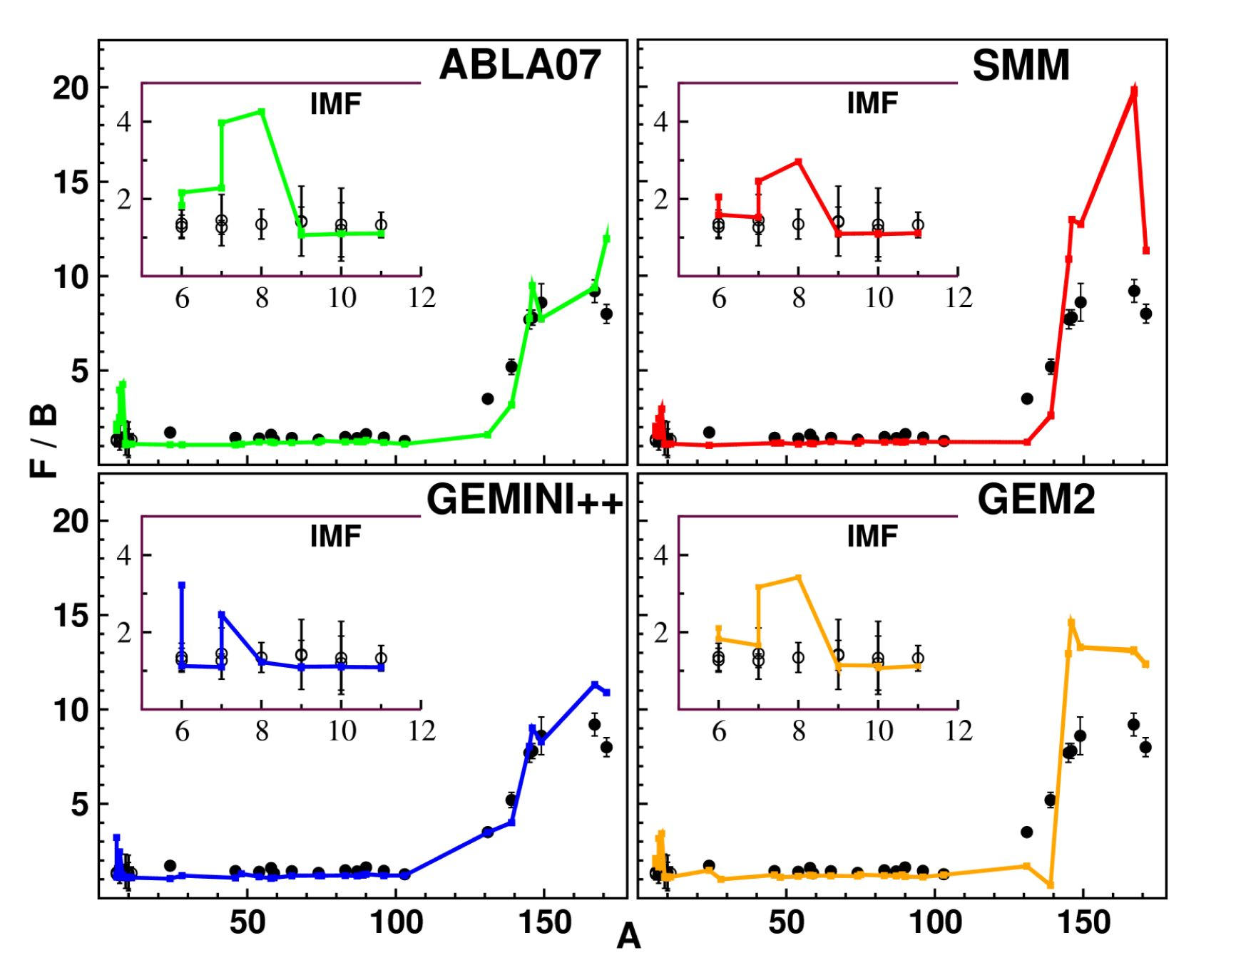
Vol. 127 (2015)
ACTA PHYSIC A POLONICA A
No. 5
Proceedings of the II Symposium on Positron Emission Tomography, Kraków, September 21-24, 2014

Angular Asymmetry in the Production of Light
and Heavy Recoil Nuclides in Proton Induced Reaction
with Au Target at GeV Energies
S.K. Sharma* and B. Kamys
Institute of Physics, Jagiellonian University, St. Łojasiewicza 11, 30-348 Kraków, Poland
It is shown that model calculations are able to reproduce main properties in terms of experimental mass
dependence of the forward-backward asymmetry of the emitted reaction products from proton-Au collisions in the
proton beam energy range from 1 GeV to 3 GeV. Qualitative as well as quantitative comparisons are done between
the measurements and the calculations performed by means of the intra nuclear cascade code INCL4.6 coupled
with four different codes: SMM, GEMINI++, ABLA07, and GEM2 with the aim to validate the selected reaction
models.
DOI: 10.12693/APhysPolA.127.1533
PACS: 25.40.Sc, 25.40.Kv

1. Introduction
The experimental mass dependence of forward-
backward (F/B) asymmetry of the reaction product
emission in proton-Au collisions varies strongly for the
proton beam energy range from 1 GeV to 3 GeV [1].
The motivation of current investigations is to study
whether the assumed reaction mechanism can reproduce
both, the product mass dependence of the F/B asymme-
try and its variation with the beam energy. The reaction
is treated as a two-step process which consists of the fast
stage of the intranuclear cascade of the nucleon-nucleon
collisions followed by a slow process of the deexcitation of
the target’s remnants. The intranuclear cascade model
INCL4.6 [2] is used to describe the first step of the process
whereas four different models (SMM [3], GEMINI++ [4],
ABLA07 [5] and GEM2 [6]) are applied for the second
step. Qualitative as well as quantitative comparisons be-
tween the measurements and the theoretical calculations
are presented.
The paper is organized as follows: In Sect. 2 we give
detailed description on how to calculate the F/B ratio
for different nuclides and the qualitative comparison be-
tween the model predictions and the experimental data,
Section 3 is dedicated to the quantitative analysis which
eventually helps to provide the ranking to different mod-
els. In Sect. 4, the summary of the results is presented.

2. The qualitative analysis of F/B asymmetry
The measurements of the forward/backward asymme-
try reported by Kaufman et al. [1], were done for both
proton beam energies of 1 GeV and of 3 GeV for a thick
Au target (24 mg/cm2). The comparison of the results
* corresponding author; e-mail: sushil.sharma@uj.edu.pl
of model calculations with the data for such a thick tar-
get has to be performed taking into consideration the
stopping of low energy reaction products in the target.
Fig. 1. Comparison between the measurements
(points) for the F/B ratio with four different theoreti-
cal models (lines): INCL4.6 coupled with ABLA07 (left
upper part), SMM (right upper part), GEMINI++ (left
lower part), and GEM2 (right lower part), at 1 GeV
proton beam energy.
The model calculations of the F/B asymmetry were
performed along to the following steps:
- Energy loss and the range of different ions in the
Au material were evaluated by using stopping range of
ions in matter (SRIM model) for a broad energy range of
the ions.
- Random sampling of the interaction point of the
proton from the beam with the target nucleus was done
in the full thickness of the target since the protons of GeV
(1533)
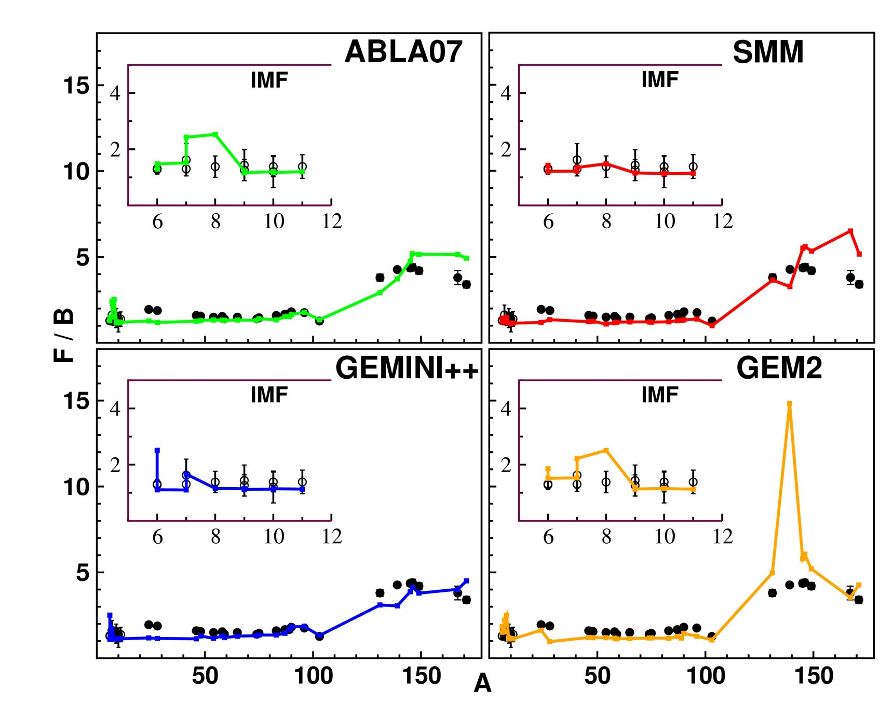
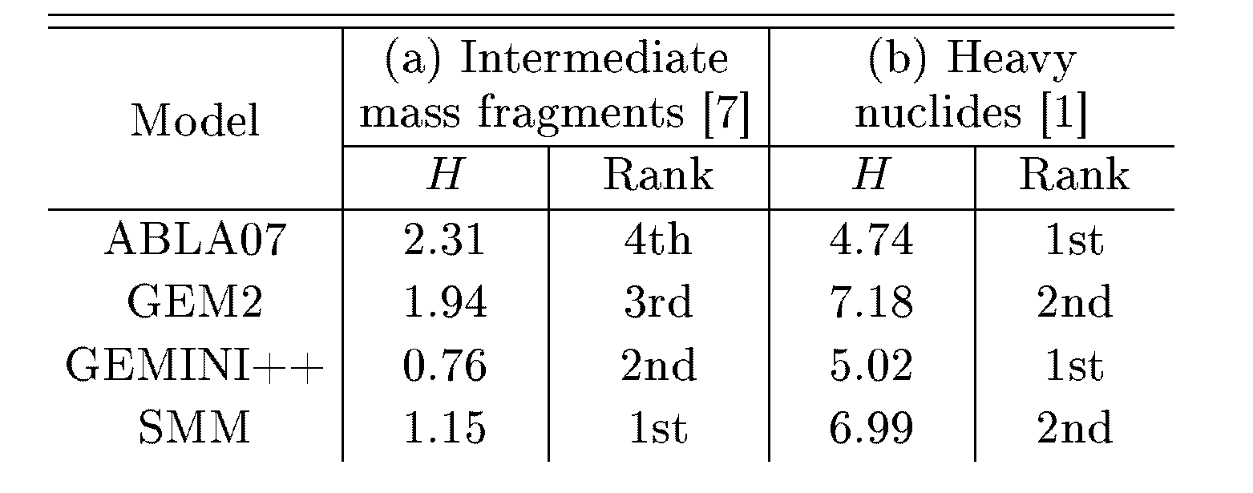
1534
S.K. Sharrna. B. Kamys
energies lose only a small part of their energy in the Au
target of the thickness of 24 mg/cm2.
- The fate of all reaction products was simulated
event-by-event. The path length of the ion-reaetion prod-
uct from the reaction point to the outer edge of the tar-
get was calculated taking into account the direction of its
emission. Then this path length was compared with the
range of the ion of given energy in the target material.
The reaction products which were able to leave the
target were used to calculate the F/B ratio.
The experimental values of the F/B ratio for interme-
diate mass fragments (IMFs) with the mass number in the
range of 6 < A < 12 measured at Tp = 1.2 GeV [7] and
heavy products (A > 24) measured at Tp = 1.0 GeV [1]
for p+Au reactions are presented in Fig. 1 (points)
whereas the same observable is depicted in Fig. 2 (points)
for IMFs at Tp = 2.5 GeV [7] and for heavy products at
Tp = 3.0 GeV [1]. The IMF data are also presented sep-
arately in the insets of the figures to show details of the
mass dependence of the F/B ratio for these particles.
Here (F/B)exp symbol represents the experimental and
(F/B)Ca1 the theoretical F/B asymmetry for i-th nu-
clide whereas A(F/B)exp is the error of experimental val-
ues. The test calculates the difference between the model
cross-sections and the experimental values in units of the
experimental error. In the case of a perfect agreement the
test has value equal to «1. More deviation from unity,
more the models are in disagreement in reproducing the
experimental data, The test values are separately calcu-
lated for IMF and for heavy products. To finally conclude
the ranking of models the test values are averaged over
both beam energies. The results of this procedure are
presented in Table.
TABLE I
Ranking of models based on H-test averaged over
both beam energies.
Fig. 2.
energy.
The same as Fig. 1 but at 3 GeV proton beam
It is clearly visible in Fig. 1 that the shape and mag-
nitude of the mass dependence of the F/B asymmetry
is best reproduced by GEMINI++ (blue line in the left,
lower part of the figure) for both IMF and heavy prod-
ucts. Excluding nuclides with masses A = 7 and 8, IMF
are well described by ABLA07, SMM and GEM2. How-
ever, the magnitude of the F/B asymmetry of heavy
products is significantly overestimated by both, GEM2
and SMM.
The data at higher energy are compared with the
model predictions in Fig. 2. The INCL4.6 model coupled
with SMM model is the best in reproducing the exper-
imental data for IMFs. It is followed by GEMINI++,
ABLA07, and GEM2. For heavy products all models
are able to reproduce the shape of the mass dependence
of F/B, whereas GEMINI++ seems to be successful

4. Summary
The INCL4.6 model coupled to GEMINI++, SMM,
ABLA07 and GEM2 models is able to reproduce the
shape of the mass number dependence of the F/B
asymmetry without introducing any free parameters.
The model predictions agree also with the beam energy
dependence of the F/B asymmetry. Ranking of the mod-
els based on the H-test is as follows: for IMF (1) SMM,
- GEMINI++, (3) GEM2 and (4) ABLA07 and for
heavy nuclides: (1) ABLA07, GEMINI++, (2) SMM,
GEM2.

Acknowledgments
One of us (S.K.S.) gratefully acknowledges the support
by the Foundation for Polish Science — MPD program,
co-hnanced by the European Union within the European
Regional Development Fund.
even in reproducing the magnitude. The GEM2 model
overestimates the F/B ratio for the particular fragment
with A = 139.

3. Ranking of the models
In order to make judgement about the best models
we used quantitative measure of agreement of the data
and theoretical F/B ratios. The statistical H-test [8]
has been used for this purpose
H = (1 N ((F/Brp - (F/B)Cal \ 211/2
^ N A (F/B )exp ) ■
Angular Asymmetry in the Production of Light and Heavy Recoil Nuclides...
1535
References
- S.B. Kaufman, E.P. Steinberg, M.W. Weisfield, Phys.
Rev. C 18, 1349 (1978).
- A. Boudard. J. Cugnon. J.-C. David. S. Lerav.
D. Mancusi, Phys. Rev. G 87, 014606 (2013).
- J.P. Bondorf, A.S. Botvina, A.S. Iljinov, I.N. Mislius-
tiu, K. Sneppen, Phys. Rep. 257, 133 (1995).
- D. Maiicusi, R.J. Cliaritv, J. Cugnon, Phys. Rev. C
82, 044610 (2010).
- A. Kelić, M.V. Ricciardi, K.-H. Schmidt,
arXiv:0906.4193, [nucl-th], 2009.
- S. Puriliata, Nuel. Instrum.. Methods Phys. Res. B
171, 251 (2000): S. Puriliata, T. Nakamura, J. Nuel.
Sei. Te.ehn.ol. 39 Suppl. 2, 758 (2002).
- A. Budzanowski, M. Fidelus, D. Filges, F. Golden-
baum, H. Hodde, L. Jarczyk, B. Kamys, M. Kist.ryn,
S. Kist.ryn, S. Kliczewski, A. Kowalczyk, E. Kozik,
P. Kulessa, H. Maclmer, A. Magiera, B. Piskor-
Ignat.owicz, K. Pysz, Z. Rudy, R. Siudak, M. Woj-
ciechowski, Phys. Rev. G 78, 024603 (2008).
- S.K. Sliarma, Acta Phys. Pol. B Proe. Suppl. 6,
1161 (2013).

