



Neurotox Res (2016) 29:143–154 DOI 10.1007/s12640-015-9571-7
Alterations of Bio-elements, Oxidative, and Inflammatory Status
in the Zinc Deficiency Model in Rats
UrszulaDoboszewska¹•BernadetaSzewczyk¹•MagdalenaSowa-Kuc´ma¹•KarolinaNoworyta-Sokołowska¹•PaulinaMisztak^{1,2}•JoannaGołe˛biowska¹•Katarzyna Młyniec²•Beata Ostachowicz³•MirosławKros´niak²•
Agnieszka Wojtanowska-Kros´niak²•Krystyna Gołembiowska¹•
Marek Lankosz³•Wojciech Piekoszewski⁴•Gabriel Nowak^{1,2}
Received: 20 September 2015 / Revised: 26 October 2015 / Accepted: 28 October 2015 / Published online: 18 November 2015
©The Author(s) 2015. This article is published with open access at Springerlink.com
Abstract Our previous study showed that dietary zinc restriction induces depression-like behavior with con- comitant up-regulation of theN-methyl-_{D}-aspartate recep- tor (NMDAR). Because metal ions, oxidative stress, and inflammation are involved in depression/NMDAR func- tion, in the present study, bio-elements (zinc, copper, iron, magnesium, and calcium), oxidative (thiobarbituric acid- reactive substances; protein carbonyl content), and inflammatory (IL-1a, IL-1b) factors were measured in serum, hippocampus (Hp), and prefrontal cortex (PFC) of male Sprague–Dawley rats subjected to azinc-adequate(ZnA) (50 mg Zn/kg) or a zinc-deficient (ZnD) (3 mg Zn/ kg) diet for 4 or 6 weeks. Both periods of dietary zinc restriction reduced serum zinc and increased serum iron levels. At 4 weeks, lowered zinc level in the PFC and Hp as well as lowered iron level in the PFC of the ZnD rats was observed. At 6 weeks, however, iron level was increased in the PFC of these rats. Although at 6 weeks zinc level in the PFC did not differ between the ZnA and ZnD rats, extracellular zinc concentration after 100 mM KCl stimulation was reduced in the PFC of the ZnD rats andwasaccompaniedbyincreasedextracellularironand
glutamate levels (as measured by the in vivo microdialy- sis). The examined oxidative and inflammatory parameters were generally enhanced in the tissue of the ZnD animals. The obtained data suggest dynamic redistribution of bio- elements and enhancement of oxidative/inflammatory parameters after dietary zinc restriction, which may have a link with depression-like behavior/NMDAR function/ neurodegeneration.
Keywords Zinc deficiency·Zinc·Iron·Oxidation·
Inflammation·Glutamate
Introduction
Zinc is the second (after iron) most prevalent trace element in the human body. Its importance has been demonstrated in many physiological processes. Zinc is crucial for normal development and function of cell-mediated immunity. Zinc deficiency primarily has an impact on T cells function and affects Th1 and (to a lesser extend) Th2 cytokines pro- duction (Bonaventura et al.2015). Zinc deficiency influ-
ences
also
production
of
interleukin (IL)-1b
by

macrophages (Bonaventura et al.2015). IL-1b plays a key role in the damaging inflammatory response in a variety of diseases (Dinarello et al.2012). Altered production of cytokines during zinc deficiency may lead toinflammation, e.g., zinc depletion from macrophages induces IL-1b secretion and activates NLRP3 inflammasome (Summers- gill et al.2014). Moreover, zinc which is (in contrast to iron) redox inactive metal, serves as an important compo- nent of antioxidant defense. It contributes to maintaining redox balance through different mechanisms, e.g., is an inhibitor of nicotinamide adenine dinucleotide phosphate (NADPH) oxidase, a co-factor of superoxidedismutase
&
Urszula Doboszewska
u.doboszewska@wp.pl;doboszew@if-pan.krakow.pl
1
Institute of Pharmacology, Polish Academy of Sciences,Sme˛tna12,31-343Krako´w,Poland
Faculty of Pharmacy, Jagiellonian University MedicalCollege,Medyczna9,30-688Krako´w,Poland
Faculty of Physics and Applied Computer Sciences, AGH University of Science and Technology, Mickiewicza 30,30-059Krako´w,Poland
Faculty of Chemistry, Jagiellonian University, Ingardena 3,30-060Krako´w,Poland
2
3
4
13
ORIGINAL ARTICLE

144
Neurotox Res (2016) 29:143–154
(SOD),andinducesthegenerationofcysteine-richmetal-lothionein, which acts as scavenger ofoxidants(Oteiza2012; Prasad2014). In contrast, zinc deficiencyisassoci-ated with increased oxidative stress markers(Prasad2014).Thereisevidencefortheinvolvementofinflammationandoxidativestressindepression(LeonardandMaes2012;Maesetal.2012a;Moylanetal.2014).Depressedpatients exhibit increased levelsofpro-inflammatorycytokines, e.g., IL-1b, whereas administrationofthesecytokines (including IL-1b) induces depression-likebehavior in experimental animals (Maes et al.2012a). Bothpreclinical and clinical data indicate also that depressionisaccompaniedbyincreasedlipid,protein,andDNAperox-idation (Siwek et al.2013a). Oxidative stressandinflam-mation may contribute to depression through effectsontheglutamatergic system (Marsden2011).Pro-inflammatorycytokines,suchasIL-1b,andreactiveoxygenspeciescanenhance the activity ofindoleamine2,3-dioxygenase(IDO),anenzymewhichcatabolizestryptophan,thepri-mary precursor of serotonin, into kynurenine,whichisfurther broken down into kynurenic acidandquinolinicacid.WhilekynurenicacidistheionotropicglutamateN-methyl-_{D}-aspartate receptor (NMDAR)endogenousantag- onist,quinolinicacidisastrongagonistofNMDAR(LeonardandMaes2012;Maesetal.2012a;FelgerandLotrich2013; Myint and Kim2014).Therefore,inflam-mationandoxidativestressviaactivationofIDOpathwaymay lead to abnormal regulation ofglutamatetransmissionthroughNMDAR,aphenomenonimplicatedinthepatho-physiologyofdepression(Sanacoraetal.2012;Ghasemiet al.2014). Moreover, a mixtureofpro-inflammatorycytokines, containing IL-1b, was shown toincreasegluta-materelease(Idaetal.2008).Thisobservationprovidesanother route by which cytokines may influence theglu-
tamatergic system and conceivably lead to depression.
In addition to oxidative/inflammatory status, NMDARis a subject to modulation by a number of agents including metal ions (Szewczyk et al.2012). At resting membrane potential magnesium blocks NMDAR channel, prohibiting calcium influx. Depletion of magnesium block during depolarization allows calcium to enter the postsynaptic neuron. Under certain conditions, magnesium and calciumcan block/permeate the channel (Mayer and Westbrook1987). Zinc is a potent inhibitor of NMDAR (Paoletti et al.2009). Also copper and iron were found to inhibitthis receptor (Vlachova et al.1996; Nakamichi et al.2002; Stys et al.2012). Of note, relationships between altered home- ostasis of bio-elements as well as increased oxidative/in- flammatory status and NMDAR function were implicated in depressive disorders (Marsden2011; Leonard and Maes2012;Serefkoetal.2013;Mlyniecetal.2014a,2015).
Recently, a low dietary zinc intake emerged as a risk factor for depression (Vashum et al.2014). Zinc deficiency
is regarded as a public health problem (Jurowski etal.2014). It induces psychopathological symptoms that cor- respond to depression symptoms (Szewczyk2013; Hag- meyer et al.2015). We have previously shown that depression-like behavior induced by dietary zinc restriction in rats is associated with up-regulation of NMDAR in brain regions (hippocampus, Hp and prefrontal cortex, PFC) (Doboszewska et al.2015). Because alterations of metals as well as oxidative/inflammatory status may be linked to abnormal NMDAR function and depression, here we measured bio-elements (zinc, copper, calcium, magnesium, and iron) and oxidation/inflammation parameters (thiobar- bituric acid-reactive substances (TBARS), protein carbonyl content (PCC), IL-1a and IL-1b) in serum, the Hp and PFC of rats following a zinc-deficient (ZnD) dietadministration. Moreover, extracellular zinc, iron, and glutamate levels weremeasured.
Materials and Methods
Animals and Diet
All procedures were conducted according to the National Institutes of Health Animal Care and Use Committee guidelines and were approved by the Ethics Committee of the Institute of Pharmacology, Krakow. In the study, 40 male Sprague–Dawley rats (Charles River Laboratories, Erkrath, Germany) were used that were delivered at theage of 4 weeks. Upon arrival, the rats were habituated to the laboratory conditions for 1 week. During the habituation phase, the rats were fed a standard diet with 35 mg Zn/kg. Following the habituation phase, the animals were divided into 4 groups; each group consisted ofn=10 rats that were fed a zinc-adequate (ZnA) diet of 50 mg Zn/kg or a ZnD diet of 3 mg Zn/kg, for 4 or 6 weeks. Detailed specification of elements: zinc, copper, calcium, magne- sium and iron for the ZnA and ZnD diets is provided in Table1. The diets were purchased from Altromin GmbH (Lage, Germany). The animals were housed 5 per cage in a controlled environment (temperature 22±2°C, 12h
Table 1 The amounts of bio-elements: zinc (Zn), copper (Cu), cal- cium (Ca), magnesium (Mg), and iron (Fe) in the zinc-adequate (ZnA) and zinc-deficient (ZnD)diets
Units
ZnA diet
ZnD diet
Zn Cu Ca Mg
Fe
mg/kgmg/kgmg/kgmg/kg
mg/kg
50
5
9482
709
179
3
5
9513
716
179
13

Neurotox Res (2016) 29:143–154
145
light/dark cycle, 40–50 % humidity) with free access to food and water. The body weight of each rat was measured weekly. Additional group (n=9) of a 4-week male Sprague–Dawley rats (Charles River Laboratories) was used in the in vivo microdialysis study. Before the in vivo microdialysis, the rats were applied a 6-week diet regimen. Briefly, following a 1-week habituation period, therats were divided into groups (n=4–5) that received a ZnA ora ZnD diet for 6weeks.
and digested in 1.5 ml of concentrated nitric acid (Supra- Pur—Merck). Brain tissue samples were mineralized using water bath for 5 h at 80°C. After cooling the samples, demineralized water was added to the total volume of 5 ml. Magnesium was measured at wavelength of 285.2 nm and calcium at 422.7 nm, both with deuterium (D2) back- ground correction. The results are presented in mg/l (for serum) or mg/kg wet weight of brain tissue.
Endocrine, Oxidative Stress, and Inflammation Assays
Tissue Processing
Following 4 or 6 weeks of the ZnA or ZnD diet, the rats were killed by rapid decapitation; their brains were rapidly dissected and immersed in cooled (2–8°C) 0.9 % sodium chloride (0.9 % NaCl) solution. Complete hippocampus (Hp) (dorsal and ventral) and prefrontal cortex (PFC) were dissected on a cold plate, immediately frozen on dry iceandstoredat-80°Cuntilfurtheranalysis.Thetrunkblood was collected into tubes without anti-coagulant. The blood was allowed to clot for 15–20 min and was cen- trifuged for 30 min at 1800 rpm at 4°C. The resulting supernatant (serum) was quickly pipetted into tubes thatwerestoredat-80°Cuntilanalysis.
Serum corticosterone (CORT), oxidative, and inflamma- tory parameters were measured using commercially avail- able kits, according to the manufacturer’s protocols. Serum CORT concentration was determined by enzyme-linked immunoassay (ELISA) using Corticosterone Rat/Mouse Elisa Kit (Demeditec Diagnostics GmbH, Kiel, Germany). The levels of lipid and protein peroxidation were measured in serum, the Hp, and PFC using thiobarbituric acid-reac- tive substances (TBARS) Assay kit or Protein Carbonyl Colorimetric Assay Kit (Cayman Chemical, Ann Arbor, MI, USA), respectively. To determine lipid peroxidation, the malondialdehyde (MDA)-thiobarbituric acid (TBA) adduct was measured fluorometrically at an excitation wavelength of 530 nm and an emission wavelength of 550 nm. The levels of IL-1a and IL-1b were measured in serum, the Hp, and PFC using Rat IL-1a or Il-1b ELISA kit(RayBiotech, Norcross, GA,USA).
Total Reflection X-Ray Fluorescence
Zinc, copper, and iron concentrations were measured in serum, the Hp, and PFC using total reflection X-ray fluo- rescence (TXRF) method, as described previously (Opoka et al.2010). The Hp and PFC were weighted and digested in 100–300lL(depending on the mass of the sample) of the concentrated nitric acid. As an internal standard, sele- nium standard was added, so that the final concentration was 5 mg/l for serum and 30–50 mg/kg for brain tissues. From the resulting solutions, 5llwas pipetted on reflectors made of clean glass used for TXRF analysis. Concentrated nitric acid, suprapur quality, additionally cleaned by sub- boiling distillation procedure, was purchased from Merck (Darmstadt, Germany). Selenium standard, 1000 mg/l selenium in nitric acid, was purchased from Sigma-Aldrich (Saint Louis, Missouri, United States). NANOHUNTER TXRF Spectrometer from Rigaku (Japan) was used. Mo X-ray tube (50 kV, 0.8 mA) was applied. The results are presented in mg/l (for serum) or mg/kg wet weight of braintissue.
In Vivo Microdialysis
Following 6 weeks of the ZnA or ZnD diet, in vivo microdialysis was performed. Five days before the micro- dialysis, the rats were anesthetized with chloral hydrate (400 mg/kg) and individually placed in a stereotaxic apparatus (David Kopf Instruments, Tujunga, CA, USA). Their skull was exposed, a burr hole was drilled, and a guide cannula (AgnTho’s, Sweden) was implanted in the rat PFC with coordinates: AP= ?2.8;L= ?0.8;V=-2.4,basedonthebrainatlas(PaxinosandWatson1998). The guide cannula was secured with dental cement (Dentalon; Heraeus-Kulzer GmbH, Germany) and a screw. After the surgical operation, each rat was housed individ- ually. Five days after implantation of the guide cannula, a microdialysis probe (3 mm, AgnTho’s, Sweden) was inserted into the PFC through the guide cannula. The microdialysis probe was connected with the microdialysis pump, which infused an artificial cerebrospinal fluid (aCSF) containing 147 mM NaCl, 4.0 mM KCl, 1.0 mM MgCl₂, 2.2 CaCl₂, and pH=7.4 with a flow of 2 ll/min. After a 2 h washout period, the fractions were collected for 2 h (to determine the basal extracellular concentrations of
Flame Atomic Absorption Spectroscopy
Calcium and magnesium concentrations were measured in serum, the Hp, and PFC using flame atomic absorption spectroscopy, as published previously (Kopanski et al.2000). The Hp and PFC were weighted (0.018–0.198 g)
13

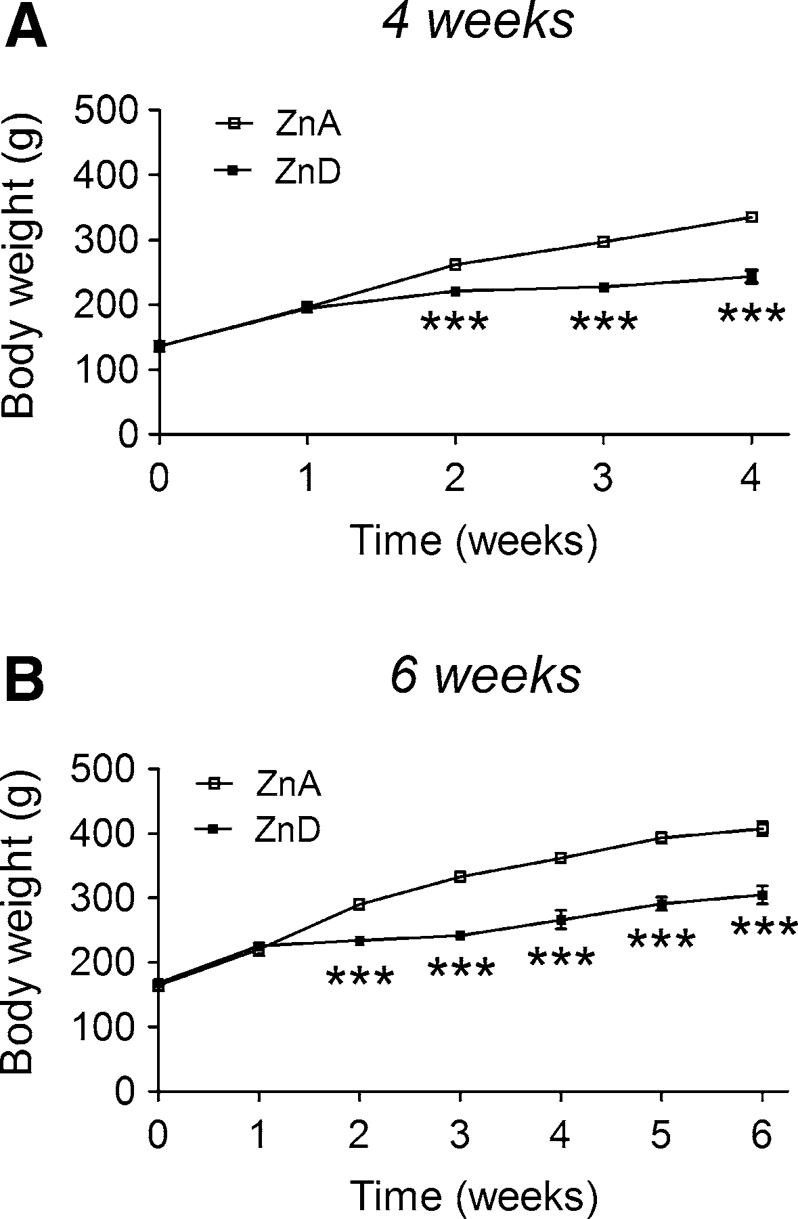
146
Neurotox Res (2016) 29:143–154
zinc, iron, and glutamate). Then, the PFC was perfused with 100 mM KCl in Ringer’s solution for 40 min, and the fractions were collected every 20 min (to determine the extracellular concentrations of zinc, iron, and glutamate after depolarization).
Analytical Procedures: Microdialysates
The extracellular concentrations of zinc and iron were measuredbyTXRFmethodusingseleniumstandard,asdescribedabove.Theextracellularconcentrationofgluta- mate was measured after derivatization withOPA/sulfite reagent. OPA/sulfite glutamate derivative was analyzed using high-performance liquid chromatography (HPLC) method with electrochemical detection.Chromatography wasperformedusingDionexP580pump(USA),anLC4Bamperometric detector with a cross-flow detector cell (BAS,IN,USA),andaHR-80column(4980mm,3lm; ESA,USA).Themobilephaseconsistedof0.1Mphos- phatebufferwithpH3.6and5%methanol.Theflowratewas0.8ml/min,andtheappliedpotentialof3-mmglassycarbonelectrodewas?650mVatasensitivityof5nA/V. Glutamate derivative concentration was calculated bycomparingitspeakareawithrespectivestandardandwas processed by Chromax 2005 (Pol-Lab, Warsaw, Poland)software run on a personalcomputer.
Fig. 1 The effects of a 4-week a or a 6-week, b dietary zincrestrictiononbodyweight.Ratswerefedazinc-adequate(ZnA)diet(50mgZn/kg)orazinc-deficient(ZnD)diet(3mgZn/kg)for4or 6 weeks. Values are expressed as the mean±SEM,n=10 per group. Repeated measures ANOVA demonstrated a significant interaction[F(4,72)=52.51,p\0.0001],asignificanteffectofthe diet[F(1,18)=58.72,p\0.0001]andasignificanteffectoftime [F(4,72)=464.16,p\0.0001]onbodyweightfollowinga4-weekZnD diet. Repeated measures ANOVA demonstrated a significantinteraction[F(6,108)=31.09,p\0.0001],asignificanteffectofthe diet [F(1,108)=49.41,p\0.0001], and a significant effect of time[F(6,108)=240.09,p\0.0001]onbodyweightfollowinga 6-weekZnDdiet.***p\0.001versusrespectiveZnA(Bonferroni post hoctest)
Statistics
Data were analyzed using unpaired, two-tailed Student’sttestorRepeatedMeasuresANOVAfollowedbyaBon-ferroni post hoc test. All results are presented as the mean±SEM.P\0.05 was considered statistically sig- nificant with 95 % confidence (Prism ver. 4, GraphPad Software, San Diego, CA,USA).
The Effects of a 4-week Dietary Zinc Restriction onZn,Cu,Ca,Mg,Fe,CORT,TBARS,andPCC
Levels in Serum
A 4-week ZnD diet significantly decreased serum zinc (Fig.2a) and calcium (Fig.2c) concentrations, increased magnesium (Fig.2d) and iron (Fig.2e) concentrations butdid not affect serum copper concentration (Fig.2b). Moreover, a 4-ZnD diet significantly increased serum CORT (Fig.2f) and PCC (Fig.2h) concentrations but decreased TBARS concentration (Fig.2g).
Results
The Effects of Dietary Zinc Restriction on Body Weight
During the zinc regimen, the rats displayed a typical earlysign of zinc deficiency of growth retardation (Prasad2012). A gradual increase in body weight in both groups in the course of time was observed, but the body weight was significantly reduced in rats fed the ZnD diet for 4 weeks, compared to rats fed the ZnA diet, in the second, third, and fourth weeks (Fig.1a). The body weight was also signifi- cantly reduced in rats fed the ZnD diet for 6 weeks. This effect emerged in the second week and persisted to the sixth week (Fig.1b).
The Effects of a 4-week Dietary Zinc Restriction on Zn, Cu, Ca, Mg, Fe, TBARS, PCC, IL-1a, andIL-
1bLevels in the Hp and PFC
A 4-week ZnD diet significantly decreased zinc levels in the Hp (Fig.3a) and PFC (Fig.3f) of rats. In addition, decreased iron level was observed in the PFC (Fig.3j), but not in the Hp (Fig.3e) of the ZnD rats. At 4 weeks, the levels of copper did not significantly differ in the Hp
13

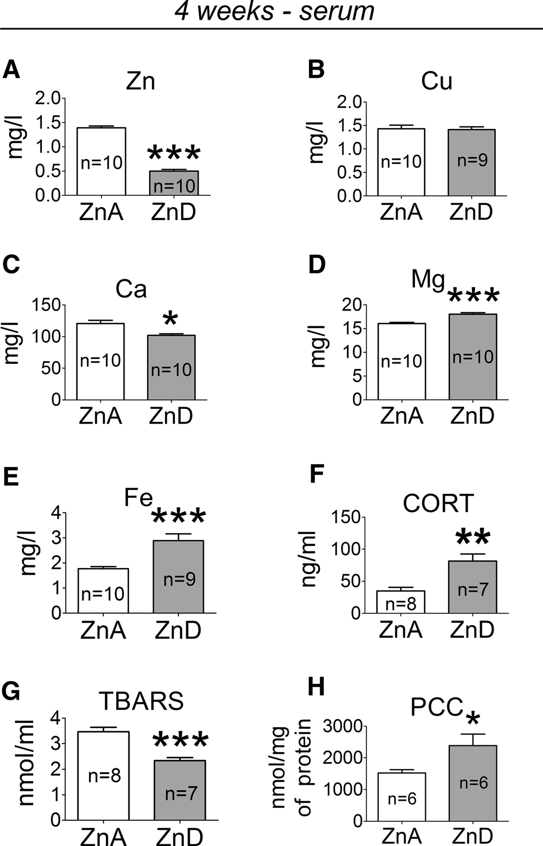
Neurotox Res (2016) 29:143–154
147
The Effects of a 6-week Dietary Zinc Restriction on Zn, Cu, Ca, Mg, Fe, CORT, and TBARS Levels inSerum
A 6-week ZnD diet significantly decreased serum zinc (Fig.5a), increased iron (Fig.5e) and CORT (Fig.5f) concentrations, but did not significantly affect copper (Fig.5b), calcium (Fig.5c), magnesium (Fig.5d), or TBARS (Fig.5g)concentrations.
The Effects of a 6-week Dietary Zinc Restriction onZn,Fe,andTBARSLevelsintheHpandPFC
At 6 weeks, there were no significant changes in zinc level in the Hp (Fig.6a) or PFC (Fig.6b) between the ZnD and control animals, whereas iron level was significantly increased in the PFC (Fig.6d), but not in the Hp (Fig.6c) of the ZnD rats. Furthermore, TBARS levels were signif- icantly increased in both the Hp (Fig.6e) and PFC (Fig.6f) of the ZnD rats at 6 weeks.
TheEffectsofa6-weekDietaryZincRestriction on Extracellular Zn, Fe, and Glutamate Levels in thePFC
At 6 weeks, the extracellular zinc level in the PFC was significantly decreased in the ZnD group, compared to the ZnA group, after a 40-min stimulation with 100 mM KCl(Fig.7c). The basal extracellular zinc level (Fig.7a) or zinc level after a 20-min stimulation with 100 mM KCl (Fig.7b) did not significantly differ between the ZnD and ZnA groups. The extracellular iron level was significantly increased in the PFC of the ZnD rats after a 20-min (Fig.7e), but not after a 40-min stimulation (Fig.7f). The basal extracellular iron level did not differsignificantly between the ZnD and ZnA groups (Fig.7d). Moreover, the basal extracellular glutamate level did not differ signifi- cantly between the ZnD and ZnA rats (Fig.7g). However, after a 20- (Fig.7h) or a 40-min (Fig.7i) stimulation, the extracellular level of glutamate was significantly increased inthePFCoftheZnDgroup,comparedtotheZnAgroup.
Fig.2Theeffectsofa4-weekdietaryzincrestrictiononzinc(Zn)(a),copper(Cu)(b),calcium(Ca)(c),magnesium(Mg)(d),iron(Fe)(e), corticosterone (CORT) (f), thiobarbituric acid-reactive substances(TBARS)(g)andproteincarbonylcontent(PCC)(h)concentrationsin serum. Values are expressed as the mean±SEM. Data were analyzedbyStudent’sttest.*p\0.05,**p\0.01,***p\0.001 versus respective ZnA. Statistical details: Zn [p\0.0001,t(18)=17.64],Cu[p=0.8373,t(17)=0.2085],Ca[p=0.0037,
t(18) = 3.329], Mg [p= 0.0002,t(18) = 4.703], Fe [p= 0.0007,t(17) = 4.112], CORT [t(13) = 3.924,p= 0.0017], TBARS [t(13) = 5.260,p= 0.0002], PCC [t(10) = 2.256,p= 0.0477]
(Fig.3b) or PFC (Fig.3g) between the ZnD and control animals. Similarly, the concentrations of calcium (Fig.3c,
h) or magnesium (Fig.3d, i) in the Hp or PFC did not significantly differ between the ZnA and ZnD groups. TBARS (Fig.4a), PCC (Fig.4b), and IL-1a (Fig.4c) but not IL-1b (Fig.4d) levels were significantly increased in the Hp of the ZnD rats at 4 weeks. The levels of TBARS (Fig.4e) and IL-1b (Fig.4h) were also significantly increased in the PFC of the ZnD group, but the levels of PCC (Fig.4f) or IL-1a (Fig.4g) did not significantly differ in the PFC between the ZnD and ZnA animals at 4 weeks.
Discussion
We have previously shown that 4 or 6 weeks of the ZnD diet induces depression-like behavior with concomitant alterations within NMDAR signaling pathway (Do- boszewska et al.2015). In the present study, we measured bio-elements and oxidative/inflammatory parameters, which may be associated with depression/NMDAR func- tion, in the ZnD rats.
13

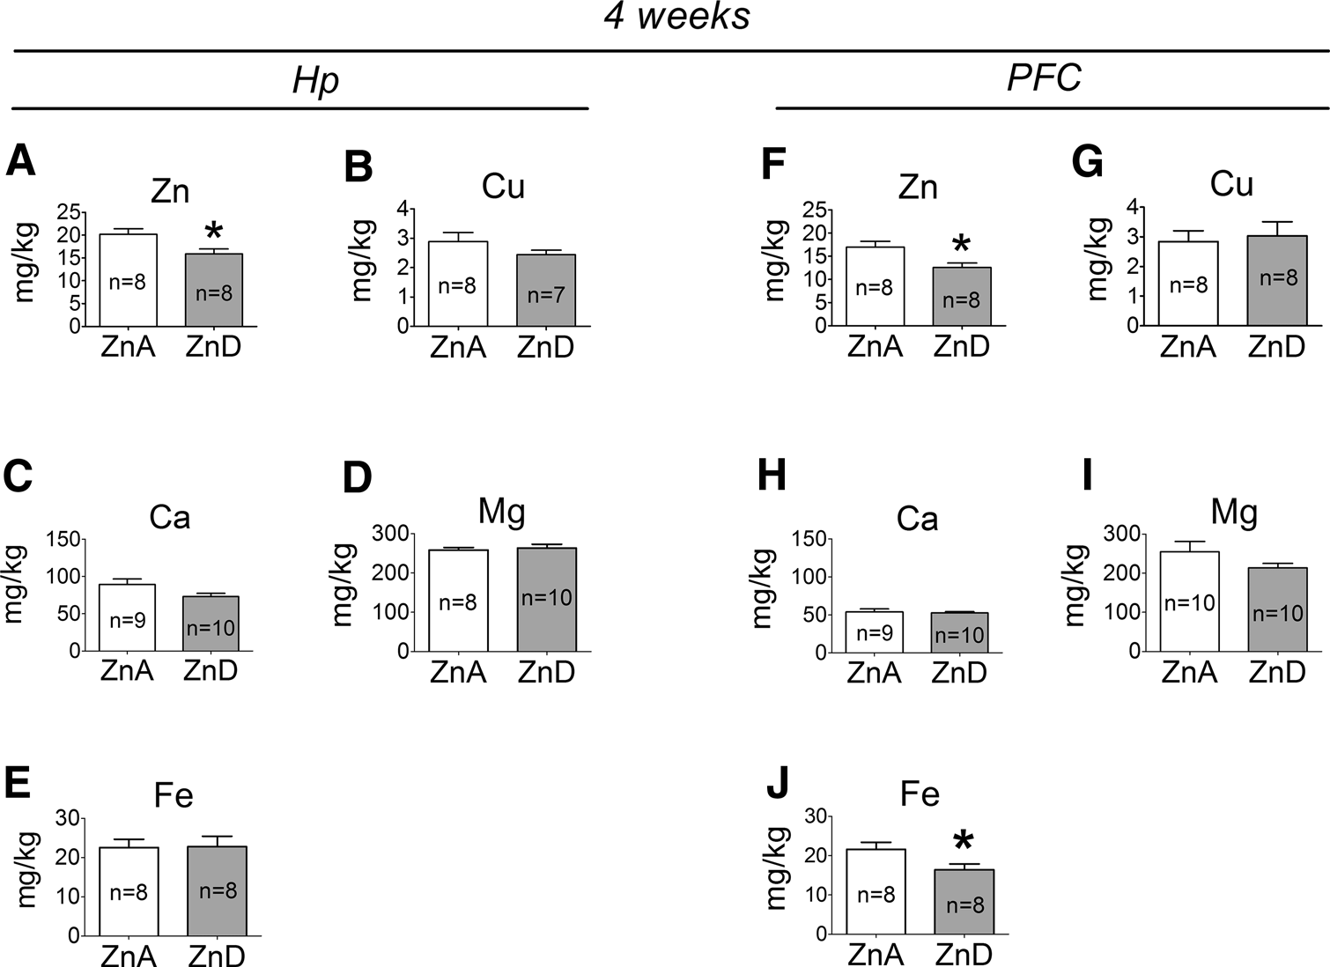
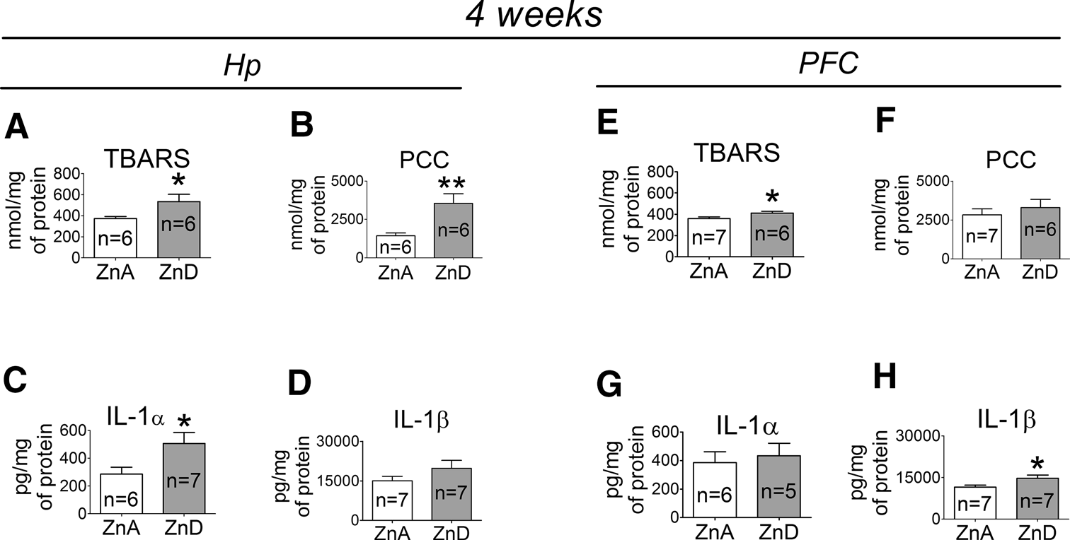
148
Neurotox Res (2016) 29:143–154
Fig. 3
The effects of a 4-week dietary zinc restriction on Zn (a), Cu
t(13) = 1.232], Ca [p= 0.0777,t(17) = 1.877], Mg [p= 0.6797,t(16) = 0.4206], Fe [p= 0.9477,t(14) = 0.06674].PFC: Zn [p= 0.0154,t(14) = 2.758], Cu [p= 0.7520,t(14) = 0.3223],Ca
[p= 0.7024,t(17) = 0.3886], Mg [p= 0.1787,t(18) =1.399], Fe [p= 0.0397,t(14) =2.268]
(b),Ca(c),Mg(D),Fe(e)levelsinthehippocampus(Hp)andonZn (f),Cu(g),Ca(h),Mg(i),Fe(j)levelsintheprefrontalcortex(PFC). Values are expressed as the mean±SEM. Data were analyzed by Student’sttest.*p\0.05versusrespectiveZnA.Statisticaldetails:
Hp:
Zn
[p=0.0199,
t(14) =2.628],
Cu
[p=0.2402,
Fig. 4 The effects of a 4-week dietary zinc restriction on TBARS (a), PCC (b), interleukin-1 alpha(IL-1a) (c), interleukin-1 beta (Il-1b)
(d) levels in the Hp and on TBARS (e), PCC (f), IL-1a (g), Il-1b
(h)levelsinthePFC.Valuesareexpressedasthemean±SEM.Data wereanalyzedbyStudent’sttest.*p\0.05,**p\0.01versus respective ZnA. Statistical details:Hp: TBARS[p=0.0499,
t(10) =2.230],
PCC
[p=0.0096,
t(10) =3.192],
IL-1a
[p= 0.0438,t(11) = 2.277], IL-1b [p= 0.1842,t(12) = 1.409].PFC: TBARS [p= 0.0443,t(11) = 2.271], PCC [p= 0.4878,t(11) = 0.7179], IL-1a [p= 0.6887,t(9) = 0.4138], IL-1b [p= 0.0389,t(12) =2.318]
We found lowered zinc level in the Hp and PFC of rats after a 4-week ZnD diet. Most of the published work demonstrated no changes in total zinc level in brain regions
following its chronic restriction (Takeda et al.2003,2005,2008a), but decreased zinc level in the Hp in a response to dietary zinc deficiency has been previously reported
13

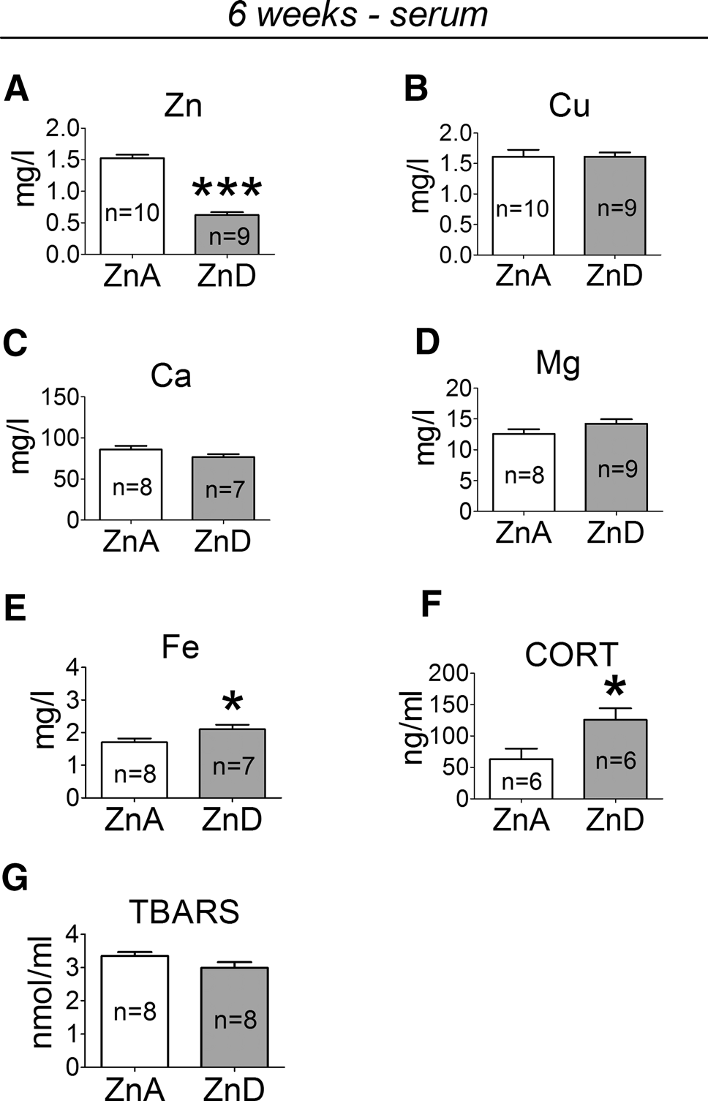
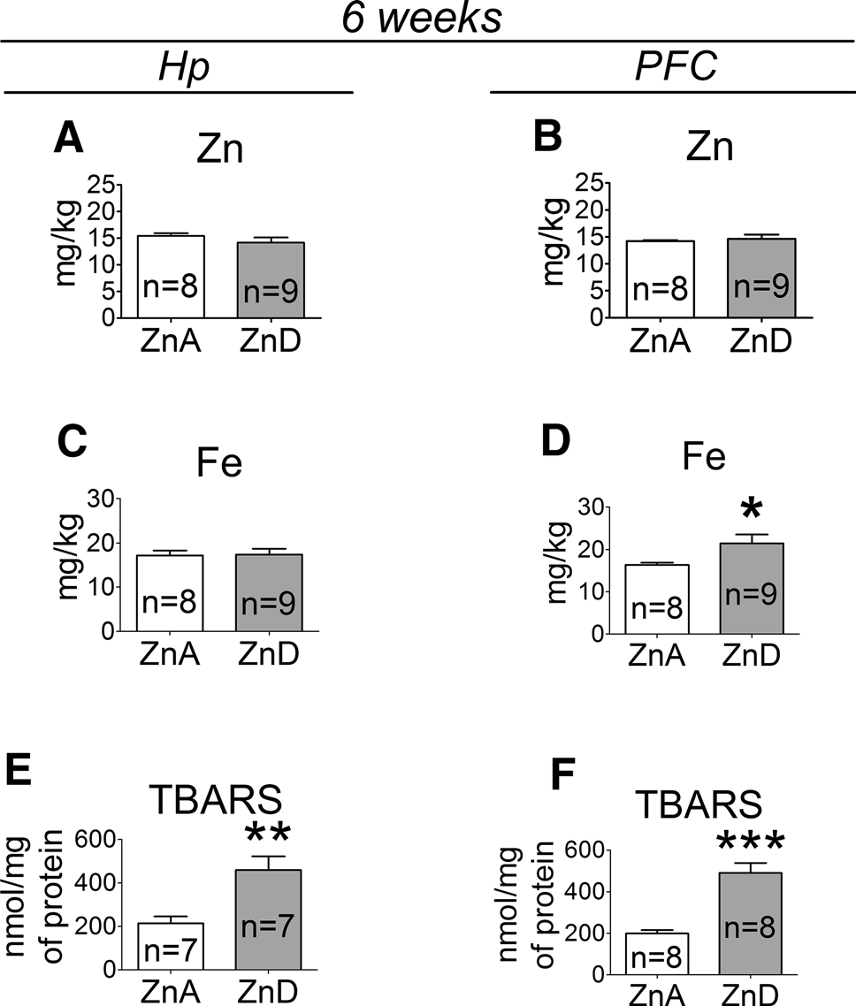
Neurotox Res (2016) 29:143–154
149
Fig. 6 The effects of a 6-week dietary zinc restriction on Zn (a), Fe (c), TBARS (e) levels in the Hp and on Zn (b), Fe (d) and TBARS
(f)levelsinthePFC.Valuesareexpressedasthemean±SEM.Data were analyzed by Student’sttest. *p\0.05, **p\0.01,
***p\0.001 versus respective ZnA. Statistical details:Hp: Zn [p=0.2708,t(15)=1.143], Fe [p=0.9077,t(15)=0.1180], TBARS [p=0.0045,t(12)=3.491].PFC: Zn [p=0.6603,
t(15) =0.4483],
Fe
[p=0.0429,
t(15)=2.212], TBARS
[p\0.0001,t(14)=5.751]
Fig.5 Theeffectsofa6-weekdietaryzincrestrictiononZn(a),Cu(b),Ca(c),Mg(d),Fe(e),CORT(f),andTBARS(g)concentrationsin serum. Values are expressed as the mean±SEM. Data were analyzed by Student’sttest. *p\0.05, ***p\0.001 versus respectiveZnA.Statisticaldetails:Zn[p\0.0001,t(17)=12.80], Cu[p=0.9929,t(17)=0.009016],Ca[p=0.1231,t(13)=1.649],
Mg [p= 0.1452,t(15) = 1.537], Fe [p= 0.0481,t(13) = 2.181], CORT [t(10) = 2.490,p= 0.0320], TBARS [t(14) = 1.661,p=0.1190]
psychological stress (Dou et al.2014) and was associated with increased serum CORT concentration (Tao et al.2013). Increased serum CORT was also demonstrated following zinc restriction (the present data, Watanabe et al.1992; Chu et al.2003; Takeda et al.2007,2008a,b,Takeda et al.2012, Mlyniec et al.2012). Thus, the ZnD diet induces changes in hippocampal zinc and serum CORT similar to those observed after exposure to stress, which is considered as a precipitant ofdepression.
The lack of differences between zinc level in the Hp or PFC of the ZnD and control rats after prolonged (a6-week) deprivation suggests dynamic redistribution of the bio- element during its dietary regimen. It should be noted, however, that at 6 weeks of the ZnD diet, a concomitant decrease in evoked zinc release in the PFC was observed, which was accompanied by increased glutamate release (as measured by the in vivo microdialysis). Because we have previously found significantly increased level of NMDAR GluN2A protein in the PFC of rats at 6 weeks of zinc restriction (Doboszewska et al.2015) (Table2) (which indicatesthata6-weekZnDdietmayalterthefunctionof
(Takeda et al.2001). Because zinc released from presy- naptic terminals of glutamatergic neurons in the cortex and Hp inhibits NMDAR on the postsynaptic side (Paoletti et al.2009), the decrease in zinc content of these brain regions may have a consequence for NMDAR function and presumably the development of depression. The observa- tion that the time-course of decreased zinc level in brain regions corresponds to the time of occurrence of depres- sion-like behavior and up-regulation of NMDAR subunits (GluN2A, GluN2B) in the Hp of the ZnD rats, which was found in our previous study (Doboszewska et al.2015) (Table2),isconsistentwiththislineofthinking.
Decreased hippocampal zinc level corresponding to depression-like behavior was found in rats exposed to
13

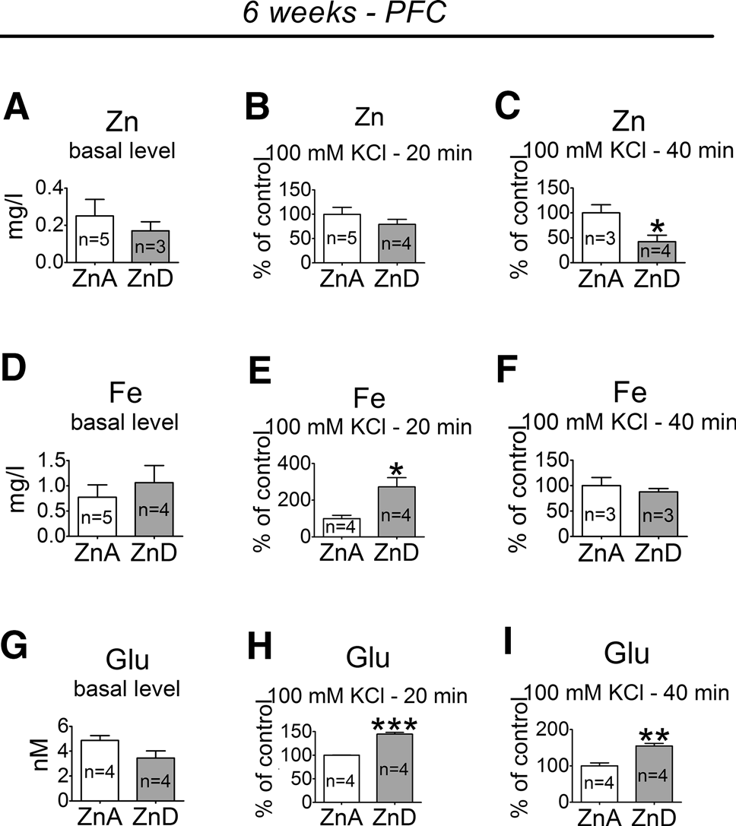
150
Neurotox Res (2016) 29:143–154
NMDAR in the PFC), our previous and present observa- tions suggest that zinc deficiency may enhance glutamate signaling through NMDAR.
Reductions in protein expression of zinc transporter 3 (ZnT3) in Brodmann area 9 (which is a part of the frontal cortex) were shown to be significantly associated with ele- vateddepressionscoresinpatientswithdementiawithLewy bodies (DLB), Parkinson disease dementia (PDD), and Alzheimer disease (AD) (Whitfield et al.2015). Because in ZnT3 knockouts, synaptic zinc is undetectable (Cole et al.1999), these data provide evidence for the role ofdecreased synaptic zinc in depression. Therefore, decreased evoked zincreleaseinthePFCoftheZnDrats,suggestingdecreased level of synaptic zinc, may be linked to depression-like behavior in the zinc deficiencyparadigm.
In the present study, the 4-week ZnD diet reduced iron content of the PFC, whereas an increase in iron content of the PFC was observed after the 6-week ZnD diet. Iron deficiency may lead to abnormal mood and behavior (Kim and Wessling-Resnick.2014). On the other hand, ironprogressively accumulates in the brain with aging (Bilgic et al.2012; Ramos et al.2014) and its accumulation in the brain has been implicated in the etiology of numerous neurodegenerative disorders (Schipper2012; Zheng and Monnot2012). There is evidence that depression is accompanied by a progressive process of neurodegenera- tion (Szewczyk et al.2011; Maes et al.2012b; Smaga et al.2014). Magnetic resonance imaging studies in elderly depressed patients have shown that an older age of onset and a greater severity of depression are associated with increased iron deposition in specific brain regions (Steffens et al.1998). Moreover, exposure to psychological stress was found to increase iron level in the cortex and Hp (Wang et al.2008; Yu et al.2011), whereas zinc supple- mentation was found to decrease iron deposition inthe cortex and Hp induced by psychological stress (Li et al.2012). Thus, the increase in iron level in the brain may bea common effect of prolonged zinc deficiency, psychological stress, anddepression.
Fig. 7
The effects of a 6-week dietary zinc restriction on extracel-
lular Zn, Fe, and glutamate (Glu) concentrations in the PFC: basal extracellular Zn level (a), extracellular Zn level after a 20-min stimulation with 100 mM KCl (b), extracellular Zn level after a 40-min stimulation with 100 mM KCl (c); basal extracellular Fe level (d), extracellular Fe level after a 20-min stimulation with 100 mM KCl (e), extracellular Fe level after a 40-min stimulation with 100 mM KCl (f); basal extracellular Glu level (g), extracellular Glu level after a 20-min stimulation with 100 mM KCl (h), extracellular Glu level after a 40-min stimulation with 100 mM KCl (i). Basal extracellular levels are expressed as the mean±SEM. The extracel- lular levels after stimulations (mean±SEM) are presented as the % of respective ZnA. Data were analyzed by Student’sttest. *p\0.05,
**p\0.01,***p\0.001versusrespectiveZnA.Statisticaldetails: Znbasallevel[p=0.5389,t(6)=0.6515],Zn20-minstimulation [p=0.2983,t(7)=1.124)], Zn 40-min stimulation [p=0.0386,t(5)=2.786],Febasallevel[p=0.4922,t(7)=0.7125],Fe20-min stimulation [p=0.0168,t(6)=3.280], Fe 40-min stimulation [p=0.5250,t(4)=0.7036], Glu basal level [t(6)=2.046,p=0.0867], Glu 20-min stimulation [t(6)=13.23,p\0.0001], Glu 40-min stimulation [t(6)=4.901,p=0.0027]
Table 2 Summary of previous findings on the zinc deficiency model in rats
4 weeks
6 weeks
Behavioral parameters
Increased immobility time in the forced swim test (FST) Anhedonia
Reduction of social behavior
Hp::GluN2A,:GluN2B,;p-CREB,;BDNF
PFC:$GluN2A,$GluN2B,$p-CREB,$BDNF
Increased immobility time in the FST Anhedonia
Reduction of social behavior
Hp::GluN2A,:GluN2B,;p-CREB,;BDNF
PFC::GluN2A,$GluN2B,;p-CREB,;BDNF
Protein levels
Rats were fed a ZnA or a ZnD diet for 4 or 6 weeks. GluN2A, GluN2B—subunits of the glutamateN-methyl-_{D}-aspartate receptor;p-CREB— phosphorylated cyclic AMP response element-binding protein; BDNF—brain-derived neurotrophic factor;:—increased protein level;;— decreased protein level;$no effects. Based on Doboszewska et al.2015
13

Neurotox Res (2016) 29:143–154
151
As mentioned above, we have previously found signif- icantly increased level of NMDAR GluN2A protein in the PFC of rats after the 6-week ZnD diet; however, no dif- ferences in the levels of NMDAR GluN2A or GluN2B proteins were observed in the PFC between the ZnD and control animals after the 4-week ZnD diet (Doboszewska et al.2015) (Table2). These data, together with the present data concerning increased glutamate release after 6 weeks of the ZnD diet administration, indicate that prolonged (6 weeks) zinc restriction may lead to activation of NMDAR in the PFC. It has been demonstrated that the stimulation of NMDAR induces iron uptake (Cheah et al.2006). This mechanism may explain iron accumulation in the PFC of rats after 6 weeks, but not after 4 weeks of zinc deprivation. Moreover, at 6 weeks, but not at 4 weeks, we found decreased brain-derived neurotrophic factor (BDNF) protein expression in the PFC of the ZnD rats (Do- boszewska et al.2015) (Table2). BDNF can ameliorate iron accumulation in neurons (Zhang et al.2014). Thus, increased iron level in the PFC of rats at 6 weeks might result from decreased level ofBDNF.
In addition to decreased zinc release, increased evoked iron release was observed in the PFC of the ZnD rats. Iron transporter ferroportin was found to be expressed in synaptic vesicles (Wu et al.2004); however, iron home- ostasis in the brain has not been clearly defined (Ward etal.2014). Presumably, the presence of iron in extracellular space may induce oxidativestress.
Moreover, both the 4- and the 6-week ZnD diets low- ered serum zinc and increased serum iron concentrations. Data concerning the relationship between depression and serum iron concentration are inconsistent (Maes et al.1996; Rybka et al.2013). In contrast, decreased serum zinc level associated with depression has been repeatedly observed (Siwek et al.2013b) and has been demonstrated through a meta-analysis of clinical studies (Swardfager et al.2013). The altered levels of magnesium and calcium in serum following zinc depletion suggest redistributionof
higher serum copper levels in patients suffering from depression have been reported (Manser et al.1989; Sch- legel-Zawadzka et al.1999). In the present study, we did not observe differences in copper levels either in serum or brain tissues. Likewise, the study of zinc deficiency in mice, which demonstrated depression-like behavior and decreased serum zinc level, did not show differences in serum copper levels (Mlyniec et al.2014b).
Associations between the increase in the lipid (TBARS) and protein (PCC) oxidation, pro-inflammatory cytokine (IL-1a and b) levels, decrease of zinc, and increase of iron levels have been noted previously in in vivo (Arruda et al.2013; Mehrpouya et al.2015) and in vitro/cell culture(Tate et al.1999; Wessels et al.2013) experiments. Moreover, a link of depression-like behavior with the enhancement of oxidative stress/pro-inflammatory status and with iron content in other experimental models and in clinicalstudies (Wayhs et al.2010; Lopresti et al.2014; Spanemberg et al.2014; Mehrpouya et al.2015; Tsai and Huang.2015) was demonstrated. Increased oxidative stress as well as pro- inflammatory cytokines may lead to NMDAR activation (Leonard and Maes.2012; Maes et al.2012a; Felger and Lotrich2013; Myint and Kim2014). Furthermore, a mix- ture of pro-inflammatory cytokines, containing IL-1b, was shown to increase glutamate release (Ida et al.2008), whereas administration of IL-1b induced depression-like behavior (Maes et al.2012a). Thus, increased levels ofpro- inflammatory cytokines and enhancement of oxidation in the Hp and PFC of the ZnD rats may contribute to increased release of glutamate, NMDAR activation, and depression-likebehavior.
Conclusions
Dietary zinc restriction induces peripheral and central alterations of bio-elements (namely zinc and iron) and enhances oxidative damage and pro-inflammatory status. These alterations share some similarities to those observed after exposure to stress and in depression, which further highlights that zinc deficiency [recently proposed as a model of depression (Whittle et al.2009; Mlyniec et al.2013; Doboszewska et al.2015)] and depression may share a common pathophysiology. The changes observed in the present study may have a link to depression-like behavior in the zinc deficiency paradigm and may lead to/resultfromenhanced glutamate transmission throughNMDAR.
these elements after dietary zinc peripheral alterations were in the accompanied by central alterations.
regimen, although present study not In this study,the
4-week ZnD diet increased serum magnesium concentra- tion. In animal models of depression based on stress exposure and in olfactory bulbectomy model, no differ- ences in serum magnesium levels were demonstrated (Zieba et al.2000); however, higher serum magnesium concentrations have been reported in depressed patients, compared to healthy controls, yet the data are not consis- tent (Serefko et al.2013). Lowered level of magnesium in the Hp was recently shown in post-mortem study of suicide subjects (Sowa-Kucma et al.2013).
Also, data regarding the relationship between serum copper concentration and depression are not consistent, but
Acknowledgments The study was partially supported by the project InterdisciplinaryPhDStudies‘‘Molecularsciencesformedicine’’(co- financed by the European Social Fund within the Human Capital Operational Programme), Grant POIG.01.01.02-12-004/09-00, and Statutory Activity of the Institute of Pharmacology PAS and Jagiel-lonianUniversityMedicalCollegeinKrako´w.
13

152
Neurotox Res (2016) 29:143–154
Compliance with Ethical Standards
Hagmeyer S, Haderspeck JC, Grabrucker AM (2015) Behavioralimpairments in animal models for zinc deficiency. Front Behav Neurosci 8:443. doi:10.3389/fnbeh.2014.00443
Ida T, Hara M, Nakamura Y, Kozaki S, Tsunoda S, Ihara H (2008) Cytokine-induced enhancement of calcium-dependent glutamaterelease from astrocytes mediated by nitric oxide. Neurosci Lett 432:232–236. doi:10.1016/j.neulet.2007.12.047
Jurowski K, Szewczyk B, Nowak G, Piekoszewski W (2014) Biological consequences of zinc deficiency in the pathomech-anisms of selected diseases. J Biol Inorg Chem 19:1069–1079. doi:10.1007/s00775-014-1139-0
Kim J, Wessling-Resnick M (2014) Iron and mechanisms of emotional behavior. J Nutr Biochem 25:1101–1107
Kopanski Z, Schlegel-Zawadzka M, Piekoszewski W, Sadlik K, Sibiga W (2000) The disturbances of magnesium in patientswiththromboembolic complications after a cholecystectomy. Thromb Res99:571–575
Leonard B, Maes M (2012) Mechanistic explanations how cell- mediated immune activation, inflammation and oxidative and nitrosative stress pathways and their sequels and concomitantsplay a role in the pathophysiology of unipolar depression.Neurosci Biobehav Rev 36:764–785. doi:10.1016/j.neubiorev.2011.12.005
Li Y, Zheng Y, Qian J, Chen X, Shen Z, Tao L, Li H, Qin H, Li M, Shen H (2012) Preventive effects of zinc against psychological stress-induced iron dyshomeostasis, erythropoiesis inhibition,and oxidative stress status in rats. Biol Trace Elem Res 147:285–291. doi:10.1007/s12011-011-9319-z
Lopresti AL, Maker GL, Hood SD, Drummond PD (2014) A review of peripheral biomarkers in major depression: the potential ofinflammatory and oxidative stress biomarkers. Prog Neuropsy-chopharmacol Biol Psychiatry 48:102–111. doi:10.1016/j.pnpbp.2013.09.017
Maes M, Van de Vyvere J, Vandoolaeghe E, Bril T, Demedts P, Wauters A, Neels H (1996) Alterations in iron metabolism andthe erythron in major depression: further evidence for a chronic inflammatory process. J Affect Disord 40:23–33
Maes M, Fisar Z, Medina M, Scapagnini G, Nowak G, Berk M (2012a) New drug targets in depression: inflammatory, cell- mediated immune, oxidative and nitrosative stress, mitochon-drial, antioxidant, and neuroprogressive pathways. And newdrugcandidates–Nrf2 activators and GSK-3 inhibitors.Inflammophar- macology 20:127–150.doi:10.1007/s10787-011-0111-7
Maes M, Fisar Z, Medina M, Scapagnini G, Nowak G, Berk M(2012b) New drug targets in depression: inflammatory, cell- mediated immune, oxidative and nitrosative stress, mitochon- drial, antioxidant, and neuroprogressive pathways. And newdrugcandidates–Nrf2 activators and GSK-3 inhibitors.Inflammophar-macology 20:127–150.doi:10.1007/s10787-011-0111-7
Manser WW, Khan MA, Hasan KZ (1989) Trace element studies on Karachi population. Part IV: blood copper, zinc, magnesium andlead levels in psychiatric patients with depression, mental retardation and seizure disorders. J Pak Med Assoc 39:269–274
Marsden WN (2011) Stressor-induced NMDAR dysfunction as a unifying hypothesis for the aetiology, pathogenesis and comor-bidity of clinical depression. Med Hypotheses 77:508–528. doi:10.1016/j.mehy.2011.06.021
Mayer ML, Westbrook GL (1987) Permeation and block ofN-methyl-D-aspartic acid receptor channels by divalent cations inmouseculturedcentralneurones.JPhysiol394:501–527
Mehrpouya S, Nahavandi A, Khojasteh F, Soleimani M, Ahmadi M, Barati M (2015) Iron administration prevents BDNF decreaseand depressive-like behavior following chronic stress. Brain Res 1596:79–87. doi:10.1016/j.brainres.2014.10.057
Mlyniec K, Davies CL, Budziszewska B, Opoka W, Reczynski W, Sowa-Kucma M, Doboszewska U, Pilc A, Nowak G (2012)
Funding The study was funded by the project Interdisciplinary PhD Studies ‘‘Molecular sciences for medicine’’ (co-financed by the European Social Fund within the Human Capital Operational Pro- gramme), Grant POIG.01.01.02-12-004/09-00, and Statutory Activity of the Institute of Pharmacology PAS and Jagiellonian UniversityMedicalCollegeinKrako´w.
Conflict of Interest The authors declare that they have no conflict ofinterest.
Open Access This article is distributed under the terms of the Creative Commons Attribution 4.0 International License (http://creativecommons.org/licenses/by/4.0/), which permits unrestricted use, distribution, and reproduction in any medium, provided you give appropriate credit to the original author(s) and the source, provide a link to the Creative Commons license, and indicate if changes were made.
References
Arruda LF, Arruda SF, Campos NA, de Valencia FF, Siqueira EM (2013) Dietary iron concentration may influence aging process by altering oxidative stress in tissues of adult rats. PLoS One 8:e61058. doi:10.1371/journal.pone.0061058
Bilgic B, Pfefferbaum A, Rohlfing T, Sullivan EV, Adalsteinsson E (2012) MRI estimates of brain iron concentration in normal aging using quantitative susceptibility mapping. Neuroimage 59:2625–2635. doi:10.1016/j.neuroimage.2011.08.077
Bonaventura P, Benedetti G, Albarede F, Miossec P (2015) Zinc and its role in immunity and inflammation. Autoimmun Rev 14:277–285. doi:10.1016/j.autrev.2014.11.008
Cheah JH, Kim SF, Hester LD, Clancy KW, Patterson SE III, Papadopoulos V, Snyder SH (2006) NMDA receptor-nitricoxide transmission mediates neuronal iron homeostasis via the GTPase Dexras1. Neuron51:431–440
Chu Y, Mouat MF, Harris RB, Coffield JA, Grider A (2003) Water maze performance and changes in serum corticosterone levels in zinc-deprived and pair-fed rats. Physiol Behav 78:569–578
Cole TB, Wenzel HJ, Kafer KE, Schwartzkroin PA, Palmiter RD (1999) Elimination of zinc from synaptic vesicles in the intact mouse brain by disruption of the ZnT3 gene. Proc Natl Acad Sci 96:1716–1721
Dinarello CA, Simon A, van der Meer JW (2012) Treating inflammation by blocking interleukin-1 in a broad spectrum of diseases. Nat Rev Drug Discov 11:633–652. doi:10.1038/nrd3800
Doboszewska U, Sowa-Kucma M, Mlyniec K, Pochwat B, Holuj M, Ostachowicz B, Pilc A, Nowak G, Szewczyk B (2015) Zinc deficiency in rats is associated with up-regulation of hippocam- pal NMDA receptor. Prog Neuropsychopharmacol Biol Psychi- atry 56:254–263. doi:10.1016/j.pnpbp.2014.09.013
Dou X, Tian X, Zheng Y, Huang J, Shen Z, Li H, Wang X, Mo F, Wang W, Wang S, Shen H (2014) Psychological stress induced hippocampus zinc dyshomeostasis and depression-like behavior in rats. Behav Brain Res 273C:133–138
Felger JC, Lotrich FE (2013) Inflammatory cytokines in depression:neurobiological mechanisms and therapeutic implications. Neu-roscience 246:199–229. doi:10.1016/j.neuroscience.2013.04.060Ghasemi M, Phillips C, Trillo L, De Miguel Z, Das D, Salehi A(2014) The role of NMDA receptors in the pathophysiology andtreatment of mood disorders. Neurosci Biobehav Rev
47C:336–358
13

Neurotox Res (2016) 29:143–154
153
Time course of zinc deprivation-induced alterations of micebehavior in the forced swim test. Pharmacol Rep 64:567–575
Mlyniec K, Budziszewska B, Reczynski W, Sowa-Kucma M, Nowak G (2013) The role of the GPR39 receptor in zinc deficient-animal model of depression. Behav Brain Res 238:30–35. doi:10.1016/j.bbr.2012.10.020
Mlyniec K, Davies CL, de Aguero Sanchez IG, Pytka K, Budziszewska B, Nowak G (2014a) Essential elements indepression and anxiety. Part I. Pharmacol Rep 66:534–544. doi:10.1016/j.pharep.2014.03.001
Mlyniec K, Ostachowicz B, Krakowska A, Reczynski W, Opoka W, Nowak G (2014b) Chronic but not acute antidepresant treatmentalters serum zinc/copper ratio under pathological/zinc-deficient conditions in mice. J Physiol Pharmacol 65:673–678
Mlyniec K, Gawel M, Doboszewska U, Starowicz G, Pytka K,Davies CL, Budziszewska B (2015) Essential elements in depressionand anxiety. Part II. Pharmacol Rep 67:187–194. doi:10.1016/j.pharep.2014.09.009
Moylan S, Berk M, Dean OM, Samuni Y, Williams LJ, O’Neil A, Hayley AC, Pasco JA, Anderson G, Jacka FN, Maes M (2014) Oxidative and nitrosative stress in depression: why so muchstress? Neurosci Biobehav Rev 45:46–62. doi:10.1016/j.neubiorev.2014.05.007
Myint AM, Kim YK (2014) Network beyond IDO in psychiatric disorders: revisiting neurodegeneration hypothesis. Prog Neu-ropsychopharmacol Biol Psychiatry 48:304–313. doi:10.1016/j.pnpbp.2013.08.008
NakamichiN,OhnoH,NakamuraY,HiraiT,KuramotoN,YonedaY
Schlegel-Zawadzka M, Zieba A, Dudek D, Zak-Knapik J, Nowak G (1999) Is serum copper a ‘‘trait marker’’ of unipolar depression? A preliminary clinical study. Pol J Pharmacol 51:535–538
Serefko A, Szopa A, Wlaz P, Nowak G, Radziwon-Zaleska M, Skalski M, Poleszak E (2013) Magnesium in depression. Pharmacol Rep 65:547–554
Siwek M, Sowa-Kucma M, Dudek D, Styczen K, Szewczyk B, Kotarska K, Misztakk P, Pilc A, Wolak M, Nowak G (2013a) Oxidative stress markers in affective disorders. Pharmacol Rep 65:1558–1571
Siwek M, Szewczyk B, Dudek D, Styczen K, Sowa-Kucma M, Mlyniec K, Siwek A, Witkowski L, Pochwat B, Nowak G (2013b) Zinc as a marker of affective disorders. Pharmacol Rep 65:1512–1518
SmagaI,Krzyz_anowskaW,PomiernyB,BudziszewskaB,PilcA,Nowak G (2014) The role of neurotoxicity in depression. In: Kostrzewa RM (eds) Handbook of neurotoxicity. Springer- Verlag, New York, pp1567–1593
Sowa-Kucma M, Szewczyk B, Sadlik K, Piekoszewski W, Trela F, Opoka W, Poleszak E, Pilc A, Nowak G (2013) Zinc, magnesium and NMDA receptor alterations in the hippocampus of suicide victims. J Affect Disord 151:924–931. doi:10.1016/j.jad.2013.08.009
Spanemberg L, Caldieraro MA, Vares EA, Wollenhaupt-Aguiar B, Kauer-Sant’Anna M, Kawamoto SY, Galvao E, Parker G, Fleck MP (2014) Biological differences between melancholic and nonmelancholic depression subtyped by the CORE measure. Neuropsychiatr Dis Treat 10:1523–1531. doi:10.2147/NDT.S66504
Steffens DC, Tupler LA, Ranga K, Krishnan R (1998) Magnetic resonance imaging signal hypointensity and iron content ofputamen nuclei in elderly depressed patients. Psychiatry Res 83:95–103
Stys PK, You H, Zamponi GW (2012) Copper-dependent regulation of NMDA receptors by cellular prion protein: implications forneurodegenerative disorders. J Physiol 590:1357–1368. doi:10.1113/jphysiol.2011.225276
Summersgill H, England H, Lopez-Castejon G, Lawrence CB, Luheshi NM, Pahle J, Mendes P, Brough D (2014) Zincdepletion regulates the processing and secretion of IL-1beta.Cell Death Dis 5:e1040.doi:10.1038/cddis.2013.547
Swardfager W, Herrmann N, Mazereeuw G, Goldberger K, HarimotoT, Lanctot KL (2013) Zinc in depression: a meta-analysis. Biol Psychiatry 74:872–878. doi:10.1016/j.biopsych.2013.05.008
Szewczyk B (2013) Zinc homeostasis and neurodegenerative disor-ders. Front Aging Neurosci 5:33. doi:10.3389/fnagi.2013.00033Szewczyk B, Kubera M, Nowak G (2011) The role of zinc inneurodegenerative inflammatory pathways in depression. ProgNeuropsychopharmacol Biol Psychiatry 35:693–701. doi:10.
1016/j.pnpbp.2010.02.010
Szewczyk B, Palucha-Poniewiera A, Poleszak E, Pilc A, Nowak G(2012) Investigational NMDA receptor modulators for depres-sion. Expert Opin Investig Drugs 21:91–102. doi:10.1517/13543784.2012.638916
Takeda A, Minami A, Takefuta S, Tochigi M, Oku N (2001) Zinchomeostasis in the brain of adult rats fed zinc-deficient diet. J Neurosci Res63:447–452
Takeda A, Hirate M, Tamano H, Oku N (2003) Release of glutamateandGABAinthehippocampusunderzincdeficiency.JNeurosci Res 72:537–542.doi:10.1002/jnr.10600
Takeda A, Tamano H, Tochigi M, Oku N (2005) Zinc homeostasis inthe hippocampus of zinc-deficient young adult rats. Neurochem Int 46:221–225. doi:10.1016/j.neuint.2004.10.003
Takeda A, Tamano H, Kan F, Itoh H, Oku N (2007) Anxiety-like behavior of young rats after 2-week zinc deprivation. Behav Brain Res 177:1–6. doi:10.1016/j.bbr.2006.11.023
Ca2?
(2002) Blockade by ferrous iron of
influx through
N-methyl-D-aspartate receptor channels in immature cultured rat cortical neurons. J Neurochem83:1–11
OpokaW,Sowa-KucmaM,StachowiczK,OstachowiczB,Szlosarczyk M,StypulaA,MlyniecK,MaslankaA,BasB,LankoszM,Nowak G (2010) Early lifetime zinc supplementation protects zinc- deficientdiet-inducedalterations.PharmacolRep62:1211–1217
Oteiza PI (2012) Zinc and the modulation of redox homeostasis. Free Radic Biol Med 53:1748–1759. doi:10.1016/j.freeradbiomed.2012.08.568
Paoletti P, Vergnano AM, Barbour B, Casado M (2009) Zinc at glutamatergic synapses. Neuroscience 158:126–136. doi:10.1016/j.neuroscience.2008.01.061
Paxinos G, Watson C (1998) The rat brain in stereotaxic coordinates, 4th edn. Academic Press, San Diego
Prasad AS (2012) Discovery of human zinc deficiency: 50 years later. J Trace Elem Med Biol 26:66–69. doi:10.1016/j.jtemb.2012.04.004
Prasad AS (2014) Zinc is an antioxidant and anti-inflammatory agent: its role in human health. Front Nutr 1:14. doi:10.3389/fnut.2014.00014
Ramos P, Santos A, Pinto NR, Mendes R, Magalhaes T, Almeida A (2014) Iron levels in the human brain: a post-mortem study of anatomical region differences and age-related changes. J Trace Elem Med Biol 28:13–17. doi:10.1016/j.jtemb.2013.08.001
Rybka J, Kedziora-Kornatowska K, Banas-Lezanska P, Majsterek I, Carvalho LA, Cattaneo A, Anacker C, Kedziora J (2013) Interplay between the pro-oxidant and antioxidant systems and proinflammatory cytokine levels, in relation to iron metabolism and the erythron in depression. Free Radic Biol Med 63:187–194. doi:10.1016/j.freeradbiomed.2013.05.019
Sanacora G, Treccani G, Popoli M (2012) Towards a glutamate hypothesis of depression: an emerging frontier of neuropsy- chopharmacology for mood disorders. Neuropharmacology 62:63–77. doi:10.1016/j.neuropharm.2011.07.036
Schipper HM (2012) Neurodegeneration with brain iron accumula- tion—clinical syndromes and neuroimaging. Biochim Biophys Acta 1822:350–360. doi:10.1016/j.bbadis.2011.06.016
13

154
Neurotox Res (2016) 29:143–154
TakedaA,TamanoH,KanF,HanajimaT,YamadaK,OkuN(2008a)Enhancement of social isolation-induced aggressive behavior ofyoung mice by zinc deficiency. Life Sci 82:909–914. doi:10.1016/j.lfs.2008.02.005
Takeda A, Yamada K, Tamano H, Fuke S, Kawamura M, Oku N (2008b) Hippocampal calcium dyshomeostasis and long-termpotentiation in 2-week zinc deficiency. Neurochem Int 52:241–246
Takeda A, Tamano H, Ogawa T, Takada S, Ando M, Oku N, Watanabe M (2012) Significance of serum glucocorticoid andchelatable zinc in depression and cognition in zinc deficiency.Behav Brain Res 226:259–264. doi:10.1016/j.bbr.2011.09.026
TaoL,ZhengY,ShenZ,LiY,TianX,DouX,QianJ,ShenH(2013) Psychological stress-induced lower serum zinc and zinc redis-tribution in rats. Biol Trace Elem Res 155:65–71. doi:10.1007/s12011-013-9762-0
Tate DJ Jr, Miceli MV, Newsome DA (1999) Zinc protects againstoxidative damage in cultured human retinal pigment epithelial cells. Free Radic Biol Med 26:704–713
Tsai MC, Huang TL (2015) Thiobarbituric acid reactive substances(TBARS) is a state biomarker of oxidative stress in bipolarpatients in a manic phase. J Affect Disord 173:22–26. doi:10.1016/j.jad.2014.10.045
Vashum KP, McEvoy M, Milton AH, McElduff P, Hure A, Byles J,Attia J (2014) Dietary zinc is associated with a lower incidenceof depression: findings from two Australian cohorts. J Affect Disord 166:249–257. doi:10.1016/j.jad.2014.05.016
Vlachova V, Zemkova H, Vyklicky L Jr (1996) Copper modulationofNMDA responses in mouse and rat cultured hippocampal neurons. Eur J Neurosci8:2257–2264
Wang L, Wang W, Zhao M, Ma L, Li M (2008) Psychological stressinduces dysregulation of iron metabolism in rat brain. Neuro- science 155:24–30. doi:10.1016/j.neuroscience.2008.03.091
Ward RJ, Zucca FA, Duyn JH, Crichton RR, Zecca L (2014) The roleof iron in brain ageing and neurodegenerative disorders. Lancet Neurol 13:1045–1060. doi:10.1016/S1474-4422(14)70117-6
Watanabe M, Inoue Y, Sakimura K, Mishina M (1992) Develop-mental changes in distribution of NMDA receptor channel subunit mRNAs. NeuroReport 3:1138–1140
Wayhs CA, Manfredini V, Sitta A, Deon M, Ribas G, Vanzin C, Biancini G, Ferri M, Nin M, Barros HM, Vargas CR (2010) Protein and lipid oxidative damage in streptozotocin-induced
diabetic rats submitted to forced swimming test: the insulin and clonazepam effect. Metab Brain Dis 25:297–304. doi:10.1007/s11011-010-9211-0
Wessels I, Haase H, Engelhardt G, Rink L, Uciechowski P (2013) Zinc deficiency induces production of the proinflammatory cytokines IL-1beta and TNFalpha in promyeloid cells via epigenetic and redox-dependent mechanisms. J Nutr Biochem 24:289–297. doi:10.1016/j.jnutbio.2012.06.007
Whitfield DR, Vallortigara J, Alghamdi A, Hortobagyi T, Ballard C, Thomas AJ, O’Brien JT, Aarsland D, Francis PT (2015) Depression and synaptic zinc regulation in Alzheimer disease, dementia with lewy bodies, and Parkinson disease dementia. Am J Geriatr Psychiatry 23:141–148.doi:10.1016/j.jagp.2014.05.001
Whittle N, Lubec G, Singewald N (2009) Zinc deficiency induces enhanced depression-like behaviour and altered limbicactivation reversed by antidepressant treatment in mice. Amino Acids 36:147–158.doi:10.1007/s00726-008-0195-6
Wu LJ, Leenders AG, Cooperman S, Meyron-Holtz E, Smith S, Land W, Tsai RY, Berger UV, Sheng ZH, Rouault TA (2004) Expression of the iron transporter ferroportin in synapticvesicles and the blood-brain barrier. Brain Res 1001:108–117. doi:10.1016/j.brainres.2003.10.066
Yu S, Feng Y, Shen Z, Li M (2011) Diet supplementation with iron augments brain oxidative stress status in a rat model of psychological stress. Nutrition 27:1048–1052. doi:10.1016/j.nut.2010.11.007
Zhang HY, Song N, Jiang H, Bi MX, Xie JX (2014) Brain-derived neurotrophic factor and glial cell line-derived neurotrophic factor inhibit ferrous iron influx via divalent metal transporter 1 and iron regulatory protein 1 regulation in ventral mesencephalic neurons. Biochim Biophys Acta 1843:2967–2975. doi:10.1016/j.bbamcr.2014.09.010
Zheng W, Monnot AD (2012) Regulation of brain iron and copper homeostasis by brain barrier systems: implication in neurode- generative diseases. Pharmacol Ther 133:177–188. doi:10.1016/j.pharmthera.2011.10.006
Zieba A, Kata R, Dudek D, Schlegel-Zawadzka M, Nowak G (2000) Serum trace elements in animal models and human depression:
part III. Magnesium. Relationship with copper. chopharmacol 15:631–635. doi:10.1002/hup.231
Hum
Psy-
13

