J Mol Model (2013) 19:2747–2758 DOI 10.1007/s00894-012-1591-0
ETS-NOCV description ofσ-holebonding
Karol Dyduch&Mariusz P. Mitoraj&Artur Michalak
Received: 16 June 2012 / Accepted: 30 August 2012 /Published online: 30 September 2012
#The Author(s) 2012. This article is published with open access at Springerlink.com
Keywords ETS-NOCV.Halogen bonding.Sigma hole bonding
Abstract The ETS-NOCV analysis was applied to describe theσ-hole in a systematic way in a series of halogen com- pounds, CF₃-X (X0I, Br, Cl, F), CH₃I, and C(CH3)_{n}H_{3-n}-I
(n01,2,3), as well as for the example germanium-based
systems. GeXH₃,X0F, Cl,
H. Further,
the ETS-NOCV
Introduction
analysis was used to characterize bonding with ammonia for these systems. The results show that the dominating contribution to the deformation density,Δρ₁, exhibits the negative-value area with a minimum, corresponding toσ- hole. The“size”(spatial extension of negative value) and“depth”(minium value) of theσ-hole varies for different X in CF₃-X, and is influenced by the carbon substituents (fluorine atoms, hydrogen atoms, methyl groups). The size and depth ofσ-hole decreases in the order: I, Br, Cl, F in CF₃-X. In CH₃-I and C(CH3)_{n}H_{3-n}-I, compared to CF₃-I,introductionofhydrogenatoms and theirsubsequentreplacements by methyl groups lead to the systematic de- creaseintheσ-holesizeanddepth.TheETS-NOCVσ-hole picture is consistent with the existence the positive MEP areaattheextensionofσ-holegeneratingbond.Finally,the NOCV deformation density contours as well as by the ETS orbital-interaction energy indicate that theσ-hole-basedbond with ammonia contains a degree of covalent contribu- tion. In all analyzed systems, it was found that the electro- static energy is approximately two times larger than the orbital-interaction term, confirming the indisputable role of theelectrostaticstabilizationinhalogenbondingandσ-hole bonding.
Halogenbondsformedbetweenterminalhalogenatoms(X) and Lewis bases (B), R–X…B, play essential role in chem- istry and biochemistry [1–8]. In parallel to hydrogen bond- ing [9,10], these type of connections attracted recently considerable attention. It has been shown that selective and directional character of these interactions make them veryimportantnotonlyindeterminationofbiologicalstruc- tures but also in rational design of solid materials[1–8].
The first steps toward understanding the geometry and reactivity of halogen bonded systems originate from the works of Hassel et al. [11,12], Parthasarathy et al. [13], andMertrangoloetal.[14,15].Inaddition,itisnecessaryto reference the computational studies of Price et al. [16] and Allenetal.[17].TheseworksallowedtoobservethatR–
X…B unit adopts linear structure (the angle R–X…B
is
180°), whereas the electrophilic species (Lewis acids–A) make the R–X…A angle in the range from 90 up to 120°. In addition the possible role of the electrostatic and the charge transfer components were discussed [16,17].
The novel concept that explains the origin of halogen bonding was proposed recently by Politzer and coworkers [1,3,6,7,18–32]. The authors noticed for the first time, based on the molecular electrostatic potential (MEP), an- isotropy in distribution of the charge on halogen atom, resulting in the existence of the positive-MEP area on the outer part of halogen atom which is collinear with the R-X bond [1,6,7]. Later this phenomenon was connected with an electron deficiency at the outer part of the halogenatom, thesocalledσ-hole[18].Hence,thehalogenatomofR–Xis characterizedbystronganisotropyoftheelectrondensity
This article is dedicated to Professor Peter Politzer
K.Dyduch:M.P.Mitoraj:A.Michalak(*)
Department of Theoretical Chemistry, Faculty ofChemistry, JagiellonianUniversity,
R. Ingardena 3,
30-060 Krakow, Poland
e-mail:michalak@chemia.uj.edu.pl
ORIGINAL PAPER

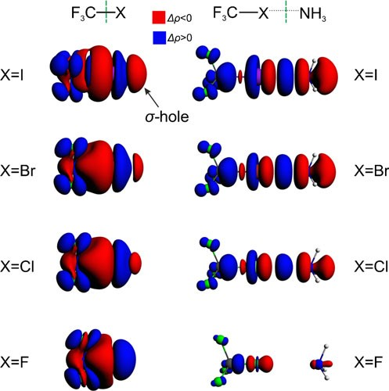
2748
J Mol Model (2013) 19:2747–2758
distribution. The existence ofσ-holeat terminal halogen atom leads to electrostatic attraction with Lewis bases. Ac- cordingly, the halogen bonding is driven mainly by the electrostatic term [1,3,6,7,18–32].Veryrecently,Politzer andcoworkersextendedtheσ-holeconcepttoanalysisofπ- holes [33]. It is noteworthy that non-typical halogen bonds of the type RNC…FCl have been studied recently by Del Bene et al. [34] and subsequently by Politzer et al. [35] Authors noted very high binding energies (~20–30 kcal mol⁻¹) and significant stretch of the F–Cl connection due to formation of RNC…FCl bond (by ca. 0.3 Å). Politzerand Murray [34] reported, based on the analysis of molecular electrostatic potential and the averaged ionization energies, that it is due to polarization of RNC unit that can lead to significant dative component of RNC…FClbond.
accurateCoulombpotentialsineachSCFcycle.Relativistic effects were included using the ZORAformalism.
Bonding analysis presented in this study is based on the ETS-NOCV approach [39] which is a combination of the extendedtransitionstate(ETS)[38]methodwiththenatural orbitals for chemical valence (NOCV) scheme [36,37]. In our analysis, each system is divided up into two individual fragments as shown schematically by green vertical linesin Fig.1. Then we used the ETS-NOCV method to study the interaction between thesesubsystems.
In the ETS energy decomposition scheme [38], theinter- action energyΔE_{int}between the fragments (exhibiting ge- ometries as in the combined molecule) is divided into three components:
$Eint¼$Eelstatþ$EPauliþ$Eorb:
ð1Þ
We have recently proposed thenatural orbitalschemical valence(NOCV) [36,37] combined with
for
the
The first term,ΔE_{elstat}, corresponds to the classical elec- trostatic interaction between the fragments as they are brought to their positions in the final molecule. The second
extended-transition-state (ETS) energy-decompositionanalysis [38]. This scheme allows for separation and quantitative assessment of the contributions to deforma- tion density (Δρ_{i}) originating from the electron charge transfer channels (σ,π,δ, etc.) [36,37]. This picture is further enriched by providing the energetic contributions (ΔE_{i}) to the bond energy within ETS-NOCV scheme [39]. It has been shown that NOCV’s lead to a compact description of not only metal–ligand or covalent connec- tions [36,37,39], but also of hydrogen bonding [40].Wehaveverified recentlytheapplicabilityofETS-NOCV scheme in a description of halogen bonding, showing in particular, that the dominating contribution to the deformation density exhibits the negative-value area that corresponds toσ-hole[41].
ThemaingoalofthepresentstudyistoanalyzetheETS- NOCV representation ofσ-hole in a more detailed, system- aticwayinaseriesofhalogencompounds,CF₃-X(X0I,Br, Cl, F), CH₃I, C(CH3)_{n}H_{3-n}-I (n01,2,3), as well as for the example germanium-based systems. XGeH3,X0F,Cl, H. TheETS-NOCVschemewillbefurtherusedtocharacterize bonding with ammonia for all analyzedsystems.
term,
ΔEPauli,
accounts for the repulsive Pauli interaction
betweenoccupiedorbitalsonthefragmentsinthecombined molecule. The third stabilizing term,ΔE_{orb,}represents the interactions between the occupied molecular orbitals ofone fragmentwiththeunoccupiedmolecularorbitalsoftheother fragmentsaswellasmixingofoccupiedandvirtualorbitals within the same fragment (inner-fragment polarization). This energy term may be linked to the electronic bonding effect coming from the formation of a chemicalbond.
Computational details
All the DFT calculations presented here are based on theAmsterdam density functional (ADF2009) programinwhich ETS-NOCV scheme was implemented [42–45]. The Becke-Perdewexchange-correlationfunctional[46,47]was applied (BP86) with an inclusion of the dispersion correc- tion (BP86-D) [48]. A triple-zeta STO basis containing two sets of polarization functions, based on the frozen coreapproximation,wasadoptedfor all of theelements(TZ2P). Auxiliarys, p, d, fandgSTO functions, centered onallnuclei,wereusedtofitelectrondensityandobtain
Fig. 1 The contours of deformation density contributionΔρ₁charac- terizing the F₃C-X bond (left column; the contour values:
±0.0003 a.u.); and the halogen bonding with ammonia in F₃C-X—NH₃(right column; contour values: ±0.0005 a. u.)

J Mol Model (2013) 19:2747–2758
2749
The natural orbitals for chemical valence allow for a decomposition of the differential densityΔρinto NOCV- contributions (Δρ_{k}):
that the contour ofΔρ₁shows significant charge anisotropy around the iodine atom, that is important for the reactivity, as the halogen atom can simultaneously act as electron donor and acceptor [18,19,52]. However, a feature of the contour ofΔρ₁that is the most important for our further discussion, is an outflow of the electron density from the outer area of iodine atom, at the extension of the C-I bond. Such a negative part ofΔρ₁describes the formation ofσ- hole within the ETS-NOCV picture.
In Fig.2(top row, left-hand side plot) another graph-
NOCV
X
$ρðrÞ¼ $ρðrÞ;
ð2Þ
k
k
based on diagonalization of the deformation-density matrix in the basis set representation [36,37]. In addition, within the combined ETS-NOCV [39] scheme, the deformation- density based picture is enriched by the energetic estima-
ical representation of the ETS-NOCVσ-hole in CF₃I
is
tion,Ek,that arises from a decomposition of the aforemen-
shown: a color-representation of theΔρ₁on the molec- ular surface(ρ00.001a.u.). This plot is compared with the corresponding visualization of molecular electrostatic potential (toprow,right-hand side plot). A comparison of the ETS-NOCV and MEP plots demonstrates a clear correspondence of the negative part ofΔρ₁with the positiveMEPatthetipoftheiodineatom.
Since both, contour plots of Fig.1and colored-surface plot of Fig.2are quite qualitative, in Fig.3we present yet anothergraphicalrepresentationofσ-hole,i.e.,thevaluesofΔρ₁along the bond-line, outside of the halogen atom.Here,
orb
tioned ETS orbital-interaction energy into the contributions
corresponding to NOCV charge-transfer channels,Δρ_{k};Ek:
orb
X
k
$E
¼ $E
ð3Þ
:
orb
orb
k
It is necessary to mention at this point that the total orbitalinteractiontermincludestheinter-fragmentselectronflowaswellastheintra-fragmentpolarization;thus,depending on the terminology used it could be considered as the polarization energy component [3,49,50].
Thecontoursandthecolor-codedplotsoftheNOCVdeformationdensitycontributionsandmolecularelectrostat-ic potential were plotted based on ADF-GUIinterface [51].Ashasalreadybeenmentioned,wewillusethedisper-sioncorrectedBP86-Dfunctional[48],hence,thedisper-
we can clearly see thatΔρ₁exhibits a minimum value, corresponding toσ-hole. Again, in the right-hand side col- umn in Fig.3, the corresponding MEP plot, as a functionofthedistancefromtheiodineatom,isshown.Thecorresponding numerical values that characterize theΔρ₁minimum, and the MEP value at the point corresponding to theσ-hole minimum are listed inTable1.
Let us now discuss the ETS-NOCV results for the halo- gen bond between the CF₃I and ammonia molecule in F₃C- I…..NH₃. In Table2we collect results of the energy decom- position analysis. Before discussing the results it should bepointed out that in the present study the ZORA relativistic approach was applied; therefore, the presented F₃C-I…NH₃bond-energy and its components are slightly different from those of our previous work (not including relativistic cor- rection) [41].
AsshowninTable1,thetotalinteractionenergybetween F₃C-I and NH₃is−7.0 kcalmol⁻¹. The results show that the total stabilization of the system is mainly due to theelectro- static interaction (-16.7 kcalmol⁻¹), that is almost two times larger than the orbital interaction energy (−9.6 kcalmol⁻¹), inagreementwiththepreviousstudiesemphasizingtherole of electrostatic stabilization [18,19,41].
The dispersion energy,−1.3 kcalmol⁻¹, is of minor im- portance here, as it was shown in the case of other systems withσ-holebonding[18,19,41,53].Itshould,however,benotedthatRileyetal. [53]studied similarmolecules(CY₃X——OCH₂,X0Cl,Br, I,Y0H,F) containing form-aldehydedonor,basedon SAPT-energydecompositionscheme–for these molecules both the electrostatic and the dispersion factors were found to be similarlyimportant
sion correction (ΔE_{disp}) will be added to describe the total bonding energy:
ΔEint
values to
$Etot¼$Eintþ$Edisp:
ð4Þ
Results and discussion
ETS-NOCV description ofσ-hole in F₃C-I and the halogen bond in F₃C-I…..NH₃
Let us start the discussion with two illustrative examples of the ETS-NOCV interpretation of bonding. We will first characterize the bond between the CF₃fragment and the iodine atom in F₃C-I, and then we will describe the interac- tion between the CF₃I and ammonia molecule in F₃C- I…..NH₃. The former example allows us to discuss and visualize theσ-hole in this system, while the latter demon- strates the NOCV picture of halogen bonding [41].
In Fig.1(top row, left-hand side plot) we present the contour plot of the dominating NOCV contributionΔρ₁in
thedeformationdensity,Δρ¼ρCF3I--ðρCF3þρIÞ.The
presented contour shows a formation of covalent C–Iσ- bond; the corresponding ETS-NOCV orbital interaction en-
E1
ergyis ¼-98:4kcal=mol.Itshouldfurtherbenoted
orb

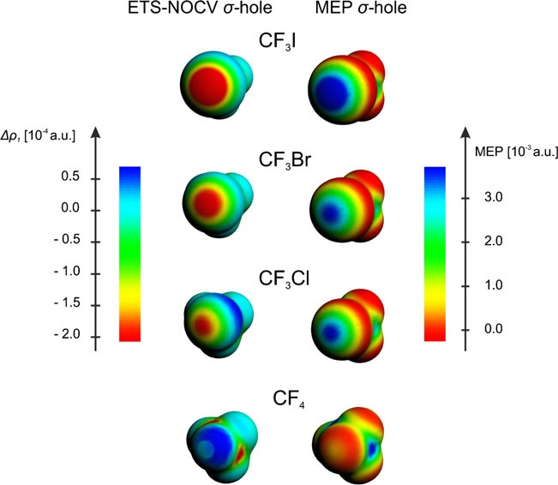
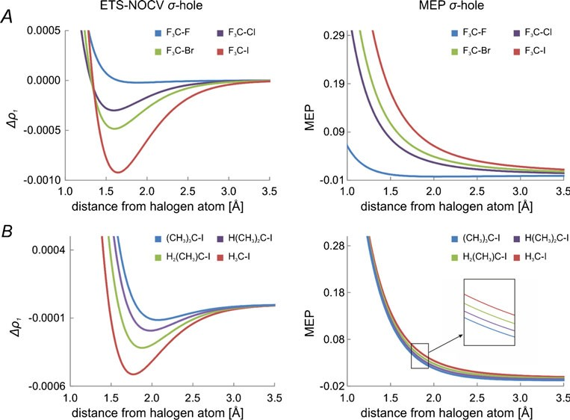
2750
J Mol Model (2013) 19:2747–2758
Fig. 2 A comparison of the ETS-NOCV deformation- density contributionsΔρ₁(leftcolumn) and the molecular electrostatic potential (right column), presented as color- coded plot on the molecular surface (ρ00.001 a.u.), for the F₃C-X systems
(moreover, forX0ClandY0H,F,the dispersion wasvisibly more important than the electrostatic term) [53]. It is also necessarytonotethatduetoinherentmethodologicaldiffer- encesbetweenSAPTandDFT-Dapproachesonecanobtain different absolute values characterizing the role of disper- sion[54].Roleofthedispersioninthearomaticcompounds was recently characterized by Riley et al.[55].
The leading NOCV deformation density channel,Δρ₁, that describes the halogen bonding between CF₃I molecule and ammonia, is shown in Fig.1(top row, right-hand side plot). The contour plot ofΔρ₁shows thecovalent bondingcontribution that originates from the electron transfer from both the nitrogen and iodine atoms to the bonding region between I and N atoms. Also, thedonationfrom the NH₃
Fig. 3 Comparison of the changes in the ETS-NOCV deformation-density contribu- tionΔρ₁(left column) and the molecularelectrostaticpotential(right column) at the extension of the carbon-halogenbond

J Mol Model (2013) 19:2747–2758
2751
Table 1 ETS-NOCV and MEP characteristics of theσ-hole localized on halogen atom in the studied systems
Molecule
σ-hole (Δρ₁) minimum [10⁻³a.u.]
Minimum distance [Å]
MEP at minimum distance [10⁻²a.u.]
Halogen-bond energy [kcal/mol]
Halogen bond distance [Å]
CF₃I CF₃Br CF₃Cl CF₄
C H₃I C(CH₃)H₂I C(CH₃)₂HI C(CH₃)₃I
−0.92
−0.48
−0.30
−0.02
−0.51
−0.32
−0.19
−0.11
1.64
1.62
1.60
1.88
1.79
1.86
1.99
2.09
12.50
8.15
5.96
−0.22
5.27
4.25
2.26
1.18
−6.96
−4.34
−2.59
——
−3.01
−2.45
−2.07
−1.87
2.862
2.857
3.016
——
3.086
3.175
3.174
3.186
fragment to CF₃I is clearly visible, with the decrease in the electrondensityonammoniaandtheincreaseintheregionof the CF₃group. Accumulation of electron density at carbon atomofCF₃isinlinewithanincreaseinthecarbons–orbital contribution due to halogen bonding, shown recently by Grabowski with NBO method[52].
It should be emphasized thatΔρ₁is the only NOCV
contribution localized in the halogen bond area, with thecorresponding energy contributionΔE¹_{orb}0−8.9kcalmol⁻¹, that covers over 93 % of the orbital interaction energy;theremainingNOCVchannels(notshown)describe the intra-fragment polarization and are characterized by much lower energies (stabilization up to−0.2kcalmol⁻¹).
linearΔρ₁plots at
the extension of the C-X bond (as a
function of the distance from atom X) are compared for the systems with different halogens. The corresponding numericalvaluesthatcharacterizetheΔρ₁minimum,and
the MEP value at the point corresponding to theσ-hole minimum are listed in Table1.
The results of Figs.1,2,3a, andTable1show consis- tently a decrease in theσ-hole“depth”(Δρ₁minimum value) and“size”(spatial extension of the negativeΔρ₁area) in the order: I, Br, Cl. In particular, the decrease of theσ-hole size is clear from the contour plot of Fig.1and the color-coded plot of Fig.2, while the decrease inσ-hole depth is nicely demonstrated by the linear plots of Fig.3a.TheminimumvaluesofΔρ₁are−0.92*10⁻³a.u.;
−0.48*10⁻³a.u., and−0.30*10⁻³a.u., for I, Br, and Cl, re-
spectively (seeTable1). When going from I to Cl, the position of the minimum moves closer to the halogenatom; the position, measured as the distance from the atom X, changes from 1.64 Å for I,through1.62 Å for Br,to
1.60 Å for Cl. For fluorine, in the case of the contour ofΔρ₁(Fig.1) and its color-coded representation (Fig.2), practically noσ-hole (negativeΔρ₁) is visible; a very shal- low minimum ofΔρ₁(−0.02*10⁻³a.u.) appears at a relative- ly large distance of 1.88 Å.
The picture resulting from ETS-NOCV analysis concerningσ-hole in the CF₃X systems are fully consistent
Comparison ofσ-hole in F₃C-X and halogen bonding with NH₃, forX0I, Br, Cl, F
Similarly to CF₃I molecule, we used ETS-NOCV method to characterizeσ-hole and halogen bonding in the anal- ogous systems involving other halogen atoms,X0Br,Cl, F in CF₃X. The contours of the main NOCV charge- transfer channel (Δρ₁) for all the systems are collected in the left-hand side column of Fig.1. Thecorresponding color-coded representation ofΔρ₁is presented Fig.2(left-hand side column), together with the similar MEP plots (right-hand side column). In panel a of Fig.3,the
Table 2 ETS-NOCV bond- energy decomposition for halo- gen bonding with ammonia for the set of studied molecules.
Values given in kcalmol^{–1}.
1
ΔEorb
Molecule
ΔEtot
ΔEdisp
ΔEelstat
ΔEPauli
ΔEorb
F₃C-I…NH₃
−6.96
−4.34
−2.59
−1.32
−1.02
−0.81
−16.65
−10.44
−5.03
20.60
12.90
5.75
−9.59
−5.78
−2.51
−8.90
−5.48
−2.43
F C-Br…NH
3
3
ΔE¹describes the contribu-
orb
F₃C-Cl…NH₃F₃C-F…NH₃H₃C-I…NH₃
H₂(CH₃)C-I…NH₃H(CH₃)₂C-I…NH₃(CH₃)₃C-I…NH₃
tion to the orbital interaction en- ergy coming from the dominating NOCV pair
(Repulsive interaction energy; no halogen-bond minimum found)
−3.01
−2.46
−2.07
−1.87
−1.19
−1.21
−1.24
−1.25
−8.05
−5.93
−5.90
−5.60
10.72
8.18
8.65
8.49
−4.49
−3.50
−3.57
−3.51
−3.95
−3.14
−3.12
−3.09

2752
J Mol Model (2013) 19:2747–2758
stabilizing (−0.5 kcalmol⁻¹and−0.4 kcalmol⁻¹, at2.1Åand 2.2 Å, respectively), but not large enoughtoovercomethe repulsive part of the interaction energy. Certainly,thesesmall energy values are not quantitativelymeaningful,andtheywillbestronglyinfluencedbythemethodologyused,so that we do not discuss all theinteraction-energycompo-nentshere.Ourpointisjusttoqualitativelyillustratethelack of pronounced halogen bonding forF₃C-F—NH₃.Fur-ther,inthelastcolumnofFig.1(right-handsideplot),forcomparisonwithothersystems,weplottedtheexampleofthe main NOCVΔρ₁channel forR_{F-N}02.15Å, thatshowsonlytheintra-fragmentpolarization,withoutthecovalenthalogen-bonding features; it should be emphasizedthatforother points that we analyzed (forR_{F-N}02.00−2.24Å)thecorrespondingΔρ₁plots arequalitativelyindistinguishable.Therefore,itmaybeconcludedthatinCF₃-XsystemstheETS-NOCV analysis shows, in agreementwithpreviousstudies[1,18],thatthesizeanddepthofσ-holedecreasesintheorderX0I,Br,Cl,F.Thistrendisreflectedbythechanges inMEP,as well as the changes in theNOCVΔρ₁componentinF₃C-X—NH₃,andthestrengthoftheinter-
action with ammonia.
with the results of the previous studies based on analysis of MEP [1] and NBO [18].Tocompare the NOCV and MEP picture in a more detailedway,based on the calculations within the same methodology, in the right-hand columns of Figs.2and3the corresponding MEP plots are presented; the numerical values of MEP at the point corresponding to theminimumofΔρ₁areinadditionlistedinthelastcolumn ofTable1. A comparison ofΔρ₁and MEP plots in Fig.2show a nice qualitative correspondence of the negativeΔρ₁and positive MEP areas at the tip of the halogen atom. The plots of Fig.3and the values fromTable1show a decrease ofMEPvaluesintheorderI>Br>Cl>F;theMEPvaluesat theΔρ₁mininumchangesfrom0.125a.u.forI,through
0.082 a.u. forBr,down to 0.060 a.u. for Cl. For the system with fluorine, the MEP is no longer positive at the tip ofthe halogen atom, but becomes negative; the MEP value at the minimum ofΔρ₁is−0.002a.u.
The trends inσ-hole, discussed above, are reflected by
the halogen bond energies in the F₃C-X interacting withammonia.Thestabilizationinthetotal bondenergydecreases in the order: F₃C-I (−7.0kcalmol⁻¹),F₃C-Br (−4.3 kcalmol⁻¹), F₃C-Cl (−2.6 kcalmol⁻¹). For F₃C-F—NH₃thereispracticallynobonding;nominimumcorresponding to the halogen bond was found within the used DFT approach.Wewill comment on the F₃C-F—NH₃interaction in a more detaillater.
As for the iodine-system discussed in the previous sec- tion,forX0BrandCltheelectrostaticcontributionisrough- ly two times larger (−10.4,−5.0kcalmol⁻¹for Br, Cl,respectively)thantheorbital interactionterm(−5.8,
−2.5kcalmol⁻¹forBr,Cl,respectively).Themostimportant NOCV charge-transfer channel,Δρ₁, accounts for 93 %, 95 %, and 97 % of the orbital interaction contribution, forI, Br, and Cl (ΔE¹_{orb}0−8.9,−5.5, and−2.4 kcalmol⁻¹, re- spectively).TheNOCVplotsintheleft-handsidecolumnof Fig.1clearly show that the NOCV picture of halogen bonding is qualitatively the same for I, Br, and Cl: for all those systems the covalent component of halogen bond is seen; only the spatial extension of the correspondingΔρ₁contoursdecreases.
Let us now discuss the F₃C-F—NH₃system. As we mentioned above, the DFT methodology applied here does not allow to find a minimum corresponding to the halogen bonding. In addition to the standard, unconstrained geome- try optimization, we have performed a set of constrained optimizations, with a frozen, increasing F-N distance, start- ing from the linear C-N-F structure withR_{F-N}02.00 Å. Up to the distance of 2.24 Å the systems stays roughly linear, and afterward the C-N-F angle starts strongly deviate from linearity. The interaction between CF₄and ammonia is repulsive within used methodology (e.g., atR_{F-N}02.1 and
2.2 Å the total bonding energyΔE_{tot}is+0.2 and +0.1 kcal
mol⁻¹, respectively); the dispersion energy is slightly
Influence of carbon-substituents in R₁R₂R₃C-I onσ-hole and halogen bonding
After discussing theσ-hole and halogen bonding in CF₃X systems, now we would like to present the ETS-NOCV results for the related CH₃I, and C(CH3)_{n}H_{3-n}-I(n01,2,3)molecules, in which the fluorine atoms of CF₃I are first replaced by hydrogen atoms, and then further by methyl groups. The respective plots describing ETS-NOCVσ-hole are shown and compared with the corresponding MEPplots inFigs.3band4;therespectivenumericaldataarecollected in Tables1and2.
A comparison of the results for CF₃I (Fig.2,3a,Table1) and CH₃I (Fig.3b,4,Table1) show that the exchange of fluorine atoms with hydrogens has a relatively strongeffect on the iodineσ-hole: the minimum changes from−0.9*10⁻³
a.u. in CF₃I to -0.5*10⁻³a.u. CH₃I. This is consistent with
MEP picture: the value of MEP at theΔρ₁minimum decreases from 0.125 a.u. in CF₃I to 0.053 CH₃I.
Consistently,asimilar effectisobservedfor thehalogen bondenergiesandtheircomponents(Table2).Thetotalstabi- lizationduetohalogenbondingdecreasesbyca.4.0kcalmol⁻¹(from−7.0kcalmol⁻¹to−3.0kcalmol⁻¹in CH₃I).Thecorresponding decreaseinstabilizationdue toorbital interac-tionis5.1kcalmol⁻¹(fromthevalueof−9.6kcalmol⁻¹inCF₃Ito−4.5 kcalmol⁻¹inCH₃I). The decreasein theelectrostatic stabilizationis 8.5 kcalmol⁻¹(fromthevalueof−16.6 kcalmol⁻¹inCF₃Ito−8.1 kcalmol⁻¹inCH₃I).Thus, theETS- NOCV analysis provides similar conclusionstothose previ- ously publishedbyPolitzeret al.[1].

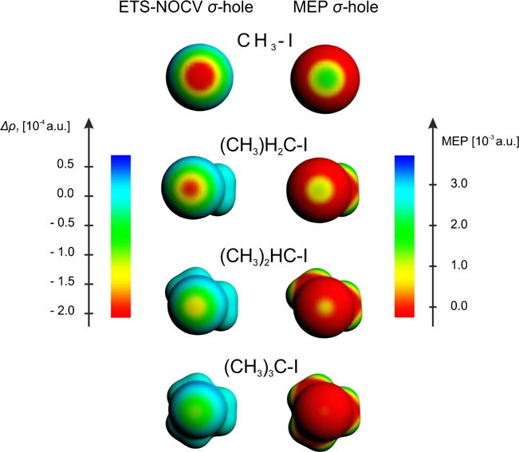
J Mol Model (2013) 19:2747–2758
2753
Fig. 4 A comparison of the ETS-NOCV deformation- density contributionsΔρ₁(leftcolumn) and the molecular electrostatic potential (rightcolumn), presented as color- coded plot on the molecular surface (ρ00.001 a.u.), for the (CH₃)_{x}H_{3-x}C-I systems
Introducing the methyl substituents on carbon leads to the further decrease in theσ-hole depth. For subsequent methyl substitution the minimum value ofΔρ₁changes in the sequence: -0.3*10⁻³a.u.,−0.2*10⁻³a.u.,−0.1*10⁻³a.u. in C(CH₃)H₂I,C(CH₃)₂HI,and C(CH₃)₃I, respectively. Again, the data of Tables1and2show that this is reflected by the changes in MEP at theσ-hole minimum (0.042, 0.022, 0.012 a.u.. respectively), as well as by the halogen- bond energies (−2.5,−2.0, -1.9 kcalmol⁻¹, respectively) and theircomponents.
thesystemsdescribedintheprevioussections,wepresentinthe left-hand side column of Fig.5the contoursofthedominant NOCV deformation-density contributionofσ-symmetry,Δρ₁, for the X-GeH₃. Thecolor-codedrepresen-tationofΔρ₁isshowninFig.6,andcomparedwiththecorresponding MEP plots. Finally, in Fig.7, thelinearplotsofΔρ₁as a function of the distance fromgermaniumatomarepresentedandcomparedwiththecorrespondingMEPcurves. The numerical values characterizing theNOCVσ-holeminimumandMEParelistedinTable3.Theσ-holebonding with ammonia is described by the contoursofΔρ₁forXH₃Ge—NH₃(right-handcolumnofFig.5),andtheETS-NOCV bond-energy components are listed inTable4.Theresultsshowthat,themainΔρ₁ETS-NOCVchannelexhibits for FH₃Ge the extended negative-valueareathatcorresponds toσ-hole (Fig.5). In thecolor-codedrepresen-tationonthemolecularsurface(Fig.6),thisareacorre-sponds to the MEP-positive-value area. For ClH₃Getheσ-holesize(spatialextension)anddepth(minimumvalue)aresmaller than for the system with fluorine (Figs.5,6,7);theΔρ₁minimum value changes from−3.2*10⁻³a.u. (at1.28
A) for FH₃Ge to−2.63*10₋₃a.u. (at 1.25 A) in ClH₃Ge.
This corresponds to the decrease in MEP at the minimum from0.248a.u.to0.247,respectively.InthecaseofH₄Gea very shallow minimum ofΔρ₁(−0.5*10⁻³a.u.) is observed at a relatively long distance from germanium (1.76 A); it corresponds to a small positive value of MEP (0.051a.u.).
The presence ofσ-hole in XH₃Ge, X0F, Cl, is responsi- ble for stabilizing interaction with ammonia and correlates qualitatively with theσ-hole-bonding energy (−5.8 kcal
σ-hole in GeH₃-X and bonding with NH₃
Although the concept ofσ-hole was proposed originally to rationalize the halogen bonding, it was shown later by Politzer and coworkers [3,22,33,34] that it is useful as well for explanation of the weak, bonding interactions in other systems. Therefore, we would like here to use ETS- NOCV to describe and visualizeσ-hole in the example
germanium compounds, GeH₃X, X0F, Cl,
H,
and their
interaction (σ-hole bonding) with ammonia molecule. It
was shown recently [22] that the molecular electrostatic potential exhibits the positive-value area on the outer part ofgermaniumatom,attheextensionoftheX-Gebond(i.e., between three Ge-H bonds); this was rationalized by theσ- hole concept, analogous to those observed at halogen atom in the compounds that can form halogen bonding[18–21].
In order to describeσ-hole formation within the ETS- NOCV scheme, we again apply the two fragmentapproach, with X and GeH₃considered as the fragments. Similarlyto

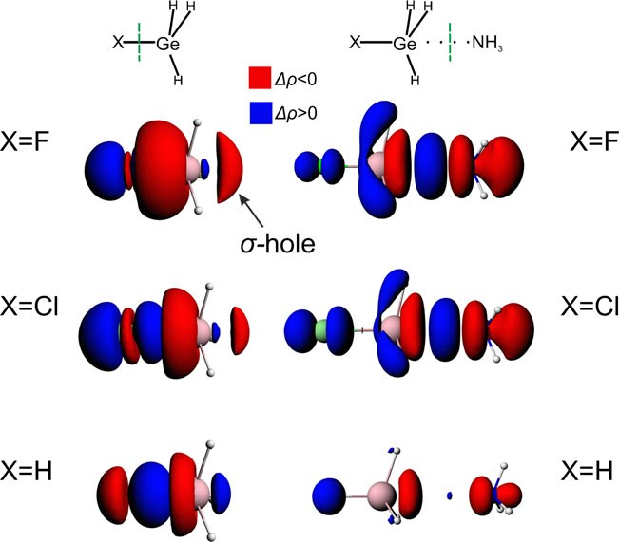
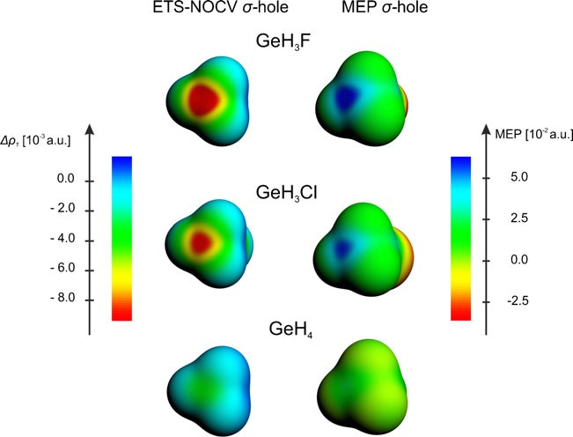
2754
J Mol Model (2013) 19:2747–2758
Fig. 5 The contours of deformation density contributionΔρ₁characterizing the X-GeH₃bond (left column; the contour values:
±0.002 a.u.); and theσ-hole- bonding with ammonia in XH₃Ge—NH₃(right column; contour values: ±0.0005 a. u.)
mol⁻¹for F and−5.3 kcalmol⁻¹for Cl). The ETS analysis shows that the electrostatic energy is approximately two timeslargerthattheorbitalinteractioncomponent,similarly to the systems discussed in the previous sections: forX0Fthe electrostatic contribution is−20.3 kcalmol⁻¹and the orbital-interaction energy is−9.3 kcalmol⁻¹; forX0Clthe two components are−16.3 kcalmol⁻¹and−7.7 kcalmol⁻¹, respectively. The NOCVΔρ₁contour (right-hand side part ofFig.5)exhibits featuresqualitatively similartothe
systems described in the previous sections: the covalent Ge-N bond and the charge-transfer H₃N➔GeH₃X.
In the case of GeH₄, the interaction with ammonia is slightly attractive (−1.1 kcalmol⁻¹) due to dispersion (−1.6 kcalmol⁻¹); the sum of the remaining components is repulsive (+0.5 kcalmol⁻¹). A relatively weak electrostatic (−3.8 kcalmol⁻¹) and orbital interaction (−1.6 kcalmol⁻¹) contributions are not large enough to overcome the Pauli repulsion (5.9 kcalmol⁻¹). TheΔρ₁contour exhibit a very
Fig. 6 A comparison of the ETS-NOCV deformation- density contributionsΔρ₁(leftcolumn) and the molecular electrostatic potential (rightcolumn), presented as color- coded plot on the molecular surface (ρ00.001 a.u.), for the germanium-based systems

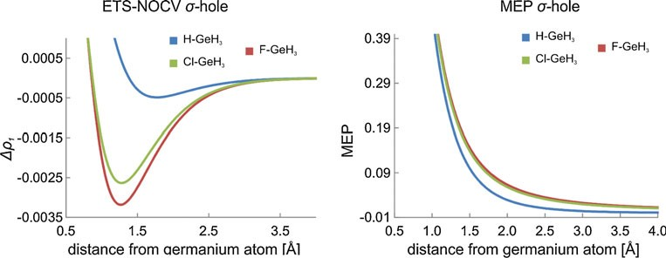
J Mol Model (2013) 19:2747–2758
2755
Fig. 7 Comparison of the changes in the ETS-NOCV deformation-density contribu- tionΔρ₁(left column) and the molecularelectrostaticpotential(right column) at the extension of the X-Ge bond(X0F,Cl,H)
small covalent-bonding area, being dominated by the intra- fragment polarization.
As for halogen bonding discussed in the previous sec- tions,theresultspresentedherefortheETS-NOCVdescrip- tion of theσ-hole in germanium compounds and theirσ- hole-bonding with ammonia are in a qualitative agreement with the picture emerging from the previous studies [1–4,18–34], emphasizing the role ofσ-hole formation for the electrostatic stabilization ofbonding.
molecular electrostatic potential presented in panel B of Fig.8, demonstrating increase of the positiveMEP.Thus, the NOCV analysis shows the polarization-induced (orhere
- enhanced)σ-hole, in a qualitative agreement the data presented in ref [56].
It is interesting at this point to analyze how the ETS- NOCV description of CF₃I—NH₃bonding will change upon considering the polarized fragments in ETS-NOCV calculations (as compared to non-polarized species NH₃and CF₃I). In order to achieve this goal we have first performed the calculations for the fragments polarized by the point-charges in the positions of theother-fragment atoms: NH₃in the field of point charges placed in the atomic positions of CF₃I; and for CF₃I fragment in the field of point charges placed in the atomic positions of ammonia. Mulliken and Hirshfeld charges were condi- dered, as presented in part A of Fig.9. Subsequently, we applied ETS-NOCV analysis using the polarized- fragments as a reference. The results are presented inTable5. The fragment density change due to polarization is shown in Fig.9.
It can clearly be seen fromTable5that applying polar- ized fragments leads to a slightly more stabilizing value of the total intreaction energy as compared to the resultsbased onnon-polarizedfragments,i.e.,ΔE_{tot}islowerby0.16kcal mol⁻¹for Hirshfeld charges and by 0.07kcalmol⁻¹for Mulliken charges. The increase in the stabilization energy comes from the fact that the reference polarized fragments are higher in energy than non-polarized fragments (opti- mized KS electron density corresponding to the minimum ofenergy).
Polarization effect onσ-hole and halogen bonding
It has been shown in ref [56] that the electric field can induce theσ-hole. Accordingly, polarization of one frag- ment by the interacting, partner fragment is an important factorindeterminingthestrengthanddirectionofhydrogen (and by implication halogen) bonds. In a similar mannerwe will characterize here the influence of polarization on the NOCV-picture ofσ-hole in CF₃I. Further, the ETS-NOCV description using themutually-polarized fragmentswill be presented for CF₃I—NH₃bonding, and compared with the non-polarizedcase.
In order to polarize CF₃I molecule we used the point- charge model, with point-charges placed in the position of the atoms of NH₃:q_{N}0−q;q_{N}0+q/3, forqchanging be- tween 0.0 and 1.2 . The results are presented in Fig.8.
As it can be seen from panel A of Fig.8the polarization by ammonia increases the“depth”ofσ-hole on iodine: theΔρ₁minimum-value becomes more negative with the in- creaseinthenegativecharge(onammonianitrogenatom).It isfully consistent withthepicture emerging fromthe
Table3ETS-NOCVandMEPcharacteristicsoftheσ-holelocalizedonthegermaniumatom(ontheextensionofX-Gebond),andtheσ-bonding with ammonia, for the analyzed X-H₃Gesystems
Molecule
σ-hole (Δρ₁) minimum [10⁻³a.u.]
Minimum distance [Å]
MEP at minimum distance [10⁻²a.u.]
σ-hole-bond energy [kcal/mol]
σ-hole-bonddistance [Å]
−3.18
−2.63
−0.49
−5.74
−5.32
−1.13
GeH₃F
GeH₃Cl GeH₄
1.28
1.25
1.76
24.85
24.65
5.07
2.646
2.742
3.261

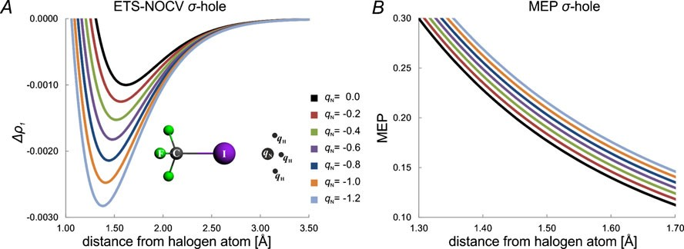
2756
J Mol Model (2013) 19:2747–2758
Table 4 ETS-NOCV bond-energy decomposition for theσ-hole- bonding with ammonia for germanium-based systems.Valuesgiven in kcalmol⁻¹.ΔE_{orb}¹describes the contribution to the orbital interac- tion energy coming from the dominating NOCVpair
weexpressthedensitychangesandthebond-energyusingthepolarized fragments as thereference,the mutual fragment polarization (or rather, its part due to the partner-electric- field)isexcludedfromboth,NOCVdensitychangesandthe orbital-interaction-energycontribution.Asaresult,sincepart of the stabilization energy has already been subtractedfrom theorbital-intaractionenergybyconsideringpolarizedfrag- ments,itsfinalvaluebecomeslessnegativeinthepolarized- fragment reference case than in the non-polarized fragment case.
The above reasoning is further confirmed when we in- spect the polarization changes in the fragment-electronden- sities, see part B of Fig.9, it is clearly seen that inclusionof the point charges at positions of neighboring fragments leadstothechargeoutflowfromI–Nbondingregion,hence, the weakening/destabilization ofσ-bonding isobserved,
ΔE_{pol}0+0.07 kcalmol⁻¹(Mulliken),ΔE_{pol}0+0.16 kcal mol⁻¹(Hirshfeld).
The remaining bonding components (ΔE_{disp}andΔE_{Pauli}) are practically the same. It should finally be mentioned that the polarization not involved in theσ-component ofCF₃I—NH₃bonding, measured by differenceΔE_{orb}– ΔE_{orb}¹, also practically does not change when we consider polarized fragments (0.6–0.7 kcalmol⁻¹in bothcases).
Summarizing, the above results show that mutual polar-
ization of the NH₃and CF₃I fragments is one of the factors stabilizing halogen bonding, by increase in theσ-hole“depth”and the electrostatic-interaction-energy component. Here, however, we considered only one example; more studies for other systems are required.
1
ΔEorb
Molecule
ΔEtot
ΔEdisp
ΔEelstat
ΔEPauli
ΔEorb
FH₃Ge…NH₃ClH₃Ge…NH₃
−5.74
−5.32
−1.13
−2.30
−2.14
−1.60
−20.32
−16.32
−3.81
26.22
20.80
5.85
−9.34
−7.66
−1.57
−8.02
−6.58
−1.27
H Ge…NH
4
3
Now,it is interesting to examine the changes in theETS- bond-energy components due to polarization of the frag- ments. The results ofTable5show that the increase in the bond stabilization is almost solely due to an increase in the stabilization originating from the electrostatic contribution (ΔE_{elstat}is lowered by 0.55–0.68 kcalmol⁻¹). This result is consistent with the polarization-picture ofσ-hole discussed above: the polarization (the partner-electric-field) induced increase in theσ-hole“depth”and the corresponding in- creaseinthepositiveMEPatthetipofiodineisreflectedby the increased electrostatic stabilization of interaction with ammonia (negatively charged nitrogenatom).
Further,theresultsofTable5showthattheorbitalinterac- tion term (ΔE_{orb}) appears to be less stabilizing when going fromnon-polarizedtopolarizedfragments(by0.36kcalmol⁻¹for Mulliken charges and by 0.54 kcalmol⁻¹for Hirshfeld charges). This result may appear surprising and counter- intuitive at the first look: one might expect the increase in orbital-interactionwhentheσ-holebecomes“deeper”.How- ever, after analyzing this effect in details, it seems to be physicalandcorrect,andinfactcouldbeexpected.Namely,when we express the density changes and the bond-energy usingthenon-polarizedfragmentsasthereference,themutual fragment polarization is included in the NOCV density- changes,andthefragment-polarizationenergyisincludedin theorbital-interactionenergyterm.When,inthesecond-case,
Conclusions
In our previous article [41], we have shown that ETS- NOCV approach can be used to successfully describe
ammonia, modeled by point chargesq_{N}0−1/3q_{H}; forqchanging be- tween 0 and 1.2. The black line (q00) corresponds to non-polarized system (shown in panel A of Fig.3–red line)
Fig. 8 Changes in the ETS-NOCV deformation-density contributionΔρ₁(panel A) and the molecular electrostatic potential (panel B) for F₃C-I at the extension of C–I bond, due to electrostatic field of

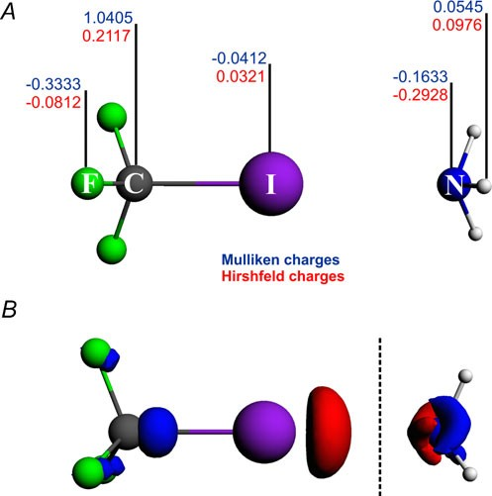
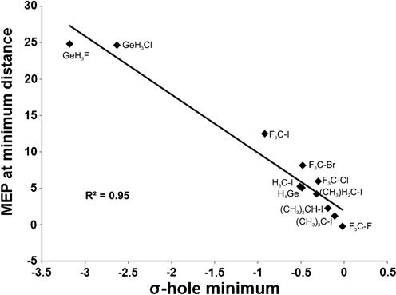
J Mol Model (2013) 19:2747–2758
2757
Fig. 10 Correlation between theσ-hole minimum (minumim value of the ETS-NOCV deformation-density contribution,Δρ₁) and the MEP value at the minimum-point for all studied systems (see Table1).
was shown that the“size”(spatial extension of negative value) and“depth”(minium value) of theσ-hole varies for different X in CF₃-X, and is influenced by the carbon sub- stituents (fluorine atoms, hydrogen atoms, methyl groups). In particular, the size and depth ofσ-hole decreases in the order I,Br,Cl, F in CF₃-X. In CH₃-I and C(CH3)_{n}H_{3-n}-I, compared to CF₃-I, introduction of hydrogen atoms and their subsequent replacements by methyl groups lead to the systematic decrease in theσ-hole size and depth.
It was further shown that the size and depth of the ETS- NOCV representation ofσ-hole byΔρ₁corresponds qual- itatively to the positive MEP area at the extension ofσ-hole generating bond, demonstrating, in agreement with the pre- vious works [1,18], that existence ofσ-hole is responsible for this important feature ofMEP. Tofurther strengthenthis point in Fig.10we show the correlation between the min-imum valueofΔρ₁and theMEPvalueattheΔρ₁minimum.
Finally, our results show that theσ-hole bond with am- monia contains a large degree of covalent contribution. It should be emphasized, that any energy partitioning method includessomearbitrarinessduetothefactthatthecontribu- tions to the total interaction energy are not physical observ- ables.However,thepresenceofthecovalentcontributionin
Fig. 9Halogen bonded system, CF₃I—NH₃, togetherwithMulliken (blue color)andHirshfeld (red color) atomic charges (panelA), usedtomodelthemutual polarizationof thefragments.InpanelBthecontourofdefor- mationdensity,Δρpol,describingthepolarizationof the CF₃I and NH₃
$rpol¼ðrCF3I-polarized-by-NH3-rCF3IÞþ
fragments is presented;
ðrNH3-polarized-by-CF₃I-rNH3Þ
halogen bonding, and that the dominating contribution to thedeformationdensityexhibitsthenegative-valueareathat corresponds toσ-hole. In the present study we analyzedthe ETS-NOCV representation ofσ-hole in a more detailed, systematic way in a series of halogen compounds, CF₃-X(X0I,Br,Cl,F),CH₃I,andC(CH3)_{n}H_{3-n}-I(n01,2,3)aswell
asfortheexamplegermanium-basedsystems.XGeH₃,X0F,
Cl, H. We also used ETS-NOCV scheme to characterize bonding with ammonia for these systems. In particular, we have used three different graphical representations of the ETS-NOCV results useful for qualitative and quantitative characterization ofσ-hole: the contour plots, color-coded molecular surface, and the linear plots ofΔρ₁at the exten- sion of theσ-hole-generating bond.
The results of presented analysis showed that the domi- nating contribution to the deformation density,Δρ₁, exhib- its the negative-value area (σ-hole area) with a minimum.It
considered. Values given in kcalmol¹. In paranthesis the diffrence in energy contributions between polarized and non-polarized case is presented
Table 5 ETS-NOCV bond-energy decomposition of halogen bonding CF₃I—NH₃when using non-polarized and polarized molecular frag- ments. Polarization based on Mulliken and Hirshfeld charges were
1
ΔEorb
Fragments
ΔEtot
ΔEdisp
ΔEelstat
ΔEPauli
ΔEorb
−6.96(0.0)
−7.03(−0.07)
−7.12(−0.16)
−1.32(0.0)
−1.32(0.0)
−1.32(0.0)
−16.65(0.0)
−17.20(−0.55)
−17.33(−0.68)
−9.59(0.0)
−9.23(0.36)
−9.05(0.54)
−8.90(0.0)
−8.60(0.30)
−8.43(0.47)
Non-polarized Mulliken charges
Hirshfeld charges
20.60(0.0)
20.72(0.12)
20.59(−0.01)

2758
J Mol Model (2013) 19:2747–2758
- MurrayJS, LaneP,PolitzerP(2008)Int JQuantum Chem108:2770–2781
- Murray JS, LaneP,Politzer P (2009) J Mol Model15:723–729
- Riley KE, Murray JS, PolitzerP,Concha MC, Hobza P (2009) J Chem Theor Comput5:155–163
- PolitzerP,Murray JS, LaneP,Concha MC (2009) Int J Quantum Chem109:3773–3780
- Murray JS, LaneP,Nieder A, Klapötke TM, Politzer P (2010) Theor Chem Acc127:345–354
- PolitzerP,Murray JS, Macaveiu L (2010) J Mol Struct THEO- CHEM943:53–58
- PolitzerP,Murray JS, BulatFA(2010) J Mol Model 16:1731–1742
- ShieldsZP,Murray JS, Politzer P (2010) Int J Quantum Chem 110:2823–2832
- Murray JS, Riley KE, PolitzerP,Clark T (2010) Aust J Chem 63:1598–1607
- Murray JS, Concha MC, Politzer P (2011) J Mol Model17:2151–2157
- MetrangoloP,Murray JS, PilatiT,PolitzerP,Resnati G, TerraneoG (2011) Crys Growth Des11:4238–4246
- Riley KE, Murray JS, Fanfrlík J,ŘezáčJ, Solá RJ, Concha MC,Ramos FM, Politzer P (2011) J Mol Model17:3309–3318
- Murray JS, LaneP,ClarkT,Riley KE, Politzer P (2012) J MolModel18:541–548
- PolitzerP,Murray JS (2012) Theor Chem Acc131:1–10
- DelBene JE, AlkortaI,ElgueroJ(2010)JPhys ChemA114:12958–12962
- MitorajM, Michalak A (2007) J Mol Model13:347–355
- Michalak A, Mitoraj M, Ziegler T (2008) J Phys Chem A 112(9):1933–1939
- ZieglerT,Rauk A (1977) Theor Chim Acta46:1–10
- MitorajM,MichalakA,ZieglerT(2009)JChemTheorComput5(4):962–975
- Kurczab R, MitorajMP,Michalak A, Ziegler T (2010) J PhysChem A114:8581–8590
- MitorajMP,Michalak A (2012) J Mol Model.doi:10.1007/s00894-012-1474-4.
- teVeldeG, Bickelhaupt FM, Baerends EJ, Fonseca Guerra C, vanGisbergen SJA, Snijders JG, Ziegler T (2001) J Comput Chem 22:931–967, and refstherein
- BaerendsEJ, Ellis DE, Ros P (1973) Chem Phys 2:41–541. Baer- ends EJ, Ros P (1973) Chem Phys2:52–59
- teVeldeG, Baerends EJ (1992) J Comput Phys99:84–98
- FonescaGeurraC,VisserO,SnijdersJG,teVeldeG,BaerendsEJ(1995) In: Clementi E, Corongiu G (eds) Methods and techniquesin computational chemistry METACC-9.STEF,Cagliari, pp303–395
46. Becke A (1988) Phys Rev A 38:3098–3100
47. Perdew JP (1986) Phys Rev B 34:7406–7406
- GrimmeS, Anthony J, Ehrlich S, Krieg H (2010) J Chem Phys132:154104-1–1154104-19.doi:154104-1
- ChenJ, Martinez TJ (2007) Chem Phys Lett438:315–320
- SokalskiWA,Roszak SM (1991) J Mol Struct THEOCHEM80:387–400
- Visser O, LeyronnasP,van Zeist WJ, Lupki M (2008) ADF-GUI2009.01,SCM,Amsterdam,TheNetherlands,http://www.scm.com
52. Grabowski S (2011) J Phys Chem A 115:12340–12347
53. Riley KE, Hobza P (2008) J Chem Theor Comput 4:232–24254. Hesselmann A (2011) J Phys Chem A 115(41):11321–11330
- RileyKE,MurrayJS,FanfrlíkJ,ŘezáčJ,SoláRJ,ConchaMC,
Ramos FM, Politzer P (2012) J Mol Model. doi:10.1007/s00894-012-1428-x
- HennemannMJ,MurrayJS,PolitzerP,RileyKE,ClarkT(2012)J Mol Model18:2461–2469
σ-hole bonding was demonstrated not only by the ETS orbital-interaction energy, but as well by the NOCV defor- mation density contours. Concerning the interaction-energy components, in all analyzed systems, it was found that the electrostatic energy is approximately two times larger than the orbital-interaction term. Thus, the results of the present analysis confirm the indisputable role of the electrostatic stabilization in halogen bonding andσ-hole bonding, em- phasized in the previous articles by Politzer and coworkers [1–4,18–34].
Acknowledgments The financial support from the National Science Center in Poland (grant NN204 198040) is acknowledged. M.P.M. acknowledge the financial support from Polish Ministry of Science and Higher Education (“Outstanding Young Researchers”scholarship 2011–2014).
OpenAccessThisarticleisdistributedunderthetermsoftheCreativeCommonsAttributionLicensewhichpermitsanyuse,distribution,and reproduction in any medium, provided the original author(s) and the source arecredited.
References
- PolitzerP,LaneP,Concha MC, MaY,Murray JS (2007) J Mol Model13:305–311
- Legon AC (2008) In: MetrangoloP,Resnati G (eds) Halogen bonding fundamentals and applications. Springer, Berlin, pp 17–64
- PolitzerP,Murray JS, Clark T (2010) Phys Chem Chem Phys 12:7748–7757
- Legon AC (2010) Phys Chem Chem Phys 12:7736–7747 5. Erd lyi M (2012) Chem Soc Rev41:3547–3557
- BrinckT,Murray JS, Politzer P (1992) Int J Quantum Chem. Quantum Biol Symp19:57–64
- Murray JS, Paulsen K (1994) PolitzerP.Proc Indian Acad Sci (Chem Sci)106:267–275
- AuffingerP,HaysFA,Westhof E, Shing Ho P (2004) Proc Natl Acad Sci101:16789–16794
- Grabowski SJ (ed) (2006) Hydrogen bonding—new insights. Springer,Berlin
10. Grabowski S (2011) Chem Rev 111:2597–2625
11. Hassel O, Stromme KO (1958) Nature 182:1155–1156 12. Hassel O (1970) Science 170:497–502
- Ramasubbu N, Parthasarathy R, Murrayrust P (1986) J Am Chem Soc108:4308–4314
- MetrangoloP,MeyerF,PilatiT,Resnati G, Terraneo G (2008) Angew Chem Int Ed47:6114–6127
- Bertania R, SgarbossaaP,VenzobA, LeljF,Amatic M, Resnatid G, PilatiT,MetrangolodP,Terraneod G (2010) Coord Chem Rev 254:677–695
- Price SL, Stone AJ, Lucas J, Rowland RS, Thornley AE (1994) 116:4910–4918
- Lommerse JPM, Stone AJ, Taylor R, Allen FH (1996) 118:3108–3116
- ClarkT,HennemannM,MurrayJS,PolitzerP(2007)JMolModel 13:291–296
- PolitzerP,MurrayJS,ConchaMC(2008)JMolModel14:659–665
- Murray JS, Concha MC, LaneP,HobzaP,Politzer P (2008) J Mol Model14:699–704

