




RESEARCH ARTICLE
Mechanisms of Attenuation of Pulmonary V’O₂Slow Component in Humans after Prolonged Endurance Training
Jerzy A. Zoladz¹*, Joanna Majerczak¹, Bruno Grassi², Zbigniew Szkutnik³, MichałKorostyński⁴,SławomirGołda⁴,MarcinGrandys¹,WiesławaJarmuszkiewicz⁵, WincentyKilarski⁶,JanuszKarasinski⁶,BernardKorzeniewski⁷
1 Department of Muscle Physiology, Chair of Physiology and Biochemistry, Faculty of Rehabilitation, UniversitySchoolofPhysicalEducation,Krakow,Poland,2DipartimentodiScienzeMedicheeBiologiche, UniversitàdegliStudidiUdine,Udine,Italy,3FacultyofAppliedMathematics,AGH-UniversityofScience and Technology, Krakow, Poland, 4 Department of Molecular Neuropharmacology, Institute of Pharmacology,PolishAcademyofSciences,Krakow,Poland,5DepartmentofBioenergetics,Instituteof MolecularBiologyandBiotechnology,AdamMickiewiczUniversity,Poznan,Poland,6DepartmentofCell Biology and Imaging, Institute of Zoology, Jagiellonian University, Krakow, Poland, 7 Faculty of Biochemistry,BiophysicsandBiotechnology,JagiellonianUniversity,Krakow,Poland
*jerzy.zoladz@awf.krakow.pl
OPEN ACCESS
Citation:ZoladzJA,MajerczakJ,GrassiB,Szkutnik Z,KorostyńskiM,GołdaS,etal.(2016)Mechanisms
of Attenuation of Pulmonary V’O₂Slow Component inHumansafterProlongedEnduranceTraining.PLoSONE 11(4): e0154135. doi:10.1371/journal. pone.0154135
Abstract
Inthisstudywehaveexaminedtheeffectofprolongedendurancetrainingprogramonthe pulmonary oxygen uptake (V’O₂) kinetics during heavy-intensity cycling-exercise and its impactonmaximalcyclingandrunningperformance.Twelvehealthy,physicallyactivemen
-1
(mean±SD:age22.33±1.44years,V’O_{2peak}3198±458mL·min)performedanendurance
Editor:ØyvindSandbakk,NorwegianUniversityofScienceandTechnology,NORWAY
trainingcomposedmainlyofmoderate-intensitycycling,lasting20weeks.Trainingresulted inadecrease(by~5%,P=0.027)inV’O₂duringpriorlow-intensityexercise(20W)andin shorteningofτ_{p}oftheV’O₂on-kinetics(30.1±5.9svs.25.4±1.5s,P=0.007)duringsubse- quentheavy-intensitycycling.Thiswasaccompaniedbyadecreaseoftheslowcomponent ofV’O₂on-kineticsby49%(P=0.001)andadecreaseintheend-exerciseV’O₂by~5%
(P= 0.005). An increase (P= 0.02) in the vascular endothelial growth factor receptor 2 mRNAlevelandatendency(P=0.06)tohighercapillary-to-fiberratiointhevastuslateralis muscle were found after training (n = 11). No significant effect of training on the V’O_{2peak}wasfound(P=0.12).However,thepoweroutputreachedatthelactatethresholdincreased by19%(P=0.01).ThepoweroutputobtainedattheV’O_{2peak}increasedby14%(P=0.003) andthetimeof1,500-mperformancedecreasedby5%(P=0.001).Computermodelingof theskeletalmusclebioenergeticsystemsuggeststhatthetraining-induceddecreaseinthe slow component of V’O₂on-kinetics found in the present study is mainly caused by two factors: an intensification of the each-step activation (ESA) of oxidative phosphorylation (OXPHOS)complexesaftertraininganddecreaseinthe‘‘additional”ATPusagerising
gradually during heavy-intensity exercise.
Received:January8,2016
Accepted:April9,2016
Published:April22,2016
Copyright:© 2016 Zoladz et al. This is an open access article distributed under the terms of theCreative Commons Attribution License, whichpermits unrestricted use, distribution, and reproduction in anymedium,providedtheoriginalauthorandsourcearecredited.
DataAvailabilityStatement:Allrelevantdataarewithin thepaper.
Funding:ThisworkwassupportedbytheEuropean UnionfromtheresourcesoftheEuropeanRegional DevelopmentFundundertheInnovativeEconomyProgram(grantcoordinatedbyJCET-UJ,No.
POIG.01.01.02-00-069/09). The funders had no role in study design, data collection and analysis, decisionto publish, or preparation of the manuscript.
Competing Interests:The authors have declaredthat no competing interests exist.
PLOS ONE | DOI:10.1371/journal.pone.0154135 April 22, 2016
1/ 25

EnduranceTrainingandPulmonaryV’O₂Kinetics
Introduction
During rest to moderate-intensity exercise transition (i.e. below the lactate threshold–(LT)) pulmonaryoxygenuptakereachesasteadystatewithinabout2–3minutes(seee.g.[1]).How- ever, in case of heavy-intensity exercise, accompanied by plasma lactate accumulation[2]aprogressiveincreaseinV’O₂isobserved—knownastheslowcomponentoftheV’O₂on-kinet- ics [1,3,4]. This“excess”in oxygen uptake originates at the LT [4,5] but becomes progressive after the so called“critical power”[3,6,7]. The critical power represents the maximal poweroutput generated by the working muscles above which no steady state in muscle and pulmo-nary V’O₂and blood pH and lactate concentration can be reached during sustained bouts of exercise.ThisisaccompaniedbyaprogressivedecreaseinmusclePCrandaprogressiveaccu- mulation of muscle metabolites involved in muscle fatigue such as P_{i}, H⁺, ADP_{free}and others (for details see, e.g. Refs.[3,6,7]).
IthasbeenreportedbyPooleetal.[8]thatmostoftheamplitude(>80%)oftheslowcom- ponentofthepulmonaryV’O₂-onkineticsinhumansisgeneratedintheworkingmuscles.
ThisfindingisfurthersupportedbymorerecentexperimentaldatabyZoladzetal.[9]showingaV’O₂slowcomponent-likeresponse(i.e.aprogressiveincreaseinV’O₂:forceratio)inelectri- cally stimulated fatiguing isolated dog gastrocnemius muscle preparationin situ. The magni- tude of this response was similar to the magnitude of the slow component of V’O₂on-kineticsobservedinhumans[9].Therefore,theunderliningmechanismofthepulmonaryslowcompo- nentoftheV’O₂on-kineticsseemstooperatemostlywithintheworkingskeletalmuscles.
Ithasbeendemonstratedthatafewweeksofendurancetrainingdecreasestheamplitudeof the pulmonary V’O₂slow component in humans [10,11,12] and the magnitude of the non-lin-ear increase in the V’O₂-power output relationship in humans [13], leading to an increase in power generating capabilities at V’O_{2max}despite of unchanged V’O_{2max}after the training (V’O_{2max}).However,thephysiologicalmechanismresponsibleforthetraining-inducedattenu-ationoftheslowcomponentoftheV’O₂on-kineticsremainsunclear.
TheslowcomponentofV’O₂kineticsoccurringintheworkingmusclecanbepotentially caused by an efficiency decrease on the side of ATP production (decrease in the P/O ratio) and/or on the side of ATP consumption (increase in the ATP usage/power output ratio) [1,3,14]. It was proposed in a recent experimental study by Cannon et al. [15] that both the above mentioned factors can beinvolved.
SincethepioneerstudiesbyHolloszyandcoworkersshowingthetraining-inducedincrease of mitochondrial enzymes activities [16], an improvement of muscle performance has beenassociated with a decrease of metabolites changes during exercise due to an enhanced mito- chondrial biogenesis [17,18]. There are, however, experimental evidences showing that the training-induced enhancement of muscle metabolic stability can precede mitochondrial bio- genesis in skeletal muscles [19,20]. Zoladz et al. [20] postulated that this effect could be achievedbythetraining-inducedintensificationofeach-stepactivation(ESA)inskeletalmus- cles (this effect of training-induced ESA increase was first proposed in a theoretical study by Korzeniewski and Zoladz [21]). According to the ESA mechanism, an increase of ATP usage duringexerciseisaccompaniedbyadirectsimultaneousactivationofalloxidativephosphory- lation complexes (complex I, III, IV, ATP synthase, ATP/ADP carrier, P_{i}carrier), NADH- supply metabolic block and glycolysis, probably by some cytosolic Ca²⁺-related mechanism (involvinge.g.,proteinphosphorylation),allowingtomaintainrelativelystableconcentrations of ATP, ADP_{free}, PCr, P_{i}and NADH in the working muscle while greatly increasing the turn- over of those intermediates [22,23,24]. In general, the ESA concept is similar to the simulta- neousactivationconceptproposedinrelationtoskeletalmusclebyHochachkaandco-workers [25],althoughtheseauthorsdidnotspecifywhichandhowmanyenzymeswouldbeactivated
PLOS ONE | DOI:10.1371/journal.pone.0154135 April 22, 2016
2/ 25

EnduranceTrainingandPulmonaryV’O₂Kinetics
(thereforetheversionofparallelactivationproposedbyKorzeniewskiiscalled‘‘each-stepacti- vation”in order to avoid confusion), and denied the possible role of Ca²⁺. It is worth noting that this concept of maintaining energy balance in the muscle during its contractions has recentlyreceivedasignificantexperimentalsupport(seee.g.Refs.[20,26,27,28]).
In a recent theoretical study [29], carried out using a computer model of skeletal muscle bioenergeticsystemdevelopedpreviously[30,31],itwasproposedthattheslowcomponentof the V’O₂on-kinetics can be caused by inhibition of ATP production by anaerobic glycolysis byprogressivecytosolacidification(togetherwithaslowdecreaseinATPsupplybycreatine kinase).Ontheotherhand,cytosolacidification,throughglycolysisinhibition,slowsdownits furtherprogress(thisisaself-limitingmechanism).Moreover,thestudy[29]suggestedalsoa
significantcontributiontotheslowcomponentofagradualincreaseofATPusageduringexer- cise of constant power output (‘‘additional”ATP usage) [1,9,15,32]. Therefore, training- induced attenuation of either metabolic acidosis or‘‘additional”ATP usage, or both during exerciseofheavy-intensityshoulddecreasethemagnitudeoftheslowcomponent[29].
The main aim of the present study was to evaluate the effect of prolonged endurance train- ingcomposedmainlyofmoderate-intensityexerciseontheV’O₂on-kineticsinyounghealthy men in relation to changes in some potential factors affecting the muscle metabolic stability like:mitochondrialbiogenesis(includingOXPHOSactivity),changesinproportionofvarious myosin heavy chains (MyHCs) content and appearance of markers of muscle capillarization. Finally, using a computer model of oxidative phosphorylation we have examined the impor-tance of the training-induced enhancement of muscle metabolic and pH stability caused by an enhancement of ESA and by a decrease in the‘‘additional”ATP usage during exercise, on the training-induced attenuationoftheslowcomponentoftheV’O₂on-kinetics.Wehavehypoth- esized that the training-induced attenuation of the slow component of the V’O₂on-kinetics willbeaccompaniedbyenhancementofmusclemetabolicstabilitycausedmainlybythetrain- ing-induced increase of ESA and decrease in the‘‘additional”ATP usage during exercise, as well as by a lower cytosol acidification caused by a smaller (anaerobic) glycolysis activation (through direct activation and ADP increase). Moreover, we have hypothesized that the train- ing-inducedattenuationoftheslowcomponentofV’O₂on-kineticswillresultinenhancement of physical performance during high-intensity exercise, despite an unchanged peak oxygen uptake (V’O_{2peak}).
Materials and Methods
Subjects
Twelveuntrained,butphysicallyactivemalevolunteers(mean±SD:age:22.3±1.44years,
2
bodyweight76.84±14.4kg,height180.3±7.89cm,BMI23.6±3.8kg·m,V’O_{2max}
-1
3198±458mL·min),tookpartinthisstudyaftergivinginformedwrittenconsent.The
recruitment of subjects to this study was based on public announcement to the student society of our University the possibility to participate in this study, by those who meet the following criteria:malesubjects,aged20–25yearsold,noinvolvementinprofessionaltraining,nosmok-
ing status, no alcohol/drugs addiction, good general health. From the volunteers we have excluded those who did not pass medical examinations based on general medical check-up, bloodtestingandECGrecording.Inaquestionnaire,performedpriortothestudy,thesubjects declared that they neither participated in a professional training programs in the past, nor do so currently, but they did perform various kinds of physical activities on a recreational level lastingonaverage3hoursperweek.
PLOS ONE | DOI:10.1371/journal.pone.0154135 April 22, 2016
3/ 25

EnduranceTrainingandPulmonaryV’O₂Kinetics
ThestudywasconductedwithpermissionoftheEthicalCommittee(CommissionforBio- ethicsattheRegionalMedicalChamberinKrakow,opinionNr48/KBL/OIL/2009)according toprinciplesestablishedintheDeclarationofHelsinkiforresearchonhumansubjects.
Exercise protocols
Allsubjectsperformedtwotypesofexerciseprotocolsbeforeandaftertraining:anincremental exerciseuntilexhaustionandaconstantpoweroutputofheavy-intensityexercise(seebelow). AllexercisetestswereperformedonacycloergometerErgo-LineGmbH&CoKG800s(Bitz, Germany)withcomputercontrolledpoweroutputs.Thepedalingrateduringalltestswas60
-1
rev·min.Subjectswereaskedtoavoidheavyexercisethedaybeforeandthedayofthetests
as well as to avoid caffeinated and alcoholic beverages 24 hours before the tests.
Incremental exercise. The incremental test started with a 6 minutes rest, i.e. with thesub- ject sitting on the cycloergometer, followed by a gradual increase of power output by 30 W every 3 minutes until voluntary exhaustion—maximal power output (PO_{max}) [5]. The incre- mentaltestwasperformedtwodaysbeforeandtwodaysafterthetwenty-weeksofendurance training (seebelow).
Constant power output test. The high intensity constant power output test consisted of 6 minutesofrestsittingonthecycloergometer,followedby6minutespriorlow-intensityexer- cise (cycling at 20 W) (baseline) and 6 minutes heavy-intensity exercise cycling at the power output corresponding to 50%Δ. The power output corresponding to 50%Δwas calculated as the difference between the power output reached at V’O_{2peak}and the power output obtained at the LT [50%Δ= PO_{LT}+ 0.5 (PO_{max}−PO_{LT})]. The level of the gas exchange variables deter- minedduringcyclingat20Wbeforethemainworkloadwasusedasabaselinefordetermin- ing the V’O₂on-kinetics. In order to improve the signal to noise ratio, the 6-minutes bouts of cyclingexercisewerecarriedoutthreetimes.Theheavy-intensityboutsofexercisewereper- formed on separatedays.
Endurance training program
The volunteers underwent a supervised endurance training program on a cycle ergometer (Monark874E,MonarkExerciseAB,Vansbro,Sweden),fourtimesaweekfor20weeks. Trainingconsistedoftwodifferentexerciseprotocols(eachlasting40minutes):amoderate- intensitycontinuouscycling(CC)andahigh-intensityintermittentcycling(IC).CCwasper- formedatthepoweroutputcorrespondingto90%ofthepreviouslydeterminedlactatethresh- old(90%LT),whereasICconsistedof6minutesofunloadedcyclingfollowedbya3minutes exerciseboutatthepoweroutputcorrespondingto50%Δ,repeatedfourtimesandfinishing with4minutesofunloadingcycling.Thepoweroutputcorrespondingto50%Δwascalculated asthedifferencebetweenthepoweroutputreachedatV’O_{2peak}andthepoweroutputobtained attheLT[50%Δ=PO_{LT}+0.5(PO_{max}−PO_{LT})].Tomaintainanadequatetrainingstimulus, thepoweroutputwasadjustedafterthefirst5weeksoftrainingandsubsequentlyaftereachof thefiveweeksperiodsofthestudy.Fromthebeginningofthe6thweekuntiltheendofthe10thweek,theunloadedcyclingintheICsessionswasreplacedbycyclingatthe90%LT.During thenext5weeks,thepoweroutputcorrespondingto90%LTwasincreasedby5%bothinCC andICprotocols(fromweek11thto15th),andby15%duringthelastfiveweeksofthetraining program(fromweek16thto20th).TheCCwasperformedonTuesdaysandFridays,andICon Mondays and Thursdays. Each training session was monitored using a heart rate monitor (PolarS810,PolarElectroOy,Kempele,Finland)andsupervisedbyoneoftheauthors(for detailsseeRef.[28]).Theendurance-trainingprogramappliedinthepresentstudywascom-posedmainlyofmoderate-intensitycyclingsince*86%ofitstotaldurationwasperformed
PLOS ONE | DOI:10.1371/journal.pone.0154135 April 22, 2016
4/ 25

EnduranceTrainingandPulmonaryV’O₂Kinetics
belowLT;i.e.,at*50%ofV’O_{2peak},andonly*14%ofitstotaldurationwasperformedinheavy-intensitydomainat*75%ofV’O_{2peak}.Duringthetrainingperiodsubjectswereaskedtokeeptheirnormalmixeddietandtoavoidtakinganynutritionalsupplementsorconsumingalcohol.
Measurements
Gas exchange variables. Gas exchange variables were recorded continuously breath-by- breath using the Oxycon Champion, Mijnhardt BV (Bunnik, The Netherlands). Before each test the gas analyzers were calibrated with certified calibration gases as previously described [5].DuringtheincrementalexercisetestamediumsizeRudolphmaskwasused(deadspace90 mL), whereas during the constant power output tests the subjects were breathing via a small sized mouthpiece (dead space 40mL).
Heart rate (HR). Heart rate was determined from the ECG tracing, registered continu- ously by the Hellige SMS 181 unit (Germany).
Blood sampling. Blood samples were collected via an Abbot Int-Catheter, Ireland (18G/1.2 × 45 mm) inserted into an antecubital vein and connected to an extension set using a“T”Adapter (SL Abbot, Ireland) (the length of the tube was 10 cm). Blood samples (0.5 mL each)weretakenatrest–6minutesbeforethetestandattheendofeachstepoftheincremen- taltest(10sbeforetheendofeachstep)aswellasattheendoftheincrementalprotocol.Sam-plesweretransferredto1.8mLEppendorftubescontaining1mgammoniumoxalateand5mg sodiumfluoride,mixedforabout20secondsandcentrifuged.
Plasma lactate concentration [La⁻]_{pl}. The supernatants containing blood plasma (about
0.2 mL) were stored at minus 40°C until further analysis of lactate concentration ([La⁻]_{pl}), whichwasdeterminedusinganautomaticanalyzer(Vitros250DryChemistrySystem,Kodak,
-1
Rochester,NY,USA).Detectionlimitwas0.5mmol·L.
Lactate threshold (LT). The lactate threshold (LT) was identified, as previously
described [5], as the highest power output above which [La]_{pl}showed a sustained increase
-1 -1
of>0.5 mmol·L·step .
Running performance. Running performance at 1,500-m was determined during a com-
petitiveraceperformedbythesubjectsonatypicaltrackandfieldartificialtrack(tartan)before and after endurance training. Running capacity was evaluated by determining the running velocityat85%HR_{max}(vat85%HR_{max});thiswascarriedoutonthebasisofthelinearrelation- shipbetweenrunningvelocityandHR,establishedforeachsubjectduringarunningfieldtest, asdescribedpreviouslybyZoladzetal.[33].
Muscle biopsy and analyses. Muscle biopsies were obtained under local anesthesia
(1% Lignocainum Hydrochloricum, Polfa, Warszawa, Poland) from the rightvastus lateralis
m.quadricipitisfemorisapproximately15cmabovetheuppermarginofpatellabyutilizinga2mmøbiopsyneedle(Pro-Mag™I2.2,Angiotech,Vancouver,Canada).Thesufficientsize of muscle samples for further measurements in this study were obtained from 11 out of 12 studied subjects. The specimens were frozen immediately in liquid nitrogen and used for further measurements of gene expression, Western immunoblotting and muscle capillariza- tion. Muscle biopsies were taken before and after the endurance training program. The sec- ond muscle biopsy (i.e. after training) was obtained 74.0 ± 2.8 hours after the last training session.
RNA isolation and quantitative PCR. The muscle biopsies specimens frozen immediately inliquidnitrogenwereusedformeasuringabundancelevelsofselectedtranscripts.Frozentissue sampleswerehomogenizedin1mLTrizolreagent(Invitrogen,Carlsbad,CA,USA)andtotal RNAwasextractedaccordingtothemanufacturerprotocol.RNAconcentrationwasmeasured
PLOS ONE | DOI:10.1371/journal.pone.0154135 April 22, 2016
5/ 25

EnduranceTrainingandPulmonaryV’O₂Kinetics
usingaND-1000Spectrometer(NanoDropTechnologiesInc.,Montchanin,DE,USA).Reverse transcription was performed with Omniscript Reverse Transcriptase enzyme (Qiagen Inc., Valencia,CA,USA)at37°Cfor60minutes.TheqPCRreactionswereperformedusingAssay- On-Demand TaqMan probes (VEGFA, Hs00900055_m1;FLT1, Hs01052961_m1;KDR, Hs 00911700_m1;HIF1A,Hs00153153_m1;MFN1,Hs00966851_m1;MFN2,Hs00208382_m1,
OPA1,Hs01047018_m1)accordingtothemanufacturer'sprotocol(AppliedBiosystems,Foster City,CA,USA)andwererunontheCFX96Real-Timesystem(Bio-Rad,FosterCity,CA,USA). Expressionofthehypoxanthine-guaninephosphoribosyltransferase(HPRT1,Hs01003270_g1) transcriptwithstablelevelsfollowingexperimentalconditionswasquantifiedtocontrolforvari- ation in cDNA amounts. The abundance of RNA was calculated as 2^{-(thresholdcycle)}. Data were normalizedtotheexpressionlevelsoftheHPRT1mRNA.
Muscleproteincontents.ProteinextractionwasperformedusingProteoExtract™Com-pleteMammalianProteomeExtractionkit(CalbiochemNo.539779,Millipore,MerckKGaA, Darmstadt, Germany) designed to extract total proteins from mammalian tissue. Proteincon-centrationsinskeletalmuscleextractsweremeasuredspectrofluorometricallyusingQubit™Fluorometer (Invitrogen, Life Technologies, Carlsbad, CA, USA). Skeletal muscle tissue extractswerestoredat-80°Cuntilfurthermeasurements.
Western blotting. Skeletal muscle tissue protein extracts were mixed with sample buffer (BioRad,#161–0737)withadditionof2.5%2-mercaptoethanolandweredenaturedat95°Cfor 5min.Gels(4%stackingand12%separatinggelsorMiniProteanTGXT4–15%cat.No456–1083, BioRad) were loaded with denatured extracts i.e. 11μg of total protein in case of sarco (endoplasmic)reticulumCa²⁺ATPase1(SERCA1),sarco(endoplasmic)reticulumCa²⁺ATPase 2(SERCA2),glyceraldehyde3-phosphatedehydrogenase(GAPDH)and7μgofproteinincase of myosin heavy chain type 2 (MyHC2). After this step electrophoresis proteins were trans- ferred overnight at a constant voltage (30 V) at 4°C in transfer buffer to nitrocellulose mem-branes(AmershamHybond™,GE™Healthcare,Pittsburgh,PA,USA).Themembraneswerethen incubated in 5% milk in Tris-buffered saline and 0.1% Tween 20 (TBST) for 12 hours at 4°C. Membranes were subsequently incubated for 1 hour, at room temperature in primary antibodiesspecificto:SERCA1(ab2819,Abcam,Cambridge,UK),diluted1:2500in2%BSAin Tris-bufferedsalineand0.1%Tween20(TBST);SERCA2(ab2861,Abcam,Cambridge,UK), diluted1:1000in2%BSAinTBST;GAPDH(ab8245,Abcam,Cambridge,UK)diluted1:5000 in2%BSAinTBST;MyHC2(ab51263,Abcam,Cambridge,UK)diluted1:1000in2%BSAin TBST. After incubation membranes were washed in TBST 3 x 10 minutes and then incubated insecondaryantibody(rabbitanti-mouseIgGH&L(HRP),ab97046,Abcam,Cambridge,UK) diluted 1:30 000 in 2% BSA in TBST for 1 hour, at room temperature. After that membranes were washed in TBST 3 x 10 minutes. For the detection of SERCA1, SERCA2, GAPDH, MyHC2,membranesweredevelopedwithchemiluminescentdetection(ECLWesternClarity,
#170–5060, BioRad, Hercules, CA, USA) in GeneGnome 5 (GeneSys 1.2.7.0, Syngene Bio Imaging,Cambridge,UK).GeneToolsSyngene(Cambridge,UK)analysissoftwarewasused fordensytometricanalysis.ThevaluesofSERCA1andSERCA2werenormalizedbyreference toGAPDHandpresentedinarbitraryunits(AU).ThevaluesofMyHC2werenormalizedby referencetoα-actin,andarepresentedinarbitraryunits(AU).
Muscle morphometry. Muscle biopsy samples were prepared routinely for examination
byelectronmicroscopy.Smallfragmentsofbiopsieswerefixedat4°Cin6.25%glutaraldehyde solution in 0.1M sodium cacodylate buffer (pH 7.4; 1100 osmol) for 2 hours. Then they were cutintoafewmillimeterssizeblocksandwashedforseveralhoursinsodiumcacodylatebuffer (pH 7.4) containing sucrose to rise osmolality to 1100 osmol. The fixed and washed samples were then post fixed in 1% osmium tetroxide for 2 hours, dehydrated in increasing series of ethanol(70–100%)andembeddedinEpoxyresin(Epon812).Polymerizedblocksoftissues
PLOS ONE | DOI:10.1371/journal.pone.0154135 April 22, 2016
6/ 25

EnduranceTrainingandPulmonaryV’O₂Kinetics
were cut on Reichert Ultracut microtome 701 701 (Reichert-Jung, Wien, Austria) approxi- matelyatrightanglestotheaxisofthemusclefibers.Thesemithinsections(1–0.5μm)were stained in the mixture of 1% toluidine and methylene blue (1:1) and photographed in the NikonOPTIPHOT-2(NIKON,Tokyo,Japan)lightmicroscope,withtheaidof×20objective photographedbyNIKONDigitalCameraDXM1200F(NIKON,Tokyo,Japan),andstoredin a computer’smemory.
The calculation of muscle fibres size and number of capillaries were performed directly fromthepicturesonthecomputerscreen(seeFig1)onwhichthetestgridwasoverlaidusingImage J1.40 g program (Wayne Rosland N.I.H., USA,http//rsb.infonihgov/ij/Java1.60–05) [34]. The grid constant was calibrated for the magnification used with a stage micrometer(1/100 mm, Carl Zeiss, Oberkochen, Germany). The constant test grid used covers the whole sectionandhad48squares,whatwasestablishedtohave900μm²each.Thecapillarynumbers wererelatedtothemusclefibrenumbersasareferencespaceinallsamplestoavoidvariation duetotheunreliablepreservationoftheintercellularspacesbythepreparationprocedures.
Thereforesizeoftheareausedtoestimatethemusclefibresizeandcapillarynumberwas 43,200μm².
The capillary network of all striated muscles consists of capillaries which lie parallel and transversaltothefibres.Ingeneralthedensityofcapillarynetworkisconsequentlydetermined bycountingcapillarycross-sectionsonmusclecross-sections.Inthesemi-thinsectionsstained withthemixtureoftoluidineandmethyleneblue,thecapillarycrosssectionwaseasilydiscern- ible.Structureswhichcouldnotbeidentifiedunequivocallyascapillarieswerenotincludedin theevaluation.Themusclefibresizeswereexpressedastheareaoftheirprofiles.
Modelling and estimation of V’O₂kinetic. The raw breath-by-breath data were prepro- cessedtoremoveoccasional,artifactualvaluesresultingfrom,e.g.,swallowingorcoughing,by meansofaproceduresimilartothatdescribedbyLamarraetal.[35].V’O₂responsesfromthe boutsofrepeatedexercisesweretime-alignedtotheonsetoftheexerciseandinterpolatedona second-by-secondbasis.Theresultingdatawerethen,foreachsubject,superimposed,averaged overthetransitionsoftheexerciseand,finally,averagedoverconsecutive10stimeintervals,as in,e.g.,Ref.[36],inordertoreducethenoise.t=0wassetattheonsetofexercise.Thefirstcar- dio-dynamic phase of the response was not modelled. Correspondingly, the data from the first 20swereignored(seeFig2).
The V’O₂responses were modelled with a double-exponential curve
t-TD1Þ=t1
V⁰O2ðtÞ¼V⁰O2þA1xðl-e^{-ð} ÞþA2
xðl-e-ðt-TD2Þ=t2Þ
(seee.g.,Refs.[37,38]).V’O₂(0)isthebaselinevalue,calculatedastheaverageoverthe3min- utesbeforetheonsetoftheexercise.Theﬁrstexponentialtermstartsatt=TD₁andthesecond one,calledtheslowcomponent,startsatt=TD₂>TD₁.
Inallcases,therelevantmodelswerefittedtothecorrespondingdatabytheleast-squares method,usingtheNonlinearEstimationmoduleofSTATISTICA,version6.Severalstarting pointsfortheiterativeminimizationprocedureweretried,inordertofindthebestfit.
Thevalueoftheslowcomponentwascomputedasthedifferencebetweenthevaluereached at the end of the exercise, and the value of the first (fast) exponential component at the end of the exercise,i.e.,
360 TD1Þ=t1 0 0
SlowComp¼V⁰O2ð360Þ-V⁰O2ð0Þ-A1xðl-e^{-ð-} Þ:VO2ð360Þ-VO2ð0Þ-A1
PLOS ONE | DOI:10.1371/journal.pone.0154135 April 22, 2016
7/ 25

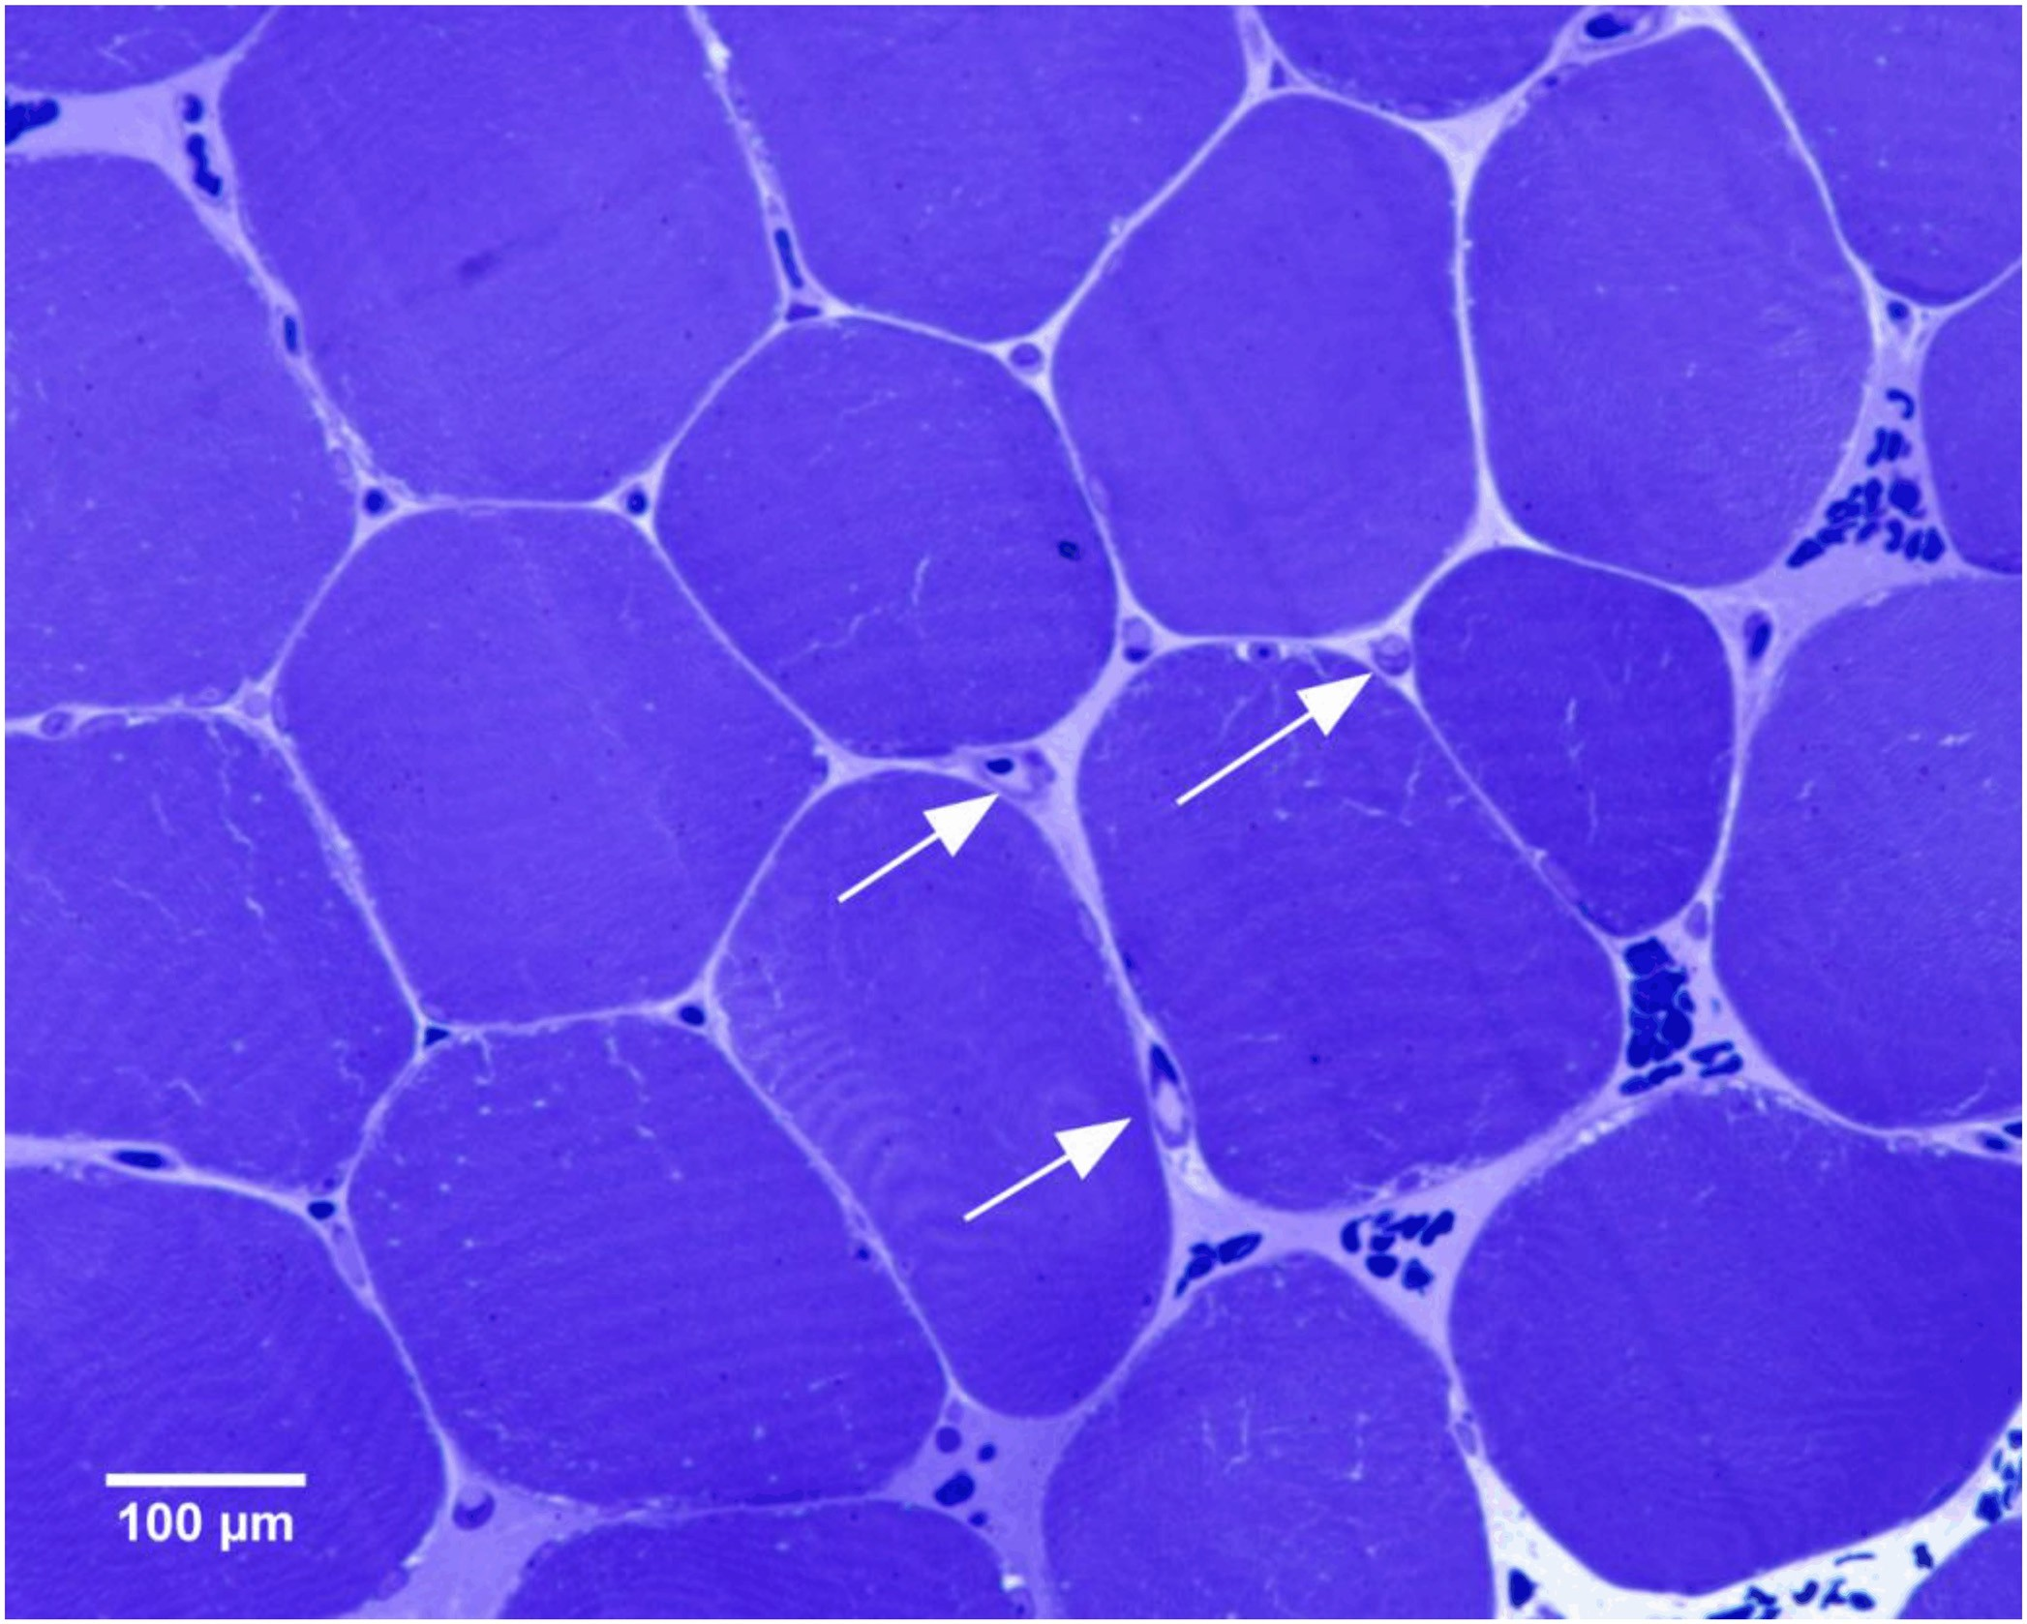
EnduranceTrainingandPulmonaryV’O₂Kinetics
Fig 1.Transverse section of human muscle fibers, preserved in epoxy resin. A representative area of a part of vastus lateralis muscle stained with the mixture of toluidine and methylene blue is showed. The arrows indicate the cross section of capillaries.
doi:10.1371/journal.pone.0154135.g001
Statistics
TheresultsarepresentedinTablesandFiguresasmeans±SD.Additionally,theTablesdem- onstrate 95% confidence intervals of the means (95% CI). The significance of the difference betweenτ₁(and other variables) measured before and after the training was tested with the matched-pairsWilcoxonsigned-ranktest,whichmeansthatforeachsubjectthechangeΔτ₁ofτ₁was computed and the Wilcoxon signed-rank test was used to check whether those differ- encesweresignificantlynon-zero.Exact(i.e.non-asymptotic),two-sidedP-valueswerecom- puted,asdescribedinZoladzetal.[38].
The non-parametric test with the exactP-values was used because of the relatively small
samplesize(:::12subjects),onwhichthecomparisonswerebased.With12datapoints,itis
notpossibletoreliablyverifytheassumptionofnormality,neededforanapplicationofstan- dard parametric tests, like the t-Student test. For the non-parametric Wilcoxonsigned-rank
PLOS ONE | DOI:10.1371/journal.pone.0154135 April 22, 2016
8/ 25

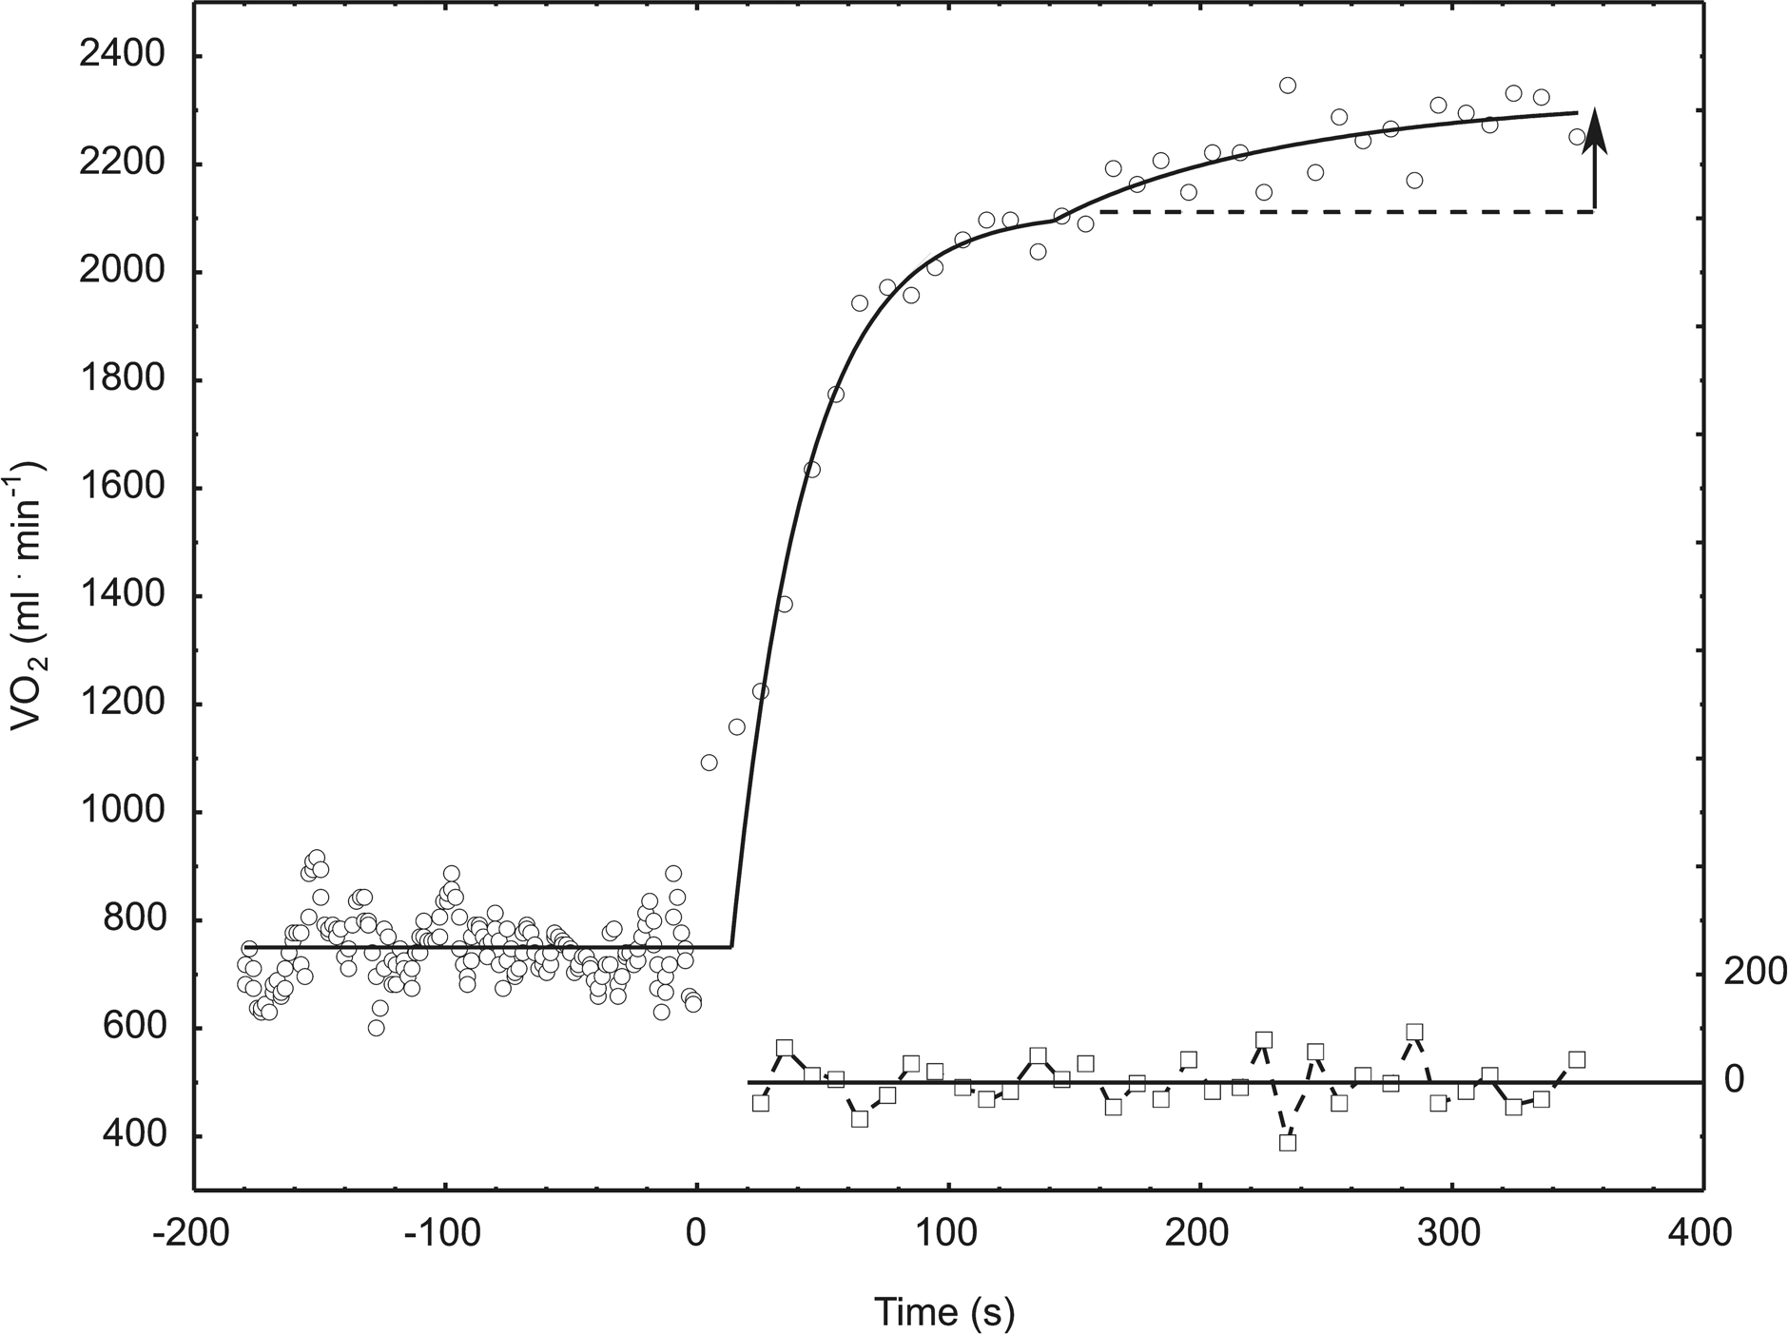
EnduranceTrainingandPulmonaryV’O₂Kinetics
Fig 2.Models fitted to subject 3 data collected during baseline-heavy-intensity exercise transition before training and the corresponding residuals.Thearrowrepresentsthesizeoftheslowcomponent,whichisdefinedasthedifferencebetweenthevaluereachedattheendoftheexercise, andthevalueofthefirst(fast)exponentialcomponent(representedwiththebrokenline).
doi:10.1371/journal.pone.0154135.g002
test,oneonlyneedstoassumethesymmetryofthedistributionwithrespecttoitsmedian, whichismuchweakerand,inouropinion,acceptableforthepresentstudy.
ComputersimulationsofmuscleV’O₂,metabolitechangesandATP fluxes during worktransitions
In the present study we utilized the theoretical model of skeletal muscle cell bioenergetics, includinganaerobicglycolysis,developedbyKorzeniewskiandLiguzinski[30],andbasedon anearliermodelbyKorzeniewskiandZoladz[31].Thismodelcomprisesoxidativephosphory- lation (OXPHOS) complexes (complex I, complex III, complex IV, ATP synthase, ATP/ADP carrier,P_{i}carrier),aerobicandanaerobicglycolysis,creatinekinase(CK),ATPusage,NADH supplyandprotonefflux/influxto/fromblood.Themodelcomprisestheinhibitionof(anaero- bic) glycolysis by protons[29,30].
Themodelhasbeenbroadlyvalidatedbycomparisonofitspredictionswithexperimental data,andhasbeenusedinnumeroustheoreticalstudies(seee.g.,Refs.[22,23,24]).Thecom- pletemodeldescriptioncanbefoundonthewebsite:http://awe.mol.uj.edu.pl/~benio/.
Themodel(someofitsparameters,inparticularATPusageactivationinrelationtorest duringpriorandmainexercise,A_{UT},OXPHOSandNADHsupplyactivation,A_{OX},and
PLOS ONE | DOI:10.1371/journal.pone.0154135 April 22, 2016
9/ 25

EnduranceTrainingandPulmonaryV’O₂Kinetics
‘‘additional”ATP usage after 6 min of main exercise) was (were) fitted to the experimentally- obtainedV’O₂vs.timedataobtainedduringtheconstantpoweroutputexercises.Afterthisfit- ting, the model generated the V’O₂kinetics that reproduced well the observed V’O₂kinetics (see”Results”,“Computersimulations”section).Alsoothervariablevalues,namelyADP,PCr, P_{i}and ATP concentrations, pH as well as ATP usage (UT), ATP supply by OXPHOS (OX), creatinekinase(CK)andanaerobicglycolysis(GL)weresimulatedandshownforillustration (see“Results”,“Computersimulations”section).ThevaluesofA_{OX}andA_{GL}alsowerefittedto give reasonable values of (changes in) ADP, PCr and pH (although they also co-determined the V’O₂kinetics).
InordertoexplainthedifferenceinV’O₂forthesamepoweroutputweassumedwithinthe model, in order to fit experimental data for prior exercise, that the ATP cost of power output was by 5.5% greater in untrained muscle than in trained muscle both during the prior and mainexercise.Inotherwords,itwasassumedthatATPusageformusclecontraction(byacto- myosine-ATPaseandCa²⁺-ATPase)decreasedby5.5%atagivenpoweroutputintheresultof muscletraining(forinstancebecauseofCa²⁺releasefromsarcoplasmicreticulumandSERCA down-regulation). This is an assumption made within the model in order to fit the experimen- tal data. We assumed that the training-induced decrease in the pulmonary V’O₂/P.O. ratio observed in experiment is a derivative of a decreases in the ATP/P.O. ratio and not in the O₂/ATPratio.Thisisbecauseitwasestimatedpreviously[29](basedontheavailabledata,see therein) that the proton leak, the main candidate for the factor affecting the O₂/ATP ratio, is responsibleforonlyabout1%ofV’O₂duringheavyexercise(althoughthisissuerequiresfur- therstudy),andthereforeweassumedthatapossibletraining-induceddecreaseinitsintensity could not lower significantly the O₂/ATP ratio. Consequently, we assumed (within the model, inordertofitexperimentaldata)thatduringthelow-intensityexercise(20W)(baseline)ATP usagewasdirectlyactivatedA_{UT}=20times(inrelationtorest)intrainedmuscleandA_{UT}=20
*1.055 = 21.1 times in untrained muscle. We assumed that during heavy-intensity exercise
ATP usage was activated A_{UT}= 80 times (in relation to rest) in trained muscle and A_{UT}= 80*
1.055 = 84.4 times in untrained muscle. In untrained muscle all OXPHOS complexes and
NADHsupplyblockweredirectlyactivatedA_{OX}=A ^{0.35}=2.91and4.72timesinrelationto
UT
restduringprior(low-intensity)andmain(heavy)exercise,respectively(thepowercoefficient p=0.35isameasureofESAintensitywithinthemodel).ThisrepresentstheESAmechanism [22,23,24] mentioned above. In trained muscle ESA was intensified, which means that OXPHOScomplexesandNADHsupplywereactivatedA_{OX}=A_{UT}^{0.38}=3.12and5.29timesin relationtorestduringprior(low-intensity)andmain(heavy)exercise,respectively(again,the powercoefficientp=0.38isameasureofESAintensity).Itwasassumedthattherewasnosig- nificantanaerobicglycolysisduringthelow-intensityexercise(NADHsupplybyglycolysis
+TCAcycleexactlymatchesNADHconsumptionbyOXPHOS).Duringheavy-intensityexer- cise glycolysis was directly activated A_{GL}= A_{UT}^{0.48}= 8.41 and 8.19 times in untrained and trainedmuscle,respectively(inthiscasep=0.48isameasureofparallelactivationofglycolysis withinthemodel).Therefore,thedirectactivationofglycolysisingeneralandanaerobicglycol- ysis in particular was higher in untrained than in trained muscle. Glycolysis was also more intensively activated indirectly in untrained muscle, through a greater increase in ADP. Both effects decreased the apparent gain in untrained muscles in relation to trained muscles. The needforadirectactivationofglycolysisduringrest-to-worktransitionswasdemonstratedpre- viously [30]. In the computer simulations the activation of the system related to the transition fromthelow-intensityexercise(20W)totheheavy-intensityexercisewasdelayedby24s(0.4 min), with respect to the experimental data, in order to take into account the cardio-dynamic phase of the V’O₂on-kinetics. It was assumed, in order to fit the measured V’O₂kinetics, that inuntrainedmusclethe‘‘additional”ATPusageduringheavy-intensityexerciseincreases
PLOS ONE | DOI:10.1371/journal.pone.0154135 April 22, 2016
10 /25

EnduranceTrainingandPulmonaryV’O₂Kinetics
graduallyfrom0%ofthe‘‘basic”ATPusageattheonsetofheavy-intensityexerciseto5%of the‘‘basic”ATP usage after 6 min of this exercise. In trained muscle this (fitted within the model)increaseofthe‘‘additional”ATPusagewassmallerandwasequalto2.5%.
Wehadtofitafewparametervalues(A_{UT},A_{OX},A_{GL},‘‘additional”ATPusage)inorderto reproducewellourexperimentaldata.Thiswasaminimumnumberofadjustableparametervalues necessary to account for the measured effect of training within the computer model used.ThemodeldoesnottakeintoaccountexplicitlythepossibleeffectofH⁺,P_{i},ADPandother fatigue-related factors on (the efficiency of) such ATP-ases as actomyosin-ATPase, Ca²⁺-ATPase, Na⁺/K⁺-ATPase or Na⁺/Ca²⁺exchanger. However, this effect is at least partly takenintoaccountasthe‘‘additional”ATPusage.Ofcourse,thereareseveralotherapproxi- mationsorsimplificationsthatalwaysappearintheoreticalmodelsofcomplexrealsystems.
Results
Cardiorespiratory variables and plasma lactate concentration
The 20 weeks of endurance training resulted in no significant (~4%) increase in V’O_{2peak}
(P= 0.12) and no significant changes in maximal minute ventilation (V’_{Emax}), maximal heart rate (HR_{max}) and maximal plasma lactate concentration ([La⁻]_{plmax}) (seeTable 1). The carbon dioxide production (V’CO₂) and respiratory exchange ratio (RER) reached at the peak power output after training were significantly higher than before training (seeTable 1).
Trainingresultedinaright-wardshiftofthelactatevs.poweroutputcurveduringtheincre- mental exercise test (seeFig3).
Physical performance
Trainingresultedinasignificant(P=0.01)increase(by~19%)ofthepoweroutputattheLT (seeTable2).AlsothepoweroutputattheV’O_{2peak}wassignificantly(P=0.003)higher(by
~14%) after training (seeTable 2).
Runningperformance,estimatedbytherunningvelocityat85%ofHR_{max}was~6%higher (P= 0.006) after training (seeTable 2). Moreover, the mean running velocity during the 1,500-mrunwas~5%higheraftertraining(P=0.001)(seeTable2).
Pulmonary V’O₂on-kinetics
Mean(±SD)V’O₂values,averagedover10seconds,beforeandduringaconstantpowerout- putcyclingexerciseperformedbeforeandaftertrainingarepresentedinFig4.
Trainingresultedinasignificant(P=0.027)decrease(by~5%)ofthebaseline(20W)V’O₂(seeTable 3). This was accompanied by a significant (P= 0.007) shortening (by ~18%) of the phaseIIτoftheV’O₂on-kinetics.NoeffectoftrainingonthephaseIIgainandabsoluteampli- tudewasfound.Asignificant(P=0.005)decrease(by49%)ofthemagnitudeoftheslowcom- ponentwasfound.Moreover,asignificant(P=0.0005)decrease(by~5%)oftheend-exercise V’O₂wasobservedaftertraining.Moreover,asignificantdecrease(P=0.005)intheend-exer- cisegainwasfoundaftertraining(asshowninTable3).
Muscle proteins
The results of the maximal COX activity, citrate synthase content, MyHC composition (elec- trophoresis) and mtDNA copy number in relation to V’O₂on-kinetics during moderate-inten- sity cycling in the same group of subjects (n = 10) has been presented in our recent paper (for details see Ref. [28]). No significant changes in myosin heavy chain composition determined by SDS-PAGE has been found (P= 0.13) after training [28]). Additionally, in this study, no
PLOS ONE | DOI:10.1371/journal.pone.0154135 April 22, 2016
11 /25

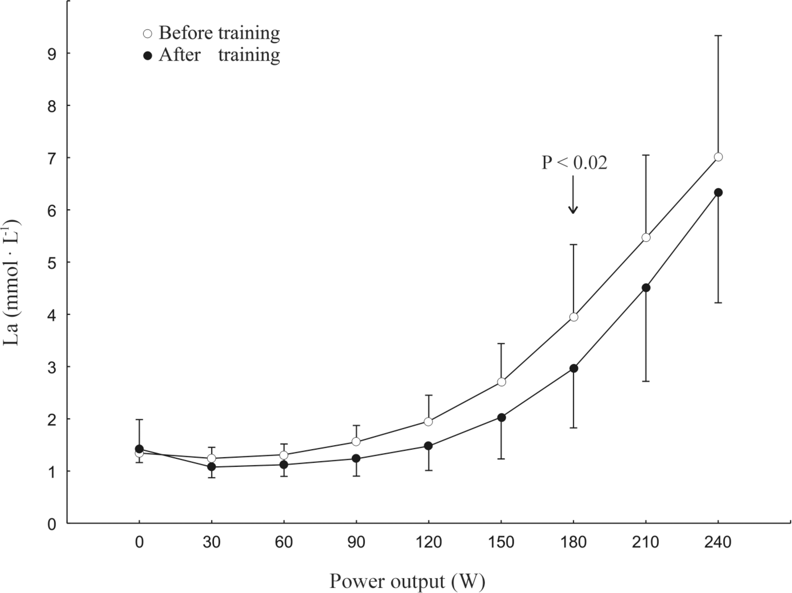
EnduranceTrainingandPulmonaryV’O₂Kinetics
Table1.Valuesofpeakpoweroutput,selectedcardio-respiratoryvariablesandplasmalactateconcentrationobtainedatexhaustionduringthe incrementalexercisetestperformedbeforeandafter20weeksofendurancetraining.
Variables
Beforetraining
After training
Pvalue
Mean ± SD
95% CI ofmean
Mean ± SD
95% CI ofmean
Data are given as mean ± SD and the 95% CI of mean, n = 12.
*Maximalplasmalactateconcentrationsdataareshownforelevensubjects.(Pvaluewascalculatedusingnon-parametricWilcoxonsigned-ranktest).
doi:10.1371/journal.pone.0154135.t001
Fig 3.Plasma lactate concentration [La⁻]_{pl}during an incremental exercise test before (white circles) and after (black circles) 20 weeks of endurancetraining.Thepoweroutputwasincreasedby30Wevery3minutesupto240W.Notetheright-wardshiftofthelactatecurveaftertrainingand especiallythedifference(P<0.02Wilcoxonsignedranktest)between[La⁻]_{pl}at180Wi.e.neartothepoweroutputatwhichtheV’O₂on-kineticshasbeen determined,beforeandafterthetraining.Dataaregivenasmeans±SDfor11subjects.
doi:10.1371/journal.pone.0154135.g003
PLOS ONE | DOI:10.1371/journal.pone.0154135 April 22, 2016
12 /25
-1
V’O_{2peak}(mL ·min) 3198±458 2907–3489 3324±325 3117–3530 0.12
-1
V’_{Emax}(L ·min) 92.7±16.4 82.3–103.1 101.5±18.9 89.5–113.5 0.09
-1
V’CO_{2max}(mL ·min) 3582±497 3266–3897 3894±477 3591–4197 0.02
RER 1.12±0.03 1.10–1.14 1.17±0.04 1.14–1.20 0.02
-1
HR_{max}(bt ·min) 187.2±8.0 182.1–192.2 188.2±8.5 182.8–193.5 0.53
[La⁻]_{pl}(mmol· L⁻¹)* 8.1±1.8 6.9–9.3 8.5±2.0 7.2–9.9 0.66

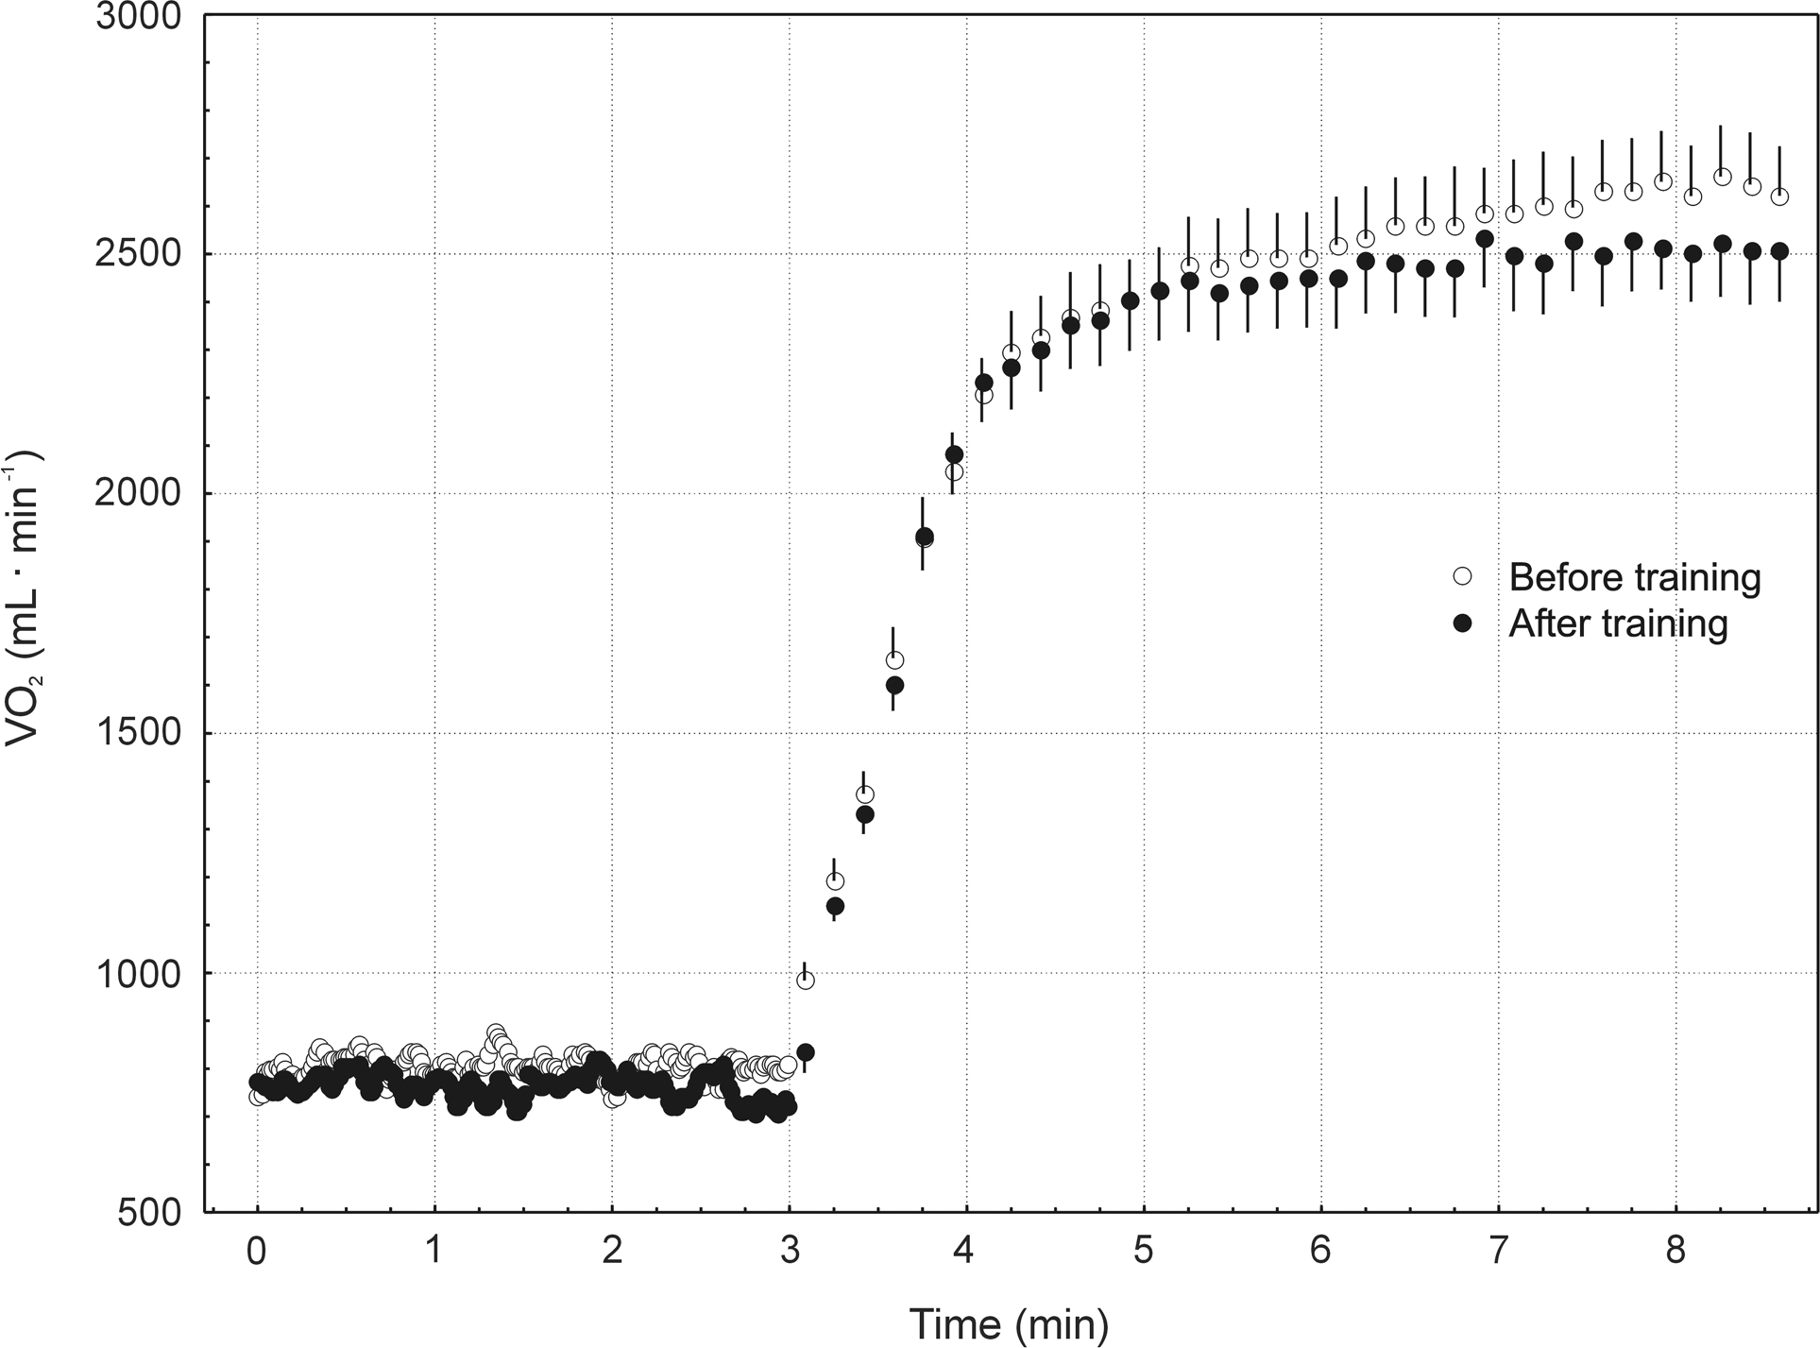
EnduranceTrainingandPulmonaryV’O₂Kinetics
Table2.Physicalperformance(cyclingandrunning)beforeandafterthe20weeksofcyclingendurancetraining.
Cyclingperformance
Beforetraining
After training
Pvalue
Mean ± SD
95% CI ofmean
Mean ± SD
95% CI ofmean
Dataaregivenasmean±SDandthe95%CIofmean,n=12.(Pvaluewascalculatedusingnon-parametricWilcoxonsigned-ranktest).
doi:10.1371/journal.pone.0154135.t002
significant difference in MyHC2 content (Western immunoblotting) after the training was found(P=0.90).MaximalCOXactivityshowedatendencytobeslightlyhigher(by~5%)after training (P= 0.08). A significant increase (P= 0.03) in mitochondrial DNA copy number in relation to nuclear DNA copy number was found after the training in relation to pre-training status[28].Moreover,inthepresentstudywehavefoundnosignificantchanges(P>0.05)in themRNAlevelsofmitofusin1(MFN1),mitofusin2(MFN2)andopticatrophy1(OPA1).
Fig 4.Mean (± SD) values of pulmonary oxygen uptake (V’O₂) for 12 subjects during baseline and during heavy-intensity transition. Note the training-induced attenuation of the slow component of the V’O₂on-kinetics during high-intensity cycling.
doi:10.1371/journal.pone.0154135.g004
PLOS ONE | DOI:10.1371/journal.pone.0154135 April 22, 2016
13 /25
PO atLT(W) 120.0±28.6 101.8–138.2 142.5±25.0 126.0–159.0 0.01
PO atV’O_{2peak}(W) 231.7±35.1 209.3–254.0 263.4±33.6 242.0–284.8 0.003
Running performance
-1
v at 85% HR_{max}(m ·s) 2.83±0.33 2.62–3.04 3.00±0.31 2.80–3.19 0.006
-1
v during 1,500-m run (m ·s) 4.16±0.33 3.96–4.37 4.37±0.44 4.09–4.65 0.001

EnduranceTrainingandPulmonaryV’O₂Kinetics
Table3.Oxygenuptakeon-kineticsduringhigh-intensitycyclingexercise,beforeandafter20weeksoftraining.
Beforetraining
After training
P
value
Mean ± SD
95% CI of
mean
Mean ± SD
95% CI of
mean
Dataaregivenasmean±SDandthe95%CIofmean,n=12.(Pvaluewascalculatedusingnon-parametricWilcoxonsigned-ranktest).
doi:10.1371/journal.pone.0154135.t003
Thistrainingresultedinasignificant(P=0.02)decrease(by~22%)inSERCA2content, whereasnosignificantchangesinSERCA1contentwerefound(P=0.73).
Muscle capillarization
NochangesinthemRNAlevelsofvascularendothelialgrowthfactorA(VEGFA)(P=0.24), hypoxia-induciblefactor-1(HIF1)(P=0.21)andvascularendothelialgrowthfactorreceptor1 (VEGFR1)(P=0.12)wereobserved.However,asignificantincrease(~40%)invascularendo- thelialgrowthfactorreceptor2(VEGFR2)mRNAlevelwasfound(P=0.02).Moreover,this increaseinVEGFR2expressionwasaccompaniedbyacleartendency(P=0.06)tohighercap-
2
illarytofiberratio(1.65±0.11vs.1.98±0.441·mm,respectively,beforeandaftertraining),
2
where95%CIofmeanofthisratioamountedto1.57–1.721·mmbeforetrainingandto1.67–
2
2.29 1·mm after training.

Computer simulations
ThesimulatedtimecoursesofV’O₂duringbaseline-heavy-intensity-exercisetransition(forfit- ted A_{UT}, A_{OX}and‘‘additional”ATP usage values) agree well with the experimental ones (seeFig 5A). Computer simulations reproduce well the experimental finding that the training caused a decrease in baseline V’O₂measured during cycling at 20 W and, especially, in V’O₂during heavy-intensity exercise. The latter was caused by the assumed/fitted decrease of the ATP cost of exercise (by 5.5%) and, especially, by the postulated decrease in the‘‘additional”ATP usage after 6 min of exercise from 5.0% to 2.5% of the‘‘basic”ATP usage (without the‘‘additional”ATPusage).ThedecreasedadditionalATPusage,beinginouropiniononeofthe two main factors responsible for the slow component of the V’O₂on-kinetics [29], leads to a decreaseofthemagnitudeoftheslowcomponent.ThisisdemonstratedinFig5A.Fig5A–5Cpresents also simulated time courses of other variables (metabolite concentrations and ATP fluxes) during the on-transition for untrained and trained muscle. Computer simulations sug- gestthatphysicaltrainingsignificantlyimprovedmusclemetaboliteandpHstabilityduring
PLOS ONE | DOI:10.1371/journal.pone.0154135 April 22, 2016
14 /25
-1
Baseline O₂uptake (mL ·min) 809±97 747–871 766±70 722–810 0.027
Phase II timeconstant(s) 30.1±5.87 26.3–33.8 25.4±5.10 22.1–28.6 0.007
-1
Phase II amplitude (mL ·min) 1668±281 1490–1847 1661±328 1452–1869 0.97
-1 -1
Phase II gain (mL · min ·W) 10.8±0.6 10.4–11.1 10.7±0.9 10.1–11.3 1.0
O₂uptake slow component timedelay(s) 160±35 137–182 93±74 46–140 0.012
-1
O₂uptake slow component (mL ·min) 186±88 130–242 94±90 36–151 0.005
RelativecontributionofslowcomponenttonetincreaseinV’O₂atend- 9.9±3.8 7.5–12.3 5.3±5.3 1.9–8.7 0.012
exercise (%)
End-exercise O₂uptake at 6thminute (mL ·min⁻¹) 2664±369 2430–2899 2520±362 2290–2750 0.0005
% peakO₂uptake 83.5±5.2 80.2–86.8 75.7±6.5 71.6–79.8 0.002
-1 -1
End-exercise gain (mL · min ·W) 11.9±0.4 11.7–12.2 11.3±0.7 10.9–11.7 0.005
Poweroutput(W) 176.1±30.2 156.9–195.3 176.1±30.2 156.9–195.3 1.0
Gain poweroutput(W) 156.1±30.2 136.9–175.3 156.1±30.2 136.9–175.3 1.0

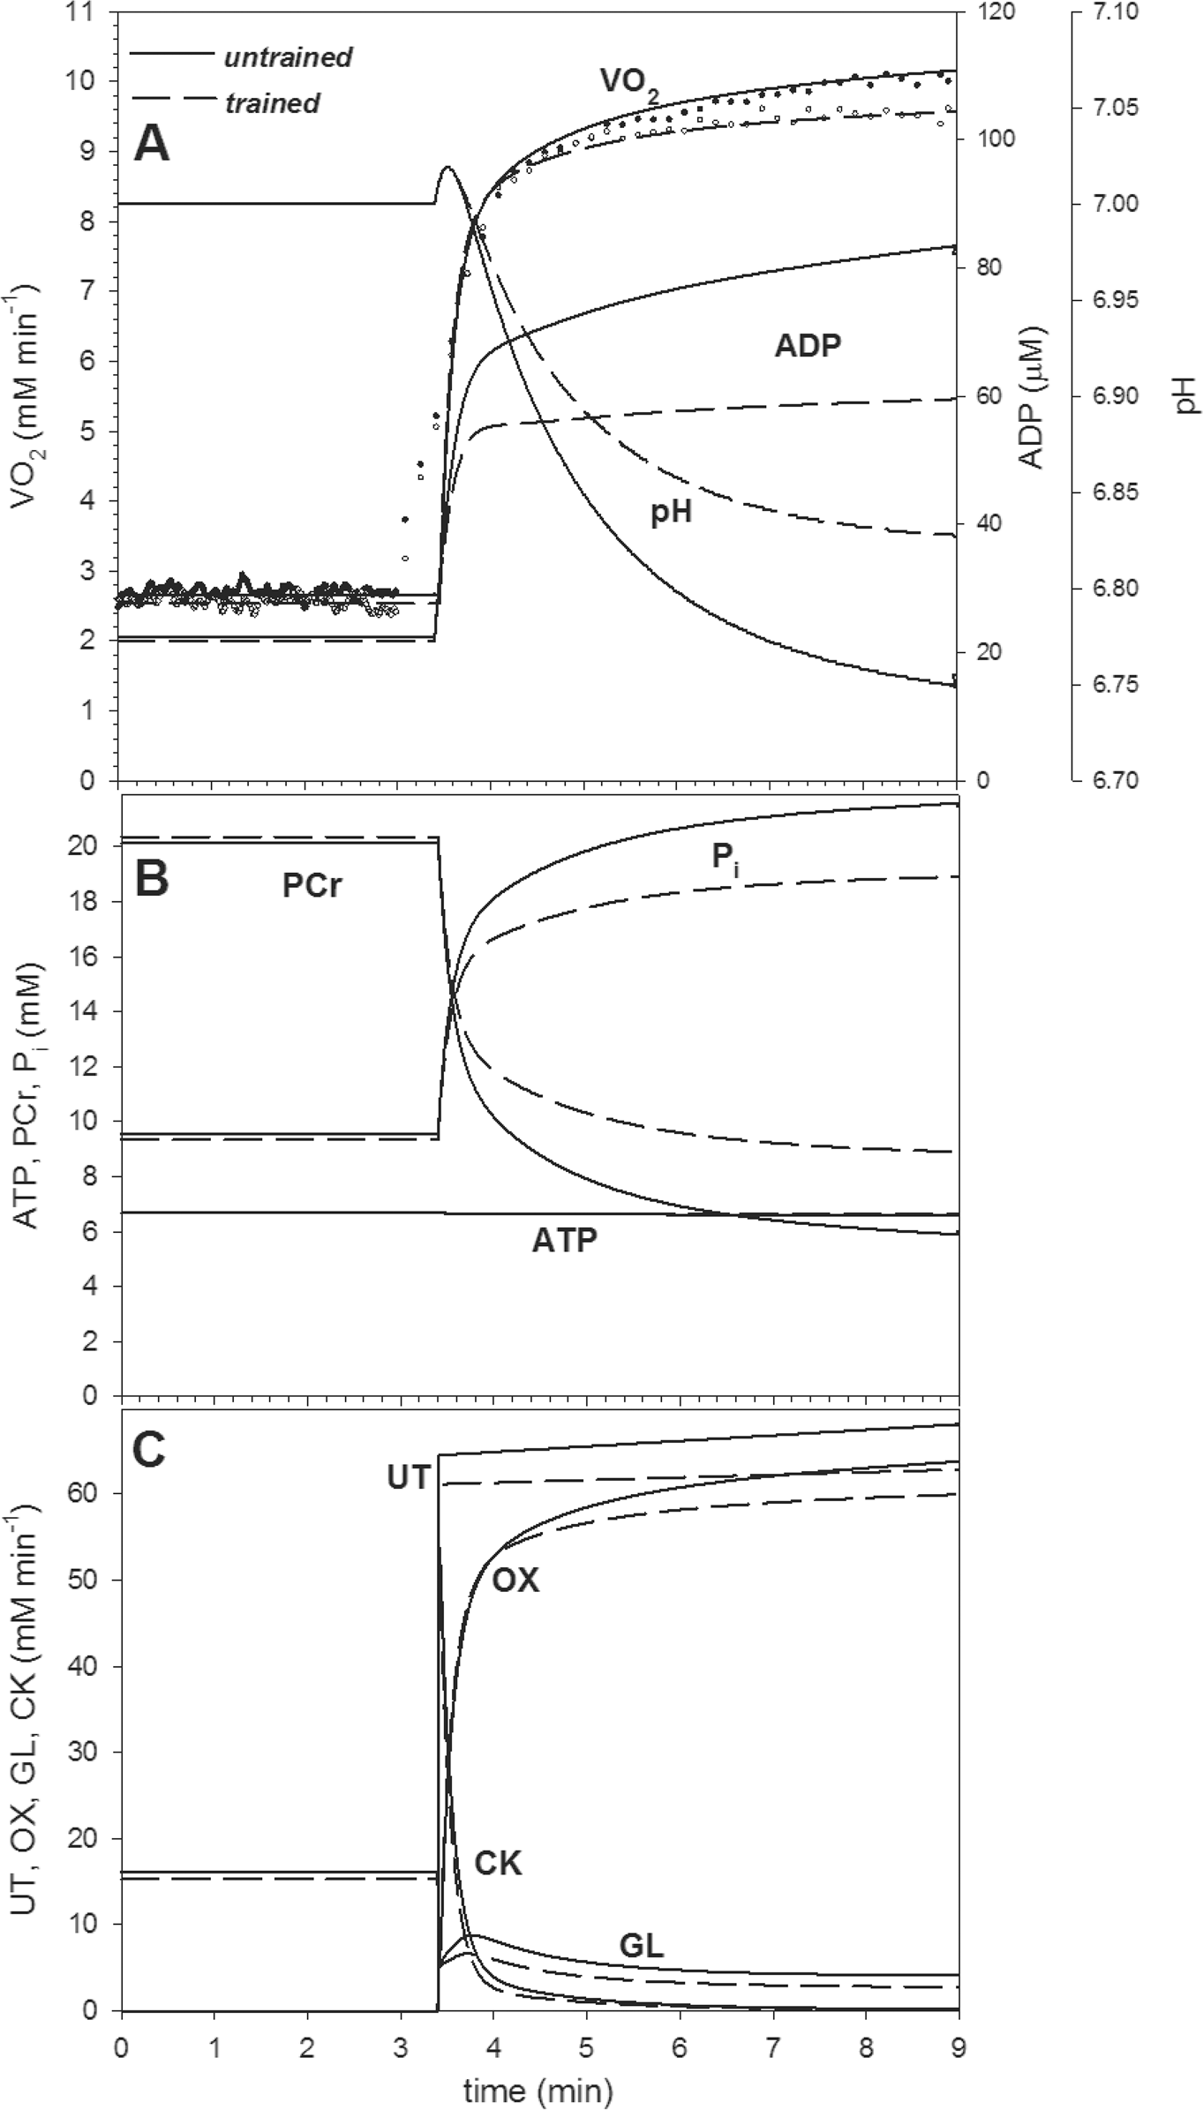
EnduranceTrainingandPulmonaryV’O₂Kinetics
Fig 5.Experimental V’O₂and simulated muscle V’O₂, metabolite concentrations and ATP usage/ supply fluxes during low-intensity (baseline) and high-intensity cycling exercise in untrained and trained muscle. (A) Experimental and simulated V’O₂, simulated ADP and pH. (B) Simulated PCr, P_{i}and ATP.(C)SimulatedATPusage(UT),ATPsupplybyOXPHOS(OX),ATPsupplybyanaerobicglycolysis (GL),ATPsupplybycreatinekinase(CK).Experimentalbaseline-heavy-intensityexercisetransition:after3
PLOS ONE | DOI:10.1371/journal.pone.0154135 April 22, 2016
15 /25

EnduranceTrainingandPulmonaryV’O₂Kinetics
min.Simulatedbaseline-heavy-intensityexercisetransition:after3.4min(thedelayby24scorrespondsto the cardio-dynamic phase of the pulmonary V’O₂on-kinetics). The muscle V’O₂is calculated based on the assumptionthatduringbaseline-intensityexercise(20W)muscleV’O₂constitutes~75%andduringheavy-intensityexercise~85%ofthepulmonaryV’O₂(seeRef.[40]).
doi:10.1371/journal.pone.0154135.g005
theon-transition:theincreasesinADPandP_{i}anddecreasesinPCrandpHwereindeedsignif-icantly smaller in trained muscle (Fig 5A and 5B). ATP usage was lower after training during low-intensity exercise (20 W) and, especially, heavy-intensity exercise, according to lower‘‘basic”and‘‘additional”ATP usage, as described in Methods. Consequently, ATP supply by OXPHOSandanaerobicglycolysiswerealsolower.Thetraining-induceddecreaseinanaerobic glycolysis, which was attributable to ESA intensification (causing a smaller increase in ADP that indirectly activates glycolysis) and to lower direct activation of glycolysis at the onset of exercise(A_{GL}=8.19timesinsteadof8.41times),ledtoasmallercytosolacidificationandthus contributed to the decreased magnitude of the slow component of the V’O₂on-kinetics (throughsmallerprogressiveglycolysisinhibitioninthecourseofheavy-intensityexercise).
While the training-induced decrease in the ATP/P.O. ratio decreased gain (pulmonary V’O₂/P.O. ratio) and the phase II amplitude (because the absolute‘‘basal”ATP usage during main exercise was much higher than ATP usage during prior exercise, 5.5% of the former is muchgreaterthan5.5%ofthelatter),thetraining-induceddecreaseintheanaerobicglycolysis intensityhadtheoppositeeffect,andthephaseIIamplituderemainedapproximatelyconstant. Additionally,anintensificationofESAitselfimprovedthemetabolitestability[39].Acompari- sonofthefluxesofATPusageandATPsupplybyanaerobicglycolysis(Fig5C)suggeststhat in the present study the gradual inhibition of the latter flux by accumulating protons contrib- utedmoretotheslowcomponentthanthe‘‘additional”ATPusage,especiallyaftertraining.
However,thisconclusionappliesonlytothefirst6minaftertheonsetofexercise.Asthegly- colysis-inhibition-related part of the slow component declines with time, while the‘‘addi- tional”-ATP-usage-related part can continue to increase linearly with time (depending on whetherP.O.isbeloworabovethecriticalpower,CP),theslowcomponentsizewillincrease intimeandafter,say,15minofexercisethelatterwouldpredominate.
Discussion
In the present study we have found that a prolonged (20 weeks) endurance training program, composedmainlyofmoderate-intensityexercise,hadnoeffectontheV’O_{2peak}butaccelerated pulmonary V’O₂on-kinetics during heavy-intensity constant power output exercise, shifted the blood lactate vs. power output curve to the right, attenuated the magnitude of the slow component of pulmonary V’O₂on-kinetics and reduced the end-exercise gain of the V’O₂response. This was accompanied by an increase of cycling endurance performance, as judged byanincreaseofthepoweroutputatV’O_{2peak},aswellasbyanimprovedrunningperformance (increases in running velocity at 85% HR_{max}and in running velocity during all-out track run over the distance of 1,500-m). Therefore, our study indicates that prolonged moderate-inten- sityendurancetraining,althoughbeinginsufficienttoincreaseV’O_{2peak},significantlyenhanced enduranceperformanceinhumans,mainlybyareductioninthedevelopmentofmuscleineffi- ciency,asjudgedbyanattenuationoftheslowcomponentofV’O₂on-kineticsandanincrease of the power output atV’O_{2peak}.
It was postulated recently [29] that the main mechanisms underlying the slow component oftheV’O₂on-kineticsinskeletalmuscleareagradualinhibitionoftheATPsupplybyanaero- bicglycolysisbyaccumulatingprotons(togetherwithaslowdecayofATPsupplybyCK)and an‘‘additional”ATPusagecontinuouslyincreasingduringexercise.Bothmechanismselevate
PLOS ONE | DOI:10.1371/journal.pone.0154135 April 22, 2016
16 /25

EnduranceTrainingandPulmonaryV’O₂Kinetics
thepotentialmismatchbetweenATPsupplyanddemand.Namely,theinhibitionbyaccumu- latingprotonsoftheglycolyticATPproductionlowersthetotalATPsupply,whilethegradu- ally increasing‘‘additional”ATP usage rises the total ATP demand. As a result, additional oxidative ATP supply must be recruited in order to match ATP demand, which is associated withprogressivelyincreasingV’O₂(theslowcomponentoftheV’O₂on-kinetics).
Inthepresentstudy,wehavedemonstrated,usingatheoreticalmodeloftheskeletalmuscle cellbioenergeticsystem,thatatraining-inducedincreaseinESAintensityleadstoadecreasein the slow component through diminishing of the former mechanism intensity. This is because intensifiedESAcausesanenhancedoxidativeATPsupply,lowerstheincreaseinADPduring exerciseandconsequentlydecreasesthe(anaerobic)glycolyticfluxandATPsupplyfromthis source, and thus decreases cytosol acidification. Consequently, the fall in the glycolytic flux during exercise is smaller, which, together with a decrease in the‘‘additional”ATP usage dur- ingexercise,decreasestheslowcomponentoftheV’O₂on-kinetics(seeFig5A–5C).
The effect of training on cycling and running performance
The training program had no effect on the V’O_{2peak}, but resulted in a significant enhancement ofmaximalcyclingandrunningperformance(seeTable2).Namely,thedurationofthemaxi- malincrementalexercisetestincreasedby~12%.Thiswasassociatedwithanincreaseinpeak poweroutputatV’O_{2peak}by~30Wi.e.by~14%(P=0.003).Ourfindingisinagreementwith thepreviousstudybyMajerczaketal.[13],showinganincreaseinthepowergeneratingcapabil- itiesatV’O_{2max}after5weeksofmoderate-intensityendurancetraining.Theobservedtraining- inducedenhancementofpowergeneratingcapabilitiesatagivenV’O₂indicatesthatthemoder- ate-intensity endurance training is potent to increase power generating capabilities at V’O_{2peak}eveninpresentsofunchangedV’O_{2peak}.Thisseemstobeespeciallyimportantincaseofpeople undertakingtrainingofmoderateintensity—knowntobebeneficialforenhancementofhealth statusbutlesseffectiveinanenhancementofV’O_{2max}thanthehighintensitytraining.
The reported increase in power generating capabilities at V’O_{2peak}can be explained by the training-induced improvement of muscle metabolic stability (seeFig 5A and 5B) and by the decreasedO₂costofcyclingathighpoweroutputs,asreflectedbydecreasedslowcomponent of the V’O₂on-kinetics (seeFig 2andTable 3). One could speculate that this effect could be caused by an improvement of cycling technique during training (learning effect). However, in the present study the applied endurance training regimen (cycling) enhanced also runningper- formance,bothatsubmaximalaswellasatmaximalintensities(seeTable2).Thisstronglysug- gests that the attenuation of the slow component of the pulmonary V’O₂on-kinetics during cyclingobservedinthepresentstudywasmainlyattributabletothetraining-inducedenhance- mentofmusclemetabolichomeostasisduringexercise(increasedESAintensityanddecreased‘‘additional”ATP usage, seeFig 5and discussion above). However, a direct comparison of those two kinds of movements requires some caution, since the“muscle working conditions”during running and cycling differs significantly e.g. in terms of tension development and its impact on muscle blood flow. Nevertheless, the enhancement of running performance after cycling training observed in the present study supports our suggestion that the observed atten- uation of the magnitude of the slow component of the V’O₂kinetics during cycling originated mainlynotfromthelearningeffectbutfromthetraining-inducedenhancementofmusclemet- abolic homeostasis duringexercise.
The effect of training on pulmonary V’O₂on-kinetics
In the present study training resulted in a significant (by ~16%) shortening of theτ_{p}of the V’O₂on-kinetics.Thiseffectissimilartothoseobtainedbyafewweeksoftraining,asreported
PLOS ONE | DOI:10.1371/journal.pone.0154135 April 22, 2016
17 /25

EnduranceTrainingandPulmonaryV’O₂Kinetics
byothers[41].Suchanaccelerationhasphysiologicalsignificance[2,42,43].Firstofall,ashort-ening of theτ_{p}, in the presence of an unchanged amplitude of the primary component of the V’O₂on-kinetics decreases the size of the O₂deficit [2]. Moreover, the acceleration of pulmo- nary and (presumably) muscle [44] V’O₂on-kinetics suggests an enhanced muscle metabolic stability [21,28,39,42]. Namely, we have previously shown [39] that at a given ATP demand and under conditions where the CK reaction works near the thermodynamic equilibrium, the half-transition timet_{0.5}(and thus alsoτ_{p}) of muscle V’O₂on-kinetics is determined by the amount of PCr that has to be converted into creatine (Cr) during the rest-to-work transition. Consequently, a linear relationship between half-transition time of muscle V’O₂on-kinetics and theΔPCr during rest to work transition has been demonstrated (see Ref. [39]–Fig 4therein). This concept is in agreement with experimental data showing a significant positive correlation between the magnitude of decrease in muscle PCr concentration during exercise and the rate of pulmonary V’O₂on-kinetics in humans [19,45]. Therefore, the observed train- ing-induced acceleration of muscle V’O₂on-kinetics can be considered as an indirect marker of an enhanced muscle metabolic stability, as described by lesser changes in muscle PCr, P_{i}, ADP_{free}, H⁺, AMP, IMP,ΔG_{ATP}, etc. during rest to work transition [21,28,39,42,43]. In this respect, the attenuation of the computer-simulated increases in muscle P_{i}, ADP_{free}, and lesser decreasesinPCrandpH,aswellastheloweranaerobicglycolyticfluxaftertraining(Fig5A–5C)appearnoteworthy.Moreover,inthepresentstudywehavealsofoundasignificantright-ward shift of the plasma lactate concentration curve during the incremental test (seeFig 3),resulting in an ~19% increase of the power output at the LT. This additionally supports our hypothesis that the applied training enhanced muscle metabolic stability during high-intensity exerciseanddecreasedtheATPsupplybyanaerobicglycolysis.
MyHCcontentandtheslowcomponentofthepulmonaryV’O₂on- kinetics
Inthepresentstudywehaveobservedasignificantdecrease(by~50%)ofthemagnitudeofthe slowcomponentoftheV’O₂on-kinetics(seeFig4andTable3).Similareffects,occurringafterafewweeksofvariedkindsoftraininghasbeenreportedbyothers[10,11,12].Themechanism bywhichtrainingattenuatestheslowcomponentremainsunclear(forreviewseeRef.[41]).It has been reported that the relative amplitude of the slow component of V’O₂kinetics during exerciseofheavy-andsevere-intensitywassignificantlyandnegativelycorrelatedwiththeper-centage of type I fibers [46,47]. It has been suggested that the training-induced attenuation of the slow component could be due to a lesser recruitment of type II muscle fibers [41]. On the otherhandZoladzetal.[9],usinganelectricallystimulatedisolateddoggastrocnemiusinsitu preparation,reportedaclearV’O₂slowcomponent-likeresponse,i.e.aprogressiveincreaseof V’O₂:forceratiointheabsenceofaprogressiverecruitmentofmusclefibers(seeRef.[9],Fig4therein). These authors concluded that not recruitment of type II muscle fibresper se, but rathertheconsequenceoftheirrecruitment,i.e.disturbancesinmusclemetabolicstability(i.e. an increase in ADP_{free}, P_{i}, H⁺, IMP, AMP, NH₃concentrations, decrease in muscle PCr con- centration andΔG_{ATP}) in already working muscle fibers would be responsible for the slow component[9].Thiscouldbeduetothemetabolitesinduceddecreaseofmechanicalefficiency andmusclefatigueofthealreadyrecruitedmusclefibers[3,9,48,49],leadingtoanincreaseof theATPcostofforceandpowergeneration(“additionalATPusage”).Namely,ithasbeenpos- tulatedthattheslowcomponentoftheV’O₂on-kineticsisaconsequenceofthemuscle
fatigue-induced decrease of muscle efficiency [9]. This concept recently received some addi- tional experimental supports [13,42,50,51]. In the present study we have found a pronounced attenuationoftheslowcomponentoftheV’O₂on-kineticsinthepresenceofnochangesinthe
PLOS ONE | DOI:10.1371/journal.pone.0154135 April 22, 2016
18 /25

EnduranceTrainingandPulmonaryV’O₂Kinetics
proportion of MyHC in the vastus lateralis muscle, which suggest that the training-induced decrease of the slow component in humans does not require changes in MyHC composition. Interestingly,inthepresentstudywefoundasignificant(P=0.02)decreaseinSERCA2con-tent (by 22%) following training. This could contribute to an enhancement of type I muscle fibers efficiency and to a decrease in the O₂cost of power generated by these muscle fibers [13,52](inparticular:oftheATP/P.O.ratio).TheroleoftypeImusclefibersintheoriginof theslowcomponentoftheV’O₂on-kineticsisnotobvious,butthereisagrowingbodyofevi- dence that their fatigue-induced decrease of mechanical efficiency can contribute to the slowcomponent[9,53].
Muscle acidosis and the slow component of V’O₂kinetics
ItiswellestablishedthattheslowcomponentoftheV’O₂on-kinetics(ortheslow-component- like response, [9]) is associated with metabolic acidosis. Namely, the slow component is nor- mallypresentduringexerciseexceedingthelactatethreshold[4,5]andbecomesprogressively greaterafterexceedingthe“criticalpower”[1,3,6,7].Accordingly,ithasbeenreportedthat
the amplitude of the slow component is linearly related to the level of lactate accumulated in blood [7,54,55]. Moreover, it has been shown by Casaburi et al. [11] that the training-induced decrease in blood lactate concentration is correlated with the attenuation of the amplitude of the slow component. On the other hand, it was reported that pharmacologically induced enhancementofbloodlactateconcentrationhadnoeffectonthemagnitudeofV’O₂slowcom- ponent in humans (for discussion of this point see Ref. [29]). Moreover, as demonstrated by Poole et al. [56], direct infusion of L-(+)-lactate, increasing lactate concentration in blood and in contracting muscles had no significant effect on the amplitude of the V’O₂slow component in dog gastrocnemius muscle. On the other hand, pre-exercise induced metabolic acidosis, obtained by ingestion of NH₄Cl, significantly increased the magnitude of the slow component of V’O₂on-kinetics in humans [57]. These findings strongly suggest that muscle acidosis, not lactatemia,isinvolvedintheappearanceoftheslowcomponentoftheV’O₂on-kinetics.
Although H⁺accumulation in muscle can affect its function by decreasing its efficiency and inducing fatigue [3], muscle acidosis developed during exercise is normally accompanied by greater disturbances in muscle metabolic stability, including an increase in ADP, P_{i}, and a decreaseinPCrconcentrationandΔG_{ATP},whichcanalsoaffectmuscleefficiency[3,9,48,49]. Decreased efficiency of the recruited muscle fibers [9] would lead to additional ATP usage, whichcouldincreasegraduallyduringahigh-intensityexercise,resultinginaslowcomponent oftheV’O₂on-kinetics.Ithasbeendemonstratedbyatheoreticalmodelofskeletalmusclebio- energetics, including anaerobic glycolysis, that the inhibition of ATP production by anaerobic glycolysis induced by progressive cytosol acidification (together with a slow decrease in ATP supplybycreatinekinase)aswellasagradualincreasein‘‘additional”ATPusageduringhigh intensity exercise, would lead to development of slow component of the V’O₂on-kinetics in order to maintain the required ATP supply [29]. The training-induced intensification of ESA and decrease in the‘‘additional”ATP usage would diminish ADP concentration during exer- cise,andthuswouldinhibit(anaerobic)glycolysis.Thisinturnwouldleadtoasmallercytosol acidificationduringexerciseandconsequentlytoasmallerdecreaseinATPsupplybyanaero- bicglycolysisinthecourseofexercise.Altogether,thetraining-inducedenhancementofmus- cle metabolic and pH stability, caused by ESA intensification and‘‘additional”ATP usage decrease,canleadtoadecreasedmagnitudeoftheV’O₂slowcomponentviaadecreaseinthe potential mismatch between ATP production and consumption. Lower cytosol acidification causes lower decrease of ATP supply by anaerobic glycolysis during exercise, while lower‘‘additional”ATPusagescauseslowerincreaseinthetotalATPconsumptionduringexercise.
PLOS ONE | DOI:10.1371/journal.pone.0154135 April 22, 2016
19 /25

EnduranceTrainingandPulmonaryV’O₂Kinetics
Generally,thesequenceofeventsisasfollows.1.ESAintensificationand‘‘additional”ATP usagedecreasecauseasmallerincreaseinADPandP_{i}duringexercise;2.(Anaerobic)glycolysis isstimulatedtoasmallerextent;3.Cytosolacidificationissmaller;4.Decreaseintheglycolytic ATPsupplycausedbyaccumulatingprotonsduringexerciseissmaller;5.Increaseinoxidative ATPsupplyinordertomatchATPusage(whichisadditionallydecreasedduetoadecreasein‘‘additional”ATPusage)issmaller;6.IncreaseinV’O₂issmaller,whichmeansasmallerslow component.
Therefore,theregulationof(anaerobic)glycolysisisself-limiting.Anincrease/decreasein (anaerobic)glycolysisintensityattheonsetofexercisecausesanincrease/decreaseincytosol acidificationduringexercise.Thisinturnincreases/decreasestheprogressiveglycolysisinhibi- tionduringexercise.Inshort,themoreglycolysisisactivatedattheonsetofexercise,themore itisafterwardsinhibitedinthecourseofexercise.
ItmustbeemphasizedthataratherlowmagnitudeoftheslowcomponentV’O₂on-kinetics was encountered in the present study, compared to other experimental studies [4,7]. Probably thiswasmainlycausedbyarelativelylow‘‘additional”ATPusage.The‘‘additional”ATPusage of2.5%(aftertraining)or5%(beforetraining)after6minofexercisewasassumedinthepres- ent study in order to match experimental data, while this value was 20% in our previous theo- reticalstudy[29].TherelativelysmallmagnitudeofthemeasuredslowcomponentoftheV'O₂on-kinetics and of simulated‘‘additional”ATP usage in the present study was due to the fact thatwehaveappliedaboutofexercisecorrespondingto50%Δ(fordetailseetheMethodssec- tions), which is commonly used to“scale”the exercise intensity when studying the V’O₂kinet- icsinhumans[10,11,41,46].Nevertheless,thisexerciseintensitybydefinitionisfarbelowthat one (near V’O_{2max}) which could generate maximal magnitude of the slow component of V’O₂on-kinetics (see e.g. Ref.[4,7]).
During the 6 min of exercise applied in the present study the relative increase in the ATP usageflux(‘‘additional”ATPusage)islessthantherelativedecreaseintheATPsupplyfluxby anaerobicglycolysis(Fig5C).Thisfactsuggeststhatthegradualinhibitionofthelatterbyaccu- mulating protons contributed more to the slow component than the‘‘additional”ATP usage, especially after training. However, in exercises of longer duration times, say 15 min, this con- clusionwouldbenolongervalid.Astheglycolysis-inhibition-relatedpartoftheslowcompo- nent declines with time, while the‘‘additional”-ATP-usage-related part can continue to increaselinearlywithtime(dependingonwhetherP.O.isbeloworaboveCP),thelatterwould predominate.
Each step activation and V’O₂on-kinetics
It has been proposed in previous theoretical studies that the two main mechanisms possibly responsible for the training-induced acceleration of muscle V’O₂on-kinetics are an increased OXPHOS activity related to mitochondria biogenesis and ESA intensification [21,39]. In our recent study concerning moderate-intensity exercise [28], involving the same subjects and trainingprotocolofthepresentstudy,weconcluded,afteranalyzingthechangesinmarkersof mitochondrialbiogenesis(mtDNAcopies,CSamountandactivity,COXactivity)thatlittleor no training-induced increase in OXPHOS activity took place. Moreover, in the present study we have found no significant changes in other markers of mitochondrial biogenesis such as themRNAlevelofmitofusin1(MFN1),mitofusin2(MFN2)andopticatrophy1(OPA1).
Therefore,wepostulatethat,alsoforhigh-intensityexercise,theobservedtraining-induced accelerationofthepulmonaryV’O₂on-kineticsandtherelatedimprovementofmetabolite homeostasisweremainlyorexclusivelyduetoESAintensification.
PLOS ONE | DOI:10.1371/journal.pone.0154135 April 22, 2016
20 /25

EnduranceTrainingandPulmonaryV’O₂Kinetics
Oxygen delivery and V’O₂on-kinetics
Some impact of the training-induced enhancement of muscle blood flow during exercise on theV’O₂on-kineticscannotbeexcluded.IthasbeenrecentlypointedoutbyMuriasetal.[58] that the V’O₂on-kinetics can be limited, at least in part and in some experimental conditions, by O₂delivery and/or the intramuscular matching O₂delivery and O₂utilization as postulated by Koga et al. [59]. Although during exercise of moderate-intensity such scenario seems unlikely (for review see Ref. [60]), during heavy-intensity exercise a limitation of O₂supply could lead to a decrease in the mitochondrial O₂level, to an impairment of oxidative metabo- lismandtoaslowerVO₂kinetics(aswellastotheappearanceoftheslowcomponent).Inade- quate O₂availability could affect muscle metabolite concentrations, including an increase inADP and P_{i}as well as a decrease in PCr [61,62,63] before limiting V’O_{2max}[64]. Such distur- bancesinmetabolicstabilitycouldcontributetoadecreaseinmuscleefficiencyandanincrease of‘‘additional”ATP usage. In the present study we did not directly determine the effects oftraining on O₂delivery during high-intensity exercise. However, we evaluated the effects of trainingontheexpressionofsomegenesrelatedtomusclecapillarizationinthevastuslateralis. Namely,wefoundasignificantincrease(by~40%)invascularendothelialgrowthfactorrecep- tor2(VEGFR2)mRNAlevelsaftercompletingthetrainingprogramme.Moreover,atendency (P= 0.06) towards higher capillary-to-fiber ratio after the training was found. Therefore, weconclude that the applied moderate-intensity training could attenuate the magnitude of the slowcomponentatleastinpart,byanenhancementofmusclemetabolicstabilitycausedbyan increased O₂delivery.
Study Limitations
AnotherfactorwhichcouldbeaffectedbytrainingandwhichcoulddecreasethemagnitudeoftheslowcomponentwouldbeanincreaseinthecouplingofOXPHOS[65,66];thisfactorwas notevaluatedinthepresentstudy.Nevertheless,weestimatedinarecentstudy[29](basedon the available data, see therein) that the contribution of proton leak to V’O₂during heavy exer- cise is rather small. However, in view of the very recent study [66] the potential effect of changes in efficiency of oxidative phosphorylation (P/O) during exercise on the magnitude of theslowcomponentofV’O₂kineticsinuntrainedandintrainedstatusrequiresfurtherexperi- ments.Inthepresentsstudywealsodonotconsiderthepotentialeffectofthetraining-induced increase in fatty acid oxidation at the cost of a decrease in carbohydrate oxidation by working muscles [67] that could slightly diminish the ATP/O₂ratio, as this effect would be small and act in the opposite direction than the training-induced changes found in our study. We should also consider that any computer model is only an approximation of the complex reality (com- pare the subsection‘‘Computer simulations of muscle V’O₂, metabolite changes and ATP fluxesduringworktransitions”).Therefore,themodelusedinthepresentstudyshouldbefur- ther verified by comparing its predictions with a broader set of system properties in different musclesandvariousexperimentalconditions,asitwasdoneinarecentpaper[68].
Conclusions
A prolonged (20 weeks) endurance training program composed mainly of moderate-intensity exercise attenuated the slow component of V’O₂on-kinetics and enhanced maximal cycling and running performances. This was accompanied by no changes in MyHC composition or enhancement of OXPHOS activity in the trained quadriceps muscle, although a modest increase in muscle fiber capillarization was observed. On the basis of simulations carried out using a computer model of skeletal muscle bioenergetics published previously, we postulate that the acceleration of the V’O₂on-kinetics and the attenuation of the slow component were
PLOS ONE | DOI:10.1371/journal.pone.0154135 April 22, 2016
21 /25

EnduranceTrainingandPulmonaryV’O₂Kinetics
mainlycausedbyatraining-inducedenhancementofESA(each-stepactivation)ofOXPHOS andbyadecreaseinan‘‘additional”ATPusage,progressivelyincreasingduringexercise.
Both effects would reduce the possible mismatch between ATP supply and demand and would increase muscle metabolite stability. The consequent decrease in the ADP rise at theonsetofexercisewoulddiminishthe(anaerobic)glycolyticfluxandreducecytosolacidifica- tion, leading to a smaller inhibition of ATP supply by anaerobic glycolysis in the course ofexercise. Therefore, the stronger (anaerobic) glycolysis flux increase at the onset of exercise, themorepronouncedadvancingglycolysisinhibitioninthecourseofexercise(self-limitation phenomenon).
Author Contributions
Conceivedanddesignedtheexperiments:JAZ.Performedtheexperiments:JAZJMMKSGMGWJWKJK.Analyzedthedata:JAZJMBGZSzWJBK.Wrotethepaper:JAZJMBGZSzMKWJWKJKBK.Performedcomputersimulations:BK.
References
1.
RossiterHB.Exercise:Kineticconsiderationsforgasexchange.ComprPhysiol.2011;1:203–244.doi:10.1002/cphy.c090010PMID:23737170
WhippBJ,RossiterHB.Thekineticsofoxygenuptake.Physiologicalinterferencesfromtheparame-ters.In:JonesAM,PooleDC,editors.OxygenUptakeKineticsinSport,ExerciseandMedicine.Lon- don: Routledge; 2005. pp.62–94.
GrassiB,RossiterHB,ZoladzJA.SkeletalMuscleFatigueandDecreasedEfficiencyTwoSidesoftheSameCoin?ExercSportSciRev.2015;43:75–83.PMID:25688762
JonesAM,GrassiB,ChristensenPM,KrustrupP,BangsboJ,PooleDC.SlowcomponentofV’O₂kinetics:mechanisticbasesandpracticalapplications.MedSciSportsExerc.2011;43:2046–2062. PMID:21552162
ZoladzJA,RademakerAC,SargeantAJ.Non-linearrelationshipbetweenO₂uptakeandpoweroutput athighintensitiesofexerciseinhumans.JPhysiol.1995;488:211–217.PMID:8568657
JonesAM,VanhataloA,BurnleyM,MortonRH,PooleDC.Criticalpower:implicationsfordetermina-tionofV’O_{2max}andexercisetolerance.MedSciSportsExerc.2010;42:1876–1890.PMID:20195180
PooleDC,WardSA,GardnerGW,WhippBJ.Metabolicandrespiratoryprofileoftheupperlimitforpro- longedexerciseinman.Ergonomics.1988;31:1265–1279.PMID:3191904
PooleDC,SchaffartzikW,KnightDR,DerionT,KennedyB,GuyHJ,etal.Contributionofexercising legstotheslowcomponentofoxygenuptakekineticsinhumans.JApplPhysiol.1991;71:1245–1253.PMID:1757346
ZoladzJA,GladdenLB,HoganMC,NieckarzZ,GrassiB.Progressiverecruitmentofmusclefibersis notnecessaryfortheslowcomponentofV’O₂kinetics.JApplPhysiol.2008;105:575–580.doi:10.1152/japplphysiol.01129.2007PMID:18483168
CarterH,JonesAM,BarstowTJ,BurnleyM,WilliamsC,DoustJH.Effectofendurancetrainingonoxy- genuptakekineticsduringtreadmillrunning.JApplPhysiol.2000;89:1744–1752.PMID:11053321
CasaburiR,StorerTW,Ben-DovI,WassermanK.Effectofendurancetrainingonpossibledetermi- nantsofV’O₂duringheavyexercise.JApplPhysiol.1987;62:199–207.PMID:3558181
WomackCJ,DavisSE,BlumerJL,BarrettE,WeltmanAL,GaesserGA.SlowcomponentofO₂uptake during heavy exercise: adaptation to endurance training. J Appl Physiol. 1995; 79: 838–845. PMID:8567526
MajerczakJ,KorostynskiM,NieckarzZ,SzkutnikZ,DudaK,ZoladzJA.Endurancetrainingdecreases the non-linearity in the oxygen uptake-power output relationship in humans. Exp Physiol. 2012; 97: 386–399.doi:10.1113/expphysiol.2011.062992PMID:22198015
ZoladzJA,KorzeniewskiB.PhysiologicalbackgroundofthechangepointinO₂andtheslowcompo- nentofoxygenuptakekinetics.JPhysiolPharmacol.2001;52:167–184.PMID:11453098
CannonDT,BimsonWE,HampsonSA,BowenTS,MurgatroydSR,MarwoodS,etal.Skeletalmuscle ATP turnover by³¹P magnetic resonance spectroscopy during moderate and heavy bilateral knee extension.JPhysiol.2014;592:5287–5300.doi:10.1113/jphysiol.2014.279174PMID:25281731
2.
3.
4.
5.
6.
7.
8.
9.
10.
11.
12.
13.
14.
15.
PLOS ONE | DOI:10.1371/journal.pone.0154135 April 22, 2016
22 /25

EnduranceTrainingandPulmonaryV’O₂Kinetics
16.
HolloszyJO.Biochemicaladaptationsinmuscle.Effectsofexerciseonmitochondrialoxygenuptake and respiratory enzyme activity in skeletal muscle. J Biol Chem. 1967; 242: 2278–2282. PMID:4290225
DudleyGA,TullsonPC,TerjungRL.Influenceofmitochondrialcontentonthesensitivityofrespiratorycontrol.JBiolChem.1987;262:9109–9114.PMID:3597408
HolloszyJO,CoyleEF.Adaptationsofskeletalmuscletoenduranceexerciseandtheirmetaboliccon-sequences.JApplPhysiolRespirEnvironExercPhysiol.1984;56:831–838.PMID:6373687
PhillipsSM,GreenHJ,MacDonaldMJ,HughsonRL.ProgressiveeffectofendurancetrainingonV’O₂kineticsattheonsetofsubmaximalexercise.JApplPhysiol.1995;79:1914–1920.PMID:8847253
Zoladz JA, Grassi B, Majerczak J, Szkutnik Z, Korostyński M, Karasiński J, et al. Training-induced accelerationofO₂uptakeon-kineticsprecedesmusclemitochondrialbiogenesisinhumans.ExpPhy- siol.2013;98:883–898.doi:10.1113/expphysiol.2012.069443PMID:23204290
KorzeniewskiB,ZoladzJA.Training-inducedadaptationofoxidativephosphorylationinskeletalmus- cles.BiochemJ.2003;374:37–40.PMID:12741955
KorzeniewskiB.RegulationofATPsupplyduringmusclecontraction:theoreticalstudies.BiochemJ. 1998;330:1189–1195.PMID:9494084
KorzeniewskiB.Regulationofoxidativephosphorylationthroughparallelactivation.BiophysChem. 2007;129:93–110.PMID:17566629
KorzeniewskiB.Regulationofoxidativephosphorylationduringworktransitionsresultsfromitskineticproperties.JApplPhysiol.2014;116:83–94.doi:10.1152/japplphysiol.00759.2013PMID:24157529
HochachkaPW,McClellandGB.Cellularmetabolichomeostasisduringlarge-scalechangeinATP turnoverratesinmuscles.JExpBiol.1997;200:381–386.PMID:9050247
GlancyB,WillisWT,ChessDJ,BalabanRS.Effectofcalciumontheoxidativephosphorylationcas- cadeinskeletalmusclemitochondria.Biochemistry.2013;52:2793–2809.doi:10.1021/bi3015983PMID:23547908
WüstRC,GrassiB,HoganMC,HowlettRA,GladdenLB,RossiterHB.Kineticcontrolofoxygencon- sumptionduringcontractionsinself-perfusedskeletalmuscle.JPhysiol.2011;589:3995–4009.doi:10.1113/jphysiol.2010.203422PMID:21690197
ZoladzJA,GrassiB,MajerczakJ,SzkutnikZ,KorostyńskiM,GrandysM,etal.Mechanismsresponsi- blefortheaccelerationofpulmonaryV’O₂on-kineticsinhumansafterprolongedendurancetraining. AmJPhysiolRegulIntegrCompPhysiol.2014;307:R1101–R1114.doi:10.1152/ajpregu.00046.2014PMID:25163914
KorzeniewskiB,ZoladzJA.PossiblemechanismsunderlyingslowcomponentofV'O₂on-kineticsinskeletalmuscle.JApplPhysiol.2015;118:1240–1249.doi:10.1152/japplphysiol.00027.2015PMID:25767031
KorzeniewskiB,LiguzinskiP.Theoreticalstudiesontheregulationofanaerobicglycolysisanditsinflu-ence on oxidative phosphorylation in skeletal muscle. Biophys Chem. 2004; 110: 147–169. PMID:15223151
KorzeniewskiB,ZoladzJA.Amodelofoxidativephosphorylationinmammalianskeletalmuscle.Bio-physChem.2001;92:17–34.PMID:11527576
PooleDC,JonesAM.TowardsanunderstandingofthemechanisticbasesofV’O₂kinetics.In:Jones AM,PooleDC,editors.OxygenUptakeKineticsinSport,ExerciseandMedicine.London:Routledge; 2005. pp.294–328.
ZoladzJA,SargeantAJ,EmmerichJ,StoklosaJ,ZychowskiA.Changesinacid-basestatusofmara- thonrunnersduringanincrementalfieldtest.Relationshiptomeancompetitivemarathonvelocity.Eur JApplPhysiolOccupPhysiol.1993;67:71–76.PMID:8375370
Collins TJ. ImageJ for microscopy. Biotechniques. 2007; 43 (Suppl 1): 25–30.
LamarraN,WhippBJ,WardSA,WassermanK.Effectofinterbreathfluctuationsoncharacterizing exercisegasexchangekinetics.JApplPhysiol.1987;62:2003–2012.PMID:3110126
RossiterHB,WardSA,KowalchukJM,HoweFA,GriffithsJR,WhippBJ.Dynamicasymmetryofphos- phocreatine concentration and O₂uptake between the on- and off-transients of moderate- and high- intensityexerciseinhumans.JPhysiol.2002;541:991–1002.PMID:12068057
Borrani F, Candau R, Millet GY, Perrey S, Fuchsloscher J, Rouillon JD. Is the V’O₂slow component dependentonprogressiverecruitmentoffast-twitchfibersintrainedrunners?JApplPhysiol.2001;90: 2212–2220. PMID:11356785
ZoladzJA,SzkutnikZ,DudaK,MajerczakJ,KorzeniewskiB.Preexercisemetabolicalkalosisinduced via bicarbonate ingestion accelerates V’O₂kinetics at the onset of a high-power-output exercise in humans.JApplPhysiol.2005;98:895–904.PMID:15516367
17.
18.
19.
20.
21.
22.
23.
24.
25.
26.
27.
28.
29.
30.
31.
32.
33.
34.
35.
36.
37.
38.
PLOS ONE | DOI:10.1371/journal.pone.0154135 April 22, 2016
23 /25

EnduranceTrainingandPulmonaryV’O₂Kinetics
39.
KorzeniewskiB,ZoladzJA.Factorsdeterminingtheoxygenconsumptionrate(V’O₂)on-kineticsinskeletalmuscle.BiochemJ.2004;375:799–804.
PooleDC,GaesserGA,HoganMC,KnightDR,WagnerPD.PulmonaryandlegV’O₂duringsubmaxi-malexercise:implicationsformuscularefficiency.JApplPhysiol.1992;72:805–810.PMID:1559962
JonesAM,KoppoK.EffectoftrainingonV’O₂kineticsandperformance.In:JonesAM,PooleDC,edi- tors. Oxygen Uptake Kinetics in Sport, Exercise and Medicine. London: Routledge; 2005. pp. 373–397.
GrassiB,PorcelliS,SalvadegoD,ZoladzJA.SlowV’O₂kineticsduringmoderateintensityexerciseasmarkersoflowermetabolicstabilityandlowerexercisetolerance.EurJApplPhysiol.2011;111:345– 355.doi:10.1007/s00421-010-1609-1PMID:20821336
ZoladzJA,KorzeniewskiB,GrassiB.Training-inducedaccelerationofoxygenuptakekineticsinskele- tal muscle: the underlying mechanisms. J Physiol Pharmacol. 2006; 57 (Suppl 10): 67–84. PMID:17242492
GrassiB,PooleDC,RichardsonRS,KnightDR,EricksonBK,WagnerPD.MuscleO₂uptakekinetics inhumans:implicationsformetaboliccontrol.JApplPhysiol.1996;80:988–998.PMID:8964765
BarstowTJ,BuchthalS,ZanconatoS,CooperDM.Muscleenergeticsandpulmonaryoxygenuptakekineticsduringmoderateexercise.JApplPhysiol.1994;77:1742–1749.PMID:7836194
BarstowTJ,JonesAM,NguyenPH,CasaburiR.Influenceofmusclefibertypeandpedalfrequencyon oxygenuptakekineticsofheavyexercise.JApplPhysiol.1996;81:1642–1650.PMID:8904581
PringleJS,DoustJH,CarterH,TolfreyK,CampbellIT,SakkasGK,etal.Oxygenuptakekineticsdur- ingmoderate,heavyandsevereintensity“submaximal”exerciseinhumans:theinfluenceofmuscle fibretypeandcapillarisation.EurJApplPhysiol.2003;89:289–300.PMID:12736837
BarclayCJ.Mechanicalefficiencyandfatigueoffastandslowmusclesofthemouse.JPhysiol.1996; 497: 781–794. PMID:9003563
WoledgeRC.Possibleeffectsoffatigueonmuscleefficiency.ActaPhysiolScand.1998;162:267–273. PMID:9578372
CannonDT,WhiteAC,AndrianoMF,KolkhorstFW,RossiterHB.Skeletalmusclefatigueprecedestheslowcomponentofoxygenuptakekineticsduringexerciseinhumans.JPhysiol.2011;589:727–739. doi:10.1113/jphysiol.2010.197723PMID:21135050
VanhataloA,PooleDC,DiMennaFJ,BaileySJ,JonesAM.Musclefiberrecruitmentandtheslowcom-ponent of O₂uptake: constant work rate vs. all-out sprint exercise. Am J Physiol Regul Integr Comp Physiol.2011;300:R700–R707.doi:10.1152/ajpregu.00761.2010PMID:21160059
MajerczakJ,NieckarzZ,KarasinskiJ,ZoladzJA.Myosinheavychaincompositioninthevastuslatera-lismuscleinrelationtooxygenuptakeandheartrateduringcyclinginhumans.JPhysiolPharmacol. 2014;65:217–227.PMID:24781731
HeppleRT,HowlettRA,KindigCA,StaryCM,HoganMC.TheO2costofthetensiontimeintegralin isolatedsinglemyocytesduringfatigue.AmJPhysiolRegulIntegrCompPhysiol.2010;298:R983–R988.doi:10.1152/ajpregu.00715.2009PMID:20130224
RostonWL,WhippBJ,DavisJA,CunninghamDA,EffrosRM,WassermanK.Oxygenuptakekineticsandlactateconcentrationduringexerciseinhumans.AmRevRespirDis.1987;135:1080–1084.
PMID:3579007
WhippBJ,WassermanK.EffectofanaerobiosisonthekineticsofO₂uptakeduringexercise.FedProc. 1986;45:2942–2947.PMID:3536593
PooleDC,GladdenLB,KurdakS,HoganMC.L-(+)-lactateinfusionintoworkingdoggastrocnemius: noevidencelactatepersemediatesV’O₂slowcomponent.JApplPhysiol.1994;76:787–792.PMID:8175590
ZoladzJ,DudaK,MajerczakJ,EmmerichJ,DomanskiJ.Pre-exerciseacidificationinducedbyinges- tion of NH₄Cl increases the magnitude of the slow component of V’O₂kinetics in humans. J Physiol Pharmacol.1998;49:443–455.PMID:9789796
MuriasJM,SpencerMD,PatersonDH.ThecriticalroleofO2provisioninthedynamicadjustmentof oxidativephosphorylation.ExercSportSciRev.2014;42:4–11.PMID:24188979
KogaS,RossiterHB,HeinonenI,MuschTI,PooleDC.Dynamicheterogeneityofexercisingmuscle bloodflowandO₂utilization.MedSciSportsExerc.2014;46:860–876.PMID:24091989
GrassiB.Delayedmetabolicactivationofoxidativephosphorylationinskeletalmuscleatexercise onset.MedSciSportsExerc.2005;37:1567–1573.PMID:16177610
HaselerLJ,RichardsonRS,VideenJS,HoganMC.Phosphocreatinehydrolysisduringsubmaximal exercise:theeffectofFI_{O2}.JApplPhysiol.1998;85:1457–1463.PMID:9760341
40.
41.
42.
43.
44.
45.
46.
47.
48.
49.
50.
51.
52.
53.
54.
55.
56.
57.
58.
59.
60.
61.
PLOS ONE | DOI:10.1371/journal.pone.0154135 April 22, 2016
24 /25

EnduranceTrainingandPulmonaryV’O₂Kinetics
62.
LiguzinskiP,KorzeniewskiB.Metaboliccontrolovertheoxygenconsumptionfluxinintactskeletal muscle:insilicostudies.AmJPhysiolCellPhysiology.2006;291:C1213–C1224.
WilsonDF,ErecińskaM,DrownC,SilverIA.Theoxygendependenceofcellularenergymetabolism. ArchBiochemBiophys.1979;195:485–493.PMID:224819
LiguzinskiP,KorzeniewskiB.OxygendeliverybyblooddeterminesthemaximalV’O₂andworkrate duringwholebodyexerciseinhumans:insilicostudies.AmJPhysiolHeartCircPhysiol.2007;293: H343–H353. PMID:17351064
WillisWT,JackmanMR.Mitochondrialfunctionduringheavyexercise.MedSciSportsExerc.1994; 26: 1347–1353. PMID:7837955
JarmuszkiewiczW,Woyda-PloszczycaA,KozielA,MajerczakJ,ZoladzJA.Temperaturecontrolsoxi- dativephosphorylationandreactiveoxygenspeciesproductionthroughuncouplinginratskeletalmus- cle mitochondria. Free Radic Biol Med. 2015; 83:12–20. doi:10.1016/j.freeradbiomed.2015.02.012PMID:25701433
BrooksGA,MercierJ.Balanceofcarbohydrateandlipidutilizationduringexercise:the"crossover" concept.JApplPhysiol.1994;76:2253–2261.PMID:7928844
KorzeniewskiB,RossiterHB.Each-stepactivationofoxidativephosphorylationisnecessarytoexplain musclemetabolitekineticresponsestoexerciseandrecoveryinhumans.JPhysiol.2015;593:5255– 5268.doi:10.1113/JP271299PMID:26503399
63.
64.
65.
66.
67.
68.
PLOS ONE | DOI:10.1371/journal.pone.0154135 April 22, 2016
25 /25

