
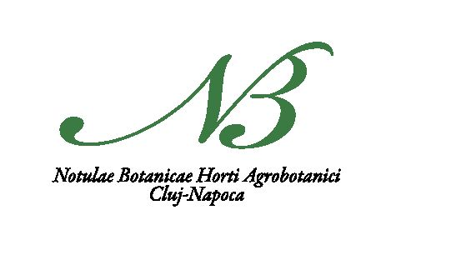
Available online: www.notulaebotanicae.ro
Print ISSN 0255-965X; Electronic 1842-4309
Not Bot Horti Agrobo, 2017, 45(1):255-261. DOI:10.15835/nbha45110727
Original Article
The Allelopathic Potential of Cirsium oleraceum (L.) Scop.
into the Fodder Meadow Plants

Beata BARABASZ-KRASNY1, Katarzyna MOŻDŻEŃ2*,
Anna SOŁTYS-LELEK3, Alina STACHURSKA-SWAKOŃ4
Pedagogical University, Institute of Biology, Department of Botany, Podchorążych 2, 30-084 Kraków, Poland; bbk@up.krakow.pl
2Pedagogical University, Institute of Biology, Department of Plant Physiology, Podchorążych 2, 30-084Kraków,
Poland; kasiamozdzen@interia.pl (Correspondingauthor)
3Ojców National Park, Ojców 9, 32-045 Sułoszowa, Poland; ana_soltys@wp.pl
4Jagiellonian University, Institute of Botany, Kopernika 27, 31-501 Kraków, Poland; alina.stachurska-swakon@uj.edu.pl
Abstract
Due to easy vegetative and generative reproduction, the most part of the Cirsium species are considered as common weeds
in different kinds of crops, on meadows and pastures. They owe their success in acquiring new area, both morphological and
physiological characteristics, such as the production of allelopathic substances. An example the species within of the Cirsium
genus, which may have the allelopathic properties, is cabbage thistle C. oleraceum (L.) Scop. It is a common meadow perennial
plant, which in disturbed habitats quickly becomes expansive species, eliminating the other components of the flora. Such
phenomenon is well-documented on the meadows of the Ojców National Park (Southern Poland). Therefore, it was
investigated the effect of aqueous extracts of dried leaves C. oleraceum on seed germination, seedlings growth, the fresh and dry
weight and the water content of the seedlings in three meadow species: Trifolium pratense L., Lolium multiflorum Lam. and
Dactylis glomerata L. The results showed that C. oleraceum exhibits the allelopathic potential, which may have limited effect on
the studied parameters of fodder species, but only when using high concentrations of extracts prepared from the leaves (15%
and 20%). D. glomerata was the most sensitive on the C. oleraceum allelopathic substances.
Keywords: allelopathy, Dactylis glomerata, fresh and dry weight, Lolium multiflorum, morphology, seedlings, Trifolium
pratense
Introduction
Allelopathic compounds are secreted by alive or dead
organisms, during the decomposition of organic matter. The
allelopathic substances secreted from the leaves or roots have
inhibitory or stimulatory effect on the growth and
development of other plants. They are produced by plants, not
only in natural ecosystems, but also in semi-natural or
anthropogenic ecosystems. They have influence on the
composition of the plant communities, especially in the case of
for mass distribution of species, which produces such
compounds (Ahmed and Wardle, 1994, Wojcik-Wojtkowiak
et al, 1998).
The cabbage thistle Cirsium oleraceum (L.) Scop.
(Asteraceae family) is an example of a species that could
potentially to have allelopathic properties. It is a common,
grand and perennial plant growing in Asia and Europe (except
the Mediterranean area). In Poland it grows on the whole area,
especially in the lowlands and at lower altitudes, having the
status of native species. Its erected, empty inside, stalk reaches a
height of 0.5-1.5 m (1.8 m). Leaves are through the entire
length of the stalk, but the lower are ragged and significantly
larger than the top. It prefers wet meadows habitats, tall herb
communities, alluvia, the banks of ditches and water reservoirs,
especially in fertile, moist and rich in calcium carbonate
(Mowszowicz, 1986). In the classification of plant
communities, this species is characteristic for the Calthion
palustris R.Tx 1936 em. Oberd. 1957 order and Angelico-
Cirsietum oleracei R.Tx 1937 em. Oberd. 1967 association
(Matuszkiewicz, 2006). It may en masse appear in the
limestone meadows (Nawara, 2006), causing the gradual
elimination of other floristic components. This kind of
phenomenon was well documented on areas of valley meadows
of the Ojców National Park (ONP) in Southern Poland
(Kornaś and Dubiel, 1991). From the point of view of
biodiversity conservation meadow ecosystems of the park, the
Received: 15 Feb 2017. Received in revised form: 11 Apr 2017. Accepted: 06 May 2017. Published online: 12 May 2017.
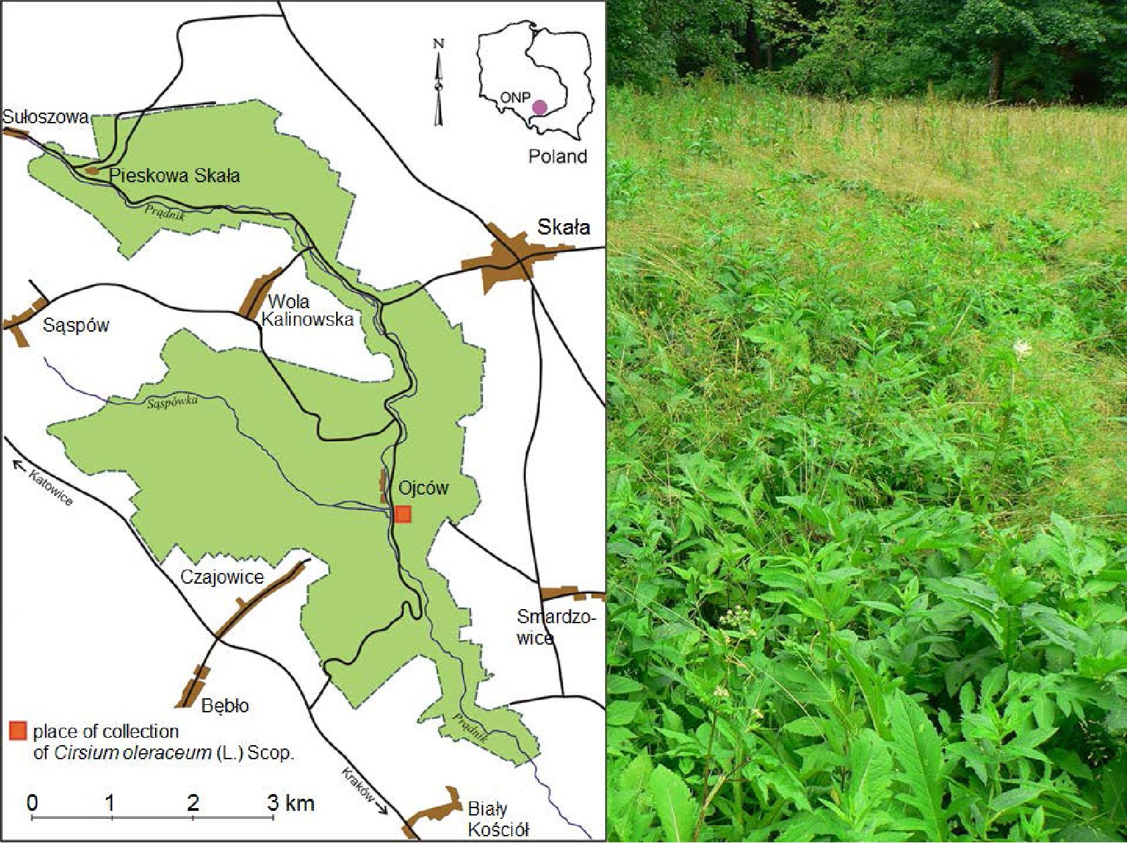
Barabasz-Krasny B et al/Not Bot Horti Agrobo, 2017, 45(1):255'261
256
species have caused significant changes in floristic composition.
Therefore, in order to effectively protect semi-natural meadow
communities it is important to get to know the allelopathic
potential of C. oleraceum, compared to other common
meadow plants.
The aim of the present study was to determine the effect of
aqueous extracts of dry leaves C. oleraceum on the seeds
germination (1), the growth (2), the fresh and dry weight (3)
and the water content of the seedlings (4) of the three forage
species: Trifolium pratense L. cv ‘Dajana-C/1PL430/09/
10060/Z47/A’, Lolium multiflorum Lam. cv ‘Mitos-C/1PL
430/09/10060/Z8/A’ and Dactylis glomerata L. cv ‘Athos-
C/1 DK-13NA0660’. These experiments were conducted to
help answer the question: ‘whether C. oleraceum has the ability
to allelopathic influence on the species of sward’?

Materials and Methods
Plant material
Specimens of Cirsium oleraceum (L.) Scop. were collected at
the turn of June and July 2015 in one of the valley meadows,
occurring in ONP - Fig. (1), (Southern Poland, N -
19°46'55,979"E 50°15'4,086"N; E - 19°51'11,998"E
50°10'29,894'N; W - 19°46'9,501"E 50°12'55,254"N; S -
19°50'47,379"E 50°10'13,017"N). In this study, the most
commonly meadow plant species used as mixtures of component
to sow meadows in order to regenerate them were selected. The
seeds of Dactylis glomerata L. cv. ‘Athos-C/1 DK-13NA0660’,
Lolium multiflorum Lam. cv. ‘Mitos-C/1PL430/09/10060/Z8/
A’ and Trifolium pratense L. cv. ‘Dajana-C/1PL430/09/10060/
Z47/A’, were bought in “KADO” Grass Warehouse s.c. A.
Rydzewska, D. Rydzewski (Pszczyna, Poland).
Preparation of extracts
The aqueous extracts of C. oleraceum at concentrations ofl, 5,
10, 15, 20% from the leaves dried at room temperature and
crushed in a mortar were prepared. Each of the extracts, depending
on the concentration, were prepared in appropriate amounts of
cold distilled water (1% - 99 ml, 5% - 95 ml, 10% - 90 ml, 15% -
85 ml, 20% - 80 ml) and they were left for 24 h at a temperature of
25 °C in order to extract allelopathic compounds. After 24 hours,
the aqueous extracts were filtered and stored in the refrigerator no
longer than a week.
Germination of seeds
Morphologically similar seeds ofD. glomerata, L. multforum
and T. pratense were washed with tap and distilled water. After
then, on the Petri dishes, sterilised at 105 °C and with filter paper,
the 25 seeds of each plant were placed. Then seeds were watered
the aqueous extracts of C. oleraceum dried leaves. The plant
materials were placed in seed tray, at a temperature approx. 25 °C.
At 24 hours for seven days it was checked number (percentage) of
germinated seeds in order to determine their energy and power of
seeds germination. As germinated seeds were considered those
whose sprouts were longer than one half of the seed.
Length of seedlings,fresh and dry weight and water content
The allelopathic effect of aqueous extracts of the leaves of C.
oleraceum on the growth of studied species seedlings
(underground and aboveground organs) was measured after
seven days from the start of the experiment. The fresh weight of
seven day old seedlings was weighed (1600 CMedicat, Poland).
To obtain a dry weight, the plant material was dried at 105 °C in
drier (Termaks 8430, Poland). The material was weighed and the
dry weight and percentage of water content were determined.
Fig. 1. Cirsium oleraceum on the meadow Ojców National Park from which the samples were taken
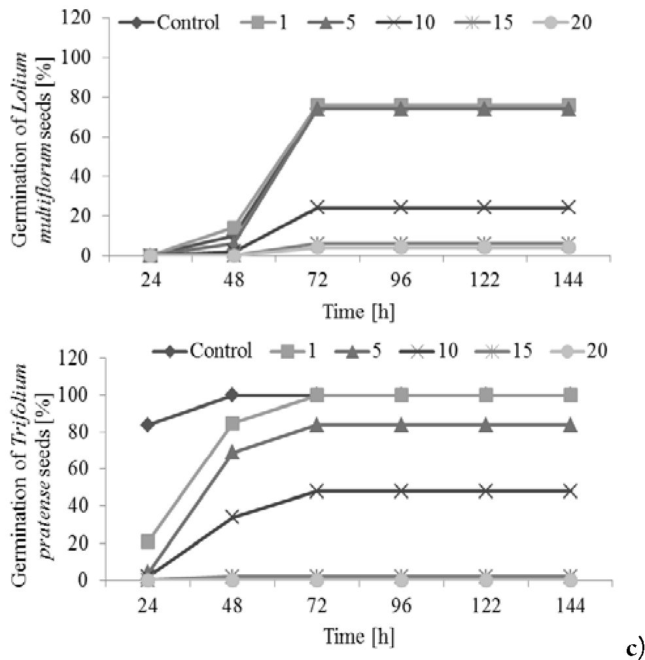
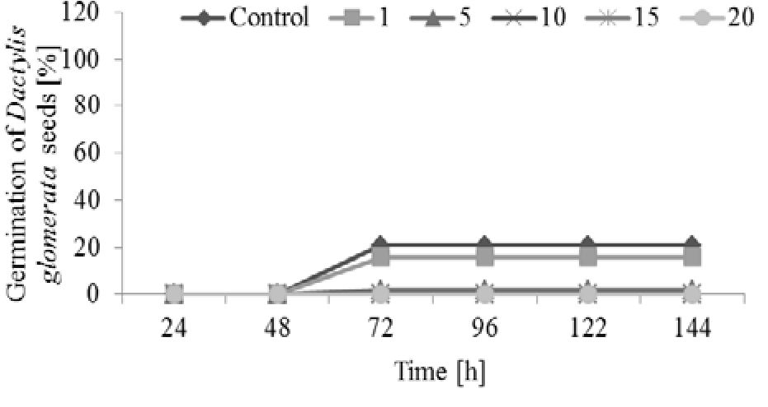
Barabasz-KrasnyB etal/NotBotHorti Agrobo, 2017, 45(1):255-261
Statistical analysis
The results are the arithmetic average of five independent
replicates (n = 5) for each extract concentration and control
group (distilled water). Besides average values, the standard
deviations (±SD) were also given. Statistical analysis was
performed using non-parametric Kruskal-Wallis test after the
Levene’s test of variance homogeneity, wherein a=0.05. The
Statistica 10.0 software for Windows was applied to perform
calculations.

Results
Germination of seeds
The aqueous extracts of the leaves Cirsium oleraceum (L.)
Scop. demonstrated varying effects on seed germination of
studied forage species (Fig. 2a-c). For example, on the 1%
extract concentration, the Trifolium pratense L. seeds
germinated as the same as seeds watered distilled water
(control). With the increase in the concentrations of the
extracts, inhibition of germination was observed in each
sample. In the 3ri day, the energy of seed germination T.
pratense was almost 60%, Lolium multiforum Lam. 23%, and
Dactylis glomerata L. 0% (no germination). On the 15% and
20% extracts of C. oleraceum, the lowest number of germinated
seeds was noticed - from 5 to 20% for T. pratense and L.
multiflorum and 0% for D. glomerata. In following days, the
number of germinated seeds studied species was changed only
in minor degree, compared to seeds germinated in the first
three days. Generally, on the extracts of C. oleraceum, the
highest energy and power of seeds germination were observed
for T. pratense, and the lowest for D. glomerata.
Length of seedlings
The length of the seedlings underground organs of T.
pratense and L. multiflorum were not significantly different
from control and 1% leaves extract C. oleraceum (Fig. 3a-c).
The D. glomerata seedlings in each of the concentrations used
extracts showed significant inhibition of growth of under-
ground organs as compared to control. In the case of T.
pratense, significant inhibition the root growth on the 10%,
15% and 20% extracts concentration was observed. While, the
L. multiflorum was also sensitive to the extract with a 5%
concentration. In the case of 20% extracts, complete inhibition
of roots growth in all three species seedlings were observed. In
addition, the 15% extract of C. oleraceum inhibited roots
growth of L. multiflorum and the 10% extract also inhibited
roots growth of D. glomerata.
In the case of aboveground organs, in almost all of the
studied species a significant inhibition of seedlings growth were
revealed. The absence of statistically significant differences
between control and extract 1% were observed for L.
multiflorum only (Fig. 3a-c). With increasing concentration of
allelopathins, a decrease in growth of aboveground organs was
observed, and even complete inhibition of growth on the 20%
extracts for all studied seedlings. In addition to a growth of
aboveground organs on the 15% extract in the case of L.
multiflorum and the 10% extract in the case of D. glomerata
was inhibited.
257
Fresh and dry weight and water content
Compared to control, a significant decrease of the fresh
weight values of T. pratense for 5% and higher concentrations
of C. oleraceum extract were observed. The fresh weight
decreased with increasing concentration of allelopathic
substances. Compared to the control, the seedlings grown on
the 10% and 15% extracts showed about the half lower values
of the fresh weight, and on the 20% extracts the values were to
10 times lower. In the case of L. multiflorum, differences in the
values of this parameter between the control and seedlings on
the 10%, 15% and 20% extracts were found. Statistically
significant decrease in the fresh weight of D. glomerata
seedlings in each concentration of extracts was showed (Table
1).
Compared to the control, the values of the dry weight of
significantly increased only for L. multiflorum seedlings in all
used extracts. In the other two cases - T. pratense and D.
glomerata, there was no significant effect of water extracts from
the leaves of C. oleraceum on increasing the dry weight values
(Table 1).
The percentage water content of the T. pratense seedlings
was decreased onlv on the 20% extract, compared to the other
L.
a)
b)
Fig. 2. The influence of the aqueous extracts of the Cirsium
oleraceum leaves on the seeds germination: a) Dactylis
glomerata; b) Lolium multiflorum; c) Trifolium pratense; mean
values ±SD, n = 5

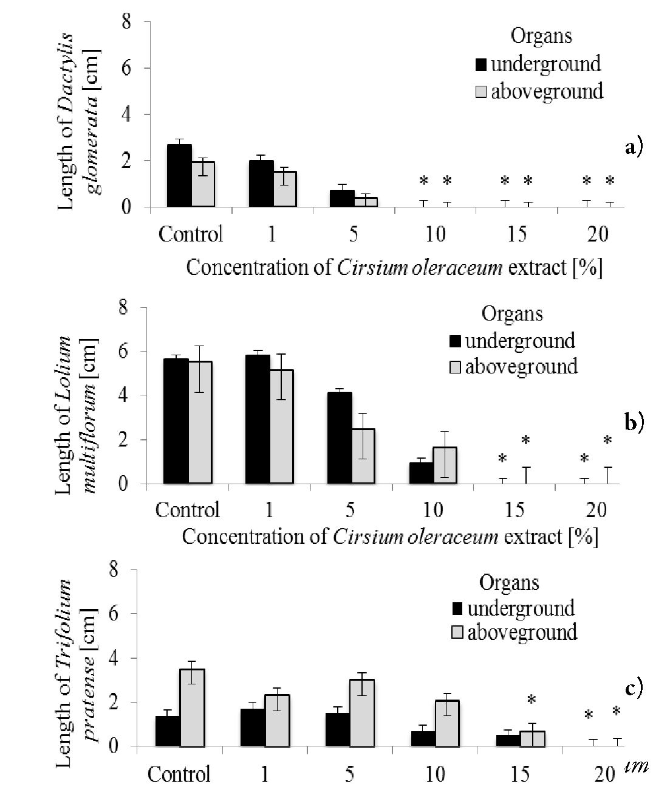
Barabasz-Krasny B et al/Not Bot Horti Agrobo, 2017, 45(1):255'261
258
multiflorum, the values of the water content of the seedlings
grown in Petri dishes with the lowest concentration of
allelopathic substances (1% and 5%) were unchanged,
compared to the control. In other cases, a significant decrease in
water content values, compared to the control and the 1% and
5% concentration of extracts were observed. Compared to
control, significantly decreasing of the water content in
seedlings of D. glomerata grown on the 10%, 15% and 20%
extracts of C. oleraceum was found (Table 1).

Discussion
In the Ojców National Park (ONP) already in the 90s of
the last century have been found patches of meadow with the
dominance of the high nitrophilous perennials, including
Cirsium oleraceum (L.) Scop. until 1/5 area of the valley
bottom (Kornaś and Dubiel, 1991). They developed on the
fertile pastures Lolio-Cynosuretum R.Tx 1937 and the tall oat-
grass meadows Arrhenatheretum elatioris Br.-Bl. ex Scherr.
1925, existing in the ONP in the 50s and later neglected of
management. The direct cause of creating this type of plant
groups was the abandonment of grazing and mowing.
Developing of grasslands with domination Urtica dioica and
Cirsium oleraceum resulted in a significant poorness of flora in
these areas - in this type of plots recorded only between 10 and
25 species per 100 m2 (Kornaś and Dubiel, 1991). The
problem of the occurrence of this community continues to
represent a serious threat to biodiversity and landscape of
meadows in the valley of the ONP.
Species of the Cirsium Mill. genus are the most common
considered as weeds, occurring in different types of crops. With
easy vegetative and generative reproduction they can prevail the
considerable areas. For example, bull thistle C. vulgare (Savi)
T able 1. The average values of fresh and dry weight and the percentage of water content in seedlings of Dactylis glomerata L., Lolium multiflorum Lam.,
Trifolium pratense L. germinated on the aqueous extracts of dried leaves Cirsium oleraceum (L.) Scop., at percentage concentrations of 1%, 5%, 10%,
15%, 20% and distilled water (control); the mean values ±SD (n = 5); the different letters within the same row are significantly different by Kruskal-
Wallis test at p < 0.05
Concentration of Cirsium oleraceum extract [%] nd
aboveground organs seedlings: a) Dactylis glomerata; b) Lolium
multiflorum; c) Trifolium pratense; the mean values ±SD (n =
5); columns marked by stars differ significantly by Kruskal-
Wallis test at p < 0.05
N ame of species |  |  |  | Concentration of Cirsium oleraceum extract (%)
N ame of species | Parameters | Control | 1 | 5 | 10 | 15 | 20
 | Fresh weight (g) | 0.11a  ±0.01 | 0.05a  ±0.01 | 0^a  ±0.01 | 0.04a  ±0.001 | 0.03ь  ±0.001 | 0.03ь  ±0.021
Dactylis  glomerata | Dry weight (g) | 0.03a  ±0.01 | 0.05a  ±0.03 | 0.02a  ±0.02 | 0.02a  ±0.001 | 0.02ab  ±0.001 | 0.009^  ±0.001
 | Water content (%) | 72.00a  ±13.80 | 65.28a  ±2.51 | 64.47a  ±3.49 | 39.08a  ±4.11 | 33.92a  ±4.00 | 32.75a  ±15.90
 | Fresh weight (g) | 0.42a  ±0.0б | 0.49a  ±0.03 | 0.47a  ±0.0б | 0.24ь  ±0.05 | 0.14b  ±0.01 | 0.13ь  ±0.01
Lolium  multiflorum | Dry weight (g) | 0.04ь  ±0.01 | 0^a  ±0.00б | 0^a  ±0.008 | 0^a  ±0.007 | 0.08a  ±0.004 | 0.08a  ±0.05
 | Water content (%) | 91.77a  ±0.5б | 87.51a  ±1.01 | 87.38a  ±0.13 | 71.12b  ±4.0б | 46.03c  ±1.10 | 41.72c  ±2.83
 | Fresh weight (g) | 0T4a  ±0.05 | 0.41a  ±0.10 | 0.38a  ±0.03 | 0.20a  ±0.01 | 0.24a  ±0.17 | 0.0бь  ±0.004
Trifolium  pratense | Dry weight (g) | 0.03a  ±0.001 | 0.03a  ±0.002 | 0.03a  ±0.004 | 0.03a  ±0.0008 | 0.02a  ±0.002 | 0.03a  ±0.007
 | Water content (%) | 95.42a  ±0.23 | 82.03a  ±11.30 | 91.75a  ±0.б4 | 84.54a  ±0.б8 | 75.81a  ±б.01 | 52.51ь  ±12.4б
Barabasz-Krasny B etal/Not Bot Horti Agrobo, 2017, 45(1):255-26l
Ten. is mentioned as a noxious weed crops in nine US states
(USD A, NRCS, 2016). In Poland it grows abundantly as a
weed of vegetable crops and pastures, drowning out
neighboring plants (Nowiński, 1966). Similarly common
creeping thistle C. arvense (L.) Scop., weeds all types of crops
and wrong managed meadows and pastures (Mowszowicz,
1986). Previous studies of species of the Cirsium genus
concerned mainly creeping thistle C. arvense (Stachoń and
Zimdahl, 1980; Uludag et al., 2006; Bhadoria, 2011; Invasive
Species Compendium, 2016), marsh thistle C. palustre (L.)
Scop. (Falk, 2000), japanese thistle C. japonicum DC. (Chon,
2004), C. pendulum Fisch. and C. vulgare (De Jong and
Klinkhmer, 1985). In the literature are available information
about their allelopathic interactions. For example Helgeson
and Konzak (1950) reported that aqueous extracts from the
roots and stalks of C. arvense inhibit the germination and
growth of wheat Triticum aestivum L. and flax Linum
usitatissimum L., and Chon (2004) that the water extracts
from the leaves, stalks, roots and flowers C. pendulum Fisch.
have inhibiting influence on the growth of lucerne seedlings
(Medicago sativa L.). Stachoń and Zimdahl (1980) noted the
fact of C. arvense reduced growth of redroot pigweed
Amaranthus retroflexus L. and green foxtail Setaria viridis L.
more than that of cucumber Cucumis sativus L. or barley
Hordeum vulgare L. However, there is not specific information
about the allelopathic properties of cabbage thistle C.
oleraceum.
In the case of cabbage thistle conducted primarily a study to
determine the chemical composition of biologically active
compounds contained in different parts of this plant, because it
is a medicinal and honey species (e.g. Shelyuto el al., 1971; Tarle
et al, 1984; Borawska et al, 2010; Kozyra et al, 2015). Active
components ofthe herb (Herba Cirsii oleracei) is a mixture of at
least seven flavonoids e.g.: linarin, pectolinarin, apigenin,
scutellarin and triterpenes, phytosterols, tannins, pectin,
hydrocarbons, resins, essential oils, mineral salts (Nazaruk and
Brzóska, 2008). In the inflorescences of C. oleraceum were
identified essential oils, among them ketones and aldehydes. In
small quantities, were shown occurrence of terpenes: thymol, (T
linalool, eugenol, carvacrol and fatty acids with odd number of
carbon atoms-waxes (Kozyra et al, 2015). The presence of
phenols in extracts from C. oleraceum revealed e.g. Borawska et
al. (2010) and Nalewajko-Sieliwoniuk et al. (2012). According
to some authors, a negative interactions allelopathic species of
the Cirsium genus (C. arvense, C. japonicum), probably due to
the release by their organs phenolic compounds (Kovacs et al.,
1988; Kazinczi et al, 2001; Chon et al, 2003). Phenols have
inhibiting influence, among others on - ATP synthesis in
mitochondria and photosynthesis (Stenlid, 1970; Johansson
and Hagerby, 1974; Dadkhah, 2012). They increase the
permeability of cell membranes by their depolarisation and
inhibition of protein synthesis and play an important role in
supplying plants with nutrients (Baziramakenga et al, 1995).
Allelopathic substances have a negative impact on the
swelling of seeds, damage of seed coat and aleuronic layer of
seeds, inhibition of mitosis and meiosis divisions and cell
elongation. The resulting anatomical and morphological
distortion delaying seed germination, inhibits germinal root
elongation, and lead to their dying off (Rice, 1984).
Disorganisation in the functioning of cells, tissues and
259
physiological processes leads to lack of root hairs formation,
lateral roots and trend of roots to the horizontal growth which
are results of direct contact root with allelopathic substances
(Baziramakenga et al, 1994). The morphogenetic changes are
the results of influence allelopathic substances which ultimately
affects the size and quality of plants (Lyu and Blum, 1990;
Skrzypek et al. 2015).
In this study, was demonstrated the inhibitory effect of
aqueous extracts of the leaves of C. oleraceum on germination
and growth of forage species (Trifolium pratense L., Lolium
multiflorum Lam., Dactylis glomerata L.) and increase their
biomass (Table 1). With increasing concentration of
compounds in the extracts, decreasing the number of
germinated seeds was observed. The lowest seeds germination
on the extracts of 15% and 20% were found (Fig. 2a-c).
Similarly, at the highest concentrations of extracts from the
leaves of C. oleraceum the length and weight of seedlings were
inhibited (Fig. 3a-c). Significant changes in the morphology of
studied seedlings were observed only at the highest
concentrations of extracts from the leaves of C. oleraceum. It
may be result from low amounts ofallelopathic substances with
inhibitory properties. For example, aqueous extracts of the
leaves of peppermint (Mentha x piperita L.) already at
concentrations of 3% and 5% inhibited germination of
common sunflower (Helianthus annuus L.) (Skrzypek et al.,
2015), and aqueous extracts from the roots and stems of the
Shepherd’s purse Capsella bursa-pastoris (L.) Medik. at 1%
concentration inhibited the germination of lettuce seeds
Lactuca sativa L. cv 'Maryna' (Możdżeń et al, 2016).
It should also be noted that the activity of allelopathic
substances is correlated with various environmental stresses. In
natural conditions, about the growth and development of
plants decide simultaneously environmental factors and
allelochemical substances in them appearing (Astarita et al.,
1996). One of the most important abiotic factors of the
environment for plants is the availability of light (Franklin and
Whitelam, 2005). The light provides various informations
about plants and the surrounding environment. In natural
conditions, some plants are exposed to shade and others on
excessive sunlight (Smith and Whitelam, 1997). In response to
the various spectral composition and intensity of light, the
plants are characterised by different morphology and different
physiological processes (Casal, 2012). C. oleraceum due to its
large size and large surface ofleaves, through most of the day has
easy access to sunlight. Other species, such as L. multiflorum, D.
glomerata, especially T. pratense, growing around C. oleraceum,
for the major part of the day are exposed to low light, because
they grow in its shadow. The reduction of light through the
plant canopy affects the same on changes in temperature,
humidity and soil. C. oleraceum has a relatively low allelopathic
effect, but the interaction with environmental stress factors
such as shading, the effect can be improved. Depending on the
species and stage of development of plants growing around
cabbage thistle, in a higher or lower degree, C. oleraceum
interferes in biochemical and physiological processes these
plants.

Conclusions
The highest of energy germination was observed in
Trifolium seeds, and the lowest in Dactylis; at the extract with
Barabasz-Krasny B et al f Not Bot Horti Agrobo, 2G17, 45(1):255-26l
260
concentrations of 15% and 20%, energy and power of seeds
germination of all three species were the lowest; the most
sensitive to the aqueous extracts of Cirsium were Dactylis seeds.
Hypocotyl growth was significantly lower for all used extracts,
especially with the largest concentration allelopathic
substances; All extracts have inhibitory effects on root and
coleoptyle growth of Dactylis, and Lolium seedlings were
i nsensitive only on the 1% extract. The fresh weight of
Trifolium seedlings decreased with increasing concentrations of
extracts; at 10%, 15% and 20% concentrations changes in the
quantity of fresh weight in Lolium were recorded; used at each
of the extracts, the fresh weight of the Dactylis seedlings
oscillated at a very low range; the highest value of the dry weight
of the Lolium seedlings was observed, and the lowest in Dactylis
seedlings. For each of the applied aqueous extracts, the water
content in seedlings had highest value in case of Trifolium and
l ower values in case ofDactylis and Lolium.
Based on the above conclusions, answer the question posed
i n the aim of this study - whether has the C. oleraceum ability to
allelopathic influence on the sward meadow species? - can be in
the following way: C. oleraceum has the ability to allelopathic
influence on the sward meadow species, however, in compared
to the other plants demonstrates lower properties. Therefore it
must be assumed that its competitive success is the result not
only of allelopathic interactions, but relatively large size of
i ndividuals, that cause effective shading of other swardspecies.

References
Ahmed M, Wardle DA (1994). Allelopathic potential ofvegetative and
flowering ragwort (Seneciojacobea L.) plants again associated pasture
species. Plant Soil 164:61-68.
Astarita LV, Ferreira AG, Bergoni JI (1996). Mimosa bimuctonata:
Allelopathy stress. AllelopathyJournal 3:43-50.
Baziramakenga R, Leroux GD, Simard RR (1995). Effects of benzoic
and cinnamic acids on membrane permeability of soybean roots.
J ournal of Chemical Ecology 21:1271-1285.
Baziramakenga R, Simard RR, Leroux GD (1994). Effects of benzoic
and cinnamic acids on growth, mineral composition, and
chlorophyll content of soybean. Journal of Chemical Ecology
20:2821-2833.
Bhadoria PBS (2011). Allelopathy: A natural way towards weed
management. American Journal of Experimental Agriculture
1(1):7-20.
Borawska MH, Czechowska SK, Markiewicz R, Socha K, Nazaruk J,
Pałka J, Isidorov VA (2010). Enhancement of antibacterial effects of
extracts from Cirsium species using sodium picolinate and
estimation oftheir toxicity. Natural Product Research 24:554-61.
CasalJJ (2012). Shade avoidance. The Arabidopsis Book. The American
Society ofPlant Biologists 10:e0157.
Chon SU (2004). Allelopathic potential of common thistle (Cirsium
japonicum) leaf extracts and residues. Korean Journal of Weed
Science 24:79-86.
Chon SU, Kim YM, Lee JC (2003). Herbicidal potential and
quantification of causative allelochemicals from several Compositae
weeds. Weed Research 43:444-450.
Dadkhah A (2012). Phytotoxic effects of aqueous extract of eucalyptus,
sunflower and sugar beet on seed germination, growth and
photosynthesis of Amaranthus retroflexus. Allelopathy Journal
29(2):287-296.
De Jong TJ, Klinkhmer PGL (1985). The negative effects of litter of
parent plants of Cirsium vulgare on their offspring: autotoxicity or
immobilization? Oecologia 65(2):153-160.
Falk A (2000). Allelopathic effect of invasive wetland plants (Lythrum
salicaria, Cirsium palustre, Rhamnusfangula) on seed germination.
General Ecology. Deep Blue at the University of Michigan.
http://hdl.handle.net/2027.42/54882.
Franklin KA, Whitelam GC (2005). Phytochromes and shade-
avoidance responses in plants. Annals of Botany96(2) :169-75.
Helgeson EA, Konzak R (1950). Phytotoxic effects of aqueous extracts
of field bindweed and of Canada thistle. A preliminary report.
North Dakota Agricultural Experiment Station Bulletin 12:71-76.
Invasive Species Compendium (2016). Cirsium arvense (creeping
thistle). Retrieved 2016 December 7 from http://www.cabi.org/
isc/datasheet/13628.
Johansson M, Hägerby E (1974). Influence of growth conditions,
metabolic inhibitors, and phenolic compounds on the ATP pool in
Fomes annosus. Physiologia Plantarum 32:23-32.
Kazinczi G, Beres I, Narwal SS (2001). Allelopathic plants. 1. Canada
thistle (Cirsium arvense (L.) Scop.). AllelopathyJournal 8:29-40.
Kornaś J, Dubiel E (1991). Land use and vegetation changes in hay-
meadow in the Ojców National Park during last thirty years.
Veröffentlichungen des Geobotanischen Institutes ETH, Zürich,
Stiftung Rübel 106:209-231.
Kovacs L, Mikulas J, Polos E (1988). Allelopathic activity of Cirsium
arvense (L.) in Hungary. Acta Agronomica Hungarica 37:65-69.
Kozyra M, Mardarowicz M, Kochmańska J (2015). Chemical
composition and variability of the volatile components from
inflorescences of Cirsium species. Natural Product Research
29(20):1942-1944.
Lyu SW, Blum U (1990). Effects of ferulic acid, an allelopathic
compound, on net P, K and water uptake by cucumber seedlings in
a split-root system. Journal of Chemical Ecology 16:2429-2439.
Matuszkiewicz W (2006). Przewodnik do oznaczania zbiorowisk
roślinnych Polski [Guide for the determination of Polish plant
communities]. Wydawnictwo Naukowe PWN, Warszawa.
Mowszowicz J (1986). Krajowe chwasty polne i ogrodowe. Przewodnik
do oznaczania. [Guide for the determination of plants]. Państwowe
Wydawnictwo Rolnicze i Leśne, Warszawa.
Możdżeń K, Barabasz-Krasny B, Soltys-Lelek A, Stachurska-Swakoń A,
Pula J (2016). Wpływ wodnych ekstraktów z tasznika pospolitego
(Capsella bursa-pastoris (L.) Medik.) na kiełkowanie i rozwój sałaty
siewnej odmiany ‘Maryna’ (Lactuca sativa L. cv ‘Maryna’). Annales
Universitatis Mariae Curie-Skłodowska, Sectio E 71(2):1-10.
Nalewajko-Sieliwoniuk E, Nazaruk J, Kotowska J, Kojło A (2012).
Determination of the flavonoids/antioxidant levels in Cirsium
oleraceum and Cirsium rivulare extracts with cerium (IV)-
rhodamine 6G chemiluminescence detection. Talanta 96:216-222.
Barabasz-Krasny B et al / Not Bot Horti Agrobo, 2017, 45(1):255-261
Nawara Z (2006). Rośliny łąkowe. Flora Polski. Oficyna wydawnicza
Multico, Warszawa.
Nazaruk J, Brzóska T (2008). Aktualny stan wiedzy na temat
aktywności farmakologicznej roślin z rodzaju Cirsium Mill. Postępy
Fitoterapii 3:170-175.
Nowiński M (1966). Chwasty łąk i pastwisk. Państwowe
Wydawnictwo Rolnicze i Leśne, Warszawa.
Rice EL (1984). Allelopathy, Academic Press (2nd ed), Orlando, Florida.
Shelyuto VL, Glyzin VI, Ban’kovskii AI, Bubon NT (1971). Flavonoid
glycosides of Cirsium oleraceum. Khimiya Prirodnykh Soedinenii
7(3):372-373.
Skrzypek E, Repka P, Stachurska-Swakoń A, Barabasz-Krasny B,
Możdżeń K (2015). Seedlings growth of common sunflower under
influence of peppermint extract. Modern Phytomorphology 9:69-
73.
Smith H, Whitelam GC (1997). The shade avoidance syndrome:
multiple response mediated by multiple phytochromes. Plant, Cell
& Environment 20:840-944.
261
Stachoń WJ, Zimdahl RL (1980). Allelopathic activity of Canada thistle
(Cirsium arvense) in Colorado. Weed Science 28(1):83-86.
Stenlid G (1970). Flavonoids as inhibitors of the formation of adenosine
triphosphate in plant mitochondria. Phytochemistry 9:2251-2256.
Tarle D, Petricic J, Kupinic M (1984). Cirsium oleraceum (L.) Scop.
Chemical and anti-microbial investigation. Farm Glas 40(11-
12):363-367.
Uludag A, Uremis I, Arslan M, Gozcu D (2006). Allelopathy studies in
weed science in Turkey - a review. Journal of Plant Diseases and
Protection 20:419-426.
USDA, NRCS. 2016. The Plants Database (http://plants.usda.gov, 7
December 2016). National Plant Data Team, Greensboro, NC
27401-4901 USA.
Wójcik-Wojtkowiak D, Politycka B, Weyman-Kaczmarkowa W
(1998). Allelopathy. Wydawnictwo Akademii Rolniczej, Poznań.

